Priloga 1:
»PRILOGA 1: Vodovarstveno območje
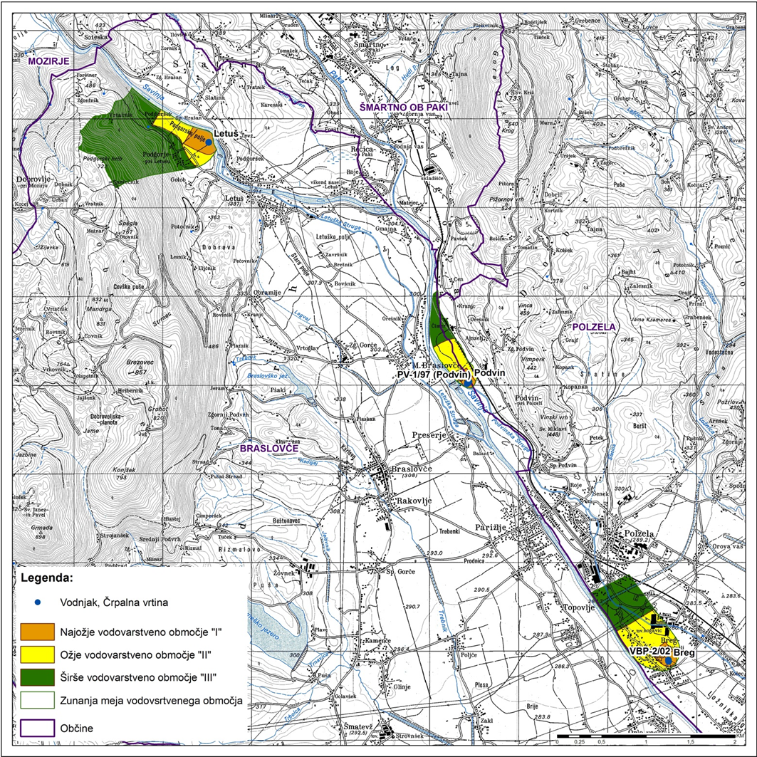

PRILOGA 2: Območje zajetja

OBMOČJE ZAJETJA

IME: Breg (Ločica)
Šifra katastrske občine: 992_POLZELA
Del parcele: 326/312

IME: Letuš
Šifra katastrske občine: 984_LETUŠ
Del parcele: 1265/2

IME: Podvin
Šifra katastrske občine: 983_MALE BRASLOVČE
Del parcele: 575/10

IME: PV-1/97 (Podvin)
Šifra katastrske občine: 983_MALE BRASLOVČE
Del parcele: 575/9

IME: VBP-2/02 (Ločica)
Šifra katastrske občine: 992_POLZELA
Del parcele: 326/311

VODOVARSTVENO OBMOČJE 1
IME: Breg (Ločica) in VBP-2/02 (Ločica)
Šifra katastrske občine: 991_ORLA VAS
Na parceli: 329/116, 329/223, 329/388, 329/435, 329/443
Del parcele: 329/51, 329/54, 329/55, 329/56, 329/115, 329/115, 329/116, 329/118, 329/204, 329/364, 329/439, 329/450, 329/570, 329/571, 612/59, 1462

Šifra katastrske občine: 992_POLZELA
Na parceli: 326/23, 326/24, 326/26, 326/27, 326/213, 326/256, 326/258, 326/259, 326/313, 326/387, 326/414, *730, 928/178, 928/190, 928/207, 928/208
Del parcele: 326/50, 326/51, 326/52, 326/53, 326/54, 326/55, 326/56, 326/57, 326/58, 326/59, 326/83, 326/84, 326/85, 326/311, 326/312, 928/146, 928/152, 928/153, 928/154, 928/158, 928/177, 928/188, 928/189, 928/191

IME: Letuš
Šifra katastrske občine: 984_LETUŠ
Na parceli: 1251, 1253/1, 1254, 1256, 1257, 1259/1, 1259/2, 1260, 1262, 1263, 1264, 1265/1, 1267, 1268, 1269, 1270, 1271, 1272, 1273, 1274, 1275
Del parcele: 1240, 1241, 1243, 1244, 1250, 1253/2, 1254, 1265/2, 1276, 1277, 1278, 1279, 1307, 1310, 1311/1, 1311/2, 1312, 1313, 1315, 1316, 1361, 1378/1

IME: Podvin in PV-1/97 (Podvin)
Šifra katastrske občine: 982_PODVIN
Na parceli: 335, 642/1
Del parcele: 331/1, 332/2, 334/1, 336/1, 336/5, 642/1

Šifra katastrske občine: 983_MALE BRASLOVČE
Na parceli: 575/1, 575/6, 575/8, 654/10
Del parcele: 575/1, 575/2, 575/5, 575/7, 575/8, 575/9, 575/10, 654/45, 654/57

VODOVARSTVENO OBMOČJE 2
IME: Breg (Ločica) in VBP-2/02 (Ločica)
Šifra katastrske občine: 988_SPODNJE GORČE
Na parceli: 962/46, 962/51, 962/60, 962/61, 962/62, 962/63, 962/64, 962/65, 962/66, 962/67, 962/68, 962/69, 962/70, 962/71
Del parcele: 961/1, 962/38, 962/56, 962/57, 962/58, 962/59, 967

Šifra katastrske občine: 991_ORLA VAS
Na parceli: *134, *147, *152, 329/50, 329/115, 329/116, 329/138, 329/139, 329/151, 329/174, 329/222, 329/238, 329/239, 329/240, 329/260, 329/364, 329/370, 329/438, 329/440, 329/449, 329/535, 329/536, 329/562, 329/563, 611/1, 611/8, 611/9, 611/10, 611/11, 611/13, 611/14, 611/16, 611/17, 611/20, 611/21, 611/22, 611/23, 611/24, 611/26, 611/28, 611/29, 611/30, 611/31, 611/32, 611/33, 611/34, 611/35, 611/36, 611/37, 611/38, 611/39, 611/40, 612/1, 612/3, 612/4, 612/6, 612/8, 612/10, 612/11, 612/12, 612/13, 612/14, 612/15, 612/16, 612/17, 612/18, 612/19, 612/20, 612/24, 612/25, 612/26, 612/27, 612/28, 612/29, 612/31, 612/33, 612/34, 612/35, 612/36, 612/37, 612/38, 612/39, 612/40, 612/41, 612/42, 612/44, 612/45, 612/46, 612/49, 612/52, 612/53, 612/54, 612/55, 612/56, 612/57, 612/58, 612/60, 612/61, 613/2, 613/5, 613/7, 613/8, 613/61, 613/62, 613/63, 613/64, 613/65, 614/1, 614/2, 614/3, 615/3, 616/1, 616/3, 617/5, 1469
Del parcele: *182, 329/50, 329/51, 329/54, 329/55, 329/56, 329/115, 329/116, 329/118, 329/149, 329/159, 329/204, 329/227, 329/228, 329/232, 329/238, 329/347, 329/348, 329/364, 329/439, 329/450, 329/562, 329/563, 329/570, 329/571, 593, 612/7, 612/40, 612/44, 612/59, 613/4, 614/1, 614/4, 615/1, 617/4, 617/5, 617/6, 670

Šifra katastrske občine: 992_POLZELA
Na parceli: 306/26, 306/67, 306/68, 306/71, 306/72, 306/73, 306/74, 306/75, 306/76, 306/77, 306/78, 306/83, 306/86, 306/87, 306/88, 306/89, 306/90, 306/100, 306/101, 306/102, 306/103, 306/104, 306/105, 306/106, 306/107, 306/110, 306/118, 306/119, 306/120, 306/121, 306/122, 306/124, 306/125, 326/50, 326/51, 326/52, 326/53, 326/54, 326/55, 326/83, 326/84, 326/85, 326/207, *575, *768, 928/4, 928/5, 928/23, 928/120, 928/121, 928/122, 928/123, 928/124, 928/125, 928/126, 928/127, 928/128, 928/129, 928/130, 928/131, 928/132, 928/133, 928/137, 928/138, 928/140, 928/141, 928/142, 928/143, 928/144, 928/145, 928/151, 928/155, 1122/1, 1125/117, 1125/118, 1125/119, 1125/120, 1125/123, 1125/124, 1125/125, 1125/126, 1125/130, 1125/132, 1125/139, 1125/140, 1125/141, 1125/143, 1125/144, 1125/146, 1125/147, 1125/148, 1125/149, 1125/169, 1125/172, 1125/176, 1125/177, 1125/178, 1125/179, 1125/180, 1125/181, 1125/184, 1125/185, 1125/189, 1125/190, 1125/191, 1125/194, 1125/197, 1125/224, 1125/231, 1125/233, 1125/234, 1125/246, 1125/248, 1125/249, 1125/250, 1125/251, 1125/252, 1125/253, 1125/255, 1125/257, 1125/258, 1125/259, 1125/260, 1125/262, 1125/263, 1125/264, 1125/265, 1125/266, 1125/267, 1125/268, 1125/269, 1125/270, 1125/271, 1125/272, 1125/275, 1125/276, 1125/277, 1125/278, 1125/279, 1125/280, 1125/281, 1125/282, 1125/283, 1125/284, 1125/285, 1125/286, 1125/287, 1125/288, 1125/289, 1125/290, 1125/291, 1125/292, 1125/293, 1125/294, 1125/295, 1125/296, 1125/297, 1125/298, 1125/299, 1125/300, 1125/301, 1125/302, 1125/303, 1125/304, 1125/305, 1125/306, 1125/307, 1125/308, 1125/309, 1125/310, 1125/311, 1125/312, 1125/313, 1125/314, 1125/315, 1125/316, 1125/317, 1132, 1162/1, 1162/2, 1162/3, 1162/4
Del parcele: 306/13, 306/19, 306/20, 306/26, 306/40, 306/81, 306/98, 306/99, 306/108, 306/109, 306/112, 306/122, 306/123, 326/50, 326/51, 326/52, 326/53, 326/54, 326/55, 326/56, 326/56, 326/57, 326/57, 326/58, 326/59, 326/83, 326/84, 326/85, 326/151, 326/152, 326/153, 326/157, 326/160, 326/161, 326/314, 326/337, 928/23, 928/82, 928/91, 928/115, 928/116, 928/117, 928/118, 928/119, 928/135, 928/146, 928/152, 928/153, 928/154, 928/158, 928/167, 928/177, 928/183, 928/184, 928/185, 928/188, 928/189, 928/191, 1122/1, 1122/1, 1125/318, 1163, 1165/1

IME: Letuš
Šifra katastrske občine: 984_LETUŠ
Na parceli: *84, 1233, 1238, 1239/2, 1308, 1309, 1314, 1318, 1319/1, 1319/2, 1320, 1321, 1322/1, 1322/2, 1323, 1324, 1325, 1326, 1333
Del parcele: 1226, 1228, 1229/2, 1230, 1231/1, 1232, 1234, 1235, 1236, 1237, 1239/1, 1240, 1241, 1243, 1244, 1245/1, 1245/2, 1246, 1250, 1253/2, 1254, 1276, 1277, 1278, 1279, 1280, 1281, 1287/1, 1288, 1289/1, 1289/2, 1304, 1305, 1306, 1307, 1310, 1311/1, 1311/2, 1312, 1313, 1315, 1316, 1327, 1328, 1329, 1330, 1331, 1332, 1335, 1352, 1361, 1362, 1363, 1378/1

IME: Podvin in PV-1/97 (Podvin)
Šifra katastrske občine: 982_PODVIN
Na parceli: 334/2, 385, 386, 387, 388, 389, 390/5
Del parcele: 331/1, 332/2, 334/1, 336/1, 336/2, 336/5, 337, 340, 390/1, 390/2, 390/3, 391/1, 391/2, 392/1, 634, 643

Šifra katastrske občine: 983_MALE BRASLOVČE
Na parceli: 450/12, 450/13, 450/14, 450/15, 450/16, 450/17, 450/18, 450/19, 450/26, 450/27, 450/29, 450/37, 450/38, 450/39, 450/40, 450/41, 450/45, 450/46, 450/49, 450/50, 575/4, 655
Del parcele: 450/9, 450/10, 450/11, 450/33, 450/34, 450/35, 450/36, 575/1, 575/2, 575/5, 575/8, 654/1, 654/45, 655

VODOVARSTVENO OBMOČJE 3
IME: Breg (Ločica) in VBP-2/02 (Ločica)
Šifra katastrske občine: 988_SPODNJE GORČE
Na parceli: *249, *251, 961/1, 962/8, 962/9, 962/10, 962/11, 962/12, 962/13, 962/14, 962/15, 962/16, 962/17, 962/18, 962/19, 962/20, 962/21, 962/22, 962/23, 962/24, 962/25, 962/26, 962/27, 962/28, 962/29, 962/30, 962/31, 962/32, 962/33, 962/34, 962/35, 962/36, 962/37, 962/39, 962/50, 962/52, 962/53, 962/54, 962/55, 962/56, 966, 968
Del parcele: 961/1, 961/1, 962/7, 962/38, 962/56, 962/57, 962/58, 962/59, 967

Šifra katastrske občine: 992_POLZELA
Na parceli: 306/2, 306/3, 306/4, 306/5, 306/6, 306/7, 306/10, 306/11, 306/12, 306/19, 306/30, 306/31, 306/34, 306/35, 306/51, 306/91, 306/92, 306/93, 306/94, 306/95, 306/96, 306/97, 306/113, 306/114, 306/115, 306/116, 306/117, *415, *427, *482, *503, *579, *595, *648, *649, 885/3, 885/4, 897/6, 899/1, 899/3, 900/1, 900/3, 900/5, 900/6, 900/7, 900/8, 900/11, 900/14, 900/15, 900/16, 900/17, 900/20, 900/21, 900/22, 900/23, 900/24, 900/25, 900/26, 901/1, 901/3, 901/5, 901/6, 901/7, 901/8, 902/2, 902/3, 902/4, 905, 906, 907/1, 907/2, 907/3, 907/4, 907/5, 907/6, 907/7, 907/8, 907/9, 907/10, 908/2, 908/3, 908/4, 909/2, 928/1, 928/13, 928/14, 928/15, 928/16, 928/17, 928/18, 928/19, 928/20, 928/21, 928/22, 928/24, 928/25, 928/26, 928/27, 928/28, 928/30, 928/31, 928/32, 928/33, 928/34, 928/35, 928/36, 928/37, 928/38, 928/39, 928/40, 928/41, 928/42, 928/43, 928/44, 928/45, 928/46, 928/47, 928/48, 928/49, 928/50, 928/51, 928/52, 928/57, 928/58, 928/59, 928/60, 928/63, 928/64, 928/65, 928/104, 928/105, 928/111, 928/112, 928/113, 928/114, 928/162, 928/163, 928/166, 928/182, 928/192, 928/193, 928/194, 928/195, 928/196, 928/197, 928/198, 928/199, 928/200, 928/201, 928/202, 928/203, 928/204, 928/205, 928/206, 1122/3, 1122/4, 1125/57, 1125/59, 1125/60, 1125/61, 1125/67, 1125/68, 1125/69, 1125/70, 1125/71, 1125/72, 1125/73, 1125/74, 1125/75, 1125/76, 1125/77, 1125/78, 1125/79, 1125/80, 1125/81, 1125/82, 1125/83, 1125/84, 1125/85, 1125/86, 1125/87, 1125/88, 1125/89, 1125/90, 1125/91, 1125/92, 1125/94, 1125/95, 1125/96, 1125/97, 1125/98, 1125/99, 1125/100, 1125/101, 1125/102, 1125/103, 1125/105, 1125/106, 1125/110, 1125/111, 1125/112, 1125/170, 1125/171, 1125/236, 1125/237, 1125/238, 1125/273, 1125/318, 1125/319, 1125/320, 1125/321, 1125/322, 1125/323, 1125/324, 1125/325, 1125/326, 1125/327, 1125/328, 1125/329, 1125/330, 1125/331, 1125/332, 1125/333, 1125/334, 1125/335, 1125/336, 1125/337, 1125/338, 1125/339, 1133/6, 1158/5, 1160, 1161/1, 1161/2, 1164, 1166/1, 1166/2, 1175
Del parcele: 306/1, 306/13, 306/19, 306/36, 306/98, 306/99, 306/108, 306/109, 306/112, *345, *393, *410/1, *410/2, *748, 885/6, 887, 896/1, 896/7, 897/3, 897/6, 899/4, 899/5, 900/2, 900/3, 900/9, 900/12, 900/13, 900/27, 901/2, 902/1, 903, 904, 909/1, 910, 912/1, 912/2, 912/6, 928/9, 928/10, 928/11, 928/12, 928/29, 928/53, 928/54, 928/56, 928/61, 928/62, 928/66, 928/68, 928/72, 928/73, 928/74, 928/75, 928/79, 928/115, 928/116, 928/117, 928/118, 928/119, 928/167, 928/173, 928/175, 928/182, 1114/1, 1114/4, 1122/1, 1125/55, 1125/56, 1125/57, 1125/58, 1125/65, 1125/66, 1125/235, 1125/318, 1133/1, 1133/7, 1133/8, 1133/9, 1158/3, 1158/4, 1163, 1165/1, 1165/2, 1174

IME: Letuš
Šifra katastrske občine: 984_LETUŠ
Na parceli: *52, *65, *66, *67, *68/1, *68/2, *69/1, *70/1, *70/2, *71/1, *93, *115, *116, *117, *123, *124, *125, *188, *200, 1023, 1024, 1025, 1026, 1027, 1032, 1043/1, 1043/3, 1044, 1045, 1046, 1047, 1048, 1049, 1050, 1051, 1052, 1053, 1054, 1055, 1056/1, 1056/2, 1057, 1058, 1059/1, 1059/2, 1060, 1061, 1062, 1064, 1065, 1066, 1067, 1229/1, 1231/1, 1231/2, 1282, 1283, 1284, 1285, 1286, 1287/2, 1290, 1291, 1292/1, 1292/2, 1293, 1294, 1295, 1296, 1297, 1298, 1299, 1300, 1301, 1302, 1303, 1334/1, 1334/2, 1334/3, 1336, 1337, 1338, 1340/1, 1340/2, 1341, 1342, 1343, 1344, 1345, 1347, 1348, 1349, 1350, 1351, 1375/4
Del parcele: *127, 1022, 1028, 1031, 1033, 1034, 1036, 1037, 1039, 1041, 1043/2, 1068, 1069, 1225, 1226, 1227/3, 1228, 1229/2, 1230, 1231/1, 1232, 1280, 1281, 1287/1, 1288, 1289/1, 1289/2, 1304, 1305, 1306, 1307, 1327, 1328, 1329, 1330, 1331, 1332, 1335, 1352, 1353, 1362, 1363, 1378/1

Šifra katastrske občine: 985_DOBROVLJE
Na parceli: *126, 604, 605, 606/2, 607, 610
Del parcele: 600, 602/1, 602/2, 603, 606/1, 609, 613/2, 613/3, 684/3

IME: Podvin in PV-1/97 (Podvin)
Šifra katastrske občine: 973_REČICA OB PAKI
Del parcele: 402/4, 965

Šifra katastrske občine: 982_PODVIN
Na parceli: 394/1, 394/2, 394/3, 394/5, 394/6, 409/3, 409/5, 409/6, 409/7, 409/8, 409/11, 409/12, 409/13
Del parcele: 390/1, 391/2, 394/4, 396, 643

Šifra katastrske občine: 983_MALE BRASLOVČE
Na parceli: 450/1, 450/2, 450/3, 450/4, 450/5, 450/7, 450/8, 450/20, 450/21, 450/22, 450/23, 450/24, 450/25, 450/30, 450/31, 450/32, 450/42, 450/43, 450/44, 450/47, 450/48
Del parcele: 450/9, 450/10, 450/11, 450/33, 654/1, 654/5, 654/9, 655, 658«.

