

Delegations will find attached document SWD(2023) 121 final.

Encl.: SWD(2023) 121 final



Table of contents

1 Introduction: Political and legal context 4

1.1 The political context 4

1.2 The legal context 6

1.3 Compulsory licence as an incentive or replacement of voluntary agreements 7

2 Problem definition 8

2.1 What is the problem? 8

2.2 Drivers of the problem 11

2.2.1 Divergent national schemes on compulsory licensing 12

2.2.2 Inadequate territorial reach of compulsory licensing 16

2.2.3 No dedicated forums to deal with compulsory licensing that could bolster EU resilience in times of crisis 18

2.3 Consequences of the problem 19

2.4 How likely is the problem to persist? 20

3 Why should the EU act? 21

3.1 Legal basis 21

3.2 Subsidiarity: Necessity of EU action 21

3.3 Subsidiarity: Added value of EU action 21

4 Objectives: What is to be achieved? 22

4.1 General objectives 22

4.2 Specific objectives 22

5 What are the available policy options? 23

5.1 What is the baseline from which options are assessed? 23

5.2 Description of the policy options 24

5.2.1 Option 1: Recommendation on compulsory licensing for crisis management 27

5.2.2 Option 2: Harmonisation of national laws on compulsory licensing for crisis management 28

5.2.3 Option 3: Harmonisation plus a binding EU-level measure on compulsory licensing for crisis management 29

5.2.4 Option 4: EU-level compulsory licensingto complement existing EU crisis instruments 31

5.3 Discarded options 33

6 What are the impacts of the policy options? 34

6.1 Option 1 – Recommendation on compulsory licensing for crisis management 34

6.1.1 Improve the key features of compulsory licensing 34

6.1.2 Territorial reach of compulsory licensing 34

6.1.3 Support to EU resilience 34

6.1.4 Impacts per stakeholder group 35

6.2 Option 2 – Harmonisation of national laws on compulsory licensing for crisis management 36

6.2.1 Improve the key features of compulsory licensing 36

6.2.2 Territorial reach of compulsory licensing 36

6.2.3 Support to EU resilience 36

6.2.4 Impacts per stakeholder group 37

6.3 Option 3 – Harmonisation plus a binding EU-level measure on compulsory licensing 38

6.3.1 Improve the key features of compulsory licensing 38

6.3.2 Territorial reach of compulsory licensing 38

6.3.3 Support to EU resilience 38

6.3.4 Impacts per stakeholder group 39

6.4 Option 4 – EU-level compulsory licensing to complement existing EU crisis instruments 40

6.4.1 Improve the key features of compulsory licensing 40

6.4.2 Territorial reach of compulsory licensing 40

6.4.3 Support to EU resilience 41

6.4.4 Impacts per stakeholder group 41

6.5 Common impacts 42

6.5.1 Impacts on fundamental rights 42

6.5.2 Social and environmental impacts 43

6.5.3 Economic and competitiveness impacts 44

6.5.4 Summary of cost and benefits specific to the compulsory licensing procedures 45

7 How do the options compare? 47

7.1 Comparison of options against the effectiveness and efficiency criteria 47

7.2 Comparison of impacts of options on stakeholders 49

7.3 Coherence with other EU policies and proportionality 50

8 Preferred option 51

8.1 REFIT and the application of the ‘one in, one out’ approach 53

9 How will actual impacts be monitored and evaluated? 53

Annex 1: Procedural information 55

Annex 2: Stakeholder consultation (Synopsis report) 57

Annex 3: Who is affected and how? 68

Annex 4: Analytical methods 72

Annex 5: Legal background and the key legal provisions 78

Annex 6: Supplementary evidence 87

Annex 7: Supplementary legal analysis: the principle of exhaustion in the Single Market 135

Annex 8: SME test 138

**Glossary**

|  |  |
| --- | --- |
| **Term or acronym** | **Meaning or definition** |
| Charter | EU Charter of fundamental rights |
| CJEU | Court of Justice of the European Union. |
| CL | Compulsory licence |
| Doha Declaration | WTO Declaration on the TRIPS agreement and public health adopted on 14 November 2001 |
| EC | The European Commission |
| EPO | European Patent Office |
| EU cross-border crisis | Crisis affecting more than one EU country |
| HERA | Health Emergency Preparedness and Response |
| IP | Intellectual property |
| NGO | Non-governmental organisation |
| OPC | Open public consultation |
| RDP | Regulatory data protection |
| SCBTH | Serious cross-border threats to health |
| Single Market | The EU single market covering EU 27 Member States |
| SME | Small or medium-sized enterprise(s) |
| SMEI | Single Market Emergency Instrument |
| SPC | Supplementary protection certificates |
| TFEU | Treaty on the Functioning of the European Union |
| TRIPS Agreement | Agreement of the World Trade Organization (WTO) on Trade-Related Aspects of Intellectual Property Rights |
| WHO | World Health Organization |
| WIPO | World Intellectual Property Organization |
| WTO | World Trade Organization |

Country codes used in the text:

AT - Austria

BE - Belgium

BG - Bulgaria

DE - Germany

DK - Denmark

CY - Cyprus

CZ - Czechia

EE – Estonia

FI - Finland

FR- France

EL - Greece

HR - Croatia

HU - Hungary

IE - Ireland

IT - Italy

LV - Latvia

LT - Lithuania

LU - Luxembourg

MT - Malta

NL – Netherlands, the

PL - Poland

PT - Portugal

RO - Romania

SK - Slovakia

SI – Slovenia

ES - Spain

SE - Sweden

# Introduction: Political and legal context

## The political context

Intellectual property (‘IP’) rights, and in particular patents, are powerful tools in support of EU innovation and the EU economic transition objectives. Patents are exclusive rights protecting inventions. They are an important asset for inventors as they can ensure investments and access to finance[1].

The balance between IP rights and other rights and interests has continuously been discussed and reassessed amid societal changes, technological developments, and crises. It is therefore not surprising that the COVID-19 crisis brought this issue once more into the spotlight. On that occasion, the conflicting interests were on the one hand, access to health products, and on the other hand preserving innovation incentives that are key to the development of new health products, such as vaccines and therapeutics. However, the pandemics also added another element to the discussion, notably on the role IP rights could and should play in a crisis. In other words, the question was how we can preserve the balance and incentives for innovation while ensuring swift access to critical products[2] and technologies in crises. Replies differed among countries in the world.

In October 2020, several World Trade Organisation (‘WTO’) members submitted a proposal to waive WTO members’ obligation to protect and enforce some IP rights in relation to the prevention, containment or treatment of COVID-19. Waiving IP rights differs from compulsory licensing. **A compulsory licence** (‘CL’) **is an authorisation granted by a government to a party other than the patent holder to use a patented invention without the consent of the patent holder.** The Agreement on Trade-Related Aspects of Intellectual Property Rights (‘TRIPS Agreement’) explicitly allows compulsory licensing, provided that some conditions, such as a limited duration and the payment of an adequate remuneration, are met. There is no mechanism in the TRIPS Agreement or in domestic systems of the WTO members to waive IP rights[3]. The EU, among other WTO members, did not support waiving TRIPS obligations that could result in the suspension of IP rights in relation to COVID-19 products. There was no evidence that IP was a barrier in the production and distribution of these products. The EU also considered that, should voluntary agreements fail, the TRIPS Agreement already provides for solutions through the existing flexibilities and, in particular, compulsory licensing[4].

In that context, the **Commission IP Action Plan**[5] of 2020 underlined ‘the need to ensure that effective systems for issuing compulsory licences are in place’. The Commission undertook to ‘explore with Member States the possibility of creating an emergency co-ordination mechanism, to be triggered at short notice when Member States consider issuing a compulsory licence’. Finally, the 2023 Commission Work Programme[6] provides that the Commission will establish clear rules for the compulsory licensing of patents.

In its resolution of November 2021[7], the **European Parliament** called on the Commission ‘to analyse and explore possible options for ensuring effectiveness and better coordination of compulsory licensing in the EU. The **Council**[8] confirmed that the EU stood ready to discuss the flexibilities of compulsory licensing for the domestic market and export purposes to third (non-EU) countries[9]. It also confirmed the need to explore possible IP tools and options to better coordinate the management of cross-border crises. At the same time, the Commission announced its willingness to table proposals to ensure the EU’s resilience to crises and new mechanisms to guarantee well-functioning supply chains in the Single Market and abroad. In that respect, reference can be made to two key EU proposals:

* Proposal for a regulation establishing a Single Market emergency instrument[10] (‘SMEI’);
* In the context of the setting-up of HERA, the regulation on serious cross-border threats to health[11] (‘SCBTH’) and the regulation on a framework of measures for ensuring the supply of crisis-relevant medical countermeasures in the event of a public health emergency at Union level (‘HERA’)[12].

These proposals qualify as crisis instruments, setting-up emergency mechanisms to ensure the supply of and access to critical goods notably in the Single Market. Other instruments, such as the Chips Act[13], also include crisis measures. None of the above instruments explicitly includes the use of compulsory licensing to address a crisis. The rationale was that IP rights apply across sectors in a uniform way. Yet, EU crisis instruments rarely apply to all sectors. For instance, despite a large material scope, the SMEI proposal does not apply to the health sector. Embedding compulsory licensing in (sector-specific) EU crisis instruments would run the risk of creating different rules on compulsory licensing across domains. Nevertheless, this initiative would be closely linked to crisis instruments as to ensure they are fully coherent and complementary.

Finally, this initiative complements the **launch of the Unitary Patent** system (expected in June 2023). The Unitary Patent is a major step towards the completion of the Single Market for patents and an EU-level compulsory licence is part of this harmonisation coordinated effort. Against this backdrop of the increasing completion of the Single Market for patents, the envisaged initiative on compulsory licensing is therefore at the crossroads between the different EU crisis instruments and the international obligations and discussions on IP rights and compulsory licensing.

## The legal context

A compulsory licence[14] refers to the possibility for a government to allow a third party to use a patent without the authorisation of the right holder, subject to certain conditions aiming at preserving the legitimate interests of the patent holders. The TRIPS Agreement sets the international legal obligations as regards compulsory licensing. It provides two types of compulsory licensing schemes: (i) compulsory licensing for the domestic market (article 31), which applies to all types of products and (ii) compulsory licensing for the export, which only applies to pharmaceutical products (article 31bis).

Article 31 allows the granting of a compulsory licence, for any type of product. In this context, the compulsory licence must be **predominantly for the supply of the** **domestic market** of the WTO Member authorising the use. The TRIPS Agreement does not list the grounds on which a compulsory licence can be granted but provides several conditions under which a compulsory licence can be authorised (see Annex 5D). As for the EU legal context, there is no harmonisation of compulsory licensing for the domestic market, including as regards European patents with a unitary effect[15]. EU countries have all implemented compulsory licensing schemes but for different grounds and following different procedures, in accordance with the flexibilities left at international level.

Under Article 31bis of the TRIPS Agreement, a country can grant a compulsory licence to the extent necessary for the purposes of production and the **export of a pharmaceutical product**. The EU implemented this new disposition in its legal order through the adoption of regulation (EC) No 816/2006[16]. The EU may only act as an exporter to the countries with no or limited manufacturing capacity. The mechanism under Article 31bis of the TRIPS Agreement was only used once, in the Canada-Rwanda case (see Annex 5F). In the context of Regulation (EC) No 816/2006, EU countries remain the main points of contacts for granting the compulsory licence, checking whether the conditions are respected and when it is terminated. The role of the Commission remains limited to the case where the export of the product under a compulsory licence would be directed to an importing country which is not a WTO member. In such case, the importing country must make a notification to the Commission instead of the WTO. Regulation (EC) No 816/2006 was never used nor evaluated.

Two other EU legislations provide for a compulsory licensing scheme. First, the Regulation on Community plant variety rights[17] provides for the possibility for the Community Plant Variety Office to grant a compulsory licence on a community plant variety right, on application by a Member State, by the Commission or by an organisation set up EU level[18]. Second, the Biotech Directive[19] provides for the possibility, where a plant breeder cannot use a plant variety without infringing a patent, to apply for a compulsory licence.

## Compulsory licence as an incentive or replacement of voluntary agreements

Compulsory licensing is often presented as a ‘last resort mechanism’[20]. In the vast majority of cases, voluntary agreements are the most efficient solution to ensure the manufacturing and supply of critical products. Stakeholders generally highlight the importance of voluntary agreements to scale-up the manufacturing of critical products. A large majority of respondents to the public consultation (74%, N=55) also considered that compulsory licensing is a last-resort mechanism that should be available only where voluntary arrangements have failed or are unavailable[21]. However, when voluntary agreements are not available, be it because such agreements do not offer a viable solution to address a crisis in a timely[22] or adequate[23] manner or because the IP owner is not willing to voluntarily license its rights, compulsory licence can have an:

* incentive role: The threat of a compulsory licence can incentivise the IP owner to grant a voluntary agreement, in particular when the IP owner has refused the licensing or the proposed conditions;
* enabling role: Should voluntary agreements still not be available or adequate to address the crisis and should another manufacturer be able to produce and deliver the goods to tackle the crisis, the public authority could decide to grant to this manufacturer a compulsory licence allowing/ ramping up production capacity.

These roles can only be fulfilled where there is an efficient, credible, and flexible compulsory licensing scheme in place.

# Problem definition

## What is the problem?

When a crisis strikes and the solution lies in using a certain product or technology, this product or technology may be protected by IP rights, for example by patents[24]. As more than 100 000 new patents are granted by the European Patent Office (‘EPO’) alone every year[25], there are high chances that an innovative technology needed in crisis could be patent protected. Public authorities willing to rely on such product and/or technology need to secure the IP rights by seeking an agreement with the patent holder[26] (e.g. in case of the European Patents (‘EP’) among roughly 103 000 companies[27]). Yet, voluntary solutions may not always be available nor adequate, in particular in the context of a crisis, when patent-protected products should be accessible under tight time constraints.

The need to resort to a compulsory licence in a crisis is supported (82%, N=61) by stakeholders who participated in the open public consultation (‘OPC’) run within the context of this initiative (see Figure 1)[28].

Figure 1: Do you consider it important that public authorities are entitled to allow production of certain products and/or use of certain technologies necessary to tackle a crisis through a compulsory licence?

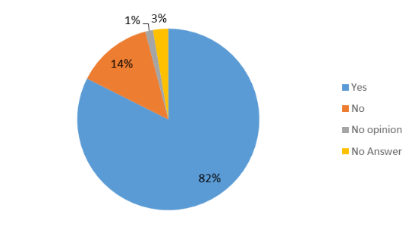

Source: OPC, N=74

However, the current settings of the compulsory licensing system in the EU make this legal instrument unfit to address cross-border crisis[29], in a timely manner. This is because EU compulsory licensing schemes have territorial limitations and are based on a patchwork of national laws that makes a coordinated and timely implementation of compulsory licences practically impossible.

This can be illustrated by a crisis striking several Member States, but where manufacturing capacities for the critical product are in other Member States. In such case, each step of the manufacturing process where IP rights are involved, should be authorised by the patent owner, usually through a licensing agreement, or - in the absence of voluntary agreements – a compulsory license. However, such compulsory licence is needed for each Member State and for each IP relevant step (be it manufacturing, exporting or importing). In case of an EU cross-border crisis, the issuance of multiple national compulsory licences with e.g. different scope (e.g. covering different patents and/or different products), procedures and conditions[30] would be necessary. In addition, great uncertainties would remain as to whether it can be exported from one Member State to another Member State and in what quantities. Finally, depending on the national procedures and conditions, these compulsory licences could be granted and implemented at different times (see section 2.2.1 below).

In a hypothetical example under the current rules, if two Member States needed a product manufactured in another two Member States, four compulsory licences might be need to secure access to such product (i.e. two compulsory licences to export and two compulsory licences to import). As shown in Figure 2, the number of compulsory licences needed for five countries in crisis with manufacturing capacities spread over five other countries, could reach ten[31].

Figure 2: Hypothetical number of compulsory licences needed for a patented product, depending on the number of manufacturing and importing Member States (up to 5 and 5 Member States only, respectively)

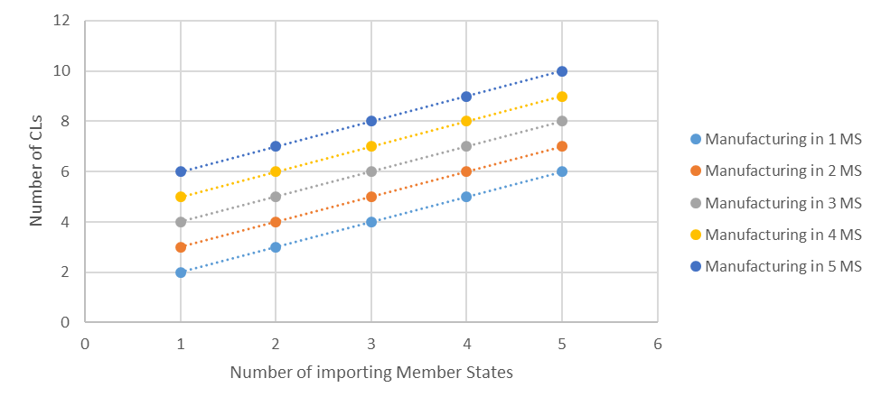

Source: own elaborations

The above example might seem excessive (up to ten compulsory licences needed for a single product), yet it is likely to occur in practice. The average number of Member States in which European Patents for COVID-related products[32] were active equals 5.18, whereas for all patents the intra-EU geographic spread was 4.35 (Member States)[33]. This means that **licensing of patent rights for a given product in the EU might require a coordinated action among four to five Member States**.

The number of patents active in several countries are not the only element to be considered. Additionally, multi-step value chains are predominant nowadays across nearly all industries. The Single Market in particular is **based on complex** **cross-border supply chains**, as products are increasingly manufactured across several Member States[34]. For example, in 2021, the share of intra-EU exports for most Member States was between 50 % and 75 % - it exceeded 75 % in HU (78 %), SK, CZ (both 80 %) and LU (81 %). Only in CY (27 %), IE (38 %) and MT (49 %) was the share of intra-EU exports lower than 50 %[35]. In absolute terms, the value of exported goods by Member State to partners within the EU in 2021 ranged from EUR 751 billion for DE to EUR 0.9 billion for CY (Figure 17, Annex 6)[36]. In view of the multi-dimensional links governing the existing value chains, it is highly probable that national compulsory licences would be needed not only for the final patented product, but also for any patented component[37] of the final product that may need to be sourced from other country. For example, the share of parts and components accounts for 50% of global trade in electrical machinery and transport equipment and 46% of trade in machinery and electronics. Over time, it is also worth noting that the importance of the Single Market has increased as a source of value added (supply and demand) in the area of goods. On the supply side (Figure 3, left), the contribution of domestic flows (i.e. within a single Member State) as source of value added in EU production has been constantly decreasing, whereas the relative importance of cross-border trade flows of industrial goods within the Single Market has slightly increased. Today, Single Market flows account for more than 25% of the total value added of EU production. A similar picture can be seen on the demand side (Figure 3, right). The relative contribution of domestic flows in terms of final demand to absorb and pay for the total value added produced in the EU has been decreasing, while the importance of the Single Market has increased.

Figure 3: Relative shares of the Single Market as a Source of Value Added (left) and of Final Demand (right) (goods, 1995-2018)

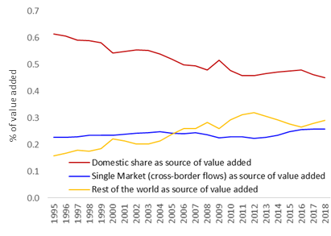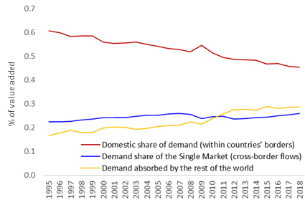

Source: Chief Economist Team (DG Internal Market, Industry, Entrepreneurship and SMEs) based on OECD TiVA data. Note: data available only until 2018

Consequently, the already significant level of complexity in the compulsory licensing system due to its fragmentation increases even further in view of cross-border value chains should manufacturing capacities of patented components be also located across different Member States. The above problem concerns compulsory licensing that would be issued **for domestic** (the EU market or several Member States), as well as for export; although the latter to a more limited extent. As regards **compulsory licensing** **for export** of pharmaceutical products to non-EU countries facing a health crisis, the system put in place by Regulation (EC) No 816/2006 was never used and stakeholders’ views diverge on the reason therefore[38]. Since no report was made on its application, it is difficult to draw definitive conclusions on its effectiveness. Similarly, to what exists for the domestic market, the cross-border value chains of manufacturing capacities could affect compulsory licensing for export purposes to non-EU countries.

To conclude, **EU compulsory licences rules are** characterised by **inadequate territorial architecture, uncoordinated national procedures and decision-making**, which is especially problematic in view of cross-border value chains increasingly predominant in the EU. This altogether results in a system whichis **ill-suited to address a cross-border crisis in a timely manner.**

## Drivers of the problem

The identified problem, its drivers, as well as consequences are presented in Figure Figure 4.

Figure 4: Problem tree

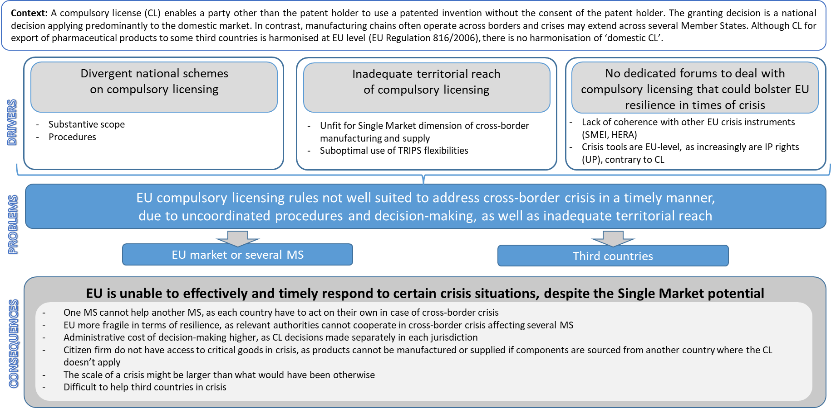

### Divergent national schemes on compulsory licensing

There is no harmonisation of compulsory licensing for the EU domestic market. The international framework includes some requirements that are mainly procedural. Outside these requirements, WTO members (including EU countries) retain a large margin of manoeuvre when deciding on their national compulsory licensing scheme. In the EU this results in a fragmented landscape when it comes to compulsory licensing for crisis management, especially concerning the trigger, the scope, the procedure and conditions of national rules (see Table 21, Annex 6). On compulsory licensing for export purposes, Article 31bis of the TRIPS Agreement has a more limited scope covering only pharmaceutical products and provides for more stringent requirements. EU Regulation (EC) No 816/2006 harmonises national laws in the field and the margin of manoeuvre left to Member States is limited. However, its application can still slightly differ across Member States, and in particular when it comes to national practices and conditions.

Trigger

The international framework on compulsory licensing does not prescribe the reasons for which a compulsory licence can be granted for the domestic market[39]. Member States usually allow compulsory licence when the patent is not used on their territory, in case of dependency of patents[40] or for public interest reasons[41]. This latter category is relevant as regards compulsory licensing for crisis management. Most Member States have general provisions allowing compulsory licensing for “public interest” or “national emergency”[42]. With few examples of use across Member States, it is however difficult to assess how these national provisions are used in practice and how they apply to crises. In contrast to these general clauses, some Member States only allow compulsory licensing for specific crises, typically health crises (i.e. BE, HU and IT)[43]. IE is the only Member State not providing for the possibility to grant a compulsory licence for crisis management. In conclusion, not all Member States provide for compulsory licensing for crisis management, some do only for certain types of crises (i.e. health) while other provide for general basis, differently worded, for which uncertainty remains as to their concrete application to crisis (see Table 19 in Annex 6).

***Concretely***, if there is an environmental crisis (e.g. flood, river pollution) affecting several Member States and the manufacturing capacities of the critical product are spread across BE, ES and FR. Issuance of compulsory licences would not provide a solution, as BE does not allow compulsory licensing for crises other than health crises.

Scope

The scope of a compulsory licence refers here to the type of IP rights it covers. This has an impact on the efficiency of the compulsory licence. For instance, ‘simple IP products’ such as water purification pills, valves for a respiratory device or masks can easily be replicated based on the patent. For complex products such as vaccines, access to trade secrets or secret know-how would be needed on top of patents. Finally, some crisis-relevant products are developed in such a short time span that the patent has not been granted yet. Only the patent application is available in such cases. Member States take a different approach as regards the scope of compulsory licences:

* Patents: All Member States’ compulsory licences law apply to patents, be it national or European patents. However, the same is not true for patent applications. A minority of Member States expressly include patent applications[44]. The Dutch national patent law expressly excludes it[45]. For the remaining Member States, their laws do not explicitly include nor exclude patent applications, leading to legal uncertainty. Yet, cutting-edge technologies to tackle a crisis are often new and still subject to a patent application. The procedure to grant a patent is also lengthy (between 3 to 5 years for the grant of a European patent). Excluding patent applications can therefore severely affect the effectiveness of a compulsory licence.
* Supplementary protection certificates (SPCs)[46]: Most national compulsory licensing laws do not explicitly refer to SPCs[47]. This leads to legal uncertainty and diverging interpretation of similarly worded provisions[48]. Where SPCs are not covered, a consequence is that a patented product which was the subject of a compulsory licence during the patent term may cease to be ‘exempted’ after the patent expiry, during the SPC term (if any). In contrast, Regulation (EC) No 816/2006 explicitly covers SPCs[49]. Where SPCs are not covered (neither explicitly nor implicitly) by the national compulsory licensing provisions in a certain Member State, its authorities are prevented from ‘lifting’ SPC protection. Consequently, despite an existing compulsory licence on the patent, the manufacturing of the SPC-protected product would still require an authorisation from the SPC holder.
* Regulatory data protection (RDP): Regulatory data protection are rules enshrined in the EU pharmaceutical legislation. Today, generic manufacturers cannot refer to the results of pre-clinical tests and clinical trials of the originator until eight years have elapsed from the date of authorisation of the medicinal product. This period of data exclusivity granted to innovative companies is complemented by an overlapping 10-year market exclusivity which prevents a generic drug to be placed on the market during this ten-year period. RDP rules are based on harmonised EU legislation[50] with no margin of manoeuvre left to Member States. Where they apply, RDP rules slow down or may even block the availability of products manufactured under a compulsory licence as it would delay the granting of marketing authorisation for medicinal products. In other words, a compulsory licence granted on a patent may be defeated by RDP still in force, preventing a generic product from being placed on the market. This can constitute a solid obstacle to the effective use of a compulsory licence[51].
* Other IP rights, trade secrets and know-how: compulsory licensing is already regulated at EU level as regards plant varieties (see supra, section 1.2). As regards other IP rights, from the available information it appears that Member States do not provide for a compulsory licence outside patent rights. Likewise, national laws generally do not address the issue of trade secrets and know-how (which might be needed for the manufacturing of complex products). The Spanish law is an exception as it imposes an obligation to act in good faith in the context of a compulsory licence, as well as a transfer of know-how to the beneficiary of a compulsory licence.[52]

In conclusion, the scope of a compulsory licence has a direct influence on its effectiveness to tackle crises. Many divergences exist across the EU in this respect.

***Concretely***, in the context of a cross-border crisis a FR company has developed a new product still subject to a patent application. FR has the manufacturing capacities and the possibility to grant a compulsory licence on a patent application. FR would therefore be able to help NL, also experiencing the crisis. However, since the NL law does not authorise compulsory licences on patent applications, it cannot issue a compulsory licence to import the FR products.

Procedure

Member States also take different approaches as regards the granting authority and the granting procedure. The granting authority can be a court, an executive body (government or ministry), an IP office or even a competition authority[53]. Regulation (EC) No 816/2006 also maintains some margin of manoeuvre for Member States as regards the competent authority to grant a compulsory licence for export purposes to non-EU countries.

Often, when it comes to compulsory licences for crisis management, a dedicated authority (typically an executive body) is competent and expedited procedures are in place. Advisory committees are also sometimes involved in the decision-making process[54]. Patent owners can be part of the procedure. This is the case for some national procedures[55] but also in the context of Regulation (EC) No 816/2006 where the patent holder is being notified of an application for a compulsory licence and can comment[56]. Member States also diverge regarding the availability of an expedited procedures for the issuance of a compulsory licence (e.g. by way of a preliminary relief[57]). While some Member States provide for such procedures, others do not, or it is at least uncertain whether a compulsory licence based on a preliminary relief is possible because national law is silent on this matter and there are no precedents in national case law[58]. Therefore, procedures (covering e.g. the assessment, granting or refusal of the applications) and granting authorities vary across Member States, including as regards compulsory licensing for export purposes to non-EU countries even if to a lesser extent[59]. Review (appeal) procedures are provided in all Member States but with again different procedures and delays. In conclusion, differences between national granting authorities and procedures result in different delays applicable to grant a compulsory licence and to review the granting decision.

***Concretely***, in the context of a crisis requiring fast actions, in DE a compulsory licence can be granted based on a preliminary relief. In contrast, in PL it is not possible to obtain a compulsory licence by way of a preliminary relief. This could lead to delays in cross-border supply, for instance when the crisis relevant products are already being produced in DE under a preliminary compulsory licence (also ready for the supply of PL), but PL cannot react in timely manner with a corresponding compulsory licence for the importation due to the lack of expedited procedure.

Conditions

Member States apply different conditions as regards the conditions under which a compulsory licence can be granted. These conditions can impact the effectiveness of a compulsory licence:

* Identification of the patent(s) and/ or product: Most Member States’ laws provide for a compulsory licence for a “patent”, leaving room for interpretation as to whether this can refer to all patents covering a product or only to a single patent (meaning that for complex products covered by multiple patents, multiple compulsory licences would need to be issued). This is source of legal uncertainty[60]. A compulsory licence can currently be based on a product under Regulation (EC) No 816/2006[61].
* Embargos: Some Member States’ law provide for an ‘embargo’ during which a compulsory licence cannot be requested before a certain period after the patent application and/ or grant which can prove particularly problematic for a compulsory licence to tackle a crisis since such an embargo effectively blocks ‘access’ to recent technologies[62].
* Calculation of the remuneration: The calculation of the adequate remuneration is determined following different criteria[63] and by different authorities across Member States[64]. The patent owner is sometimes invited to file observations on the level of remuneration[65].

In conclusion, Member States’ law considerably vary when it comes to conditions under which a compulsory licence can be granted. These divergences can lead to distorting consequences and further fragmentation, e.g. different procedures in the granting of a compulsory license, including the impossibility in the case of the embargos, to issue a compulsory licence before several years, different remunerations granted, etc. Those differences can significantly affect efforts across the EU to provide a uniform reply.

***Concretely***, in the context of a crisis where manufacturing capacities are located in AT but the patent was recently granted, AT could not issue a compulsory licence because its national law provides for an embargo on compulsory licences for patents registered for less than three years.

### Inadequate territorial reach of compulsory licensing

Cross-border supply of goods manufactured under a compulsory licence is complex under the current EU legal framework. Member States face obstacles when willing to both export and import within the EU goods manufactured under a compulsory licence. Consequently, there is simply no Single Market when it comes to compulsory licensing in the EU. Article 31 of the TRIPS Agreement provides for that a national compulsory licence must be used predominantly for the supply of the domestic market. The domestic market usually amounts to the national territory of the country having granted the compulsory licence. However, this is not necessarily always the case. Under the TRIPS Agreement, the Single Market can be considered a domestic market as the EU is a Member of the WTO and of the TRIPS Agreement in its own rights.

In contrast, all Member States’ laws are territorially limited, in the sense that the effects of a national compulsory licence are limited only to the national territory of the granting Member State[66]. Current national compulsory licensing schemes are indeed designed to meet the national needs of their own population and satisfy the public interest of the issuing Member State[67]. They do not reflect the EU as being one domestic market, as allowed under the TRIPS Agreement. Furthermore, uncertainty exists as regards import of goods manufactured under a compulsory licence from other Member States. The uncertainty results from the exhaustion principle (see Annex 7). Patents, like other IP rights, exhaust within the Single Market once the patented goods have been put on the EU market in one Member State by the patent owner or with consent of the patent owner[68].

The question therefore was raised as to whether the putting onto the market of a good manufactured under a compulsory licence can be considered done with the patent owner’s consent[69]. In 1985, the ECJ replied in the negative to this question[70]. It indeed decided that where a compulsory licence is granted to a third party which allows to carry out manufacturing operations, the patent owner cannot be deemed to have consented to the operation of that third party. This means that the patent owner is allowed to stop the import of goods into a Member State in case the goods have been manufactured under a national compulsory licence in another Member State due to the exceptional lack of EU-wide exhaustion of the patent. A (voluntary or compulsory) licence is therefore also needed in the importing country to avoid the importation being stopped by the patent holder.

As regards compulsory licensing for export to non-EU countries, Article 31bis of the TRIPS Agreement explicitly allows for the export of the products to a third country[71]. There is no limitation as to the part that can be exported from an EU country to certain countries outside the EU, under Article 31bis of the TRIPS Agreement and Regulation (EC) No 816/2006. On the contrary, the compulsory licence granted under the Regulation covers the manufacturing of the product for export and distribution in the countrie(s) cited in the application[72]. There is therefore no problem as regards the *possibility to export* pharmaceutical goods to non-EU countries. However, a non-EU country could also face a situation within the EU where the supply and manufacturing chain of a product requires multiple compulsory licences in different Member States. In addition, the importing non-EU countries would have to issue a compulsory licence to import the products[73], unless the products are not protected by a patent in the importing country.

In conclusion, despite the flexibility that exists at international level, compulsory licensing in the EU is designed to exclusively supply national territories. In other words**,** there is currently **no Single Market for products and no free movement of goods produced under a compulsory licence.**

### No dedicated forums to deal with compulsory licensing that could bolster EU resilience in times of crisis

The EU has faced numerous crises throughout its history and has gradually implemented policy and institutional changes to enhance its resilience to crises (see Annex 6, Table 22). This is still true today with the Union currently working on different instruments aiming at tackling crises (e.g. the SMEI proposal and the setting-up of HERA) or including crisis-specific provisions (e.g. the Chips Act). The COVID-19 crisis has indeed confirmed that action at EU level allows a better, faster, and more efficient response to crises. Yet, compulsory licensing schemes remain fragmented and purely territorial.

There is currently no or very limited interplay between compulsory licensing schemes and existing and envisaged EU crisis instruments:

* EU crisis instruments may include a **coordination mechanism** providing for exchange of information, coordination and monitoring of national crisis countermeasures. The objective being to enable coordinated decision making in support of an EU response. Currently, it is uncertain whether and how these coordination mechanisms would apply to compulsory licensing.
* EU crisis instruments usually allow the **declaration or activation of a crisis mode**, in the context of which emergency measures can be taken. Currently, there is no link between the EU possibility to activate a crisis mode and the trigger at national level to grant a compulsory licence.
* EU crisis instruments usually allow **decision-making at EU level**, as a means to more efficiently tackling EU crises. Yet, decision-making remains at national level as regards compulsory licensing, which can undermine efforts to build an EU-level crisis response mechanism.
* Regulation (EC) No 816/2006 harmonises the conditions and procedure for Member States to grant a **compulsory licence for export purposes to non-EU countries**. However, the Regulation does not provide for any coordination nor cooperation between Member States. The Commission also has a limited role. This uncoordinated and purely national process can hamper the use of the mechanism put in place by Regulation (EC) No 816/2006.

In conclusion, the current compulsory licensing system that could complement and support the EU’s ability to tackle crises appears disconnected from EU crisis instruments. In addition, there is no coordination at EU level should several Member States wish to coordinate their national actions as regards compulsory licensing. This is also not in line with the increased harmonisation of EU patent law, and in particular the upcoming launch of the **unitary patent system**[74], which will make unitary patent protection much easier than before in a large portion of the EU[75]. In contrast, purely national compulsory licensing systems and their resulting divergences would conflict with the increasing European integration of patent law.

## Consequences of the problem

A coherent compulsory licensing system for crisis management does not currently exist in the EU. Instead, a patchwork of national laws with different triggers, scope, conditions, and procedures on compulsory licensing makes it difficult for a Member State with manufacturing capacities in critical goods to help another Member State (without such manufacturing capacities). Likewise, in case of a manufacturing process spanning across several EU countries (e.g. components sourced from other countries), the current licensing scheme in the EU is unfit to match its complex cross-border nature. The above fragmented architecture leaves the EU more fragile in terms of resilience, as Member States cannot effectively cooperate in cross-border crises. Furthermore, Member States are not able to leverage their bargaining position based on an optimal compulsory licensing scheme. As a result, they may have no choice but to rely on voluntary agreements only. The fragmented system also results in administrative costs for public authorities granting the compulsory licence, potential licensees, and patent owners, in a sense that multiple procedures might be initiated across several jurisdictions.

The next link in the chain of consequences affects the citizens and/or firms that might have no access to critical goods in crisis, as products cannot be manufactured or supplied from another country. This consequence could aversively impact citizens’ well-being and/or firms’ economic standing, especially if a particular crisis is larger and lasts longer than what would have been otherwise (i.e. with a more efficient compulsory licensing scheme). In other words, today’s rulebook on compulsory licensing can lead to a situation when access to certain goods in crisis is not secured on time, which may generate broad negative socio-economic consequences.

Finally, non-EU countries also face a fragmented and complex legal landscape, which can be an important obstacle when seeking a CL for critical pharmaceutical goods. The compulsory licensing scheme for export to non-EU countries is also not suited to address cross-border supply chain in the EU and in that respect, third countries face similar problem as EU countries.

To conclude, the **current system does not provide for an EU-wide compulsory licensing mechanism, as the national legislations are heterogeneous and would not allow a flexible use of production capacities across the EU**. When it comes to compulsory licences there is simply no Single Market. And thus unlike EU main trading partners with unitary regime of compulsory licences[76], the EU would not be able to respond in a timely and coherent manner to cross-border crises requiring such a compulsory licence (be it within the EU or outside the EU). Finally, the discussion on the scale of the identified problem and the likelihood that a more streamlined compulsory licencing rules could be needed in the event of a cross-border crisis are based on the assumption that there is a non-zero chance that such situation could materialise in the future in the EU (e.g. of a similar scale to COVID-19 pandemics). Irrespective of what the future threats might look like (infectious, environmental, affecting IT or energy networks, etc.), in can be assumed that any attempt to strengthen crisis-preparedness and ultimately speed up the response time should be encouraged or at least further investigated.

## How likely is the problem to persist?

The problem described under 2.1 is most likely to persist. Some Member States could decide to streamline their national compulsory licensing laws, as some already did in the aftermath of the COVID-19 crisis but the lack of coherence between national compulsory licences in the EU, the limited territorial effect of these licences, the burdensome and lengthy administrative procedures, and the lack of Single Market for products subject to compulsory licensing would remain. Furthermore, recently tabled EU crisis instruments, such as SMEI, SCBTH or HERA, do not provide for compulsory licensing within their framework. As a consequence, a gap concerning compulsory licencing as a crisis remedy tool is likely to remain. Even the forthcoming introduction of the unitary patent system enabling the possibility to obtain such protection in a large portion of the EU will not change the persistence of the problem. Within the legal framework creating the unitary effect it is foreseen that compulsory licences for European patents with unitary effect should be governed by the laws of the participating Member States as regards their respective territories (Recital 10 of Regulation (EU) No 1257/2012[77]). This prevents - even in a cross-border crisis situations - that the recognition of an event triggering a compulsory licence in one participating Member State (for instance a specific public interest) can lead to the granting of a compulsory licence for the territory of all participating Member States. Consequently, it would mean that in the future, also under the new unitary patent system, the fragmented national regimes and practices for compulsory licensing would remain.

# Why should the EU act?

## Legal basis

The proposed initiative will be based on Articles 114 and 207 of the Treaty on the Functioning of the EU (‘TFEU’). Article 114 TFEU confers on the EU the power to adopt measures, which have as their object the establishment and functioning of the internal market and has provided legal basis for a wide range of EU instruments in the area of IP rights. Since the envisaged initiative aims at ensuring that compulsory licensing is fit for purposes as regards the Single Market, this initiative should be based on Article 114 TFEU. Article 207 TFEU confers on the EU competence in the field of common commercial policy, including as regards IP rights. Regulation (EC) No 816/2006, relating to the compulsory licensing of medicines for export purposes to non-EU countries, is based on Articles 95 and 133 of the TEC (i.e. Article 114 and 207 of the TFEU). Since the envisaged initiative would have an impact on Regulation (EC) No 816/2006, and on the possibility to export goods manufactured in the EU, the initiative should also take article 207 TFEU as a basis. Insofar as derogations from regulatory pharmaceutical protections are concerned, the latter are mainly regulated by Directive 2001/83, based on Article 95 TEC (i.e. Article 114 TFEU). Internationally, any new EU initiative should take place against the backdrop of, and in compliance with the TRIPS Agreement, and in particular its Articles 30, 31 and 31 bis.

## Subsidiarity: Necessity of EU action

Action at EU level is justified to ensure the smooth functioning of the Single Market in crises. Currently, Member States can only act nationally meaning that they can grant a compulsory licence for their own territory. This can be sufficient for purely national crises, where both the crisis and the manufacturing capacities are in the same Member State. However, this will not be sufficient when a crisis has a cross-border dimension – the latter is highly probable due to prevalence of cross-border supply chains. The incapacity of Member States to properly address a crisis with a cross-border dimension finds its origin in the territoriality of national compulsory licensing schemes and the divergent, sometimes sub-optimal, compulsory licensing schemes in place to tackle a crisis. The proposed EU action will act on these specific points by creating an EU-level compulsory licence with a streamlined procedure. Without action at EU level, Member States would remain vulnerable to crises with a cross-border dimension. In contrast, introducing an EU compulsory licensing scheme will contribute to building a more resilient EU by providing an additional collective tool in support of other crisis instruments such as SMEI or HERA.

## Subsidiarity: Added value of EU action

The objective of the initiative is to build an EU-level compulsory licensing scheme able to tackle crises with a cross-border dimension, in addition to the existing compulsory licensing national schemes for grounds other than crises. Any instrument that is to be considered in this impact assessment would be limited to what is necessary to tackle crisis with a cross-border dimension, only when such action cannot be implemented at national level or when such implementation would be inefficient. Ultimately, the proposed instrument would be also complementary to the other crisis instruments aimed at strengthening the resilience of the Single Market.

# Objectives: What is to be achieved?

To address problems discussed in section 2, the proposed initiative aims to create a compulsory licensing system that would be less fragmented and better-suited for EU-wide crises. Since compulsory licensing may have a significant impact on IP holders, this should remain an exceptional measure, applicable in case of unavailability or unsuitability of voluntary agreements. Working within the bounds of the TRIPS Agreement, the initiative should not lead to higher aggregate burdens or risks for patent holders relative to national regimes, but rather a more convergent, predictable, and workable regime in the exceptional cases where recourse to compulsory licensing at EU scale is necessary. Details of objectives to be achieved are presented below:

Figure 5: Objectives

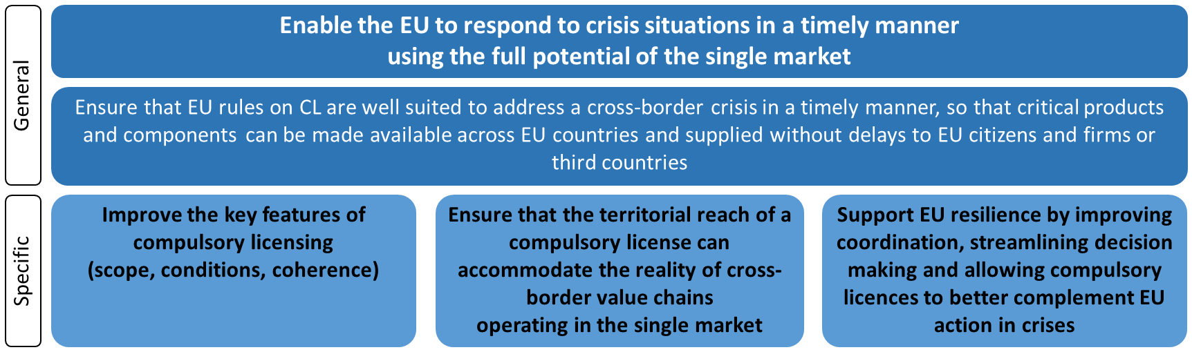

## General objectives

Our general objective is to enable the EU to respond to crisis situations in a timely manner using the full potential of the Single Market and ensure that in time of crisis, critical products and components can be made available across EU countries and supplied without delays to EU citizens and firms or non-EU countries.

## Specific objectives

With a view of creating a convergent, predictable and workable compulsory licensing system in the EU for crisis management, both for the domestic market and for export purposes to non-EU countries, the specific objectives (‘SO’) would aim at:

* SO1: Improve the key features of compulsory licensing, such as the trigger, scope and conditions of compulsory licensing, as well as improve the coherence of compulsory licensing in the EU to improve its effectiveness and efficiency in a crisis. This objective would in other words aim at reducing the fragmentation. This would mainly concern the domestic market as Regulation (EC) 816/2006 already provides for harmonisation of compulsory licensing for export purposes to non-EU countries;
* SO2: Ensure that the territorial reach of a compulsory licence, including for export purposes, can accommodate the reality of cross-border value chains operating in the Single Market. This objective does not aim at making compulsory licensing more frequent but rather ensuring that the territorial reach of a compulsory licence, including for export purposes to non-EU countries, is adequate to the reality of cross-border value chains operating in the Single Market;
* SO3: Support EU resilience by improving the coordination, streamlining the decision making and allowing compulsory licences to better complement EU action in crises, including for export purposes to non-EU countries. This objective would also aim at ensuring adequate coherence between (national) compulsory licensing schemes and EU crisis instruments.

# What are the available policy options?

## What is the baseline from which options are assessed?

Under the baseline scenario (*status quo*) the compulsory licensing system in the EU would continue to operate based on the existing national rules and Regulation (EC) No 816/2006. As a result, compulsory licensing schemes for crisis management would remain purely national, also for cross-border or EU-wide crises. There would be no coordination between Member States and compulsory licensing would remain mainly applicable to national territories (and subject to possible restrictions such as embargos). This would result in maintaining an inefficient tool for addressing crises in the Single Market, unfit for the cross-border nature of EU supply chains. This option may lead to a situation that voluntary agreement is the only viable option or where Member States could only rely on the goodwill of private economic operators and their willingness to enter into voluntary agreements, as public authorities will not be able to leverage their bargaining position based on an optimal compulsory licensing scheme. This option would neither support the EU’s efforts in building tools to foster its resilience when facing crises nor ensure a link between EU emergency instruments and compulsory licensing. Furthermore, the following factors would continue to affect stakeholders involved in a compulsory licensing procedure under the *status quo* (Table 1).

Table 1: Key factors affecting stakeholders involved in compulsory licensing procedure (relevant in a crisis situation) - the baseline

|  |  |
| --- | --- |
|  | **Key factors affecting stakeholders** |
| Patent owners | * Cost to participate in licensing negotiations in each jurisdiction, where the compulsory licensing may be pending; * Lack of legal certainty (e.g. on the scope of compulsory licensing, amount of remuneration) due to fragmentation. * Loss of control over patent rights in a EU country concerned. |
| Manufacturers – potential licensees | * Cost to participate in licensing negotiations in each jurisdiction, where the compulsory licensing may be pending. * Cost of adapting the manufacturing facilities to the production of CL-covered item. |
| EU countries | * Cost of launching and implementing the compulsory licensing procedure (incl. negotiations with the patent holders and manufacturers). * Crisis tackled individually, less leverage. |
| EU citizens | * Risk of unavailability or delays in supply of critical products during crisis. |
| Non-EU countries[78] | * Cost and legal uncertainty when initiating the compulsory licensing procedure in the EU. |

As compulsory licensing is very rare[79], data on the actual costs of such procedures is scarce and accessing its economic impacts proves challenging. Nonetheless, the following characteristics can be attributed to selected entries indicated in the above Table:

* Currently, compulsory licensing procedure is complex and, based on the available examples, it may take a year or longer to complete, even if carried out only at national level (see Table 25, Annex 6 – the duration lasting from at least ca. 1 year and 10 months[80], to ca. 2 years and 2 months including the negotiation phase[81], or ca. 2 years and 8 months[82]). The only example where a compulsory licence for export was successfully issued (the Canada-Rwanda case) took roughly three years[83] to complete. For both, domestic and export markets, the length and complexity of procedure has direct influence on cost for all parties involved. The cross-country differences between compulsory licensing procedures are also source of legal uncertainty.
* Costs are borne separately in each jurisdiction – as indicated in the problem statement (section 2.1), the average number of Member States in which patents for COVID-related products were active was around 4 to 5. Using this as a proxy for products that can be subject to a CL during a crisis, it can be assumed that in the event of a cross-border crisis compulsory licensing procedures might need to be repeated at least four times for the same product (i.e. separately in each jurisdiction where the relevant patent should be lifted).

The policy options proposed in this impact assessment will be evaluated compared to the above factors, as identified for the baseline. The general economic and competitiveness impacts of compulsory licencing that are valid irrespective of a crisis incident occurrence are discussed in section 6.5.3.

## Description of the policy options

Each option will consider the ensuing elements, in line with the specific objectives:

* **Improve the key features of compulsory licensing (addressing SO1)**: Features of a compulsory licensing scheme play an important role to ensure the effectiveness and efficiency of a CL for crisis management purposes. As illustrated in the problem definition, shortcomings currently exist in the national systems. These shortcomings concern:
* The trigger (i.e. possibility to grant a compulsory licence for crisis management or only limited to certain types of crises): clarifying this aspect is broadly in line with stakeholders opinions as only few of them (5%) are against the use of compulsory licence for crisis management[84]. In addition, those having expressed an opinion are in favour of a compulsory licensing scheme covering a large range of crises. For this reason, *the different options provide for the granting of a compulsory licence for crisis management, covering all types of crises*.
* The scope (i.e. covering or not patent applications, SPCs, RDP and know-how): as illustrated in the problem definition, a limited scope can seriously limit the efficiency and effectiveness of a compulsory licence. Not covering patent applications could prevent the use of critical new products or technologies to tackle a crisis. Not covering SPC and RDP could maintain protection other than IP, making the compulsory licence useless. This is acknowledged by many categories of stakeholders, as far as patents[85], SPC[86], RDP[87] are concerned. In contrast only a third of stakeholders are in favour of including know-how[88] in the scope of compulsory licensing. However, good collaboration from the patent owner, including in some circumstances access to know-how, may be necessary to ensure the success of a compulsory licence[89]. In that context, all the options include a good cooperation obligation for patent owners. For this reason, *all options include a scope covering patents (unitary and national patents), patent applications, (unitary) SPCs and RDP[90] as well as a good collaboration obligation*. Other IP rights would not be covered (see discarded options).
* The procedure (i.e. absence of an accelerated procedure): as illustrated in the problem definition, the absence of an accelerated procedure can delay the granting of a compulsory licence. Yet, a large majority of respondents (74%, N= 55) consider the speed of ensuring access to the required products and/ or technologies as a high priority for compulsory licensing in crisis[91]. For this reason, *all options include an accelerated procedure.*
* The conditions (i.e. burdensome identification requirements, embargos and rules on remuneration): as illustrated in the problem definition, identification of a patent or imposing an embargo can undermine the efficiency of compulsory licensing for crisis management. Pre-defined rules on remuneration can to the contrary support a swift granting of a compulsory licence[92]. For this reason, *all options include as conditions streamlined identification of patents/ product the prohibition of embargos and rules on remuneration.*

Consequently, the legislative options allow for the granting of a compulsory licence to tackle *all types of* crises, providing a *large scope* (covering SPCs and RDP), subject to a *streamlined procedure* and with *optimal conditions*. The options differ as they propose different ways to implement these features. Each option therefore details how trigger, scope, conditions and procedure are clarified. Additionally, each option specifies who decides to issue a compulsory licence and the applicable procedure.

* **Territorial reach of compulsory licensing (addressing SO2)**: Each option indicates the territorial coverage and the need – or absence thereof – to issue multiple compulsory licences, and therefore how it fits the inherently cross-border nature of supply chains in the Single Market. In this context it is worth noting that almost half of the respondents to the public consultation consider that a compulsory licence should enable the manufacturing of products across several EU countries (46%, N=34) or to be exported in another Member State than the one in which the product is manufactured (45%, N=33 replies)[93].
* **Support to EU resilience (addressing SO3)**: Each option specifies the role it plays in supporting the EU efforts to foster resilience to crises and the coherence with the different EU crisis instruments as well as the streamlining, transparency and coordination efforts on decision making. Because of the horizontal nature of IP rights, the envisaged initiative on compulsory licensing will build on these crisis instruments, by relying on the concepts and mechanisms already in place and complement them. Finally, all options envisage certain reporting obligations[94] imposed on Member States if a compulsory licence is considered to tackle a cross-border crisis. The scope of such obligation differs according to options, as it may range from exchanges of information during compulsory licensing negotiations, to *post-factum* reporting on the implementation of the CL. The reporting requirements would not necessitate any additional ICT infrastructure nor data collection, as they would refer to basic information included in the licence agreements.

The results of the public consultation show that a large majority (82%, N=61) of respondents consider that public authorities should be entitled to allow production of critical goods through a CL. Respondents are usually less in favour of a decision-making role of European institutions (28%, N= 21) than a coordinating role (36%, N=27). This can be explained by the fact that businesses and industry representatives expressed low support in this respect, whereas they were the dominant group of respondents[95] to the OPC. That being said, the option of granting a CL at EU level is generally deemed more positive by stakeholders as regards the EU’s ability to tackle crises (35%, N=26) than the granting of a CL at national level (respectively, 11%, N=8). Stark contrast exists among stakeholders with again low support from industry representatives: a majority (around 50%) of companies and business associations considering that the impact would be negative. In contrast, no respondent in other categories considers the impact to be negative. A large majority (65%, N=22) considers it positive (4% considers the impact to be neutral and the rest did not reply).

### Option 1: Recommendation on compulsory licensing for crisis management

Under this non-legislative option, the Commission would propose a recommendation on compulsory licensing for crisis management with the objective of increasing the efficiency and effectiveness of national compulsory licensing schemes, including for export purposes to non-EU countries (i.e. cases covered by Regulation (EC) No 816/2006). In this recommendation, the Commission would clarify the international legal framework, both in terms of obligations and flexibilities. Based on that, the recommendation would identify good national practices as regards compulsory licensing for crisis management and good coordination practices with a view to foster their uptake in Member States.

* Improve the key features of compulsory licensing: In addition to identifying and listing national provisions for issuing a compulsory licence for crisis management, the recommendation would clarify, in collaboration with Member States, the optimal features of compulsory licensing for crisis management (including the trigger, scope and the conditions), as well as clarify the procedures to apply for and grant such CL. The recommendation would list remedies available to patent owners, including the competent judicial authorities, and provide concrete guidance on how patent owners can file an appeal against the granting decision. On compulsory licensing for export to non-EU countries, the recommendation would identify good practices among Member States as regards national formal or administrative requirements.
* Territorial reach of compulsory licensing: The recommendation would clarify the territorial scope of compulsory licensing granted at national level, and in particular the possibility to distribute part of the goods manufactured under a compulsory licence to another Member State.
* Support to EU resilience: The recommendation would identify relevant EU crisis instruments and related transparency and coordination requirements. Against that background, the recommendation would clarify how to align national compulsory licensing schemes with EU crisis instruments. It would also outline and promote good practices in terms of cooperation, transparency and information sharing between Member States, including compulsory licences for export to non-EU countries. Finally, PO1 would propose good practices in information exchange concerning granted compulsory licenses and encourage Member States to share such info with the EC.

Figure 6: Simplified scheme for Option 1

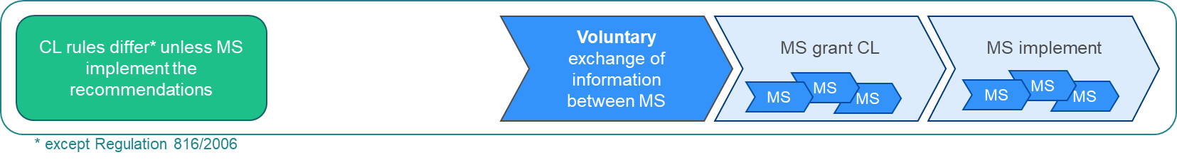

### Option 2: Harmonisation of national laws on compulsory licensing for crisis management

Under this option, the Commission would propose a legislative initiative that would harmonise national laws as regards the ground, scope, procedure, and conditions for the granting of a compulsory licence for crisis management. The legislative initiative would ensure that all Member States have in their national laws a compulsory licensing scheme for crisis management. The compulsory licensing would remain in the remit of Member States and have predominantly a national effect. PO2 would not harmonise compulsory licensing schemes other than for crisis management. In line with the identified objectives, it would focus on three building blocks as described below:

* Improve the key features of compulsory licensing: PO2 would require all Member States to include in their national law a compulsory licensing scheme for crisis management. Although the definition of a crisis would be harmonised (using existing definitions at EU level), the granting decision, and the interpretation given to the notion of crisis, would be left to Member States. The harmonisation would cover the procedure, scope and conditions for granting a compulsory licence, along the lines of what was described in section 5.2. The issuance of a CL for crisis management would remain a national decision. PO2 would ensure that remedies available to patent owners, including the competent judicial authorities, are aligned in all Member States.
* Territorial reach of compulsory licensing: PO2 would require Member States to allow, in cross-border crises, the possibility to export manufactured under a compulsory licence to another Member State. There would be no exhaustion of patent rights under this option (i.e. importing Member States would still need to issue a licence to import the goods).
* Support to EU resilience: This option would clarify that national compulsory licences could be issued in the context of an EU decision activating or declaring a crisis mode or an emergency. The EC would have a coordination role in case of cross-border crises, as it would provide support to Member States and facilitate coordination of national compulsory licences (e.g. ensure the same subject-matter, duration, remuneration, etc.) to ensure coherence across the EU. PO2 would also include transparency and information exchange obligations for Member States as regards applications for and granting of compulsory licences for crisis management and in the context of Regulation (EC) No 816/2006. Member States would have to inform the EC when they are considering granting and/or have granted a compulsory licence for crisis management (i.e. transparency obligation) as well as provide information on the compulsory licence (the subject matter of the compulsory licence, companies involved such as patent holders and/or manufacturers, the conditions agreed, etc.).

Figure 7: Simplified scheme for Option 2

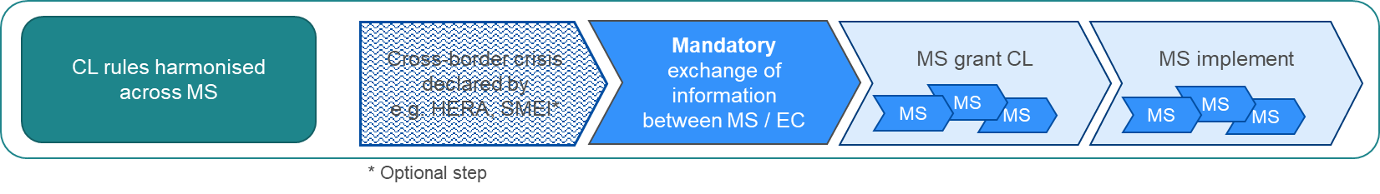

A detailed scheme describing the procedural steps foreseen under Option 2 is provided in Figure 19 (Annex 6).

### Option 3: Harmonisation plus a binding EU-level measure on compulsory licensing for crisis management

Under this option, the compulsory licence could be triggered in two scenarios. First, it could be triggered by an EU-level decision activating a crisis mode or declaring an emergency under an existing EU crisis instrument[96] (e.g. activation of the emergency mode under SMEI). Second, the compulsory licence could be triggered upon a request made to the Commission by more than one Member State in the event of a cross-border crisis[97]. In such case, the notion of crisis would be defined along the line of existing definitions in EU legislation[98]. It would cover all types of crises (e.g. not limited to health-related crisis) but would always require a cross-border aspect[99]. The Commission would adopt an activation measure[100] requiring one or several Member States to issue a compulsory licence for crisis management. The Commission would be assisted by an advisory committee composed of Member States representatives that should provide the Commission with a non-binding opinion. Its main tasks would include the assistance of the Commission in the determination of the necessity to rely on compulsory licensing at Union level, and under which conditions. In case there is an existing crisis instrument, the advisory body would be the one foreseen in the context of this crisis instrument (e.g. Advisory Group under SMEI). For cases falling outside existing crisis instruments or where there is no such advisory body, an *ad hoc* advisory body would be set up[101]. The advisory committee would also hear the patent owner(s)[102]. This should enable the Commission to make an assessment and consider the individual merits of the situation and determine on this basis the adequate conditions of the compulsory licence, in particular the adequate remuneration[103] for the rights-holder. It would lead to the issuance of several national compulsory licences, each being applicable to the territory of several EU countries or the whole EU. An appeal against the decision would be available[104]. PO3 would not harmonise national compulsory licensing schemes other than for cross-border crisis management. In line with the identified objectives, it would focus on the following building blocks:

* Improve the key features of compulsory licensing: PO3 would require all Member States to include in their national law a compulsory licensing scheme for cross-border crisis management (i.e. triggered by an EU-level decision activating a crisis mode or declaring an emergency or upon request of Member State(s)). The option would require Member States to provide for an accelerated granting procedure (e.g. an executive order). Although the granting decision will be a national decision, its basis will be a Commission act defining the conditions strictly linked to the crisis, namely the purpose (e.g. production of this product protected by this(es) patent(s)), the duration, and the territorial scope of the compulsory licence. This option would provide harmonisation on other features[105] such as the scope and the conditions, but still leaving some margin of manoeuvre for Member States[106]. The licensee(s) could be identified by the Commission, Member States and/ or directly apply to benefit from a compulsory licence.
* Territorial reach of compulsory licensing: Under this option, the compulsory license could have an EU-wide effect. However, the activation measure and the national decision would specify the exact territorial scope, considering the crisis. The scope could be modified depending on the circumstances (e.g. crisis expanding to other countries, need for further manufacturing capacities).
* Support to EU resilience: This option would provide the possibility for the Commission, being assisted by the relevant advisory body[107], to order the granting of national compulsory licences for cross-border crises management. The option would also include transparency and information exchange obligations for Member States[108] as regards applications for and granting of compulsory licences based on the Commission activation measure and in the context of Regulation (EC) No 816/2006. Yet, to the extent Member States are to be involved in the implementation of the compulsory licence, they would be also bound to report on the outcomes of the process to the Commission. Finally, under this option a single contact point[109] would be set-up so that non-EU countries[110] could submit a request for coordination to the Commission in case of cross-border supply and manufacturing, which would require the granting of several national compulsory licences. In order to process the request, the Commission would be assisted by an advisory committee composed of Member States representatives. This committee would, along the lines of what would exist for the EU domestic market under this option, ensure coordination and cooperation among Member States and the EC, with the aim to provide support to non-EU countries so that they can better plan their activities of manufacture and sale for export under Regulation (EC) No 816/2006.

Figure 8: Simplified scheme for Option 3

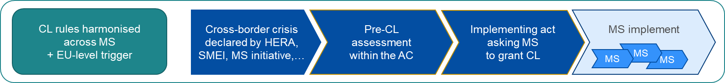

A detailed scheme describing the procedural steps foreseen under Option 3 is provided in Figure 20 and Figure 21 (Annex 6).

### Option 4: EU-level compulsory licensingto complement existing EU crisis instruments

Under this option, the triggers would be the same as under PO3 (i.e. two possible triggers, namely either an EU level decision in the context of an existing EU crisis instrument[111], or a request made to the EC by more than one Member State[112]). The Commission would adopt an activation measure granting a compulsory licence for cross-border crisis management. The Commission would be assisted by an advisory committee composed of Member States representatives[113]. This option would lead to the issuance, by the Commission, of **one** **compulsory licence**, applicable to the territory of several EU countries or the whole EU, with its own procedure[114] and conditions. PO4 would leave unchanged national legislations on compulsory licensing[115]. The patent owner(s) would be able to share their views and provide information in the context of the discussions of the advisory body[116]. The Member States could initiate the procedure[117] and would participate in the advisory body[118]. An appeal procedure would be set-up[119]. In addition, the Commission would have the possibility to review, upon motivated request, whether the licence conditions are respected[120]. In line with the identified objectives, PO4 would focus on three building blocks as described below:

* Improve the key features of compulsory licensing: PO4 would allow the EC to directly grant, through an activation measure, a compulsory licence for crisis management. PO4 would specify the conditions of such EU-level compulsory licence, including the purpose (i.e. manufacturing of this product, protected by this(es) patent(s) to tackle a specific crisis), the duration (that will be limited to the purpose[121]), the remuneration[122], the territorial scope (including safeguards to avoid diversion of goods to unauthorised territories), and the good collaboration obligation[123]. These conditions should consider the EU decision activating a crisis mode or declaring an emergency, and the conditions therein (such as the duration and territorial coverage). The efficiency and timeliness of EU-level compulsory licence would be ensured by adequate governance design[124]. In compliance with the TRIPS Agreement, the EU-level compulsory licence would be non-exclusive and non-assignable.
* Territorial reach of compulsory licensing: Under this option, the compulsory licence could have an EU-wide effect. However, the activation measure would specify the exact territorial scope, considering the crisis. The scope could be modified depending on the circumstances (e.g. crisis expanding to other countries, need for further manufacturing capacities). Under PO4, compulsory licences having a cross-border effect could also be granted by the Commission in the context of Regulation (EC) No 816/2006 should the manufacturing of the pharmaceutical product be spread across several Member States, subject to concerned Member States’ approval.
* Support to EU resilience: In the context of an EU decision activating a crisis mode or declaring an emergency, this option would provide the possibility for the Commission to grant EU-level compulsory licences for cross-border crises management. PO4 would provide full harmonisation as regards the granting of compulsory licence to tackle a cross-border crisis in the EU. It would build upon and complement existing EU crisis instruments by providing an additional tool to help tackle a crisis. Under this option, the Commission would have a consultative role, to ensure participation of relevant stakeholders. The licensee(s) could be identified by the Commission, Member States and/ or directly apply to benefit from a compulsory licence. Yet, to the extent Member States are to be involved in the implementation of the compulsory licence, they would be also bound to report on the outcomes of the process to the Commission. Finally, as in PO3, a single contact point would be set-up in the context of Regulation (EC) No 816/2006. However, under PO4 the function of the single contact point goes beyond a coordination role. PO4 would provide non-EU countries with the possibility to submit directly to the single contact point (Commission) an application for an EU-level compulsory licence in case of cross-border supply and manufacturing (see above, point on the territorial reach of compulsory licensing). Under this option, the Commission would retain its coordination role, assisted by the advisory body, as already provided under PO3.

Figure 9: Simplified scheme for Option 4

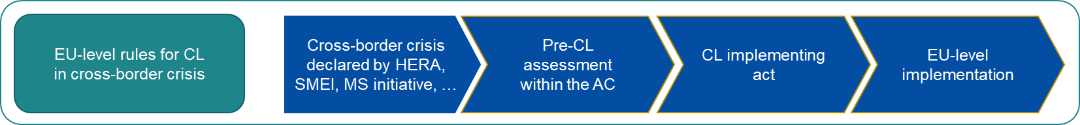

A detailed scheme describing the procedural steps foreseen under Option 4 is provided in Figure 22 and Figure 23 (Annex 6).

## Discarded options

The possibility for a compulsory licence to cover other IP rights, and in particular plant variety rights, design rights or copyright, was discarded. The possibility to grant a compulsory licence for a Community plant variety right already exists[125]. Designs protection[126] covers the appearance of a product and does not extend to the features of appearance of a product that are solely dictated by its technical function. Since the technical features of a design that could prove necessary to manufacture a critical good are free of design rights, a compulsory licence does not appear necessary in the field. The same reasoning applies to copyright which protects a specific expression of an idea or creation. These ideas or creations can be expressed in another way should it be necessary to use them in the context of the manufacturing of crisis goods. The same applies to computer programmes protected under copyright law[127].

# What are the impacts of the policy options?

## Option 1 – Recommendation on compulsory licensing for crisis management

### Improve the key features of compulsory licensing

Under Option 1, Member States would retain their margin of manoeuvre as regards the features of their national compulsory licensing schemes. The recommendation envisaged under PO1 could clarify and improve the features of national compulsory licensing schemes for crisis management and improve coherence across Member States. Although, the recommendation would raise awareness across Member States on the importance of an effective and efficient compulsory licensing for crisis management, the risk remains that not all Member States would fully implement it because of the non-binding nature of the recommendation. PO1 could therefore have only a limited harmonising effect. In addition, one deviation by a Member State (for instance an embargo period in the Member State with the manufacturing capacities) would already suffice to block or significantly impair the supply of crisis relevant goods produced under a compulsory licensing in certain cross border situations. Consequently, Option 1 is expected to lead to limited improvements, in terms of effectiveness and efficiency, of national compulsory licensing schemes for crisis management.

### Territorial reach of compulsory licensing

Under Option 1 compulsory licensing would remain in the remit of Member States and their effect would be limited to the national territory. By clarifying the obligations and flexibilities under the TRIPS agreement, the recommendation would bring legal certainty as to the possible territorial reach of national compulsory licences, including on the possibility to export a part of the goods manufactured under a compulsory licence to another Member State. However, Member States would remain free to decide whether and how to take advantage of these flexibilities. In addition, the lack of EU-wide exhaustion would continue to limit the territorial reach of a compulsory licence. Multiple compulsory licences[128] would still be needed for distributing products produced under a compulsory licence within the Single Market. Coherence between the national compulsory licences would be subject to Member States’ willingness to carry out a joint harmonising effort of their national granting decisions and procedures. Consequently, the objective of giving national compulsory licences a more appropriate cross-border reach in crisis would be achieved to a very limited extent under Option 1.

### Support to EU resilience

By identifying the relevant EU crisis instruments and related transparency and coordination requirements, the recommendation would clarify the role compulsory licensing can play in the context of the different EU crisis instruments. In that respect, the recommendation could support the EU resilience by reinforcing coherence between national compulsory licences and EU crisis instruments. However, the decision to trigger the compulsory licence would remain in the Member Sates’ remit. A seamless embedding of national compulsory licensing schemes into EU crisis instruments is therefore not to be expected. The promotion of good practices in terms of cooperation, transparency and information sharing between Member States, including for compulsory licences for export purposes to non-EU countries would facilitate interaction among Member States and between Member States and the Commission. However, divergences regarding the granting authority of a compulsory licence would remain. National actors would remain diverse, which would frustrate the possibility of communication between authorities across borders and could ultimately create barriers against engaging in holistic and uniform crisis responses across the EU.

### Impacts per stakeholder group

As PO1 would be based on non-binding actions, the cost and benefits are to a large extent uncertain, as they depend on individual decisions of each Member State. First, the countries which decide to apply the recommendation on good practices would bear certain one-off cost of implementing them. Second, if the majority of Member States follows such approach, then it could be assumed that impact discussed in Table 2 below, can indeed materialise in the event of a cross-border crisis.

Table 2: Impacts on stakeholders in the event of a cross-border crisis - Option 1 compared to the baseline

|  |  |  |
| --- | --- | --- |
|  | **Advantages** | **Disadvantages** |
| Patent owners | (0/+) Somewhat lower costs of compulsory licensing negotiations, if recommendation applied by majority of MS.  (0/+) Increased legal certainty (e.g. more clarity on the scope and what amount of remuneration may be expected), if recommendation applied by majority of MS. | / |
| Manufacturers – potential licensees | (0/+) Somewhat lower costs of compulsory licensing negotiations if recommendation applied by majority of MS. | / |
| EU countries | (0/+) Marginally lower costs of running the compulsory licensing procedure as EU countries can rely on additional information or support from other MS, but the main cost of launching and implementing the compulsory licensing procedure (negotiations with the patent holders and manufacturers) remain unchanged. | (0/-) Cost of information exchange with other EU countries and the EC (optional). |
| The general public (EU citizens) | (0/+) Marginally lower risk of delays or unavailability of critical products during crisis, if recommendation applied by majority of MS. | / |
| Non-EU countries | (0/+) Somewhat lower costs and improvement in legal certainty as regards compulsory licensing for export, if recommendation applied by majority of MS. | / |

Note: (0) neutral impact; (+) minor positive impact; (++) positive impact; (+++) significant positive impact; (-) minor negative impact; (- -) negative impact; (- - -) significant negative impact

The impacts on **patent owners** would stay broadly the same as in the baseline. The cost of participating in compulsory licensing negotiations would still be borne in each jurisdictions concerned, but they could be marginally lower if the compulsory licence features gain in coherence across the EU. Recommendations could improve legal certainty of patent holders, for example as regards the determination of remuneration (still, the remuneration to compensate the loss of income is likely be lower than the one to be received in voluntary agreements). **Potential licensees** would not experience much difference compared to the baseline scenario, except for a more streamlined approach of negotiations, and consequently marginally lower participating costs, should recommendations be implemented at national level. **EU countries** could entail costs should they decide to implement the recommendation as regards cooperation, transparency and information sharing. The costs of running compulsory licensing procedures could be decreased should all Member States adopt a more coherent approach to national compulsory licensing and share information thereon. Under the condition that the respective Member State makes use of the recommendation, **citizens** might profit from an improved welfare as their possibility of gaining access to critical products would be more effective. If Member States would implement EU-wide best practices on cooperation, transparency and information sharing for export purposes, **non-EU countries** might benefit of increased legal certainty and some administrative savings.

## Option 2 – Harmonisation of national laws on compulsory licensing for crisis management

### Improve the key features of compulsory licensing

Under PO2, a directive would be adopted to approximate national laws on the grounds, procedures, scope, and conditions of compulsory licensing for crisis management. This would create a certain degree of harmonisation on e.g. key aspects of the procedure, the competent granting authority and criteria for the calculation of the remuneration. This would improve and clarify the features of national compulsory licensing for crisis management across the EU. However, the Member States would remain competent to determine whether a crisis exists and whether to grant a compulsory licence. Hence, the risk would remain that the directive would not be implemented and applied in a uniform manner due to existing differences in national law proceedings and judicial traditions. Those minimum standards of harmonisation could result in incoherent national compulsorylicences for crisis management.

### Territorial reach of compulsory licensing

The harmonisation of national schemes envisaged under PO2 could facilitate the cross-border supply of goods as both, the compulsory licence granted in the manufacturing Member State and those granted in the importing Member States, would be based on similar rules. However, this would only slightly improve the situation if manufacturing capacities are located in multiple Member States. The lack of exhaustion would still require each importing Member States to issue a licence to import the critical goods.

### Support to EU resilience

Under PO2, clarification will be provided that national compulsory licences could also be issued in the context of an EU decision activating or declaring a crisis or emergency mode. Thereby, the risk of frictions and opposing decisions resulting from the two levels of decision making (at EU level and at national level) could be mitigated (e.g. the risk that a national authority denies the existence of a crisis in the context of its decision on a compulsory licence, despite a decision at EU level declaring a crisis and activating an emergency mode). Transparency and information sharing obligation would allow national compulsory licences to be better coordinated and therefore to provide a better support to EU crisis. As the granting authority of a compulsory licence is one of the aspects subject to harmonisation, Option 2 could facilitate cooperation and coordination among Member States and between Member States and the Commission.

### Impacts per stakeholder group

The impacts of PO2 per stakeholder group are summarized in Table 3 below.

Table 3: Impacts on stakeholders in the event of a cross-border crisis - Option 2 compared to the baseline

|  |  |  |
| --- | --- | --- |
|  | **Advantages** | **Disadvantages** |
| Patent owners | (+) Somewhat lower costs of compulsory licensing negotiations as rules more coherent across MS.  (+) Some improvement in legal certainty (e.g. clarity on the scope and what amount of remuneration may be expected), as rules more coherent across MS. | (0/-) Loss of control over patent rights, if harmonisation leads to wider geographical scope of CL. |
| Manufacturers – potential licensees | (+) Somewhat lower costs of negotiations, as rules more coherent across MS. | / |
| EU countries | (0/+) Potentially lower costs of running the compulsory licensing procedure as EU countries can rely on additional information or support from other MS, but the main cost of launching and implementing the compulsory licensing procedure (negotiations with the patent holders and manufacturers) remain unchanged.  (+) Better exchange of information about availabilities of product(s), in case of local shortages or cross-border value chain disruptions. | (-) Cost of information exchange with other MS; (-) Cost of reporting to the EC on the implemented CL. |
| The general public (EU citizens) | (+) Marginally lower risk of delays or unavailability of critical products during crisis, as rules more coherent across MS. | / |
| Non-EU countries | (+) Increased legal certainty and administrative savings due to EU countries information sharing and transparency obligation as regards compulsory licensing for export. | / |

Note: (0) neutral impact; (+) minor positive impact; (++) positive impact; (+++) significant positive impact; (-) minor negative impact; (- -) negative impact; (- - -) significant negative impact

**Patent owners and potential licensees** would benefit from this option as increased clarity and more coherent rules would improve legal certainty and facilitate negotiations. This would reduce their costs in participating in such negotiations as well as providing patent owners with a better framework for determining the remuneration. However, they would still face costs in each Member State launching a compulsory licensing process. **EU countries** would face one-off adjustment costs in the context of the implementation of the directive through the adaptation of their national compulsory licensing schemes. While Member States would benefit of an improved information exchange and EC support (reducing the costs related to compulsory licence procedure), the obligation on information sharing and reporting would at the same time incur a minor recurring administrative cost for Member States, each time they (envisage) grant(ing) a compulsory licence. However, these costs would remain low because compulsory licensing is a last resort instrument, expected to be rarely used. In case of crisis, **EU** **citizens** would face a marginally lower risk of unavailability of critical products during crisis due to the reduction of fragmentation in national compulsory licensing schemes. As the directive would contain obligations regarding cooperation, transparency and information sharing in the context of compulsory licensing for export purposes, **non-EU countries** would benefit of increased legal certainty throughout the Union and administrative savings.

## Option 3 – Harmonisation plus a binding EU-level measure on compulsory licensing

### Improve the key features of compulsory licensing

Under Option 3, all Member States would introduce in their national law a compulsory licensing scheme for cross-border crisis management triggered by an EU-level decision or initiated by concerned Member States. Albeit the co-existence of two triggering mechanisms may seem to add complexity to the system, yet it provides for more flexibility to address all possible types of cross-border crisis. The national compulsory licences granted under this scheme would be based on a Commission activation measure. This would provide full harmonisation on some of the key conditions (e.g. territorial scope, duration) and allow clarity and coherence of the different national compulsory licences. Under this option, Member States would be required to grant a compulsory licence in certain cases. This option would therefore result in improving the legal framework on compulsory licensing for cross-border crises. However, although PO3 would require Member States to set-up accelerated procedures, these procedures can differ nationally. In addition, some conditions such as remuneration would be decided at national level. Therefore, despite harmonised criteria for determining the remuneration, the actual assessment can greatly vary from one Member State to another. Consequently, despite the harmonisation provided under Option 3, coherence and clarity would not be optimal as regards all the features of the national compulsory licences.

### Territorial reach of compulsory licensing

Option 3 would provide a dynamic and efficient solution as regards the territorial scope of the compulsory licence: the licence would cover all EU countries being affected by the crisis and its territorial scope could be modified depending on the evolution of the crisis. National granting decisions would still be needed for each Member State where the manufacturing of products will take place. However, importing Member States would no longer need to issue a compulsory licence, as national granting decisions would have a cross-border effect, coupled with an exhaustion for the EU market. Consequently, products manufactured under a national compulsory licence having its source in an EU activation measure could be exported to other EU countries without the need for the importing countries to issue a compulsory licence. This option would also solve the discrepancies that may currently exist between the compulsory licence to export and the one to import (cf. *supra*).

### Support to EU resilience

This option would complement other EU crisis instruments as the activation of a crisis mode under an EU crisis instrument, such as SMEI, can be the trigger leading to the granting of one or more compulsory licence(s). The reliance on the existing advisory body when the trigger originates in an EU crisis instrument, also ensures an optimal coherence with EU crisis instruments. The transparency and information exchange obligations for Member States as regards applications for and granting of compulsory licences based on the Commission activation measure and in the context of Regulation (EC) No 816/2006 would improve the coordination of compulsory licences in the EU. The support provided by the Commission to third countries would facilitate decision-making in the context of Regulation (EC) No 816/2006 in case multiple compulsory licences in different Member States are required to address the third country’s needs. Both, non-EU countries and Member States would benefit from improved cooperation at EU level. Non-EU countries would benefit from greater clarity as regards the manufacture and sale for export under Regulation (EC) No 816/2006. However, in the absence of a compulsory licence with an EU-wide effect for export to third countries, they would still need to apply for several compulsory licences if the cross-border manufacturing chain of the product concerned requires it and may face legal uncertainty in that respect (including as regards the possibility to allow cross-border manufacturing of the final product).

### Impacts per stakeholder group

The impacts of PO3 per stakeholder group are summarized in Table 4 below.

Table 4: Impacts on stakeholders in the event of a cross-border crisis - Option 3 compared to the baseline

|  |  |  |
| --- | --- | --- |
|  | **Advantages** | **Disadvantages** |
| Patent owners | (+ +) Lower costs of negotiations, as they would partially be run at EU level instead of multiple procedures in each EU country concerned.  (+ +) Improvement in legal certainty (e.g. clarity on the scope and what amount of remuneration may be expected), as rules more coherent across MS. | (- -) In case of a broader geographical scope of a CL, wider loss of control over patent rights. |
| Manufacturers – potential licensees | (+ +) Lower costs of negotiations, as they would partially be run at EU level instead of multiple procedures in each EU country concerned.  (+) Lower costs of adapting the manufacturing facilities to the production of CL-covered item(s) due to economies of scale, if harmonisation leads to wider geographical scope. | / |
| EU countries | (+ +) Lower costs of running the compulsory licensing procedure (no or limited negotiations with the patent holders or manufacturers), as EU countries will mainly implement a decision made at the EU level *(D).*  (+) Better exchange of information about availabilities of product(s), in case of local shortages or cross-border value chain disruptions  (+) Better decision-making and cooperation in the context of compulsory licensing for export to non-EU countries *(E).* | (-) Cost of participating in the advisory committee assisting the single contact point *(E).*  (-) Cost of reporting to the EC on the implemented CL. |
| The general public (EU citizens) | (+ +) Lower risk of delays or unavailability of critical products during crisis, as rules more coherent across EU countries *(D).* | / |
| Non-EU countries | (+ +) Increased legal certainty and administrative savings due to better coordination at EU level *(E).* | / |

Note: (0) neutral impact; (+) minor positive impact; (++) positive impact; (+++) significant positive impact; (-) minor negative impact; (- -) negative impact; (- - -) significant negative impact; (D) applies only in case of an EU-level compulsory licensing for domestic purposes, (E) applies only in case of compulsory licensing for export purposes (in the context of Regulation (EC) No 816/2006).

Under PO3, **patent owners** would benefit from a reduction of costs as regards the participation in the compulsory licensing process, since the process will be centralised to a large extent. This would streamline the negotiations on many aspects (e.g. duration, scope) as there will no longer be differences between the national compulsory licences granted on the basis on the activation measure. Nevertheless, patent owners would still face cost in each country issuing a compulsory licence, as they would need to negotiate not harmonised aspects (e.g. remuneration) and participate in the national procedures. They would however benefit from increased legal certainty through, on the one hand, the single EU binding decision and, on the other hand, harmonisation of aspects left for the national level (i.e. elements such as the national procedure or the remuneration). Under this option, patent owners may experience a more important loss of control on their patent rights as this option would give a broader effect to a national compulsory licence, allowing it to have a cross-border effect. Overall, the situation of **potential licensees** would improve under PO3. They would benefit from the centralised procedure as this would decrease their cost of participating in negotiations. In addition, the wider territorial scope of the licence would allow them to benefit from economies of scale (i.e. larger volumes of production) when manufacturing the required items (also in terms of lower cost for adapting the production facilities). **EU countries** would bear the adjustment costs resulting from the implementation of the directive into their national law. They would also face some minor administrative costs, linked to the transparency obligation (reporting). On enforcement costs, Member States would also bear the cost of participating in the advisory committee, but overall they would benefit from the centralised procedure. Costs of direct negotiations with the patent owners and the manufacturers would be replaced by the costs of participating in the EU level negotiations (the latter are expected to be lower than handling the entire negotiations process nationally i.e. fewer staff involved per case per Member State). The cost of granting the national compulsory licence based on the Commission’s activation measure would remain (i.e. the issuance of a government order granting a compulsory licence for Member States with manufacturing capacities on their territory). Member States with no manufacturing capacities would not have to bear any cost related to a national compulsory licence as a licence to import would no longer be needed. Member States would benefit from a more coherent approach at EU level when tackling crisis, and in particular as regards the use of compulsory licence in conjunction with another EU level crisis instrument. As regards the export to non-EU countries, Member States would benefit from an improved decision-making and cooperation due to the establishment of a single contact point (the Commission) assisted by an advisory committee. At the same time, the participation in the advisory committee could generate some minor costs for Member States, but only when such situation occurs. In case of a crisis, **EU** **citizens** would benefit from PO3 as it would improve the EU’s ability to conclude voluntary agreements and its ability to issue an effective and efficient compulsory licence for the whole EU, including in case of cross-border supply chain. **Non-EU countries** would benefit from administrative savings due to the increased coordination at EU level.

## Option 4 – EU-level compulsory licensing to complement existing EU crisis instruments

### Improve the key features of compulsory licensing

Under PO4 the Commission would directly grant a compulsory licence and specify the conditions under which this licence is granted. The granting decision would specify all the conditions of the compulsory licence, including the remuneration. These conditions would be the same for all territories where the compulsory licence applies. This would ensure an optimal clarity and coherence as regards the conditions of the compulsory licence. Since there would only be one procedure – at EU level – there would not be divergences due to national decisions and/ or implementation. Consequently, by relying on a fully harmonised scheme, Option 4 provides an optimal coherence and clarity as regards all the features of compulsory licensing for crisis management.

### Territorial reach of compulsory licensing

PO4 would provide an optimal solution as regards the territorial scope of the compulsory licence: one single compulsory licence would cover all EU countries being affected by the crisis and all EU countries having the relevant manufacturing capacities. By creating an EU-level system, this option would guarantee a solution that is fully coherent and equally applicable in all Member States. A unique compulsory licence offers an efficient compulsory licensing scheme, which avoids national divergences likely to slow down an EU reply to a cross-border crisis. The cross-border effect guarantees an effective compulsory licensing scheme as it matches the reality of the Single Market and its inherently cross-border supply chains and can supply the whole EU market (instead of one country). A CL applicable on a wider territory can serve as an incentive for licensees to change their production line to accommodate the need for critical goods.

### Support to EU resilience

Just like in PO3, this option would complement other EU crisis instruments as the activation of a crisis mode under an EU crisis instrument, such as SMEI, can be the trigger leading to the granting of a compulsory licence. The reliance on the existing advisory body when the trigger originates in an EU crisis instrument, also ensures an optimal coherence with EU crisis instruments. In addition, such EU-level system would provide the EU and its Member States with an efficient and credible compulsory licensing system. This would give more bargaining power to the EU when negotiating voluntary agreements, hence supporting other EU crisis instruments. Should voluntary agreements fail, the EU would still have the possibility to rely on compulsory licence to start manufacturing of critical goods in the EU and provide an EU response, complementing other crisis measures. As in PO3, the coordination at EU level for third countries would facilitate decision-making in the context of Regulation (EC) No 816/2006, should different compulsory licences be required to address the third country’s needs. Non-EU countries would benefit from the possibility to only have one compulsory licence covering multiple EU countries, in case of cross-border manufacturing.

### Impacts per stakeholder group

The impacts of PO4 per stakeholder group are summarized in Table 5 below.

Table 5: Impacts on stakeholders in the event of a cross-border crisis - Option 4 compared to the baseline

|  |  |  |
| --- | --- | --- |
|  | Advantages | Disadvantages |
| Patent owners | (+ +) Lower costs of negotiations, due to a single procedure at EU level instead of multiple procedures in each MS concerned.  (+ + ) More legal certainty (e.g. clarity on what level of remuneration may be expected), as a single procedure at EU level instead of multiple procedures in each EU country concerned. | (- -) In the event of a broader geographical scope of a CL, wider loss of control over patent rights. |
| Manufacturers – potential licensees | (+ +) Lower costs of negotiations, due to the single procedure at EU level instead of multiple procedures in each EU country concerned.  (+) Lower costs of adapting manufacturing facilities to the production of the item(s) covered by the licence, due to economies of scale, if EU-level compulsory licensing leads to wider geographical scope. | / |
| EU countries | (+ + +) Significantly lower costs of running the compulsory licensing procedure (no negotiations with the patent holders or manufacturers), as EU countries will only implement a single decision made at EU level *(D).*  (+) Better exchange of information about availabilities of product, in case of local shortages or cross-border value chains disruptions.  (+) Better decision-making and cooperation in the context of compulsory licensing for export to non-EU countries *(E).* | (-) Cost of participating in the advisory committee assisting the single contact point *(E).*  (-) Cost of reporting to the EC on the implemented CL. |
| The general public (EU citizens) | (+ + +) Significantly lower risk of delays or unavailability of critical products during crisis, as rules are consistent across all EU countries *(D).* | / |
| Non-EU countries | (+ + +) Increased legal certainty and administrative savings when accessing critical goods in case of cross-border supply chains due to direct coordination at EU level *(E).* | / |

Note: (0) neutral impact; (+) minor positive impact; (++) positive impact; (+++) significant positive impact; (-) minor negative impact; (- -) negative impact; (- - -) significant negative impact; (D) applies only in case of an EU-level compulsory licensing for domestic purposes, (E) applies only in case of compulsory licensing for export purposes (in the context of Regulation (EC) No 816/2006).

Under PO4, **patent owners** would benefit from a reduction of costs and legal uncertainty since, in the absence of national procedures, negotiations would be limited to participation in one EU-level procedure. In addition, they would gain legal clarity as the remuneration will be set at EU-level, no longer at national level. However, patent owners would still face an important loss of control on their patent rights since the impact of compulsory licensing would no longer be limited to a given Member State. Under PO4, the greater territorial reach would also extend to compulsory licences for export to a non-EU country. Overall, the situation of **potential licensees** would improve under PO4. They would benefit from the centralised procedure and the wide territorial scope of the licence that can bring economies of scale. **EU countries** would need to bear limited adjustments costs as PO4 would provide an EU-level compulsory licence, through a regulation, on top of existing national legislation. They would face some monitoring costs in the event of a crisis, linked to the transparency obligation. However, better sharing of information would also allow a reduction of costs for Member States as it could help identifying best practices. On enforcement costs, Member States would also bear the cost of participating in the advisory committee, but overall they would benefit from the centralised procedure, as costs linked to the negotiations with the patent owners and the manufacturers would be incurred solely at EU level (i.e. although the costs of participating in the EU level negotiations would remain, they are expected to be lower as tasks would be shared among many countries). The new compulsory licensing rules would also strengthen EU bargaining position as 27 countries would run negotiations together and at once. In case of crisis, **EU citizens** would greatly benefit from this option as it would improve the EU’s ability to issue an effective and efficient compulsory licence for the whole EU, including in case of cross-border supply chain disruptions. **Non-EU countries** would also benefit from this option as this would provide the possibility to rely on a compulsory licence covering a cross-border supply chain.

## Common impacts

### Impacts on fundamental rights

This initiative will have a clear impact on fundamental rights as it would provide an additional tool to face crises, including health-related (right to health care – article 35 of the Charter) or environmental crises (right to environmental protection – article 37 of the Charter). Through the increased probability of supply of critical goods and services the most fundamental needs and rights of EU citizens such as safety and health, in a crisis setting, would be more swiftly and efficiently catered to.

Collective licensing, of course, also concerns the right to intellectual property of patent owners (article 17(2) of the EU Charter of fundamental rights – the ‘Charter’), as compulsory licensing partially deprives patent owners of the control of their rights. The extent to which this initiative impacts these rights – as compared to the baseline – is discussed in section 6.5.3 below. IP rights are not absolute rights and limitation to the exercise of these rights are allowed under the Charter, provided that the proportionality principle is respected. In that respect, this initiative provides for that compulsory licensing would remain an exceptional mechanism, with a scope limited to cross-border crises. In addition, compulsory licence would always be granted on a non-exclusive basis and subject to a definite duration. Finally, patent owners would have the possibility to share their position as regards the granting of a compulsory licence and the conditions surrounding it. An important aspect of the conditions concerns the ability for patent owners to receive a fair compensation for the limitation of their right. In that respect, the present initiative provides for that patent owners would always be entitled to receive an adequate remuneration in respect of each compulsory licence granted under this initiative. This remuneration would be determined, following clear criteria set in the EU legislation. In addition, patent owners would be entitled to share their position as regards this remuneration, in the context of discussions within the advisory body. As explained in the next title, this initiative may have a positive impact on other fundamental rights as it would provide an additional tool to face crises, including health-related (right to health care – article 35 of the Charter) or environmental crises (right to environmental protection – article 37 of the Charter).

### Social and environmental impacts

Improved EU readiness to tackle a major crisis would bring positive social impacts, as it could help limit various disruptions to everyday societal processes by curbing the crisis or eliminating it altogether. Notwithstanding that societal disruption can be caused by a crisis in any domain (e.g. threats to the environment, national security, etc.), the recent COVID-19 pandemic provided multiple examples of disruptions that could have been avoided with a more effective resilience tool. They included challenges to socio-economic activities underpinning people’s lives (e.g. the loss in GDP due to restrictive measures, limited access to education, businesses closed due to lock-downs, unemployment) affecting health and wellbeing (COVID-19 death toll, implications related to mental health, etc.). The exact amount of potential indirect economic impacts that can be avoided is impossible to quantify[129], whereas the cost of major crisis can be paramount to any economy[130].

As far as the environmental impacts are concerned, they will predominantly depend on the type of crisis that the EU may face in the future, assuming that it would be targeted by the new initiative (i.e. addressing such crisis would require access to patent protected products). If the crisis concerns environmental threats, the positive impacts of the initiative could be decisive in increasing access to products and technologies able to tackle the crisis. Finally, since no environmental legislation is affected by this proposal and its principal objective is to streamline and harmonise compulsory licensing procedures in cross-border crises**, no significant harm** to the environment is expected under any of the options analysed. Potential impacts on relevant SDGs are discussed in Annex 3.

### Economic and competitiveness impacts

This initiative rests on a precautionary principle regarding unforeseeable future crisis events, with a small probability but immense economic aftermath. For this reason, the economic and competitiveness impacts strictly hinge on a balance of probabilities. It is fair to assume that the probability of crises events remains unaffected by this initiative. At the same time, the likelihood that any given crisis requires a Single Market response would normally be higher over time, as EU value chains increasingly interweave.

This initiative is intended to **increase the likelihood of supply and decrease the lead time of such supply of patent protected critical goods**, should a cross-border crisis happen. In a situation of a health or an environmental crisis, any improvement in the expected supply of such critical products – however marginal – generates economic and competitiveness benefits of macro-economic proportions. That in itself trumps all other economic and competitiveness effects.

Regarding the potential trade-off between keeping the incentives for innovation through IP protection[131] and ensuring at the same time access to critical products in cross-border crisis situations through compulsory licensing, it is possible that frequent recourse to compulsory licencing could in the long term carry the risk of dis-incentivising research and development[132] (i.e. compulsory licensing might have a chilling effect on innovation and investment by IP holders concerned, as it marginally reduces the overall revenues from innovation). However the likelihood of using a compulsory licence for crisis management is extremely low and its duration limited. Consequently, the potential revenue loss is expected to be negligible compared to the overall revenue from the patented product and the proposed initiative is not expected to impact long-term innovation investments of the patent holder. Furthermore, of import here is assessing solely the incremental impact of this initiative, as compared to the *status quo* – namely the existence of national compulsory licences. This counterfactual boils down to the change in the frequency of compulsory licensing events and their size (volume of critical goods). On the one hand, the intended streamlined and unitary EU compulsory licensing procedures lower the compliance and enforcement cost of their launch. On the other hand, this weakens the case for dis-coordinated national compulsory licences and increases the incentive for voluntary solutions (deterrence effect). When it comes to the volume of goods produced under a compulsory licence, the demand for critical goods is fairly fixed, by the number of EU citizens in need in a crisis situation. Yet, given the scope of proposed alignment (depending on the option) compulsory licences could cover wider geographic scope, as compared to the baseline, because some previously existing differences in national rules would be removed (e.g. embargos, exemptions in material scope or sectorial coverage, etc.). This may imply that a greater volume of goods may be ultimately affected. Still, the new compulsory licensing rules would become more orderly and predictable, which – if anything – should make the business climate more amendable to innovation and investment.

Last but not least, an orderly and modern regime for an EU compulsory licence should provide comfort to the civil society that in case of need critical goods will be effectively and swiftly supplied. This also allows a predictable and TRIPS compliant compulsory licensing scheme in the EU, which should prove beneficial to EU competitiveness and licensors alike.

### Summary of cost and benefits specific to the compulsory licensing procedures

The costs and benefits specific to compulsory licensing procedures and identified across all four options, can be grouped into the following main categories: one-off and recurrent costs/benefits (see Figure 24, Annex 6).

The **one-off** implications consist of cost that would be borne shortly after the proposed instrument enters into force (e.g. the legislation is enacted). They would mainly focus on direct compliance costs for the authorities (Member States and the EU institutions), linked with the need to adjust the existing legal provisions on CL. It mainly affects PO2 to PO4, as PO1 is voluntary so the extent of such actions is unknown. As far as the Commission is concerned, we assume that the activity of developing new recommendations or legislation forms part of its normal activities. There will be no one-off direct adjustment cost for firms. There will be no one-off direct benefits of the proposal either.

As for the second category of cost/benefits, namely the **recurrent** ones, they would occur only if a cross-border crisis hits the EU and they would consist of the following:

* Direct compliance and enforcement costs/benefits for authorities in charge of the negotiations and implementation of the terms of the compulsory licence, as well as the provision of information (i.e. the monitoring costs due to the reporting obligation), see Figure 10 below.

Figure 10: Task division between the Options, as compared to the baseline (PO0)

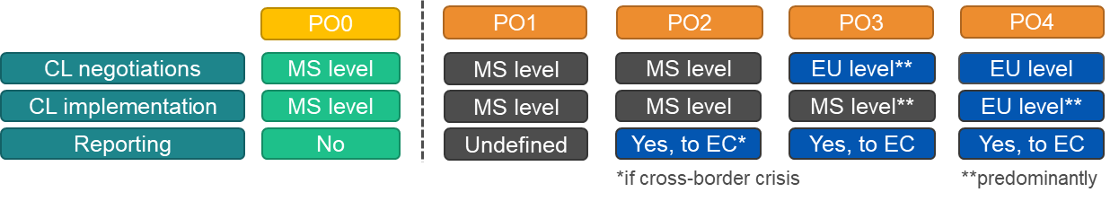

Most of these costs would materialise anyway, if - in the absence of the proposed changes - the same compulsory licensing negotiations and implementation were to be conducted at national level. In other words, the cost of compulsory licensing negotiations and implementation at national level would stay unchanged, when compared to the *status quo*. If national negotiations were to be replaced by the EU-level negotiations, the cost for Member States might stay unchanged or actually decrease as the same effort would be shared among several countries.

The collection of basic information on compulsory licensing for the reporting obligations would be carried out by Member States[133] as part of the normal documentation of any compulsory licensing procedure - the additional cost of such task is therefore judged to be very low. Concretely, in PO2 the reporting obligation would generate some additional small cost of sharing information with the EC, but it would affect only the Member State where a compulsory license is to be granted in the event of a cross-border crisis. In PO3 and PO4 the EC would be directly involved in the compulsory licensing negotiations, so no additional information sharing by Member States would be needed in this respect. Yet, under PO2, PO3 and to a lesser extent under PO4, Member States would still need to report on the implementation of the CL, for which the existing administrative procedures should be used. As the reporting requirements would apply only in the event of a cross-border crisis, hence such costs would be rare. Finally, the reporting should not require any additional infrastructure nor data collection, therefore the digital impacts are judged to be not relevant in the context of this initiative[134].

* Direct compliance costs/benefits for firms (i.e. patent holders, as well as the manufacturers or potential licensees): the costs of participating in compulsory licensing procedures would stay broadly the same as long as they remain at the national level (i.e. PO2 or partially PO3), with some potential marginal benefits due to increased coherence (lower legal uncertainty). However, whenever the compulsory licensing negotiations take place at EU-level instead of fragmented and overlapping processes carried out in several Member States they would be the source of cost savings for firms. The central procedure is estimated to replace roughly 4-5 procedures in each jurisdiction[135]. In such case, the savings for companies would be estimated at 75% to 80% of resources that would be needed otherwise, such as in-house staff or costs of external services, legal assistance, etc.
* Indirect wider socio-economic benefits for the EU citizens (general public) stemming from the timely availability of products needed in crisis and the fact that the crisis could be marginally shorter and/or constricted (e.g. affects less sectors than otherwise would be the case) and that severe economic repercussions are avoided.

Additionally, the European institutions can also bear certain direct costs linked with this initiative. In case of a cross-border crisis the Commission services would need to ensure good governance of the overall process and run the central compulsory licensing negotiations (PO3 and PO4), or grant and implement the CL. As for the EU-level CL, such additional costs would appear mainly if none of the existing emergency bodies or instruments (e.g. SMEI or HERA coordination committees) can be re-used to take up this role. If a new sector-specific body needs to be set up[136], then the Commission would bear the relevant costs, but given their *ad hoc* character - predominantly by drawing on resources and expertise already available in the Commission services[137]. As a cross-border crisis requiring the granting of a compulsory licence is assumed to be rare, these tasks should be undertaken by the available commission staff, also assuming certain flexibility and cooperation between Directorates General, especially when the crisis concerns their policy area.

The **direct and indirect benefits of a well-functioning compulsory licensing system for crisis management are assumed to greatly outweigh the** above mentioned minor **direct** **compliance and enforcement costs**, especially when compared with the indirect wider socio-economic impacts of a timely access to essential products needed to combat a crisis. Given the exceptional character of compulsory licencing, no significant administrative costs are expected as a result of the proposed initiative.

# How do the options compare?

As discussed in the objectives, a compulsory licensing system should be able to efficiently tackle EU cross-border crisis in a timely manner and guarantee the supply of critical goods and technologies across the Single Market, even in the absence of voluntary agreements. It should also protect investment in innovation by adequately safeguarding the interests of IP owners. Lastly, it should offer a coherent and coordinated approach, in line with other EU crisis instruments in order to reinforce EU resilience.

## Comparison of options against the effectiveness and efficiency criteria

Compulsory licensing for crisis management requires specific features that would ensure compulsory licences to be effectively granted to tackle the crisis (i.e. adequate ground and scope) and allow the efficient granting of a compulsory licence, in a swift manner. **Clarification of these features** – and their actual implementation – is therefore necessary to fulfil effectively and efficiently the general objective of having a compulsory licensing scheme that enables the EU to timely tackle crises. In that respect, PO1 is the least efficient option as it does not require Member States to implement these features in their national law. PO2 and PO3 would increase the clarity and coherence since they require Member States to harmonise some features. However, the harmonisation does not cover all features, such as the remuneration (PO3) or the trigger (PO2). In addition, divergences could still exist across Member States at the implementation phase. Granting would also remain national, opening the door for divergent practices and timing, when executing the national decisions. This would result in less coherence between national compulsory licences. In contrast, PO4 provides clarity as regards the features of the compulsory licence, as well as coherence, since there would be one single EU-level compulsory licence.

A compulsory licence to tackle cross-border crises could only be effective if it applies to the countries manufacturing the critical goods, as well as those facing the crises. The ability to export goods manufactured under a compulsory licence from one Member State to the other is therefore a key element. PO1 and PO2 prove insufficient in that respect since they allow at best the export of goods. Such solution is impracticable in case of cross-border supply chain. In addition, the lack of exhaustion would still require importing Member States to issue a licence. PO3 and PO4 provide a better solution as they both provide for an **EU-wide effect to the compulsory licences** (i.e. both are effective in guaranteeing a territorial scope that fits cross-border crises), whereas PO4 is the most efficient as regards compulsory licensing for export, as it also allows a cross-border effect in this case.

All options can **support other EU crisis instruments** by ensuring that compulsory licences can be used in that context, albeit with different degree of effectiveness and efficacy. PO1 scores low on this objective as it solely provides for the possibility for national compulsory licence to be granted in the context of EU crisis instruments. PO2 provides a better solution as this option would explicitly make the link between national compulsory licences and EU crisis instruments, mitigating the risk that a Member State denies the granting of a compulsory licence in the context of an EU decision activating a crisis mode. PO3 and PO4 go a step further by embedding compulsory licences in the EU crisis instruments (i.e. by using them as a trigger to grant a compulsory licence and by relying on the existing crisis bodies). The last two options would also strengthen EU bargaining position as 27 countries would run negotiations together and at once. As far as the information exchange and transparency is concerned, PO1 provides no obligation and has therefore limited added-value compared to the baseline. All the other options score better in this respect, although the exchange of information and coordination between Member States and the Commission may generate some minor administrative costs (yet, under PO4 such costs are the lowest, as where there would only be one compulsory licence granted centrally). Finally, PO3 and PO4 also score high in terms of transparency in decision making concerning export as they both allow the Commission, assisted by an advisory body, to provide support – through increased coordination – to non-EU countries.

Table 6: Comparison of policy options against the effectiveness and efficiency criteria

|  |  |  |  |  |
| --- | --- | --- | --- | --- |
|  | **Effectiveness in meeting policy objectives** | | | **Efficiency** |
| **Improve the key features of compulsory licensing** | **Territorial reach of compulsory licensing** | **Support EU resilience** |
| **PO0** | (0) | (0) | (0) | (0) |
| **PO1** | (0/+) Limited harmonisation affecting coherence between national CLs. | (0) Unfit territorial reach to tackle cross-border crises. | (0/+) No full embedding of **compulsory licensing** in EU crisis instruments. | (0/+) Uncertain social and economic outcomes in the event of a crisis; regulatory cost depend on uptake. |
| **PO2** | (+) Increased harmonisation but risk of non-aligned national CLs. Decision on crisis and compulsory licensing belongs to MS. Limited improvement for cross-border situations. | (0/+) EU countries can authorise export to limited extent, but no exhaustion (i.e. need of compulsory licensing to import). | **(+)** Better embedding of national **compulsory licensing** in EU crisis instruments and improved coherence between national CLs. | (+) Social and economic benefits for society if crisis limited or avoided, but may be undermined by national divergences in implementation; can be obtained at low regulatory costs. |
| **PO3** | (++) Increased clarity and coherence through harmonisation and one single act (basis for national CLs), but limited harmonisation on other key aspects. | (++) EU-wide effect of the compulsory licensing based on an activation measure and exhaustion would result in fewer CLs. Territorial reach better fit to tackle cross-border crises. | **(+++)** Full alignment between EU crisis instruments and **compulsory licensing** (alignment of trigger and relevant bodies); support of EU bargaining power. | (++) Social and economic benefits for society if crisis limited or avoided; can be obtained at low regulatory costs. |
| **PO4** | (+++) Clarity and coherence resulting from one single procedure and one single CL at EU level. | (+++) One single CL with adequate territorial reach (potentially the whole EU) and exhaustion would create an efficient tool to tackle cross-border crises, also addresses export. | **(+++)** Full alignment between EU crisis instruments and **compulsory licensing** (alignment of trigger and relevant bodies); support of EU bargaining power. | (+++) Social and economic benefits for society if crisis limited or avoided – highest probability due to a streamlined procedure; can be obtained at low regulatory cost. |

Note: (0) neutral impact; (+) minor positive impact; (++) positive impact; (+++) significant positive impact; (-) minor negative impact; (- -) negative impact; (- - -) significant negative impact

As far as the **subsidiarity/ proportionality** is concerned none of the options go beyond what is necessary to achieve the identified problems/objectives. Their respective scope is limited to aspects that Member States cannot achieve satisfactorily on their own and where the Union action can produce better results (for example, in terms of faster decision making in times of crisis) or is necessary (for example issuing an EU-level compulsory licence to solve the exhaustion problem). As explained in section 2, Member States could not solve the problem due to insufficient scale of legal instruments at their disposal. Options considered provide a mix of Member States and EU level actions with gradual increase of the EU level intervention. Possible instruments for implementing policy options are in case of PO1 a set of recommendations; in case of PO2-PO3, a harmonisation through a directive and in PO4, the introduction of a new layer through an EU regulation establishing an EU-level compulsory licence. Intervention of the Member States is guaranteed through the use of existing EU crisis instruments or through the initiative power given to Member States to start the process leading to EU-level compulsory licence. The initiative is limited to compulsory licensing to tackle cross-border crises. Member States retain their full competence as regards compulsory licensing on other grounds.

## Comparison of impacts of options on stakeholders

Under PO1, the impacts on **patent holders** would stay broadly the same as in the baseline: patent holders would still face a fragmented system but could benefit from more legal certainty as regards compulsory licensing across the Member States that apply the recommendation. This increased legal certainty would improve even more under the remaining options (PO2 to PO4) due to less divergences in the compulsory licensing rules. However, under PO3 and PO4 patent holders may face certain loss of control on their patent rights since the scope of compulsory licensing would no longer be limited to a given Member State. In addition, as negotiations would be run at EU level, it could reduce their negotiation power. This would be mitigated to a limited extent by cost savings whenever patent owners would participate in one procedure only.

The situation of **potential licensees** would barely improve under PO1 as their situation in terms of increased legal certainty will depend on the uptake of the recommendation by Member States. PO2 would provide them with more coherent rules, which would positively impact the legal certainty and reduce costs. However, their situation would significantly improve only under PO3 and PO4. Under PO3 and PO4, they would benefit from the centralised procedure that would be the source of administrative savings (although PO3 would maintain negotiations on some aspects at national level). If the streamlined compulsory licensing procedure results in wider territorial scope of the licence, this could translate into economies of scale when manufacturing the critical items.

**EU countries** could entail some costs under PO1 but only to the extent that they decide to implement the recommendation. Under PO2 and PO3, costs for Member States would be higher as they would face one-off costs linked to the implementation of the directive into their national laws. In both case they would also face recurring costs linked to transparency obligations in the event of a crisis (hence with a very low frequency). As granting procedures would remain national under PO2-PO3, this would entail enforcement costs for Member States. These costs would disappear under PO4, as the granting of the compulsory licence would be implemented at EU level.

The risk of unavailability of critical products during crises decreases as compulsory licensing schemes become more effective and efficient. For this reason, **EU citizens** would suffer the lowest risk under PO4. Such option would indeed allow a fully coherent and cross-border compulsory licence, which is not the case under any other option. As regards the **non-EU countries**, PO1 and PO2 only provide soft measures, likely to support to non-EU countries to a limited extent. PO3 brings an added-value as it foresees the possibility for non-EU countries to benefit from the support of the Commission, assisted by an advisory body, when facing a cross-border manufacturing process. This benefit would remain under PO4. In addition, PO4 ensures that products being manufactured across several EU countries could also be the subject of a compulsory licence for export purposes to non-EU countries. This option appears therefore highly beneficial to non-EU countries.

Table 7: Comparison of the impacts of policy options on stakeholders (in the event of a crisis)

|  |  |  |  |  |  |
| --- | --- | --- | --- | --- | --- |
| **Affected** | **IP holders** | **Manufacturers - future licensees** | **EU countries** | **The general public (EU citizens)** | **Non-EU countries** |
| Selected firms from the population of 103.000[138] | Selected firms from the population of  2 million[139] | 27 | Citizens affected by the crisis among 447 million (2021) | Countries covered by Regulation (EC) No 816/2006 |
| **PO0** | (0) | (0) | (0) | (0) | (0) |
| **PO1** | (0/+) Somewhat lower costs of compulsory licensing negotiations, and increased legal certainty. | (0/+) Somewhat lower costs of compulsory licensing negotiations. | (0) Marginally lower costs of implementing the CL, but cost of information exchange with other EU countries (if applicable, as no obligation). | (0/+) Marginally lower risk of delays or unavailability of critical products during crisis. | (0/+) Somewhat lower costs and improvement in legal certainty. |
| **PO2** | (+) Somewhat lower costs of compulsory licensing negotiations and some improvement in legal certainty, as rules more coherent across MS. | (+) Somewhat lower costs of negotiations, as rules more coherent across MS. | (0/+) Potentially lower costs of implementing the compulsory licensing as and better exchange of information between MS, but cost of information exchange; cost of reporting to the EC. | (+) Marginally lower risk of delays or unavailability of critical products during crisis, as rules more coherent across MS. | (+) Increased legal certainty and limited administrative savings for non-EU countries. |
| **PO3** | (+) Lower costs of negotiations and improvement in legal certainty, but marginal loss of control over patent rights, if harmonisation leads to wider geographical scope. | (+ +) Lower costs of negotiations and lower costs of adapting the manufacturing facilities if harmonisation leads to wider geographical scope. | (+) Lower costs of launching the CL, better exchange of information between MS, including compulsory licensing for export but cost of participating in compulsory licensing negotiations on non-harmonised aspects, cost related to the single contact point and cost of reporting to the EC | (+ +) Lower risk of delays or unavailability of critical products during crisis, as rules more coherent across MS. | (+ +) Increased legal certainty and administrative savings due to better coordination at EU level. |
| **PO4** | (+) Significant lower costs of negotiations and improvement in legal certainty but loss of control over patent rights, if EU-level compulsory licensing leads to wider geographical scope. | (+ +) Lower costs of negotiations and lower costs of adapting the manufacturing facilities if EU-level compulsory licensing leads to wider geographical scope. | (+ +) Significantly lower costs of launching the CL, better exchange of information between MS, but cost related to the single contact point and cost of reporting to the EC. | (+ + +) Significantly lower risk of delays or unavailability of critical products during crisis, as rules coherent across all MS. | (+ + +) Increased legal certainty and administrative savings due to coordination at EU level. |

Note: PO 1 is conditional on the implementation of recommendations by majority of MS.

To complement the outline of impact on stakeholders, see also the SME test (Annex 8).

## Coherence with other EU policies and proportionality

This initiative is fully coherent with other EU initiatives, especially those aiming at improving the EU’s resilience to crises (HERA, SMEI, etc.). Coherence with EU crisis instrument is above all ensured by making such instrument the trigger of an EU-level compulsory licence. In addition, this initiative provides that consultation of Member States and stakeholders must be carried out within the relevant (advisory) bodies, as provided for by the relevant EU crisis instrument.

As far as the proportionality is concerned, under PO1 Member States retain freedom to introduce or not the recommendation. Under PO2, harmonisation would be proportionate and limited to provisions essential to tackle a crisis. Member States would retain competence for compulsory licensing other than crisis management. The same would apply to PO3. Under PO4, Member States’ empowerment would be limited, but only in exceptional circumstances. The EU-level compulsory licensing rules would be proportionate and limited to provisions essential to tackle a cross-border crisis, while Member States will be consulted in the relevant (advisory) bodies throughout the process.

# Preferred option

All the options considered in the impact assessment are expected to improve on the *status quo*, but to a varying extent. However, when considering the specific objectives, it appears that **Option 4** would be the most effective and efficient to achieve the objectives of this initiative.The preferred option would create a single procedure to grant an EU-level compulsory licence with adequate features to tackle a crisis. The Commission activation measure would ensure that conditions are the same across the EU and would avoid national discrepancies likely to slow down or prevent a compulsory licensing from tackling cross-border crises. This single compulsory licence would be applicable in all relevant territories, therefore covering any cross-border situation (i.e. would also cover smaller-scale crises, not affecting the whole EU). This would be the case for both the EU market and for export purposes to non-EU countries. Coherence with EU crisis instruments would be ensured by the possibility to refer to a common trigger, as well as to the (advisory) bodies set-up by the EU crisis instruments. Alternatively, the procedure could be initiated by Member States affected by a crisis. Negotiations and coordination would be carried out at EU-level to ensure coherent approach across the EU. To prevent and stop any misuse of the compulsory licence[140], safeguards should be in place to allow the Commission to take appropriate measures including, if need be, the reduction of the remuneration and the termination of the compulsory licence to ensure that the conditions of the compulsory licence are respected. The measures taken by the Commission should be effective, proportionate and dissuasive. The implementation of the preferred option would require adopting a new regulation establishing an EU-level compulsory licence for crisis management. PO4 is the most balanced and proportionate approach, which also takes account of the views and concerns of stakeholders. The preferred option would address the identified problem (i.e. “*EU compulsory licensing rules not well suited to address cross-border crisis in a timely manner, due to uncoordinated procedures and decision-making, as well as inadequate territorial reach*”).

Table 8: How the preferred option achieves the policy objectives?

|  |  |
| --- | --- |
| **Objective** | **Preferred option: PO 4 (EU-level CL)** |
| SO1: Improve the key features of compulsory licensing, such as the trigger, scope and conditions of compulsory licensing, as well as improve the coherence of compulsory licensing in the EU to improve its effectiveness and efficiency in a crisis | PO4 would ensure that optimal features are in place to guarantee a swift granting procedure in the event of a cross-border crisis or a crisis affecting the Single Market. As it would create a single procedure at EU-level, the current fragmentation slowing down or preventing the use of compulsory licensing in crises would therefore be removed. |
| SO2: Ensure that the territorial reach of a compulsory licence, incl. for export purposes, can accommodate the reality of cross-border value chains operating in the Single Market | PO4 would establish a compulsory licensing scheme in the EU able to tackle cross-border crisis (including covering cross-border supply chains, also for export purposes to non-EU countries). |
| SO3: Support EU resilience by improving the coordination, streamlining the decision making and allowing compulsory licences to better complement EU action in crises, including for export purposes to non-EU countries | PO4 would provide the EU with a compulsory licensing tool that could be used in support of EU crisis instruments (as incentive to voluntary agreement or as a last resort measure to replace / complement them). Coherence with other EU crisis instruments would be ensured by referring to such instruments in order to the trigger an EU-level compulsory licensing (the exact choice of instrument will depend on the type of crisis). PO4 would also support non-EU countries needing to rely on compulsory licensing in the EU. |

The impacts of the preferred option on stakeholders were discussed in section 6.4.4. They can be summarized as follows: the preferred option (PO4) is more effective as it (i) removes fragmentation and provides more clarity and coherence on the features of compulsory licensing for crisis management; (ii) provides an adequate territorial reach able to cover cross-border crises and supply chains; (iii) provides alignment with EU-crisis instruments. The impact on **EU countries** would be positive as it would increase their ability to tackle cross-border crises in a coherent and efficient way. Member States would benefit from a reduction of enforcement cost as negotiation would be centralised at EU level. **EU citizens** would also benefit from this initiative as it improves the ability of the EU to take full advantage of the Single Market and to provide access to critical goods in crises. For **patent owners,** this initiative would indeed remove compulsory licensing fragmentation in the EU and costs associated with the participation in multiple national procedures. However, in the event of a broader geographical scope of a CL, wider loss of control over patent rights. This impact is however limited as compulsory licensing is an exceptional measure. In addition, patent owners would still benefit from a remuneration and the limitation of their right would be for a definite period. In addition, this solution would generally only apply once voluntary agreements were not available. **Potential licensees** would benefit from administrative savings due to the centralised procedure and economies of scale if its results in wider territorial scope of the CL. **Non-EU countries** would also benefit from this initiative as it should facilitate access to a compulsory licence covering a cross-border supply chain.

Finally, the EU-level compulsory licensing rules would be proportionate and limited to provisions essential to tackle a cross-border crisis. The EU level compulsory licensing decision would limit Member States empowerment only in exceptional circumstances. Member States retain competence for compulsory licensing other than cross-border crisis management and will be consulted in the relevant (advisory) bodies throughout the process.

## REFIT and the application of the ‘one in, one out’ approach

This preferred PO4 foresees the establishment of a new legal instrument where an EU-level compulsory licensing could be granted in a cross-border crisis using a single procedure instead of several national procedures.

Table 9: REFIT – cost savings related to the preferred option (PO4)

|  |  |  |
| --- | --- | --- |
| **Description** | **Amount** | **Comments** |
| Savings for patent holders and manufacturers (potential licensees). | 75%-80% less resources than in the baseline, in the event of a cross-border crisis | The compulsory licensing negotiations would take place only once at the EU-level instead of fragmented and overlapping processes in several EU countries (or instead of ca. 4-5 procedures in each jurisdiction that could be needed otherwise). |
| Savings for MS administrations. | Impossible to estimate precisely | Cost of running compulsory licensing negotiations are expected to decrease, as resources would be shared at EU-level. |

In the event of an unforeseen future crisis, PO4 would lower the costs of participation in compulsory licensing negotiations incurred by patent holders, manufacturers and Member States (notwithstanding the identification of some minor administrative costs of reporting, which may be incurred by Member States and thus do not fall under the ‘one-in one-out’ approach). As far as the firms are concerned, such costs could be lower by roughly 75% to 80% when compared to the *status quo* scenario (i.e. based on a hypothetical situation where a single compulsory licensing procedure would replace 4-5 procedures in each jurisdiction). For Member States, if national compulsory licensing negotiations were to be replaced by the EU-level negotiations, the compliance and enforcement cost might stay unchanged or actually drop as the same effort would be shared among several countries. The exact monetary value of cost savings for stakeholders is not possible to provide due to scarcity of such events and also because the type of future potential crisis and its scale is unknown. Additionally, as the new instrument should be used only during major crisis affecting the EU and as the last resort measure, hence its expected frequency is also very low.

# How will actual impacts be monitored and evaluated?

The legislation to be proposed would include a provision requiring an evaluation report five years after the granting of the first EU-level compulsory licence. The preferred option obliges Member States to inform the Commission when they are considering granting and when they have granted a compulsory licence for crisis management, as well as providing information on the compulsory licence (i.e. transparency obligation on the subject matter of the compulsory licence, the manufacturer, the conditions, etc.). As discussed in section 1.3., the recourse to compulsory licensing is expected to be rare as it will be triggered by exceptional circumstances. As a consequence, the overall number of compulsory licences issued on the basis of the proposed instrument is expected to be low[141], which subsequently means that monitoring of the basic descriptive indicators would not require setting up of additional systems for data collection and monitoring (the collection and processing of information can be done manually).

Table 10: Monitoring indicators

|  |  |
| --- | --- |
| **Indicators** | **Sources of information** |
| *Objective 1. Improve the key features of compulsory licensing:*  Perceptions about the new compulsory licensing system when compared with the *status quo*, especially with regards to its efficiency (e.g. duration as compared to the baseline), clarity. | Online survey using similar questions as the OPC (to be carried out 3 years after entry into force); EU countries reporting; Information collected in the context of the work of crisis advisory bodies. |
| *Objective 2. Territorial reach of compulsory licensing:*  Number of compulsory licensing cases where there is a cross-border element;  Number of EU countries covered by compulsory licensing granted under the new system. | ECJ, WTO and EU national case law;  EU countries reporting; Information collected in the context of the work of crisis advisory bodies |
| *Objective 3. Support EU resilience:*  Use or absence of use of compulsory licensing in the context of EU crisis instruments; | Reporting on EU crisis instruments; EU countries reporting; Information collected in the context of the work of crisis advisory bodies |

Annex 1: Procedural information

1. Lead DG, D*e*cide Planning/CWP references

Lead DG:

* DG for Internal Market, Industry, Entrepreneurship and SMEs (DG GROW).

Other Services involved:

* SG, SJ, COMP, ENER, SANTE, HERA, TRADE, RTD, INTPA, JRC

Agenda Planning Reference:

* Ref. PLAN/2021/11425
* The initiative is included in the Intellectual Property (IP) Action Plan that the Commission adopted on 25 November 2020 and in the Commission work programme 2023.

1. Organisation and timing

The Call for Evidence was published on 1 April 2022. It was followed by a feedback period that lasted until 29 April 2022. 57 stakeholders submitted feedback. The Commission held a public consultation from 7 July 2022 to 29 September 2022. This consultation was available on the Better Regulation Portal of the Commission and open to anyone who wished to reply. The public consultation received 74 replies through the EU survey.

The work on the Impact Assessment was carried out from April 2022 to January 2023, during which an Interservice Steering Group (ISSG) met three times to give an update on the ongoing work and discuss preliminary versions of the Impact assessment report, together with all the supporting documents.

The following Commission services participated: SG, SJ, COMP, ENER, SANTE, HERA, TRADE, RTD, INTPA and JRC.

The deadline for adoption of a proposal by the Commission is April 2023.

1. Consultation of the RSB

The Regulatory Scrutiny Board (RSB) was consulted in an upfront meeting on 15 July 2022. The present impact assessment report was submitted to the RSB on 06.01.2023. The Impact Assessment was discussed with the RSB on 01.02.2023. On 03.02.2023 the RSB delivered a positive opinion. The table below shows RSB comments and how they were addressed in the revised text.

Table 11: RSB comments to the initial version of the impact assessment

|  |  |
| --- | --- |
| ***RSB comments*** | ***DG GROW replies*** |
| (1) The problem definition is not sufficiently clear on the remaining scale of the problem. | Additional clarifications have been introduced in sections 2.3 and 2.4, in particular concerning the likelihood that the envisaged EU compulsory licensing rules will be needed and the gap EU compulsory licensing rules would cover in the event of a cross-border crisis. |
| (2) The report does not sufficiently describe the content and functioning of the EU level options, including the intended safeguards. The expected efficiency gains and overall effectiveness are not sufficiently demonstrated. | Additional clarifications have been introduced in section 8 concerning safeguards to prevent any misuse of the proposed compulsory licence scheme. The efficiency and timeliness of EU-level compulsory licence would be ensured by adequate governance design, which is now discussed at more length in section 5.2.4. |
| (3) The report does not comprehensively analyse the impact on competitiveness and innovation, including investments in innovative products in case of crisis. | Section 6.5.3 has been expanded by referring to a broader policy trade-off between keeping the incentives for innovation through IP protection while ensuring access to critical products in cross-border crisis situations. |

1. Evidence, sources and quality

Analysis presented in this impact assessment is based on the following key sources:

* Feedback to the Call for Evidence on Compulsory Licensing in the EU that the Commission published on 1 April 2022 (<https://ec.europa.eu/info/law/better-regulation/have-your-say/initiatives/13357-Intellectual-property-revised-framework-for-compulsory-licensing-of-patents_en> ).
* Replies to the Open Public Consultation on Compulsory Licensing in the EU that was open until 29 September 2022 (<https://single-market-economy.ec.europa.eu/news/commission-seeks-views-and-input-compulsory-licensing-patents-2022-07-07_en> ), referred to as ‘OPC’.
* “Compulsory licensing of intellectual property rights”, Center for International Intellectual Property Studies (CEIPI), Université de Strasbourg (UNISTRA), Impact Licensing Initiative (ILI), Ecorys Nederland BV (Ecorys), Brussels 2023 ([link available once published]), referred to as ‘CEIPI(2023)’.
* “Compulsory licensing in Europe, A country-by-country overview”, European Patent Office, 2018 (<https://www.epo.org/learning/materials/compulsory-licensing-in-europe.html> ), referred to as ‘EPO(2018)’.

Additionally, the following data sources were used in order to perform an in-house analysis:

* PatentSight® database (https://go.patentsight.com/login.html).

The remaining sources are provided in the footnotes, whenever they are referred to in the text.

Annex 2: Stakeholder consultation (Synopsis report)

Introduction

As underlined in the Commission’s intellectual property action plan (2020), the Commission sees a need to ensure that effective systems for issuing compulsory licences are in place. Against that background the Commission started in 2022 consulting stakeholders on compulsory licensing of patents in the EU, especially in a cross-border crisis. Consultation of stakeholders also covered the efficiency of the EU procedure on compulsory licensing of patents for pharmaceutical products for export to countries with public health problems (Regulation (EC) No 816/2006).

Consultation activities

The European Commission published a **Call for evidence**[142] on 1 April 2022. The feedback period to this call for evidence lasted 4 weeks and ended on 29 April 2022. The objective of this call for evidence was to gather views, opinions and evidence from all public and private sector stakeholders, such as IP right holders, users of IP-protected technologies and products, the health sector (including generic manufacturers, start-ups and patient associations), public authorities, national IP offices, non-profit organisations, civil society representatives, consumer associations, research centres, the European Medicines Agency and IP lawyers. It gathered views on the different grounds and procedures for issuing compulsory licences in a crisis and aimed to discover bottlenecks and to assess the impact of compulsory licensing on stakeholders. In total, 57 feedbacks were received, of which one third came from business associations and 23% from non-governmental organisations (NGOs). Most of the feedback was received from respondents from BE (21%), DE (19%) and FR (11%).

In March 2022, the Commission launched the study ‘Compulsory licensing of intellectual property rights’ [CEIPI(2023)]. The objective of the study was to assist the Commission in defining potential problems as regards compulsory licensing in the EU as well as identifying and assessing policy options to improve coherence and effectiveness in the field. To this end, the study aimed at collecting data through desk research, case studies, interviews with stakeholders as well as organising two workshops. The study was conducted by the Center for International Intellectual Property Studies (CEIPI), the Université de Strasbourg (UNISTRA), the Impact Licensing Initiative (ILI) and Ecorys Nederland BV (ECORYS).

In the context of the Study, Member States experts were contacted to complete a **questionnaire.** The questions focused on the national experiences with compulsory licensing, the scope of application of compulsory licences and procedural aspects. In addition, a series of 25 semi-structured interviews of national experts, academia, policy representatives and industry experts were conducted. These interviews focused on gathering ‘non-published’ data on national procedures and legal requirements of compulsory licensing.

Two workshops were held:

* A first workshop on ‘Information collection on specific compulsory licence cases with exchange of views and experiences in the field of IPRs’ was held in Brussels on 28/29 April 2022;
* A second workshop on ‘Policy options for compulsory licensing in Europe in case of a crisis’ was held in Brussels on 9/10 June 2022.

A total of 24 participants attended both workshops, representing patent attorneys from multiple Member States, policy officials and representatives from different industries.

The European Commission also held an **Open Public Consultation** from 7 July 2022 to 29 September 2022. This public consultation aimed to collect views from all stakeholders on how to build the most efficient compulsory licensing scheme in the European Union as well as to ensure that it is fit to tackle EU-wide and global crises. This consultation was available on the Better Regulation Portal of the Commission and open to everybody. The public consultation received 74 replies. More than half of the answers came from business associations (30%) and company/business organisation (24%), mostly from the health sector (34%). The largest number of replies were from Germany (15), Belgium (11) and FRFR (10). See for more statistics about the respondents and the key findings, the Factual Summary Report, published on the Better Regulation Portal of the Commission.

Table 12: Number of replies received in the open public consultation by stakeholder type

|  |  |  |
| --- | --- | --- |
| **I am giving my contribution as** | **Freq.** | **Percent** |
| Academic/research institution | 5 | 6.76 |
| Business association | 22 | 29.73 |
| Company/business organisation | 18 | 24.32 |
| Consumer organisation | 1 | 1.35 |
| EU citizen | 12 | 16.22 |
| Non-governmental organisation (NGO) | 6 | 8.11 |
| Other | 6 | 8.11 |
| Public authority | 4 | 5.41 |
| **Total** | **74** | **100** |

Source: OPC

Analysis of responses

Compulsory licensing as a crisis instrument

In the context of the consultation activities, stakeholders were asked about the **relevance of compulsory licence as a crisis management instrument**. In that respect, a large majority of all groups of respondents[143] (82%, N= 61) consider it important for public authorities to allow production of certain products and/or use of certain technologies necessary to tackle a crisis through a compulsory licence. This is also true for respondents likely to be subject to a compulsory licensing decision (N=12), with 75% of them agreeing with the importance for public authorities to rely on compulsory licensing for crisis management purposes. In particular, in view of recent crises, such as the Covid-19 pandemic and the war in Ukraine, respondents consider compulsory licensing as a crisis management tool generally as positive (43%, N=20), even though it has been also pointed out that existing mechanisms of compulsory licensing under the TRIPS Agreement and national IP laws revealed not to be sufficient to solve the problem of urgent access to life-saving medical tools during critical situations such as an ongoing war, a pandemic or situations of severe medicines shortage and instead rather voluntary licensing agreements played a pivotal role, increasing production and supply for the needed medicines.

When asked about the **fitness of current rules on compulsory licensing for crisis management**, stakeholders’ views are contrasted. Many respondents consider that current national laws on compulsory licensing are fit to tackle national crises (58%, N=43), EU-wide crises (51%, N=38), and global crises (50%, N=37). However, stark disparities exist between stakeholders. All NGOs considered that current compulsory licensing rules are unfit to tackle EU-wide crises. In contrast, all business associations and companies considered that compulsory licensing rules are fit to tackle EU-wide crises. Generally, compulsory licensing rules are considered less fit to tackle EU-wide crises than national and global ones[144].

When asked about the **types of crises for which compulsory licensing should be possible**, almost half of the respondents (45%, N=33) considered that compulsory licensing should be allowed only for specific crises. Interestingly, three quarters of the respondents likely to be subject to a compulsory licensing decision were of the same opinion. Another quarter considered that compulsory licensing should be allowed whenever a situation is determined to be a crisis by relevant authorities. Only few respondents considered that compulsory licensing should never be used (55%, N=4). When asked about the types of specific crisis, respondents first mentioned health-related crises (34%, N=25), then war and/ or large-scale attack (28%, N=21), and finally energy-related crises and natural disasters (each 26%, N=19).

On **priority aspects of compulsory licensing for crisis management**, a large majority of stakeholders (74%, N=55) consider the speed of ensuring access to products/ technologies as a high priority. However, only a third of stakeholders (34%, N=25) considered that putting a time limit on negotiations could speed up the granting of a compulsory licence for crisis management. Views diverged on the need to provide a clear time limit, some considering that a defined time period (e.g. 1 month) would be necessary to avoid lengthy negotiations, others considering that this would not provide a flexible solution. In contrast, pre-defined rules on essential terms of the licence are quoted as an efficient way to speed-up the granting of a compulsory licence. Pre-defined rules on remuneration appear particularly important with 42% of respondents (N=31) considering that it would speed up the granting of a compulsory licence. This is in line with the finding that protection of right holders (including an adequate remuneration) was considered a high priority for 64% of respondents (N=47) to the public consultation.

A final aspect concerned the **importance of voluntary agreements on intellectual property rights**, including in crises. Stakeholders generally highlight the importance of voluntary agreements to scale-up the manufacturing of critical products. This view was often reflected in the feedback to the call for evidence as well as in the replies to the public consultation. According to many stakeholders, the COVID-19 pandemic has showed that voluntary agreements offer a viable solution for the manufacturing of critical goods in crises. Along these lines, three quarters of the respondents to the public consultation (74%, N=55) agreed that compulsory licensing is a last-resort mechanism that should be available only where voluntary arrangements have failed or are unavailable.

However, views are contrasted on this issue: although almost all companies and business association (97%) agree with the last resort approach, two-thirds of NGOs disagree. In addition, several respondents to the public consultation highlighted that Article 31(b) of the TRIPS Agreement does not require seeking the authorisation of the patent owner (i.e. a voluntary agreement) in cases of a national emergency or other circumstances of extreme urgency or in cases of public non-commercial use.

As regards aspects to determine whether voluntary agreements have failed, the majority of respondents favour whether reasonable efforts have been made by the licence seeker to obtain an agreement with the IP owner and the time period allowed for concluding a voluntary agreement over the types of voluntary agreements that have proven to be unsuccessful or unavailable, such as agreements with suppliers or agreements between competitors.

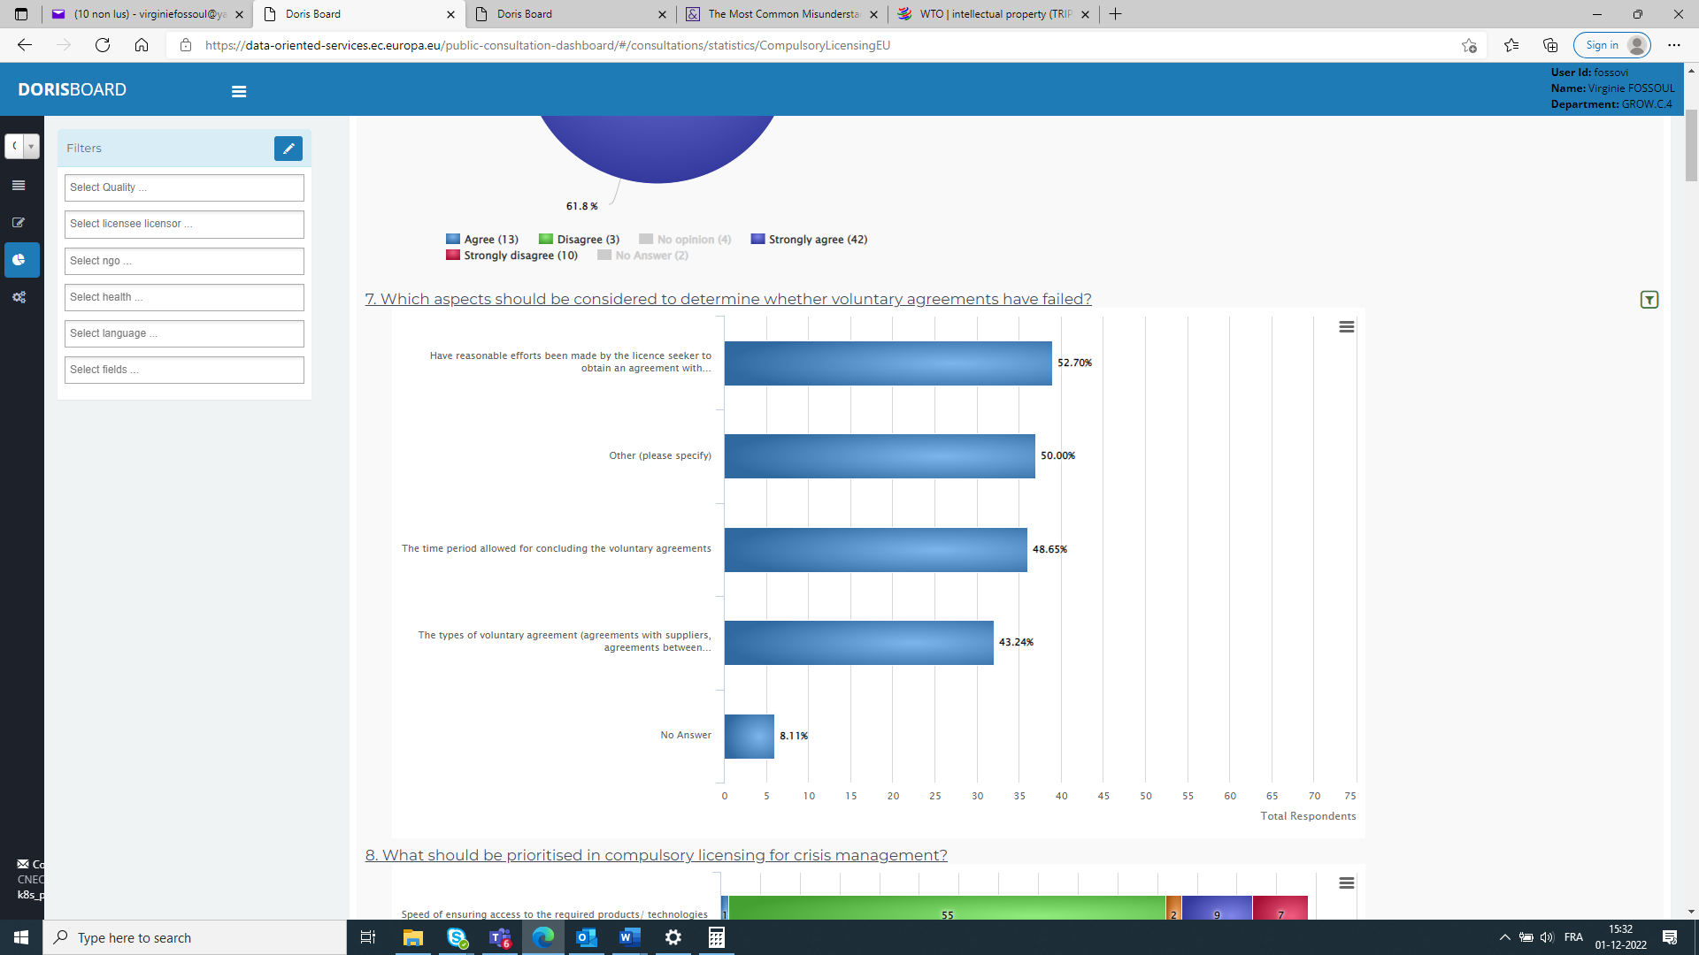

Almost half of the respondents mentioned other aspects to be considered. These aspects included the scope of the licence (whether it is strictly limited to what is necessary), the protection of trade secrets and commercial interests of the IP owner and the guarantees given by the licensee.

As regards the **impact of compulsory licensing on the various players**, opinions are divided between stakeholders. While companies and business associations point to the negative impact of compulsory licensing to IP rights holders, lowering the value of their investments in IP rights, impairing the IP system and harming society in the long run, NGOs are emphasizing the positive impact on citizens and the entire society by ensuring affordable and sustainable access to essential health products, when needed, at reasonable prices, in adequate quantity and good quality, while guaranteeing a balance with the innovation and IPR system.

Policy options as regards compulsory licensing for the domestic market – Article 31 of the TRIPS Agreement

Different consultation activities[145] have examined experiences of stakeholders and national experts with compulsory licensing at Member State level, in particular regarding possible policy options to ensure an effective compulsory licensing system for crisis management.

When presented with three main **policy options to speed-up the compulsory licensing process for crisis management**, stakeholders favoured the option consisting of facilitating communication on the request/ granting of compulsory licences and the sharing of information between EU countries (42%, N=31). The second preferred option referred to the possibility of aligning rules on compulsory licences (28%, N=21). The least preferred option concerned the adoption of non-binding guidelines (22%, N=16). Three out of four of the public authorities having replied to the public consultation are in favour of an alignment of rules. This is in stark contrast with NGOs and consumer organisations, of which only one NGO would welcome an alignment of rules. This reluctance towards an alignment of rules could be explained by the willingness to preserve the ability of Member States to trigger compulsory licences at national level, as this appears from discussions with stakeholders.

The public consultation further investigated the option, and in particular the **relevant features of uniform rules on compulsory licences for crisis management**. In general, respondents to the public consultation consider that the three main features to be aligned should be the grounds on which a compulsory licence can be granted (43%,N=32), the scope (42%, N=31) and the procedure (32%, N=24). Divergences exist between the different categories of stakeholders. Companies and business associations are less likely to consider that alignment is needed on the different features. They are only a bit more than a fifth to consider necessary to align the grounds and the scope and only 17% in favour of aligning the procedure. In contrast, more NGOs, public authorities, and academia are in favour of aligning the scope (73%), the grounds (67%) and the procedure (53%).

The public consultation further examined the different features of a compulsory licence for crisis management purposes, which can be summarised as follows:

**Grounds for granting a compulsory licence**– Around one third of the respondents to the public consultation consider that the following grounds for granting a compulsory licence should be aligned: the territorial scope of crises (the possibility to declare a national, multinational or pan-European-crisis), the types of crises for granting a compulsory licence (e.g. health) as well as the definition of crises that allow a compulsory licence to be granted should be the same. Divergences exist between the different categories of stakeholders, with companies and business associations being less in favour of an alignment of the grounds for granting a compulsory licence than academia, public authorities and NGOs having replied to the public consultation.

**Scope of the compulsory licence** *–* More than a third (35%, N=26) of the respondents to the public consultation consider it necessary that the alignment of the scope of what a compulsory licence covers should extent to all aspects deemed necessary to allow the manufacturing of complex products.

In particular, the Public Consultation reveals that 65% of the respondents (N=48) are of the opinion that compulsory licences should also apply to *supplementary protection certificates*. In this sense, responses of national experts to the questionnaire sent in the context of the Study, show that the lack of explicit reference to *supplementary protection certificates* in national compulsory licensing provisions gives rise to legal uncertainty and different interpretation of similarly worded provisions[146]. Half of the respondents of the Public Consultation, i.e. 50% (N=37), favour compulsory licences that apply to *patents as well as published patent applications*.

36% of respondents (N=27) welcome if compulsory licences also included the *know-how*. Views are extremely contrasted on this point with only 5% of companies and business associations being in favour (in contrast, considering academia and NGOs and public authorities, all but one are in favour of including know-how in the scope of a compulsory licence).

Moreover, stakeholders having participated in the context of the study generally agree that *regulatory data protections* for medicinal products should not be an obstacle to the effective implementation of a compulsory licence.[147] In contrast, only 35% of respondents (N=27) (and only 12% of the companies and business associations) consider it useful when compulsory licences also apply to regulatory data protections for medicinal products. Finally, a third of the respondents are of the opinion that a compulsory licence should also apply to *other IP rights* but did not elaborate much further on the types of other IP rights.

**Conditions for granting a compulsory licence** *–* Consultation activities have identified that alignment of the conditions for granting a compulsory licence should encompass the duration of the licence (38%, N=28), the content of an application for a compulsory licence (e.g. indicate the patent, the owner of the patent, the concerned products, etc.) (35%, N=26), remuneration (34%, N=25) and the framework and duration of the negotiations (31%, N=23). During the consultation activities, stakeholders explained that patent holders which are subjected to a compulsory licence run risks that may not adequately be dealt with by the enforcement of patent and compulsory licence-relevant laws alone.[148] Insofar safeguards are needed in the form of complementary contractual control mechanisms which can help to reduce the negative consequences of the compulsory licence. In this sense, protection for rights holders, such as a reasonable period of time to allow negotiations between the licence seeker and the rights holder, a clear limitation of the duration of the compulsory licence and an adequate remuneration for rights holders is considered of high priority by the majority of respondents of the Public Consultation (69%).

**Procedure for granting a compulsory licence** *–* As regards the procedure for granting a compulsory licence, 43% of the respondents to the public consultation (N=32) would welcome an alignment of the type of procedure (administrative or judicial procedure). When it comes to NGOs and academia, 8 out of the 11 respondents are in favour of such alignment. Only 27% of the respondents to the public consultation (N=20) would like to see an alignment on whether or not the manufacturing should be subject to a final decision on all aspects of the compulsory licence.

Procedures on compulsory licences for crisis management should, according to stakeholders, rather be initiated by a competent authority (28%, N=21) than on request of the licence seeker (4%, N=3), or alternatively, providing both possibilities (23%, N=17).

As regards an alignment of the recourse procedure for granting a compulsory licence, a majority of respondents to the public consultation would agree with an alignment of the time limit within which the application of an appeal is admissible (42%, N=31) and an accelerated appeal procedure (38%, N=28). 35% of the respondents (N=26) are in favour of the suspensive effect of an appeal.

**Competence to administer compulsory licences** *–* Even though at national level, as demonstrated in the questionnaires sent to national experts and as confirmed by stakeholders across all categories, various types of authorities are empowered to issue a compulsory licence for different purposes[149], a strong preference was expressed by stakeholders during interviews and workshops for allocating responsibilities for administering compulsory licences to ‘specialised’ or expert authorities: authorities which hold the requisite knowledge of a product and relevant expertise in order to properly evaluate applications for compulsory licences and make key assessments regarding the necessary scope of a compulsory licence.[150]

As to the role of the European institutions, the Public Consultation revealed that a slight majority of respondents favour a consultative role on the request of EU countries, public authorities, rights holders, licence seekers, etc., asking for advice (39%, N=29) or a coordinating role (e.g. by setting up channels/forums and methods for information sharing among EU countries and steering mutual assistance between EU countries) (36%, N=27) over a decision-making role of European institutions (e.g. by declaring a crisis, possibly triggering the granting of a compulsory licence (28%, N=21).

Compulsory licensing for exports

Regulation (EC) No 816/2006 regulating compulsory licensing of patents for pharmaceutical products for export purposes had never been used. It was therefore important to collect views from stakeholders on how they consider this regulation, and in particular the fact that it was never used.

41% of the respondents to the public consultation (N=30) considered that Regulation (EC) No 816/2006 allows for speedy and efficient procedures for granting compulsory licences to export pharmaceutical products to non-EU countries.

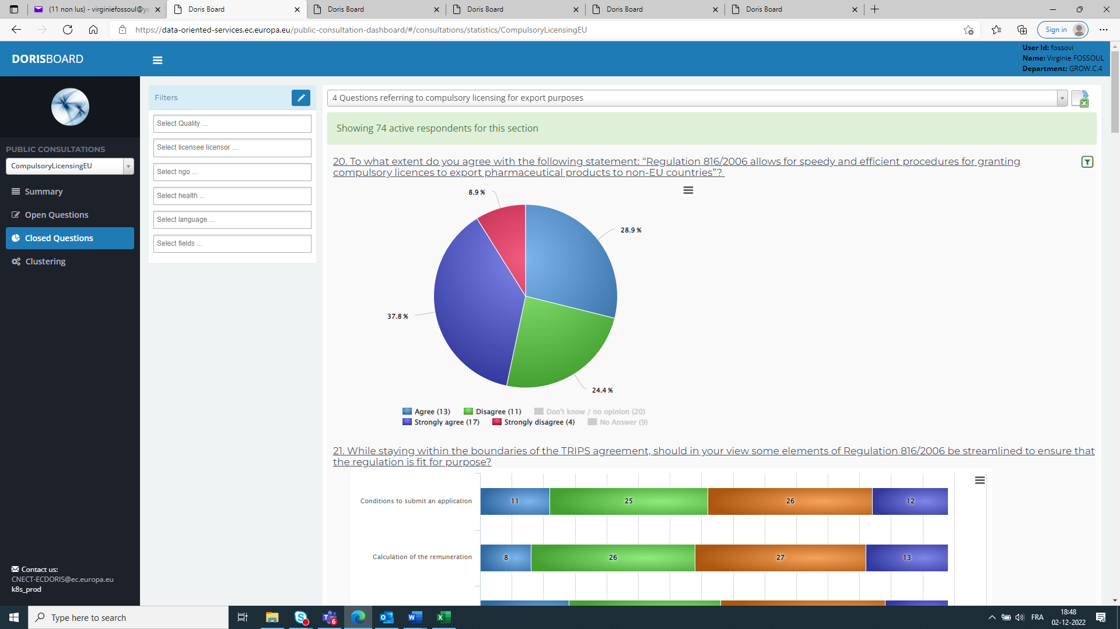

Views are however extremely contrasted on this issue: among companies and business associations, 95% agree with this view. In contrast, all NGOs having participated in the public consultation consider that this is not the case.

On aspects of the Regulation that could be streamlined, we witness a lot of respondents having no opinion (around a third) or having not replied (around 15%). Replies appear again contrasted between companies and business associations, on the one hand, and NGOs, on the other hand. In the first group, only one respondent considered that elements of the regulation should be streamlined (i.e. conditions to submit an application, calculation of the remuneration and the simplified and accelerated procedure). In contrast, all but one NGOs considered that conditions to submit an application and the calculation of the remuneration should be streamlined. All NGOs considered that the simplified and accelerated procedure should be streamlined.

Stakeholders generally disagree that the procedure set by Regulation (EC) No 816/2006 should be made more flexible to adapt to the needs of the importing country (25 respondents disagreed, 17 agreed and 32 did not reply or had no opinion). On whether the Regulation provides for sufficient guarantee against trade diversion, the majority of respondents (38%, N=28) agreed, while a minority of 6 respondents (8%) disagreed (the largest majority – 40 respondents – did no reply or had no opinion on the issue).

Impacts of the different options

Several questions on the impact of possible options were part of the public consultation. These impacts are summarised below, with a particular focus on the impacts on EU businesses, IP owner, the ability of the EU to tackle crisis and the access to critical goods in crises.

The majority of the respondents of the Public Consultation are seeing the **introduction of a uniform compulsory licensing scheme** for crisis management rather negative for EU businesses (38%, N=28) and EU IP owners (43%, N=32). However, it is generally perceived more positive as regards the EU’s ability to tackle crises (38%, N=28) and the provision of access to critical goods (36%, N=27).

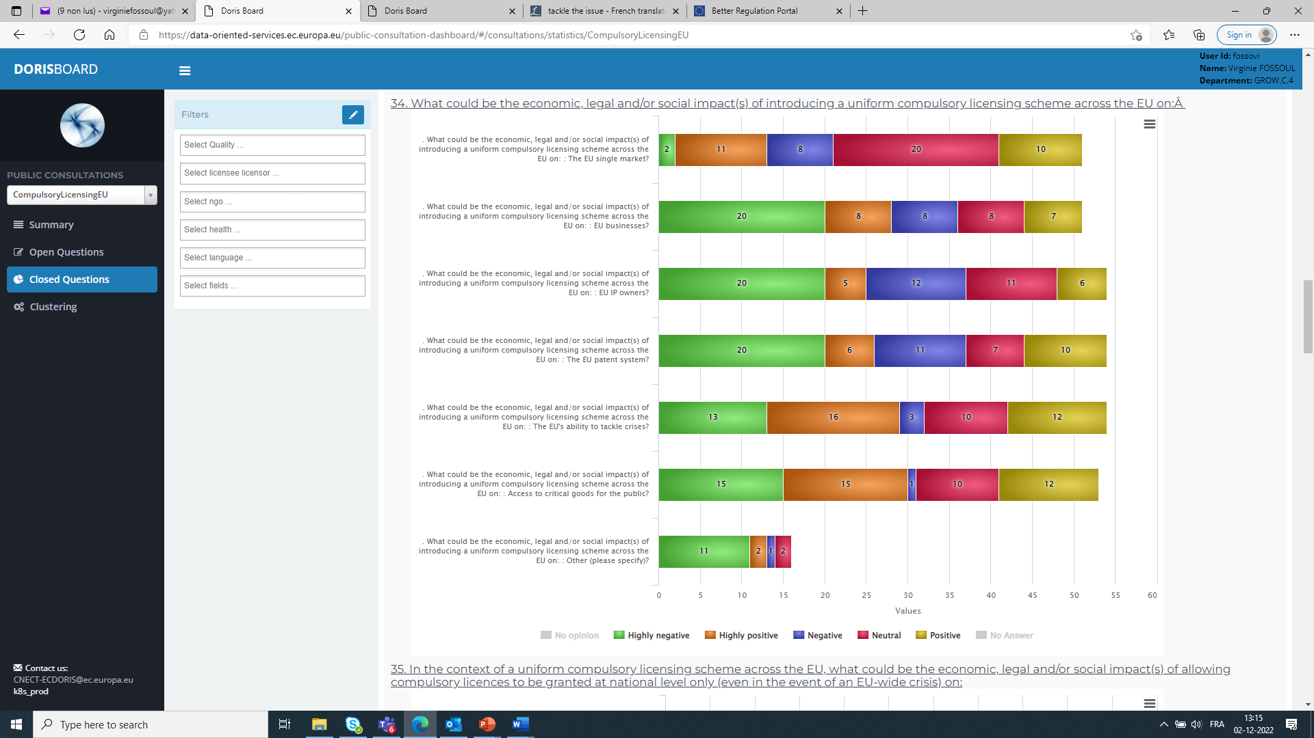

Stakeholders favour the **option of allowing a compulsory licence to be granted at EU level in the event of an EU-wide crisis** compared to nationally granted compulsory licences for EU-wide crises. In that respect, the responses to the Public Consultation show that the option of granting a compulsory licence at EU level is generally deemed more positive by stakeholders as regards the EU’s ability to tackle crises (35%, N=26) and for providing access to critical goods (34%, N=25) than the granting of a compulsory licence at national level (respectively, 11%, N=8 and 12%, N=9). There is again a stark contrast between stakeholders. All NGOs consider that the granting of a compulsory licence at EU level for EU-wide crises would have a positive effect on the ability to tackle crises and the access to critical goods. However, a majority (around 50%) of companies and business associations consider that the impact would be negative. A larger majority of companies and business associations considers that such option would have a negative effect on EU businesses (87%) and IP owners (90%).

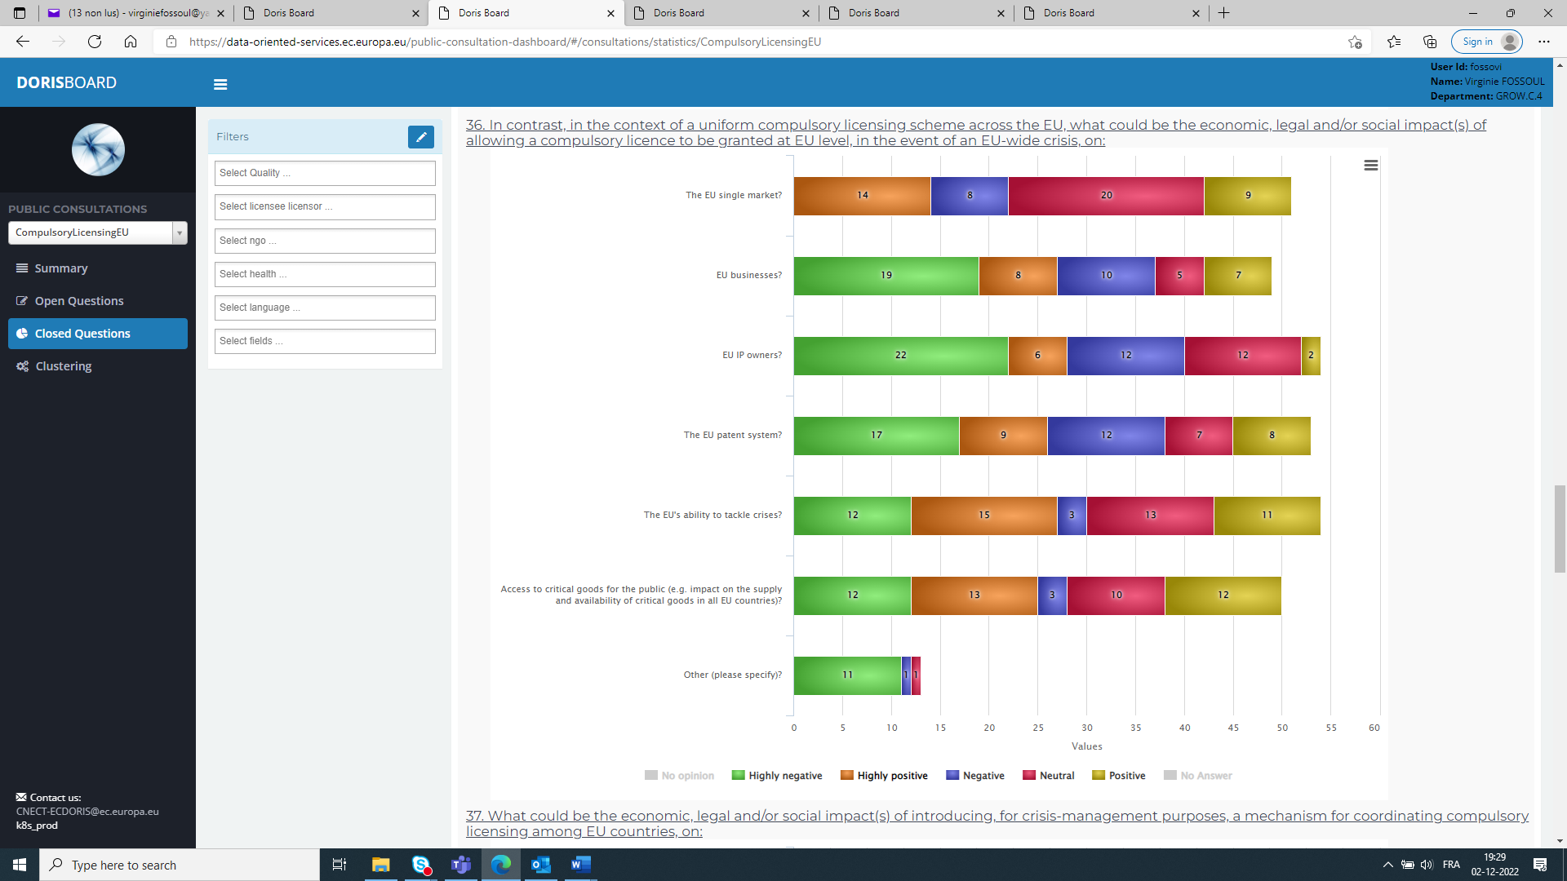

As regards the impact of **introducing a mechanism for coordinating compulsory licensing among EU countries,** it is seen positive for the EU Single Market by 35% of the respondents (N=26). For the impact on EU businesses (28%, N=21), EU IP owners (25%, N=26) and the EU patent system (35%, N=26), negative responses predominate, especially by companies, business organisations and business associations, whereas, again, respondents are more positive about the impact on the EU’s ability to tackle crises (35%, N=26) and the impact on the access to critical goods for the public (28%, N=21). This is the case, above all, for NGOs. Moreover, the impact of introducing a mechanism for coordinating compulsory licensing among EU countries on the public authorities’ decision-making processes is viewed positively by the majority of the respondents (29%, N=22).

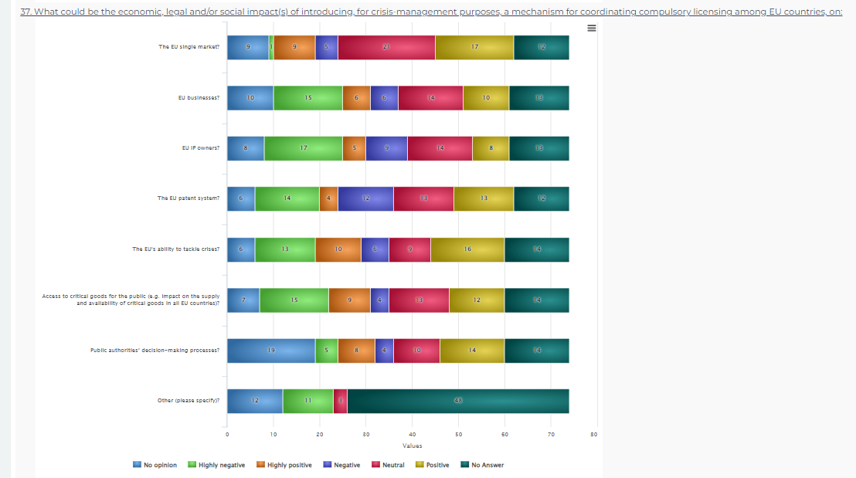

The questions on the impact of creating an EU single contact point and coordination mechanism between Member States and of an EU-level centralised procedure to grant compulsory licences on export of pharmaceutical products to non-EU countries received only few evaluable answers. Most of the respondents either had no opinion, answered in a neutral way, or did not submit any answer. However, of the responses on the impact of **creating an EU single contact point and coordination mechanism between Member States** for compulsory licences for export of pharmaceutical products to non-EU countries, positive answers on the impact on the EU Single Market predominate (19%, N=14 vs negative answers: 3%, N=4), even by companies, business organisations and business associations. As to the impact on EU businesses and EU IP owners, companies, business organisations and business associations see it rather negative (53%, N=21 and 55%, N=22), whereas NGOs have a rather positive view. The majority of the respondents also saw the creation of an EU single contact point and coordination mechanism between Member States for compulsory licences for export of pharmaceutical products to non-EU countries more positively as regards the impact on the EU patent system (18%, N=13), the EU’s ability to tackle crises (18%, N=13), access to critical pharmaceutical products for non-EU countries (19%, N=15) and on the public authorities’ decision-making process (19%, N=15).

Of the answers received on the impact of an **EU-level centralised procedure to grant compulsory licensing on export of pharmaceutical products to non-EU countries**, negative answers predominate on the questions about the impact on EU businesses and EU IP owners, mostly stemming from companies, business organisations and business associations, whereas more positive answers were received on the impact on the EU patent system, on EU’s ability to tackle crises, access to critical pharmaceutical products for non-EU countries and on the public authorities’ decision-making process.

How the results of consultation activities were used?

The results of the various consultations presented above underpin the whole evaluation of the currently fragmented framework of national compulsory licensing systems of patents for domestic purposes as well as of the efficiency of the EU procedure on compulsory licensing of patents for export to countries with public health problems (Regulation (EC) No 816/2006). They were used to judge the effectiveness and efficiency of compulsory licensing in the EU to tackle cross-border crises and helped in formulating policy options for the future.

Annex 3: Who is affected and how?

1. Practical implications of the initiative

The new instrument is intended to make the issuing of CLs in crisis situations more coherent and streamlined, especially in terms of timing. This would reduce the multiplicity of authorities involved in such procedures and therefore increase legal certainty that is crucial for patent holders/companies that may be concerned by a CL. The proposed changes will also improve the transparency of the process, which is especially important for stakeholders. The key stakeholders that may be affected by the new provisions are the current patent holders, followed by any company that may take the role of a future manufacturer (licensee). As far as patent holders are concerned, the majority of such companies are large enterprises - a breakdown of patent applications originating from European countries shows that 75% of them were filed by large companies, 20% by individual inventors and SMEs, and 5% by universities and public research organisations.

Figure 11: Patent applications originating from European countries by applicant type [%]

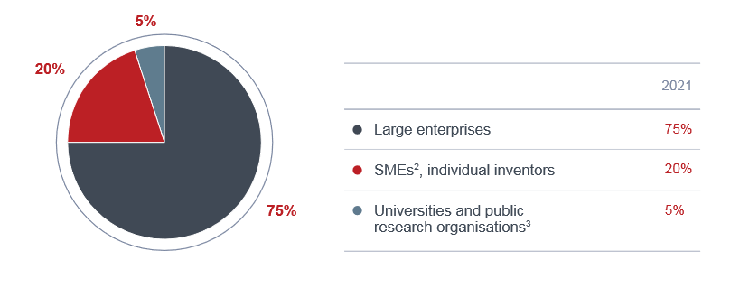

Source: Patent Index 2021 – At a glance, EPO, status: 1.2.2022

1. Summary of costs and benefits

|  |  |  |
| --- | --- | --- |
| **I. Overview of Benefits (total for all provisions) – Preferred Option** | | |
| ***Description*** | ***Amount*** | ***Comments*** |
| ***Direct benefits*** | | |
| Savings for patent holders and manufacturers (potential licensees) | 75%-80% less resources than in the baseline, in the event of a cross border crisis. | The compulsory licensing negotiations would take place only once at the EU-level instead of fragmented and overlapping processes in several EU countries (or instead of ca. 4-5 procedures in each jurisdiction that could be needed otherwise).  **Main recipients**: firms involved in compulsory licensing granting process. |
| Savings for MS administrations. | Impossible to estimate precisely | The cost of running compulsory licensing negotiations are expected to decrease[151], as resources would be shared at EU-level  **Main recipients**: MS administrations |
| Access to critical goods in times of crisis. | Impossible to estimate precisely | Availability of products that otherwise would not be accessible, which also prevent other costs from occurring.  **Main recipients:** EU citizens or firms in need of the critical goods. |
| ***Indirect benefits*** | | |
| Better overall EU-level response to crisis due to availability of critical goods. | Impossible to estimate precisely | Wide socio-economic benefits due to limited scale of a crisis  **Main recipients:** EU citizens / the entire society. |
| ***Administrative cost savings related to the ‘one in, one out’ approach\**** | | |
| n.a. | n.a. | n.a. |

|  |  |  |  |  |  |  |  |
| --- | --- | --- | --- | --- | --- | --- | --- |
| **II. Overview of costs – Preferred option** | | | | | | | |
|  | | **Citizens/Consumers** | | **Businesses** | | **Administrations**  **(EU countries)** | |
| **One-off** | **Recurrent** | **One-off** | **Recurrent**[152] | **One-off** | **Recurrent** |
| Create EU-level compulsory licensing for crisis management | Direct adjustment costs | 0. | 0 | 0 | 0 | Cost of implementing the legislation | 0 |
| Direct administrative costs | 0 | 0 | 0 | 0 | 0 | 0 |
| Direct regulatory fees and charges | 0 | 0 | 0 | 0 | 0 | 0 |
| Direct enforcement costs | 0 | 0 | 0 | Costs of compulsory licensing negotiations (but lower than in *status quo* as a single procedure at EU level would replace multiple procedures in each EU country concerned) | 0 | Cost of compulsory licensing negotiations and EU countries involvement in the committee for the adoption of the activation measure[153]. |
| Indirect costs | 0 | 0 | 0 | 0 | 0 | 0 |
| ***Costs related to the ‘one in, one out’ approach*** | | | | | | | |
| **Total** | Direct adjustment costs | 0 | 0 | 0 | 0 |  |  |
| Indirect adjustment costs | 0 | 0 | 0 | 0 |  |  |
| Administrative costs (for offsetting) | 0 | 0 | 0 | 0 |  |  |

1. Relevant sustainable development goals

|  |  |  |
| --- | --- | --- |
| **III. Overview of relevant Sustainable Development Goals – Preferred Option(PO4)** | | |
| **Relevant SDG** | **Expected progress towards the Goal** | **Comments** |
| More effective response to a major cross-border crisis affecting the EU can be potentially related to: | | |
| Goal 3: Good health and well-being | * facilitate access to critical products that may be necessary to prevent epidemics, reduce mortality, ensure access to healthcare. | If the crisis concerns health-related aspects. |
| Goal 6: Ensure availability and sustainable management of water and sanitation for all  Goal 13: Take urgent action to combat climate change and its impacts | * depending on the exact type of crisis, for example: ensure access to clean water, reduce pollution, minimize the release of hazardous chemicals, etc. * strengthen resilience and adaptive capacity to climate-related hazards and natural disasters, | If the crisis concerns environmental aspects. |
| Goal 7: Ensure access to affordable, reliable, sustainable and modern energy for all | * depending on the exact type of crisis, for example: ensure access to energy, improve energy efficiency, upgrade technology for supplying modern and sustainable energy | If the crisis concerns energy networks and energy supply. |
| Goal 8: Promote sustained, inclusive and sustainable economic growth, full and productive employment and decent work for all | * help sustain per capita economic growth in accordance with national circumstances (despite the crisis); * help restore full and productive employment. | If the crisis affects productive activities, jobs or entrepreneurship. |
| Goal 9: Build resilient infrastructure, promote inclusive and sustainable industrialization and foster innovation | * help restore quality, reliable, sustainable and resilient infrastructure, including regional and trans-border infrastructure, to support economic development and human well-being; * help restore the technological capabilities of industrial sectors. | If the crisis concerns industrial, regional or trans-border infrastructure, or technologies and industrial processes. |
| Goal 11: Make cities and human settlements inclusive, safe, resilient and sustainable | * depending on the exact type of crisis, for example: provide access to safe, affordable, accessible and sustainable transport systems, reduce the number of people affected and substantially decrease the direct economic losses relative to global gross domestic product caused by disasters, including water-related disasters; | If the crisis concerns urban infrastructure or other human settlements. |

Figure 12: Relevance to UN Sustainable Development Goals – example of European Patents active in Germany

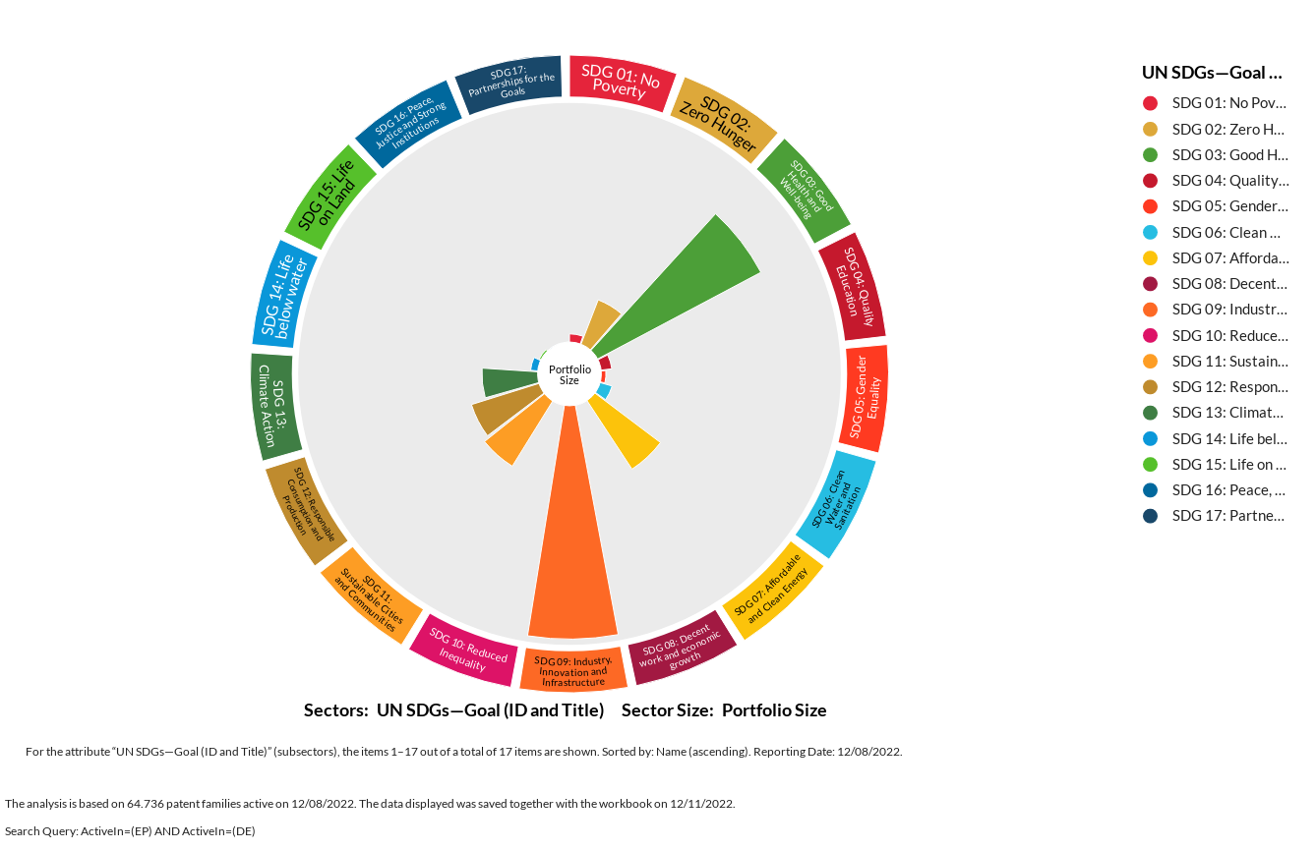

Source: PatentSight®, search executed on 11/12/2022.

Annex 4: Analytical methods

The analysis contained in this impact assessment predominantly builds on input from stakeholder collected via the open public consultation, a dedicated study “*Compulsory licensing of intellectual property rights*” (see Annex 1, point 4) and data collected from desk research (e.g. academic studies, existing impact assessment reports such as SMEI proposals, etc.). Whenever possible, a quantitative information is provided and analysed. For example, a small in-house analysis concerning the geographical coverage of European patents was carried out and then used in the problem definition – the methodology applied for this task is discussed below.

Nonetheless, as compulsory licensing is the “last resort instrument” it is used only in exceptional circumstances therefore the available data on the subject is extremely scarce. In view of the absence of granular data on the subject, this assessment discusses the plausible magnitude of potential impacts of each policy option, rather than its exact quantification in monetary terms. As a consequence, the cost/benefit analysis is not developed to the level that otherwise is expected in an impact assessment. As a fall-back strategy, the main evidence base of the report comes from the consultations with stakeholders (see Annex 2).

Geographical coverage

The objective of this task was to identify the average number of Member States in which patents needed in a crisis situation are active. In order to build such hypothetical case, the recent COVID pandemics was used as a proxy for a possible crisis. A list of patents that could be needed in such situation was established based on PatentScope COVID-19 INDEX[154] where the following areas were identified as pertinent to a global health crisis caused by coronavirus:

* Artificial respiration,
* Diagnostics,
* Disinfection,
* Informatics,
* Medical Equipment,
* Medical Facilities and Transport,
* Medical Treatment,
* Medical treatment/Prophylactic,
* Medical treatment/Therapeutic,
* Personal protective equipment.

The PatentScope COVID-19 INDEX defines the exact scope of relevant patents by using International patent classification (ICP)[155] codes listed in Table 13, below.

Table 13: List of IPC codes used in PatentScope COVID-19 Index

|  |  |
| --- | --- |
| A61H 31/00 | Artificial respiration or heart stimulation, e.g. heart massage |
| A61M 16/00 | Devices for influencing the respiratory system of patients by gas treatment, e.g. mouth-to-mouth respiration; Tracheal tubes |
| A61B | DIAGNOSIS; SURGERY; IDENTIFICATION |
| A61B 1/00 ->A61B 16/00 | Instruments for performing medical examinations of the interior of cavities or tubes of the body by visual or photographical inspection, e.g. endoscopes; Illuminating arrangements therefor |
| A61B 5/00 | Measuring for diagnostic purposes; Identification of persons |
| A61B 5/01 | Measuring for diagnostic purposes; Identification of persons + Measuring temperature of body parts |
| A61B 5/08 | Measuring for diagnostic purposes; Identification of persons + Measuring devices for evaluating the respiratory organs |
| A61B 6/00 | Apparatus for radiation diagnosis, e.g. combined with radiation therapy equipment |
| C12Q | MEASURING OR TESTING PROCESSES INVOLVING ENZYMES, NUCLEIC ACIDS OR MICROORGANISMS; COMPOSITIONS OR TEST PAPERS THEREFOR; PROCESSES OF PREPARING SUCH COMPOSITIONS; CONDITION-RESPONSIVE CONTROL IN MICROBIOLOGICAL OR ENZYMOLOGICAL PROCESSES |
| C12Q 1/00 | Measuring or testing processes involving enzymes, nucleic acids or microorganisms; Compositions therefor; Processes of preparing such compositions |
| C12Q 1/68 | Measuring or testing processes involving enzymes, nucleic acids or microorganisms; Compositions therefor; Processes of preparing such compositions + involving nucleic acids |
| C12Q 1/70 | Measuring or testing processes involving enzymes, nucleic acids or microorganisms; Compositions therefor; Processes of preparing such compositions + involving virus or bacteriophage |
| G01N | INVESTIGATING OR ANALYSING MATERIALS BY DETERMINING THEIR CHEMICAL OR PHYSICAL PROPERTIES |
| G01N 33/48 | Investigating or analysing materials by specific methods not covered by groups G01N1/-G01N31/131 + Biological material, e.g. blood, urine; Haemocytometers |
| G01N 33/569 | Investigating or analysing materials by specific methods not covered by groups G01N1/-G01N31/131 + Biological material, e.g. blood, urine; Haemocytometers + Chemical analysis of biological material, e.g. blood, urine; Testing involving biospecific ligand binding methods; Immunological testing + Immunoassay; Biospecific binding assay; Materials therefore + for microorganisms, e.g. protozoa, bacteria, viruses |
| A61L 2/00 | Methods or apparatus for disinfecting or sterilising materials or objects other than foodstuffs or contact lenses; Accessories therefor |
| A61L 9/00 | Disinfection, sterilisation or deodorisation of air |
| F24F 3/16 | Air-conditioning systems in which conditioned primary air is supplied from one or more central stations to distributing units in the rooms or spaces where it may receive secondary treatment; Apparatus specially designed for such systems + characterised by the treatment of the air otherwise than by heating and cooling + by purification, e.g. by filtering; by sterilisation; by ozonisation |
| G16B | BIOINFORMATICS, i.e. INFORMATION AND COMMUNICATION TECHNOLOGY SPECIALLY ADAPTED FOR GENETIC OR PROTEIN-RELATED DATA PROCESSING IN COMPUTATIONAL MOLECULAR BIOLOGY |
| G16C | COMPUTATIONAL CHEMISTRY; CHEMOINFORMATICS; COMPUTATIONAL MATERIALS SCIENCE |
| G16H | HEALTHCARE INFORMATICS, i.e. INFORMATION AND COMMUNICATION TECHNOLOGY SPECIALLY ADAPTED FOR THE HANDLING OR PROCESSING OF MEDICAL OR HEALTHCARE DATA |
| A61B 50/00 | Containers, covers, furniture or holders specially adapted for surgical or diagnostic appliances or instruments, e.g. sterile covers |
| A61B 50/39 | Containers, covers, furniture or holders specially adapted for surgical or diagnostic appliances or instruments, e.g. sterile covers + Containers specially adapted for packaging, protecting, dispensing, collecting or disposing of surgical or diagnostic appliances or instruments + for collecting or disposing of used articles + the containers containing antimicrobial, antiviral or disinfectant agents |
| A61M | DEVICES FOR INTRODUCING MEDIA INTO, OR ONTO, THE BODY; DEVICES FOR TRANSDUCING BODY MEDIA OR FOR TAKING MEDIA FROM THE BODY; DEVICES FOR PRODUCING OR ENDING SLEEP OR STUPOR |
| A61M 1/00 | Suction or pumping devices for medical purposes; Devices for carrying-off, for treatment of, or for carrying-over, body-liquids; Drainage systems |
| B25J | MANIPULATORS; CHAMBERS PROVIDED WITH MANIPULATION DEVICES |
| B25J 9/00 | Programme-controlled manipulators |
| C12M | APPARATUS FOR ENZYMOLOGY OR MICROBIOLOGY |
| C12M 3/00 | Tissue, human, animal or plant cell, or virus culture apparatus |
| A61G | TRANSPORT, PERSONAL CONVEYANCES, OR ACCOMMODATION SPECIALLY ADAPTED FOR PATIENTS OR DISABLED PERSONS; OPERATING TABLES OR CHAIRS; CHAIRS FOR DENTISTRY; FUNERAL DEVICES |
| A61G 3/00 | Ambulance aspects of vehicles; Vehicles with special provisions for transporting patients or disabled persons, or their personal conveyances, e.g. for facilitating access of, or for loading, wheelchairs |
| A61G 10/00 | Treatment rooms for medical purposes |
| A61G 12/00 | Accommodation for nursing, e.g. in hospitals, not covered by groups A61G1/-A61G11/120; Prescription lists |
| A61K | PREPARATIONS FOR MEDICAL, DENTAL, OR TOILET PURPOSES |
| A61K 35/00 | Medicinal preparations containing materials or reaction products thereof with undetermined constitution |
| A61K 45/00 | Medicinal preparations containing active ingredients not provided for in groups A61K31/-A61K41/132 |
| C07K | PEPTIDES |
| A61K 35/76 | Medicinal preparations containing materials or reaction products thereof with undetermined constitution + Microorganisms or materials therefrom + Viruses; Subviral particles; Bacteriophages |
| A61K 38/00 | Medicinal preparations containing peptides |
| A61K 39/00 | Medicinal preparations containing antigens or antibodies |
| A61K 39/12 | Medicinal preparations containing antigens or antibodies + Viral antigens |
| A61K 39/215 | Medicinal preparations containing antigens or antibodies + Viral antigens + Coronaviridae, e.g. avian infectious bronchitis virus |
| C07K 14/165 | Peptides having more than 20 amino acids; Gastrins; Somatostatins; Melanotropins; Derivatives thereof + from viruses + RNA viruses + Coronaviridae, e.g. avian infectious bronchitis virus |
| C12N | MICROORGANISMS OR ENZYMES; COMPOSITIONS THEREOF; PROPAGATING, PRESERVING, OR MAINTAINING MICROORGANISMS; MUTATION OR GENETIC ENGINEERING; CULTURE MEDIA |
| C12N 7/00 | Viruses, e.g. bacteriophages; Compositions thereof; Preparation or purification thereof |
| C12N 15/00 | Mutation or genetic engineering; DNA or RNA concerning genetic engineering, vectors, e.g. plasmids, or their isolation, preparation or purification; Use of hosts therefor |
| C12N 15/50 | Mutation or genetic engineering; DNA or RNA concerning genetic engineering, vectors, e.g. plasmids, or their isolation, preparation or purification; Use of hosts therefor + Recombinant DNA-technology + DNA or RNA fragments; Modified forms thereof + Genes encoding microbial proteins, e.g. enterotoxins + Genes encoding viral proteins + Proteins from RNA viruses, e.g. flaviviruses + Coronaviridae, e.g. infectious bronchitis virus, transmissible gastroenteritis virus |
| A61K 31/00 | Medicinal preparations containing organic active ingredients |
| A61K 33/00 | Medicinal preparations containing inorganic active ingredients |
| A61K 36/00 | Medicinal preparations of undetermined constitution containing material from algae, lichens, fungi or plants, or derivatives thereof, e.g. traditional herbal medicines |
| A61K 39/395 | Medicinal preparations containing antigens or antibodies + Antibodies; Immunoglobulins; Immune serum, e.g. antilymphocytic serum |
| A61K 39/42 | Medicinal preparations containing antigens or antibodies + Antibodies; Immunoglobulins; Immune serum, e.g. antilymphocytic serum + viral |
| A61K 39/44 | Medicinal preparations containing antigens or antibodies + Antibodies; Immunoglobulins; Immune serum, e.g. antilymphocytic serum + Antibodies bound to carriers |
| C07 | ORGANIC CHEMISTRY |
| C07D | HETEROCYCLIC COMPOUNDS |
| C07H | SUGARS; DERIVATIVES THEREOF; NUCLEOSIDES; NUCLEOTIDES; NUCLEIC ACIDS |
| C07H 21/00 | Compounds containing two or more mononucleotide units having separate phosphate or polyphosphate groups linked by saccharide radicals of nucleoside groups, e.g. nucleic acids |
| C07K 16/10 | Immunoglobulins, e.g. monoclonal or polyclonal antibodies + against material from viruses + from RNA viruses |
| C12P | FERMENTATION OR ENZYME-USING PROCESSES TO SYNTHESISE A DESIRED CHEMICAL COMPOUND OR COMPOSITION OR TO SEPARATE OPTICAL ISOMERS FROM A RACEMIC MIXTURE |
| C12P 19/34 | Preparation of compounds containing saccharide radicals + Preparation of nitrogen-containing carbohydrates + N-glycosides + Nucleotides + Polynucleotides, e.g. nucleic acids, oligoribonucleotides |
| A41D 13/11 | Professional, industrial or sporting protective garments, e.g. surgeons' gowns or garments protecting against blows or punches + protecting only a particular body part + Protective face masks, e.g. for surgical use, or for use in foul atmospheres |
| A41D 13/12 | Professional, industrial or sporting protective garments, e.g. surgeons' gowns or garments protecting against blows or punches + Surgeons' or patients' gowns or dresses |
| A61B 42/00 | Surgical gloves; Finger-stalls specially adapted for surgery; Devices for handling or treatment thereof |
| A61F 9/04 | Methods or devices for treatment of the eyes; Devices for putting in contact-lenses; Devices to correct squinting; Apparatus to guide the blind; Protective devices for the eyes, carried on the body or in the hand + Eye-masks |
| A62B 7/00 ->A62B 33/00 | Respiratory apparatus |
| A62B 18/02 | Breathing masks or helmets, e.g. affording protection against chemical agents or for use at high altitudes+ Masks |
| A62B 23/00 | Filters for breathing-protection purposes |
| A62B 23/02 | Filters for breathing-protection purposes + for respirators |
| A62D 5/00 | Composition of materials for coverings or clothing affording protection against harmful chemical agents |
| A62D 7/00 | Composition of materials for transparent parts of gas-masks, respirators, breathing bags, or helmets |
| A62D 9/00 | Composition of chemical substances for use in breathing apparatus |

The IPC creates a hierarchical system for the classification of patents (and utility models) according to the different technical fields to which they belong. The classification system contains about 70 000 entries, i.e. classification symbols or codes that can be allotted to patent documents. Symbols are arranged in a hierarchical, tree-like structure:

* at the highest level are the eight **sections** corresponding to very broad technical fields (e.g., Section C deals with chemistry and metallurgy);
* sections are further subdivided into **classes** (e.g., Class C21 deals with the metallurgy of iron);
* classes are divided into more than 600 **subclasses** (e.g., Subclass A21B contains bakers' ovens and machines or equipment for baking).[156]
* subclass is divided into **groups** (e.g., “A23F 3: Tea; Tea substitutes […]”). Groups are either main groups (e.g., “A23F 3/00: Tea; Tea substitutes […] (Not otherwise classified)”) or **subgroups** (e.g., “A23F 3/16: Tea extraction […]”). The symbols of the main groups end with “/00”.

At this point it is important to note that the list of IPC codes selected for the PatentScope COVID-19 INDEX contains many subclasses (e.g. C07D HETEROCYCLIC COMPOUNDS), as well as even a class (i.e. C07 ORGANIC CHEMISTRY). Yet, such high level definitions seemed too broad for the intended analysis[157], as they may contain a significant share of patents that were only indirectly related to fighting the pandemics. As a consequence, these high level codes were not taken into account in the analysis (marked with caps lock in Table 13). Nonetheless, all the remaining codes from the Table, with the level of granularity of groups or subgroups, were used as a basis in the search of active patents and later used to come up with the final estimate.

Once the crisis-related patents were identified according to PatentScope list of IPC, PatentSight®[158] database was used to extract the information on the number and geographical coverage of such patents within the EU. The query resulted in 216 381 patent families in which at least one member was currently active[159] in EU-27 Member States. The dataset reporting date (i.e. last server update) was 12/08/2022. The variables extracted were the following: Patent Family, Active Authorities Today, IPC Subclasses (Symbol)[160].

First, the observations were identified by their granting patent office – the basic tabulation for the main dataset is provided below (Table 14), showing that the European Patents accounted for 87.5% of all patents in the dataset.

Table 14: Origin of patents in the retained dataset – frequency and percentage by patent office.

|  |  |  |
| --- | --- | --- |
| **Patent office** | **Freq.** | **Percent** |
| EP | 189 316 | 87.49 |
| National patent offices of EU-27 | 15 678 | 7.25 |
| US | 8 235 | 3.81 |
| WO | 2 396 | 1.11 |
| Other | 756 | 0.35 |
| **Total** | **216 381** | **100** |

Second, information contained in the Active Authorities variable was processed in order to remove all other jurisdictions were the members of each patent family were active, except for EU-27 countries. This step makes this exercise different from the usual approach to counting the patent family size[161] as defined in the literature, because it will capture only the “EU subset” of a patent family (i.e. the patent family size would normally include a validation in for example the US, whereas here information on non-EU validations is ignored).

Annex 5: Legal background and the key legal provisions

5A. The international legal context

The Paris Convention[162] of 1883 already enabled countries to take legislative measures providing for the grant of compulsory licences to prevent abuses resulting from the exercise of patent exclusive rights[163]. This explains why, at the time the TRIPS Agreement was negotiated, most countries in the world already had in place compulsory licensing schemes. The TRIPS Agreement leaves untouched the principles on compulsory licensing laid down in the Paris Convention. However, it provides several conditions for the granting of compulsory licences.

As indicated in the introduction, a compulsory licence[164] refers to the possibility for a government to allow a third party to use a patent without the authorisation of the right holder, subject to certain conditions aiming at preserving the legitimate interests of the patent holders. The TRIPS Agreement sets the international legal obligations as regards compulsory licensing. It provides two types of compulsory licensing schemes: (i) compulsory licensing for the domestic market (Article 31), which applies to all types of products and (ii) compulsory licensing for the export, which only applies to pharmaceutical products (article 31bis).

Article 31 allows the granting of a compulsory licence, for any type of product. In this context, the compulsory licence must be predominantly for the supply of the **domestic market** of the WTO Member authorising the use. This condition limits in practice the export of goods made under a compulsory licence.

The TRIPS Agreement **does not list the grounds on which a compulsory licence can be granted**. The WTO members retain their margin of manoeuvre in this respect, as explicitly confirmed by the Doha Declaration[165]. Nor does the TRIPS Agreement limit the purposes of a compulsory licence, which can be to import or locally manufacture products. In contrast, the TRIPS agreement provides several **conditions** under which a compulsory licence can be authorised (see Annex 5). These conditions constitute the frame for any TRIPS-compliant compulsory licensing scheme for the domestic market.

Among other conditions, Article 31 of the TRIPS Agreement does not allow compulsory licensing to supply foreign markets (or at least not predominantly). This condition was the result of negotiations on the TRIPS Agreement but it left a gap in the compulsory licensing system whereby countries with no or limited manufacturing capacity were not able to make us of this system. The link between the TRIPS Agreement and public health was clarified in 2001 Doha Declaration (Annex 5) which also mandated further work on the issue of the members with no or limited manufacturing capacity. This resulted in implementation of the so-called Paragraph 6 system which in turn led to the adoption of Article 31bis of the TRIPS Agreement.

Under Article 31bis of the TRIPS Agreement, a country can grant a compulsory licence to the extent necessary for the **purposes of production and the export of a pharmaceutical product**. It establishes a specific mechanism of mainly procedural requirements (e.g. transparency, packaging) that would allow to address the circumstances of two sides – the exporting country and the importing country. Depending on where the product is protected by a patent, either only the exporting or both the exporting and the importing country may need to issue relevant compulsory licences. The European Union implemented this new disposition in its legal order through the adoption of regulation (EC) No 816/2006[166]. The EU may only act as an exporter to the countries with no or limited manufacturing capacity.

5B. The EU legal context and practice

There is no EU harmonisation as regards compulsory licensing for the domestic market, including as regards European patents with a unitary effect[167]. EU countries have all implemented compulsory licensing schemes but for different grounds and following different procedures, in accordance with the flexibilities left at international level.

In contrast, compulsory licensing for export purposes of pharmaceutical products is regulated by Regulation (EC) No 816/2006. In the context of Regulation (EC) No 816/2006, EU countries remain the main points of contacts for granting the compulsory licence, checking whether the conditions are respected and when it is terminated. The role of the Commission remains limited to the case where the export of the product under a compulsory licence would be directed to an importing country which is not a WTO member. In such case, the importing country must make a notification to the Commission instead of the WTO.

The mechanism under Article 31bis of the TRIPS Agreement was only used once, in the Canada-Rwanda case (see Annex 5d). In 2021 Bolivia and Antigua and Barbuda notified the WTO of their intention to use Article 31bis of the TRIPS Agreement for the production of COVID-19 vaccines, but this has not resulted in a compulsory licence under the system. For the system to function, a manufacturer of these products must be identified and the exporting country where that manufacturer is located must be ready to issue a compulsory licence for that purpose. Regulation (EC) No 816/2006 was never used nor evaluated[168].

Two other EU legislations provide for a compulsory licensing scheme. First, the Regulation on Community plant variety rights[169] provides for the possibility for the Plant Variety Office to grant a compulsory licence on a community plant variety right, on application by a Member State, by the Commission or by an organisation set up EU level[170]. Second, the Biotech Directive[171] provides for the possibility, where a plant breeder cannot use a plant variety without infringing a patent, to apply for a compulsory licence.

As discussed in section1.3, compulsory licensing is often presented as a ‘last resort mechanism’[172]. In the vast majority of cases, voluntary agreements are the most efficient solution to ensure the manufacturing and supply of critical products. Voluntary cooperation ensures not only the licensing of necessary IP, but is likely to provide the crucial tools needed to manufacture the product, including know-how, technical expertise, qualified personnel for training and even access to raw materials. For instance, in the context of the COVID-19 crisis, hundreds of voluntary agreements were concluded to ensure the scaling up of the COVID-19 related products across the globe. There were several tries to increase the production of certain products through compulsory licences, e.g. in Israel, Hungary and Russia, but it does not appear that they have brought major results in terms of access to these products. Likewise, to this date, no compulsory licence was granted to produce COVID-19 vaccines based on the WTO Decision on the TRIPS Agreement.

5C. Compulsory licensing and the TRIPS waiver

On 2 October 2020, several WTO members submitted a proposal for a decision by the WTO General Council that would waive WTO members’ obligation to protect and enforce some IP rights in relation to the prevention, containment or treatment of COVID-19. The assumption was that IP rights were an impediment to a swift scaling-up of manufacturing capacities and that access to vaccines in developing countries could not be found by operating within the IP system. The proposal was then made to waive IP rights. The EU submitted an alternative proposal on 18 June 2021, insisting on the need to make full use of the flexibilities of the TRIPS Agreement, especially as regards compulsory licensing.

Waiving IP rights differs from compulsory licensing. A compulsory licence is an authorisation granted by a government to a party other than the patent holder to use a patented invention without the consent of the patent holder. The TRIPS Agreement explicitly allows compulsory licensing, provided that some conditions, such as a limited duration and the payment of an adequate remuneration, are met. The TRIPS Agreement does not provide for a mechanism to waive IP rights. Waiving IP rights consists of depriving the patent owner of its rights, including of the possibility to ask for a remuneration.

This explains why the EU, among other WTO members, were not in favour of waiving IP rights. The EU considered that the TRIPS Agreement already provides for a solution, namely compulsory licensing. Compulsory licensing is a legitimate tool to scale up the production of critical goods. For compulsory licensing to be an efficient tool, it is however necessary to ensure proper implementation at national level, taking full advantage of the flexibilities of the TRIPS Agreement.

Discussions at WTO level pursued and led to a consensus during the 12th Ministerial Conference of June 2022. The agreement mainly provides clarifications of existing flexibilities (i.e. the calculation of the remuneration can take into account the humanitarian and not-for-profit purpose of vaccine distribution programme, there is no need to make efforts to obtain the authorisation from the right holder in case of an emergency, and a compulsory licence can be based on any instrument available in the law). In addition, the agreement waived the “predominantly for the domestic market” condition, meaning that products manufactured under a compulsory licence can more easily be exported to other countries.

This agreement, valid for 5 years, is applicable to developing countries and limited to COVID-19 vaccines, with the possibility of an extension to cover the production and supply of COVID-19 diagnostics and therapeutics. Discussions are still ongoing as regards the extension of the agreement.

5D. Conditions under which a compulsory licence can be granted under Article 31 of the TRIPS Agreement

Article 31 of the TRIPS agreement provides several **conditions** under which a compulsory licence can be authorised which can be summarised as follows:

* The compulsory licence shall be considered on *its individual merits*. This condition aims at preventing blanket authorisations not taking into account the circumstances of each authorisation.
* Prior to the compulsory licence, the user shall made *efforts to obtain authorisation from the right holder on reasonable terms and conditions*. This requirement may be waived in the case of a national emergency or other circumstances of extreme urgency[173] or in cases of public non-commercial use.
* The scope and duration of the compulsory licence shall be limited to the purpose for which it was authorised.
* The compulsory licence shall be *non-exclusive and non-assignable*.
* The compulsory licence shall be authorised predominantly for the supply of the *domestic market*.
* The compulsory licence shall be terminated if and when the *circumstances which led to it cease to exist* and are unlikely to recur. This condition is subject to the legitimate interests of the licensee.
* The right holder shall be paid *adequate remuneration*.
* The legal validity of any decision relating to the authorisation of a compulsory licence and any decision relating to the remuneration shall be subject to *judicial review*.

5E. Article 31bis of the TRIPS Agreement and its implementation in EU law

Article 31 of the TRIPS Agreement does not allow compulsory licensing to supply foreign markets (or at least not predominantly). At the height of the AIDS epidemic this quickly proved controversial. Once bound by the TRIPS Agreement, countries with manufacturing capacities could no longer export goods manufactured under a compulsory licensing to foreign markets. Some countries, facing grave public health problems, consider that the system implemented by the TRIPS Agreement severely affected their access to medicines[174]. This led in 2001 to the Doha Declaration which in turn led to the adoption of Article 31bis of the TRIPS Agreement.

The Doha Declaration first recognised the “gravity of the public health problems affecting many developing and least-developed countries, especially those resulting from HIV/ AIDS, tuberculosis, malaria and other epidemics.” With that background, the Doha Declaration reaffirmed the right of WTO members to ‘use, to the full, the provisions in the TRIPS Agreement, which provide flexibility for this purpose’. These flexibilities include:

* the right for each Member to grant compulsory licences, to freely determine the grounds for such licences, and to freely establish its own exhaustion regime;
* the right for each Member to determine what constitutes a national emergency or other circumstances of extreme urgency.

Importantly, paragraph 6 of the Doha Declaration stated that “WTO Members with insufficient or no manufacturing capacities in the pharmaceutical sector could face difficulties in making effective use of compulsory licensing under the TRIPS Agreement. We instruct the Council for TRIPS to find an expeditious solution to this problem”.

Based on that, the WTO Decision of 30 August 2003 was adopted. It introduced Article 31bis into the TRIPS Agreement, whose main feature can be summarised as follows:

* This mechanism only concerns *pharmaceutical products* which are defined in the 2003 Decision as any patented product, or product manufactured through a patented process, of the pharmaceutical sector needed to address the public health problems[175].
* Export is only possible to *eligible importing Members*. The 2003 Decision specifies that eligible importing Members include any least-developed country Member and any other Member that has made a notification to the Council for TRIPS of its intention to use the system as an importer[176]. EU countries have opted out of using the system as importers.
* The *importing country must make a notification* to the Council of TRIPS on (i) the names and expected quantities of the expected products, (ii) its insufficient or lack of manufacturing capacities[177] and (iii) its intention to grant a compulsory licence in accordance with article 31 of the TRIPS Agreement.
* *The compulsory licence issued by the exporting country must respect the following conditions*: (i) only the amount necessary to meet the needs of the eligible importing Member(s) may be manufactured under the licence and the entirety of this production shall be exported; (ii) the products produced under the licence shall be clearly identified through specific labelling or marking and (iii) before shipment begins, the licensee shall post on a website information on the quantities being supplied to each destination and the distinguishing features of the product(s). The exporting country must also notify to the Council of TRIPS the grant of the licence.
* *Adequate remuneration* must be paid in the exporting country but not in the importing country if the compulsory licence to import was granted for the same products already covered by the compulsory licence to export.
* Importing countries must take reasonable *anti-diversion measures* to prevent re-exportation of products made under the compulsory licence (best efforts obligation).

The European Union implemented this new disposition in its legal order through the adoption of Regulation (EC) 816/2006 which relevant features can be summarised as follows:

* The regulation covers compulsory licensing[178] for the manufacture and sale of *pharmaceutical products[179]* intended for export to eligible importing countries in need of such products.
* In terms of *procedure*, Member States can provide a compulsory licence to any person making an application[180] to the competent authority[181] of the Member State(s) where the patents and supplementary protection certificates have effect and cover the manufacture and sale for exports. A person can apply for a compulsory licence to authorities in more than one country. In accordance with the TRIPS Agreement, importing country(ies) must make a notification to the WTO or, in case of a non-WTO member, to the Commission.
* The application for a compulsory licence must include *evidence of a specific request* from (i) authorised representatives of the importing country(ies), (ii) a non-governmental organisation acting with the formal authorisation of the importing country(ies), or (iii) UN bodies or other international health organisations with the formal authorisation of the importing country(ies).
* The compulsory licence must be *limited to the purpose of manufacturing the product for export and distribution* in the country(ies) cited in the application. Products made or imported under the compulsory licence cannot be put on the market of another country[182]. To this end, the regulation provides for specific labelling obligations as well as the setting-up of a website with relevant information on the quantities and features of products made under the compulsory licence.
* *Adequate remuneration* must be paid by the licensee to the right-holders as determined by the competent authority.

5F. The Rwanda – Canada case under Article 31bis of the TRIPS Agreement

The mechanism under Article 31bis of the TRIPS Agreement was only used once, in the context of the Canada-Rwanda case. *Médecins Sans Frontières* (Doctors without Borders) had identified five urgently needed drugs for its field projects, one of them being a treatment for HIV/ AIDS. Rwanda was the importing country in need of access to HIV medicine[183]. A Canadian privately held generic manufacturer, Apotex, agreed to produce the drugs. The chronology of the process of exporting Apo-TriAvir went as follows[184]:

Figure 13: Chronology of the process of exporting Apo-TriAvir

Source: CEIPI(2023), p. 65.

The first shipment of the Apotex drug was sent to Rwanda in September 2008[185]. However, it appears that, by the time the first shipment of Apo-TriAvir arrived to Rwanda, a generic product made by a Chinese manufacturer was already on the market.

Although the export of Apo-TriAvir is the first and only fully executed case of compulsory licensing under Art. 31bis, all parties involved in the procedure criticized the Canadian compulsory licensing law and deemed it “unworkable”[186]. In their review of the Canadian compulsory licensing law submitted to the Government of Canada, Médecins Sans Frontières criticized the process provided for in the Canadian compulsory licensing law as being onerous and unnecessarily hindered by Health Canada’s approval for eligibility under the regime[187]. A key criticized element is the timeframe in the Rwandan case expanding over four and a half years before the first shipment was ever made. Upon completion of the application, the manufacturing company in Canada declared that they would not go through the Canadian compulsory licensing law process again unless it were simplified[188]. The delay could be explained by the implication of Health Canada and the Canadian Intellectual Property Office as evidenced by the process map below (Figure 14).

Figure 14: Access to Medicine Process - Health Canada and the Canadian Intellectual Property Office

 Access to medicine process initiated

Source: CEIPI(2023), page 66.

The Canadian compulsory licensing law has been amended several times since the *Médecins Sans Frontières* initiative, but it appears it has not been used since the Rwandan case, as demonstrated by Health Canada’s[189] most recent reports as well as the WHO, WIPO and WTO 2020 study on “Promoting Access to Medical Technologies and Innovation”[190].

Annex 6: Supplementary evidence

Illustration of the need for several national compulsory licences in case of EU cross-border crisis

Figure 15 and Figure 16 below are provided to illustrate the need for several national compulsory licences in case of EU cross-border crisis affecting the Single Market, especially with regards to the need of issuing corresponding licences for all partners involved in the manufacturing process, as well as in the final use. In addition, national compulsory licences remain applicable to the national territory, meaning that the goods produced under a compulsory licence cannot be exported to another Member State, or only in small quantities

Figure 15: National compulsory licensing systems in practice in case of a patented product with cross-border value chains – example

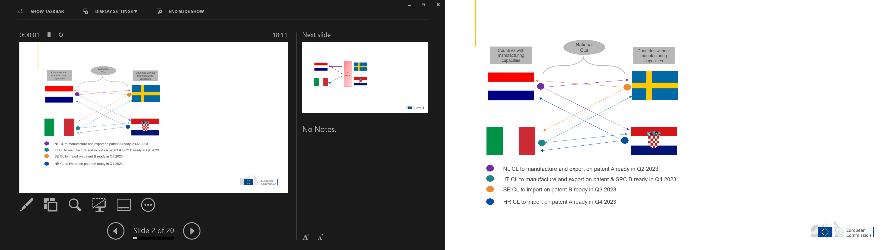

Source: own elaborations.

Figure 16: EU compulsory licensing system in practice in case of Member States with export limitations – example

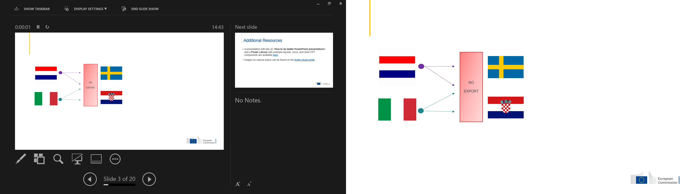

Source: own elaborations.

Figure 17: Export of goods to other Member States, 2021, [EUR billion]

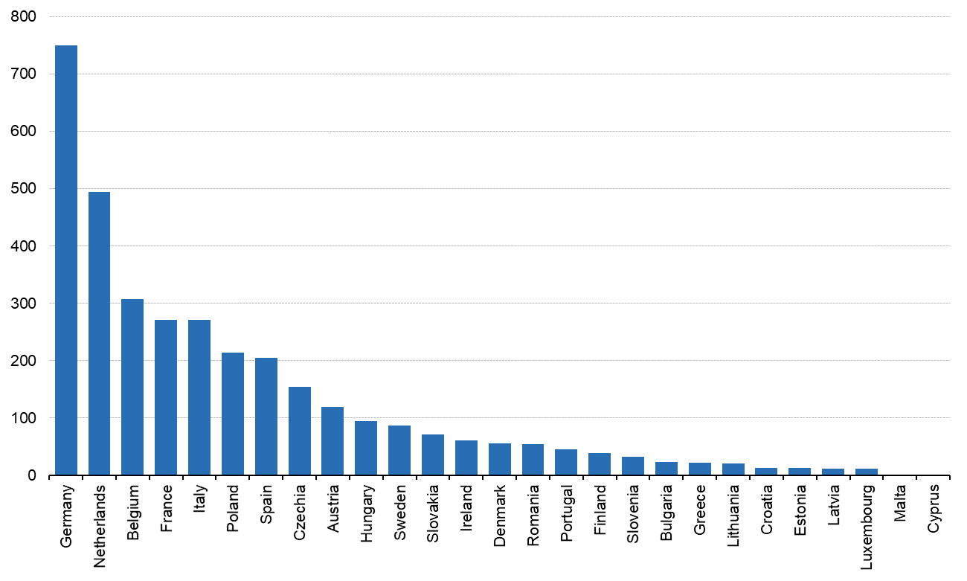

Source: Eurostat - Comext DS-018995, https://ec.europa.eu/eurostat/statistics-explained/index.php?title=Intra-EU_trade_in_goods_-_main_features

Table 15: Are current national laws on compulsory licensing fit to tackle: national crisis?

|  |  |  |  |  |
| --- | --- | --- | --- | --- |
| **I am giving my contribution as** | **No** | **No opinion** | **Yes** | **Total** |
| Academic/research institution | 3 | 1 | 1 | 5 |
| Business association | 1 | 1 | 19 | 21 |
| Company/business organisation | 1 | 1 | 15 | 17 |
| Consumer organisation | 1 | 0 | 0 | 1 |
| EU citizen | 6 | 1 | 4 | 11 |
| Non-governmental organisation (NGO) | 6 | 0 | 0 | 6 |
| Other | 2 | 2 | 2 | 6 |
| Public authority | 1 | 1 | 2 | 4 |
| Total | 21 | 7 | 43 | 71 |

Source: Open public consultation, Question 3

Table 16: Are current national laws on compulsory licensing fit to tackle: EU crisis?

|  |  |  |  |  |
| --- | --- | --- | --- | --- |
| **I am giving my contribution as** | **No** | **No opinion** | **Yes** | **Total** |
| Academic/research institution | 4 | 1 | 0 | 5 |
| Business association | 2 | 1 | 18 | 21 |
| Company/business organisation | 2 | 1 | 14 | 17 |
| Consumer organisation | 1 | 0 | 0 | 1 |
| EU citizen | 7 | 1 | 3 | 11 |
| Non-governmental organisation (NGO) | 6 | 0 | 0 | 6 |
| Other | 1 | 2 | 2 | 5 |
| Public authority | 2 | 1 | 1 | 4 |
| Total | 25 | 7 | 38 | 70 |

Source: Open public consultation, Question 3

Table 17: Are current national laws on compulsory licensing fit to tackle: global crisis?

|  |  |  |  |  |
| --- | --- | --- | --- | --- |
| **I am giving my contribution as** | **No** | **No opinion** | **Yes** | **Total** |
| Academic/research institution | 4 | 1 | 0 | 5 |
| Business association | 2 | 1 | 18 | 21 |
| Company/business organisation | 1 | 1 | 15 | 17 |
| Consumer organisation | 1 | 0 | 0 | 1 |
| EU citizen | 7 | 1 | 2 | 10 |
| Non-governmental organisation (NGO) | 5 | 0 | 0 | 5 |
| Other | 1 | 3 | 1 | 5 |
| Public authority | 1 | 2 | 1 | 4 |
| Total | 22 | 9 | 37 | 68 |

Source: Open public consultation, Question 3

Table 18: Number of Member States where EP patents were active, by COVID-related IPC as defined in PatentScope COVID Index (WIPO)

|  |  |  |  |
| --- | --- | --- | --- |
| IPC Description | Average all patents | Average EP | Total patent families |
| A41D - OUTERWEAR; PROTECTIVE GARMENTS; ACCESSORIES | 2.35 | 3.61 | 1738 |
| A61B - DIAGNOSIS; SURGERY; IDENTIFICATION | 2.49 | 3.01 | 61955 |
| A61F - FILTERS IMPLANTABLE INTO BLOOD VESSELS; PROSTHESES; [...] BANDAGES [...]; FIRST-AID KITS | 3.62 | 4.03 | 8987 |
| A61G - TRANSPORT, PERSONAL CONVEYANCES, OR ACCOMMODATION SPECIALLY ADAPTED FOR PATIENTS OR DISABLED PERSONS | 2.76 | 3.52 | 1970 |
| A61H - PHYSICAL THERAPY APPARATUS;[...] ARTIFICIAL RESPIRATION; | 2.86 | 3.40 | 1834 |
| A61K - PREPARATIONS FOR MEDICAL, DENTAL, OR TOILET PURPOSES | 6.53 | 7.27 | 99648 |
| A61L - METHODS OR APPARATUS FOR STERILISING MATERIALS OR OBJECTS [...]; DISINFECTION, STERILISATION [...] | 3.70 | 4.47 | 14964 |
| A61M - DEVICES FOR INTRODUCING MEDIA INTO, OR ONTO, THE BODY | 3.52 | 3.88 | 22375 |
| A62B - DEVICES, APPARATUS OR METHODS FOR LIFE-SAVING | 2.31 | 2.96 | 2663 |
| A62D - [...] COMPOSITION OF CHEMICAL MATERIALS FOR USE IN BREATHING APPARATUS | 3.46 | 4.09 | 202 |
| B25J - MANIPULATORS; CHAMBERS PROVIDED WITH MANIPULATION DEVICES | 1.90 | 2.62 | 9734 |
| C07D - HETEROCYCLIC COMPOUNDS | 7.74 | 8.18 | 24052 |
| C07H - SUGARS; DERIVATIVES THEREOF; NUCLEOSIDES; NUCLEOTIDES; NUCLEIC ACIDS | 6.45 | 6.74 | 9689 |
| C07K – PEPTIDES | 7.20 | 7.54 | 33736 |
| C12M - APPARATUS FOR ENZYMOLOGY OR MICROBIOLOGY | 3.87 | 4.23 | 8780 |
| C12N - MICROORGANISMS OR ENZYMES; COMPOSITIONS THEREOF; [...] | 6.16 | 6.54 | 46613 |
| C12P - FERMENTATION OR ENZYME-USING PROCESSES TO SYNTHESISE A DESIRED CHEMICAL COMPOUND[...] | 6.77 | 7.06 | 14042 |
| C12Q - MEASURING OR TESTING PROCESSES INVOLVING ENZYMES, NUCLEIC ACIDS OR MICROORGANISMS | 4.63 | 5.07 | 26094 |
| G01N - INVESTIGATING OR ANALYSING MATERIALS BY DETERMINING THEIR CHEMICAL OR PHYSICAL PROPERTIES | 4.33 | 4.78 | 33219 |
| G16B - BIOINFORMATICS, [...] ICT SPECIALLY ADAPTED FOR GENETIC OR PROTEIN-RELATED DATA PROCESSING [...] | 4.84 | 5.15 | 2072 |
| G16C - COMPUTATIONAL CHEMISTRY; CHEMOINFORMATICS; COMPUTATIONAL MATERIALS SCIENCE | 4.79 | 5.02 | 329 |
| G16H - HEALTHCARE INFORMATICS, [...] ICT SPECIALLY ADAPTED FOR THE HANDLING OR PROCESSING OF MEDICAL OR HEALTHCARE DATA | 2.73 | 3.26 | 7441 |
| F24F - AIR-CONDITIONING; AIR-HUMIDIFICATION; VENTILATION; USE OF AIR CURRENTS FOR SCREENING | 2.35 | 3.14 | 1744 |

Source: own analysis based on PatentSight® data for selected IPC codes; Note: IPC descriptions shortened.

Figure 18: Main branch groups in parts and components - share of parts and components in each branch group’s trade (%)

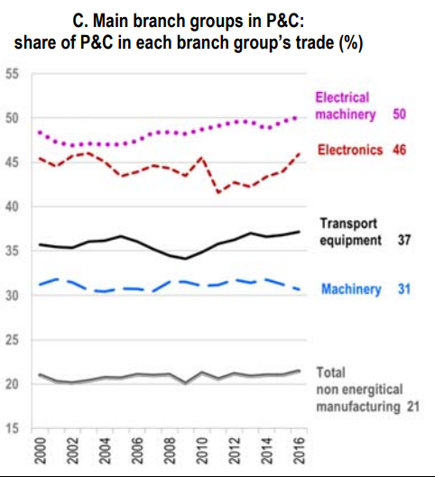

Source: Gaulier, G., Sztulman A., Ünal D., Are Global Value Chains Receding? The Jury Is Still Out. Key Findings from the Analysis of Deflated World Trade in Parts and Components, CEPII Working Paper 2019-01, Paris, page 18.

Table 19: Overview of different national grounds for a compulsory licensing(CL) applicable in crises

|  |  |  |  |  |
| --- | --- | --- | --- | --- |
| Member State | Legal provision for granting CL for crisis management | Competent authority for crisis CL | Assessment | Comment |
| Austria | Austrian Patent Act (Patentgesetz), section 36(5) | Austrian Patent Office | Public interest crises | “public interest”, could be also in case of a “national emergency” or “other circumstances of extreme urgency” |
| Belgium | Code of Economic Law, Art. XI.38 | Council of Ministers (for public health CL). | Public health crises | “public health grounds”  “a) a medicine, a medical device, a medical device or product for diagnosis, a derived or combinable therapeutic product; b) the process or product necessary for the fabrication of one or more products indicated under a); and c) a diagnostic method applied outside the human or animal body” |
| Bulgaria | Law of Patents and Utility Models Registration (1993), Art. 32(2) | Bulgarian Patent Office (Disputes department) | Public interest | “public interest, even if negotiations with the right owner have not been conducted” |
| Croatia | Patent Act, Art. 104(5) | Zagreb Commercial Court | National urgency | “in situations of extreme urgency on a national level, in particular for national security, public interest protection in the field of health, food supply, environmental protection and improvement, or to remedy an anti-competitive practice” |
| Cyprus | Cypriot Patents Act, Sec. 55 | Council of Ministers | National security or public safety | “in situations of extreme urgency on a national level, in particular for national security, public interest protection in the field of health, food supply, environmental protection and improvement” |
| Czechia | Act on Inventions and Rationalisation Proposals No. 527/1990 Coll. (Czech Patent Act), Sec. 20 | Industrial Property Office | Public Interest | “in there exists a threat to an important public interest” |
| Denmark | Danish Patents Act, Sec. 47 | Maritime and Commercial High Court in cases on the merits (Section 50 of the Patents Act) | Public interest | “essential public interests render it necessary” |
| Estonia | Estonian Patents Act of 16 March 1994, Sec. 47(1) | Harju County Court (court of first instance) | National defence and public interest | “national defence, environmental protection, public health and other significant national interests of the Republic of Estonia require the use of the invention, including the need to use the invention in connection with a natural disaster or other emergency”  “in the event of an epidemic” and in an emergency situation” (referring to the meaning set in the Communicable Disease Prevention and Control Act and in the Emergency Situation Act) |
| Finland | Finnish Patents Act (550/1967), Sec. 47 | Market Court | Public interest | “considerable public interest” |
| France | French Intellectual Property Code (CPI), Art. L613-16 | Ministry in charge of industrial property (on request of the Ministry of Public Health) | Public heath | “Interests of public health”:  “(a) a medicinal product, a medical device, an in vitro diagnostic medical device or an ancillary therapeutic product  (b) a process for obtaining them, a product necessary for obtaining them or a process for manufacturing such a product  c) an ex vivo diagnostic method.”  “The patents for these products, processes or diagnostic methods may only be subject to the ex officio license system in the interest of public health when these products, or products derived from these processes, or these methods are made available to the public in insufficient quantity or quality or at abnormally high prices, or when the patent is exploited under conditions that are contrary to the interest of public health” |
| Art. L613-18 CPI | Ministry in charge of industrial property | National economy | “in the interest of the national economy”: “if the absence of working or the inadequacy in quality or quantity of the working undertaken is seriously prejudicial to economic development and the public interest” |
| Art. L613-19 CPI | Ministry in charge of industrial property (on request of the ministry in charge of national defence) | National defence | “in the interest of the national defence” |
| Law n° 2020-290 of March 23, 2020 of emergency to face the epidemic of covid-19 introduced a new article L.3131-15 in the public health code | Prime Minister | Public health | This article allows the Prime Minister, when a state of health emergency is declared, and for the sole purpose of guaranteeing public health :  - to order the requisition of all goods and services necessary for the fight against the health disaster as well as of any person necessary for the functioning of these services or the use of these goods;  - to take any measure allowing the provision of appropriate medicines to patients for the eradication of the health disaster. |
| Germany | Sec. 24(1) Patent Act (Patent Gesetz) | Federal Patent Court (Bundespatentgericht) | Public interest | “the public interest calls for the grant of a compulsory licence”.  Public interest cannot be described in general. It exists if a medicine to treat serious illnesses has specific therapeutic characteristics that comparable medicines do not have, or not to the same extent or if the use of such a medicine leads to a reduction of side effects that would have been suffered when prescribing/using different medicines. However, public interest cannot exist if there is a similar treatment possible with a different medicine[191]. |
| Infektionsschutzgesetz - IfSG and Sec. 13 German PA | Federal Ministry of Health |  | “epidemic situation of national importance is determined by the German Bundestag” |
| Greece | Arts. 13 Greek Patents Act | Hellenic Property Organisation (OBI) | National health or national defence | “Imperative need for purposes of national health or national defence exists”. |
| Hungary | Art. 33/B(1) Hungarian Patents Act | Hungarian Intellectual Property Office (HIPO) is  competent to grant compulsory licences based on  Art. 33/A PA (for the treatment of public health problems). | Public health | “For the interest of public health problems”  “In the interest of meeting domestic demand stemming from a public health crisis” referred to in Subsection (2) of Section 228 of Act CLIV of 1997 on Health Care.  Covering patented medicinal products, active substances or investigational medicinal products as well as medical devices or for patented procedures, equipment or devices required for the production of healthcare products. |
| Ireland | Sections 70 to 75 of the Patents Act 1992. Buscar cual | Controller of Patents, Trade Marks and Designs | X | “a demand in the State for the subject matter of the patent is not being met or is not being met on reasonable terms or that the establishment or development of commercial or industrial activities in the State is unfairly prejudiced” |
| Italy | Intellectual Property Code (Codice della proprietà industriale  2005, hereinafter IP Code or IPC), Art. 70-bis | Italian Minister of Health in agreement with the Italian Minister of Economic Development | National emergency | “national health emergency” for “medicines and medical devices deemed essential for dealing with the health emergency” (requires the declaration of a state of emergency) |
| Latvia[192] | Art. 54(3) of the Patent Law of 2007, amended on 1 January 2016. | Administrative court of first instance | National defence or economic interests | “vital importance for the welfare, defence or economic interests of the people of Latvia” |
| Art. 54(5) Patent Law | Cabinet of Ministers | National emergency | “state of national emergency” |
| Lithuania | Patent Law of the Republic of Lithuania of 18 January 1994,  No. I-372 (modified on 3 February 2012). | Government of the Republic | Public needs, national security or public health | “public needs, national security and public health protection, development of economically important sectors, or if a competent court determines that a method of the exploitation of a patented invention by its owner or licensee is anti-competitive” |
| Luxemburg | Law of 20 July 1992 on Patents, Art. 63 | Government | Public interest | “public interest”. They are also called ex-officio licences, which are delivered by the Government where the invention has been declared by decree of public interest. |
| Malta | Art. 39 of the Patents and Designs Act (Cap. 417 of the Laws of Malta) | Minister responsible for the protection of industrial property | National security | “where the national security or public safety so requires, even without the agreement of the proprietor of the patent or the patent application” |
| Netherlands | Patents Act of 15 December 1994 (Dutch Patent Act), Art. 57(1) | Minister of Economic Affairs | Public interest | “public interest” |
| Art. 59 Dutch Patent Act[193] | N/A | National defence | “national defence” |
| Poland | Act of 30 June 2000 on Industrial  Property, Art. 82(1) | Patent Office | National emergency | “to prevent or eliminate the state of national emergency, in particular in the field of defence, public order, the protection of human life and health, as well as the protection of the natural environment” |
| Act of 30 June 2000 on Industrial  Property, | Patent Office | Public interests | “to prevent or remove a threat to important state interests, in particular public safety and order” |
| Portugal[194] | Industrial  Property Code in Arts. 107 to 112. | Government | Public interest | “public interest” |
| Romania | Arts. 43(4) of the Romanian Law No. 64/1991 on patents (Romanian Patents Act) | Bucharest Tribunal | National emergency | “a) in national emergency cases;  b) in other cases of extreme emergency;  c) in cases of public use for non-commercial purposes.” |
| Slovakia | Slovak  Patent Act, Sec. 27 | District Court Banská Bystrica | Public interest | “in case of threat to an important public interest” |
| Slovenia | Art. 125(1) Industrial Property Act (ZIL-1-UPB3) (amended up  to 6 December 2013). | District Court of Ljubljana | Public interest or national security | “where the public interest is concerned, in particular if national security, nutrition, health or the development of other vital sectors of the national economy so requires” |
| Spain | Patents Act (Ley 24/2015), Art. 95(2) | Patent and Trademarks Office (OEPM) (by request of the Government) | Public interest | “public interest”, meaning:  (a) the initiation, increase or generalisation of the exploitation of the invention, or the improvement of the conditions under which such exploitation takes place, are of major importance for public health or national defence.  (b) The non-exploitation or the inadequacy in quality or quantity of the exploitation carried out is seriously detrimental to the economic or technological development of the country.  c) The needs of national supply. |
| Sweden[195] | Section 47 of the Swedish Patents Act No. 837 of 1967 as  amended. | Patent and Market Court | Public interest | “public interest of utmost importance requiring a compulsory licence to be granted to someone who intends to exploit the invention commercially” |

Table 20: Institutions competent to grant compulsory licences across Member States

|  |  |  |  |  |  |  |  |
| --- | --- | --- | --- | --- | --- | --- | --- |
|  | Ministry/ Government | Patent Office/ IPO | Court | Agency | Competition Authority | Other | # of Auth. competent to grant CL |
| Austria |  | X |  |  | X |  | 2 |
| Belgium* | X |  |  |  |  | X[196] | 2 |
| Bulgaria | X | X |  |  |  |  | 2 |
| Croatia |  |  | X |  |  |  | 1 |
| Cyprus | X | X |  |  |  |  | 2 |
| Denmark |  |  | X |  |  |  | 1 |
| Estonia | X |  | X |  |  |  | 2 |
| Finland |  |  | X |  |  |  | 1 |
| France | X |  | X |  |  |  | 2 |
| Germany | X |  | X |  |  |  | 2 |
| Greece* | X | X |  |  |  |  | 2 |
| Hungary |  | X | X |  |  |  | 2 |
| Ireland |  | X |  |  |  |  | 1 |
| Italy* | X | X |  | X | X |  | 4 |
| Lithuania* | X |  | X |  |  |  | 2 |
| Luxembourg* | X |  | X |  |  |  | 2 |
| Malta | X |  |  |  |  |  | 1 |
| Netherlands | X |  | X |  |  |  | 2 |
| Poland |  | X |  |  |  |  | 1 |
| Romania |  |  | X |  |  |  | 1 |
| Slovakia |  |  | X |  |  |  | 1 |
| Slovenia |  |  | X |  |  |  | 1 |
| Spain | X | X |  |  |  |  | 2 |
| Sweden |  |  | X |  |  |  | 1 |
| TOTAL | 13 | 9 | 14 | 1 | 2 | 1 | 40 |

Source: CEIPI (2023), pp 32-33  
Note: Results exclude Latvia and Portugal. *= In times of crisis, the usual authority for applying for/granting compulsory licences is different. From Questionnaire Responses, Member States responses on question 18.

Table 21: Overview of divergences in scope, procedures and conditions

|  |  |  |  |  |  |  |  |  |
| --- | --- | --- | --- | --- | --- | --- | --- | --- |
| **Member State** | **Scope** | | | | **Procedures** | | **Conditions** | |
| **Patent Appl.[197]** | **SPC[198]** | **RDP[199]** | **Trade secrets/know-how** | **Appeal** | **Preliminary relief** | **Embargos[200]** | **Criteria for remuneration** |
| Austria | No | No | No | No | Yes  (Appeal to the Higher Regional Court of Vienna and (in exceptional cases) to the Austrian Supreme Court) | Uncertain  (The Austrian Patent Code does not foresee the specific possibility of a compulsory licence by way of a preliminary injunction but provides for an expedited decision before the Austrian Patent Office, in case a patented invention is needed in the public interest) | Yes  (Four years after application date or three years after grant date if the patented invention is not exploited to an appropriate extent). | Yes  Appropriate remuneration determined by the Austrian PO considering the economic value of the licence (section 37.1 Patent Code). |
| Belgium | No | No | No | No | Yes  (Administrative appeal for annulment of the decision can be introduced before the Council of State) | No | Yes  (Four years from the filing date of the patent application or three years from the grant date of the patent in case there is a lack of exploitation) | Yes  Adequate remuneration to the patentee, taking the economic value of the licence into account. |
| Bulgaria | No | No | No | No  (However, Art. 9 Trade Secret Law states: “The acquisition, use or disclosure of a trade secret shall not be considered unlawful in the following cases [...] for the protection of an interest recognized by the law of the European Union or by the Bulgarian legislation.”) | Yes  The BPO decision may be appealed within three months of its announcement to the parties before the Sofia City Administrative Court. The decision of the Sofia City Administrative Court is subject to cassation before the Supreme Administrative Court, whose decision is final. The Sofia City Administrative Court and the Supreme Administrative Court may return the case back to the BPO for a new decision on the merits based on the court’s explicit instructions on the application of the law. | _ _ | Yes  (The invention has not been exploited for a period of four years from the date of filing of the patent application or three years from the grant of the patent) | Yes  Art. 32(10) provides that the compulsory licensee shall owe the patent owner a remuneration but does not provide as to who determines it. |
| Croatia | Yes | Yes | No | No | Yes  The decisions of the court issued in the procedures for the grant of a compulsory licence may be appealed in accordance with the rules laid down in the Act on Civil Proceedings. The High Commercial Court has jurisdiction on appeal. | _ _ | Yes  (Lack of exploitation: after the expiration of a period of four years from the filing date of a patent application, or after the expiration of three years from the date the patent was granted) | Yes  Taking into account the economic value of the authorisation and need to correct anti-competitive practice (Art. 69(5) PA). |
| Cyprus | No | No | No | No | Yes  The Registrar’s decision may be referred to the Administrative Court for review and the decision of the Administrative Court may be appealed before the Supreme Court panel of three Supreme Court judges. | _ _ | Yes  (Any time after the expiration of four years from the date of the grant of a patent – Art. 49 Patent Laws) | Yes  Reasonable remuneration according to the nature of the invention and the economic value of the authorisation. |
| Czech Republic | No | Yes | No | No | Yes  The decision on grant or rejection of the compulsory licence may be appealed within one month to the President of the Office. The appellate decision may be subject to administrative review relating to all factual and legal aspects before the Prague City Court. The judgment of the Prague City Court may be challenged in a cassation complaint with the Czech Supreme Administrative Court. | _ _ | Yes  (In case of an insufficient use of the invention, a compulsory licence cannot be granted before four years from patent application filing date or three years from the grant) | Yes  The grant of a compulsory license shall not affect the right of the proprietor of the patent for the compensation of the value of the license. If the value of the license is not agreed by concerned parties it shall be determined, upon request, by the court, taking into account the importance of the invention and the value of the license contracts in the relevant technical field (Section 20.7). |
| Denmark | No | No | No | No | Yes  Decisions delivered by the Maritime and Commercial High Court or the district court can be appealed to the Eastern or Western High Court, or the Supreme Court (Danish Administration of Justice Act, Sections 368(1) and (4)). According to Section 368(4) of the Danish Administration of Justice Act, a decision delivered by the High Courts or the Maritime and Commercial High Court may be appealed to the Supreme Court if the outcome of the case is of fundamental legal importance and of general importance to the application and development of the law or has significant societal implications in general, or where there are other special reasons why the case should be heard before the Supreme Court. | Uncertain[201] | Yes  (In case the invention is not exercised, three years of the grant of the patent or four years from the filing of the patent application) | Yes  The Maritime and Commercial Court shall decide as the court of first instance whether a compulsory licence shall be granted and shall also determine the extent to which the invention may be exploited, fix the compensation and lay down the other terms of the compulsory licence (Section 50). |
| Estonia | No | Yes | No | No | Yes  The court decision granting or refusing a compulsory licence for an invention may be appealed first to the circuit court and further to the Supreme Court. | _ _ | Yes  (Lack of use of the invention within three years from the publication of the notice concerning the grant of the patent or within four years from the filing of the patent application) | A court shall determine the terms and conditions of the compulsory licence, including the extent and duration of the use of the invention and the amount and procedure for payment of the licence fee (Art. 47.3). |
| Finland | Yes[202] | Uncertain  (Section 70d of the Finnish PA could argue for the extension to SPCs) | No | No | Yes  Under Section 7(4) of the Market Court Proceedings Act (100/2013), a party may appeal by submitting a written petition of appeal to the Supreme Court. Any appeal to the Supreme Court is subject to a leave to appeal. The period for filing a request for an appeal is 60 days from the day of the Market Court’s initial adjudication. | Uncertain  (Possible according to the law wording, uncertain in practice) | Yes  (If three years have elapsed since the grant of the patent and four years have elapsed from the filing of the application and the invention is not worked or brought into use to a reasonable extent in Finland – section 45 PA) | Compulsory licences shall be granted by a court of law, which shall also decide the extent to which the invention may be exploited and shall determine the remuneration to be paid and any other conditions under the licence (Section 50). |
| France | Yes  Art. L613-19 French Intellectual Property Code (CPI) | No | No | No | Yes  Decisions may be appealed following the regular civil appeal procedures (i.e. within one month). Decisions of the ministry in charge of industrial property may be appealed pursuant to the relevant public law provisions. | Uncertain  (The law does not foresee it. There is no case law to date) | Yes  (Lack of exploitation: three years following the grant of the patent, or four years following the publication of the application) | Yes  According to special conditions, which might be determined by a tribunal (Art. L613-12). |
| Germany | No  (CL expressly only permissible after the patent has been granted) | Yes  (CL extends also to a SPC, it may also be applied for and granted in isolation only for the SPC) | No | No | Yes  The decision of the Federal Patent Court may be appealed before the FCJ (Bundesgerichtshof). | Yes  (Section 85 Patent Code) | No | Yes  Equitable remuneration considering the economic value of compulsory licensing. |
| Greece | Yes | Yes | No | No | Yes  The decision can be appealed before the Court of Appeal, whose decision can be further appealed before the Supreme Court. In the case of a compulsory licence granted by the State, the decision may be appealed before the Supreme Administrative Court. | No | Yes  (Three years from grant or four years from filing of a patent have passed) | Yes  Established by the competent court and accompanied by an opinion of the IP office regarding, amongst others, the terms of the compensation and the amount, which are determined in accordance with the extent of the industrial exploitation of the protected invention.  (Article 13.5 and 13.6). |
| Hungary | No | Yes | No | No | Yes  CL for public health grounds:  The decision of the HIPO may be subject to judicial review before the Metropolitan Court. The decision of the Metropolitan Court may be appealed before the Metropolitan Court of Appeal, and the decision of the Metropolitan Court of Appeal is subject to judicial review before the Curia (Hungarian Supreme Court). | Yes[203]  (There is no court practice relating to the preconditions and its scope) | Yes  (Lack of exploitation: four years from the date of filing of the patent application or within three years from the grant of the patent) | Yes  The patentee shall receive adequate compensation for the compulsory license, which shall be fixed, failing agreement between the parties, by the court. The compensation shall take into adequate account the economic value of the compulsory license. In particular, it shall be commensurate with the royalty the holder of the compulsory license would have paid on the basis of an exploitation contract concluded with the patentee, taking into account the licensing conditions in the technical field of the invention (Article 33.3). |
| Ireland | Yes  (Section 76(1) Irish PA) | No | No | No | Yes  A decision of the Controller can also be appealed to the High Court. The decision of the High Court can be further appealed to the Court of Appeal on a point of law. If the 63 IE matter is of general public importance or the interests of justice require it, an appeal shall lie to the Supreme Court. | Uncertain  (The Irish courts have not, to date, granted a compulsory licence by way of preliminary relief) | No | Yes  Adequate remuneration, considering the economic value of the licence. |
| Italy | No | Uncertain  (Law refers explicitly to patents only, coverage of SPC is a matter of legal interpretation)) | No | No | Yes  The decision is taken by the UIBM (IPO), which is a branch of the Ministry of Productive Activities. Hence, it can be appealed as an administrative procedure before the Lazio Regional Administrative Court (T.A.R. Lazio). | Yes  (An IP civil court may issue an order equivalent to a compulsory licence but there is no precedent for this. Such an order may be also applied via a preliminary measure in order to skip the length of the UIBM procedure.) | Yes  (Four years after application and three years after grant if lack of effective exploitation by the patent owner). | Yes  Adequate remuneration, determined considering the economic value  of the authorization (Art. 70bis.2). |
| Latvia | No | No | No | No | Yes  Since the decision to grant a compulsory licence is taken by an administrative court of first instance, it may be appealed to the Administrative Court of Appeal. The rulings of the latter, in turn, may be appealed to the Supreme Court of Latvia. | _ _ | Yes  (if a patented invention has not been used in Latvia or has been used to an insufficient degree within four years from the date of application or three years from the date on which the grant of a patent was published) | Yes  Determined by the court, observing the economic value of the licence, the extent of use of an invention and other circumstances (Section 54.9). |
| Lithuania | No | Yes | No | No  (However, the laws of the Republic of Lithuania may establish obligation to trade secret holder to disclose information constituting trade secret for reasons of public interest to court, government, or public administration institution and (or) body.) | Yes  All final decisions of a competent court or authority described in the above may be appealed to a Court of Appeal of Lithuania. | _ _ | No | Yes  Fair remuneration, taking into consideration economic value of the invention (Art. 39.2). |
| Luxembourg | No | No | No | No | Yes  Before the Luxembourg Court of Appeal. | _ _ | Yes  (Lack of exploitation: three years from the grant of a patent or four years from the filing date of the patent application) | Yes  Adequate remuneration, considering the economic value of the licence. |
| Malta | Yes  (Art. 40 Maltese Patent and Designs Act) | No | No | No | Yes  For compulsory licences granted in the public interest the decision may be appealed to the relevant court of first instance indicated herein and, even if the Act is silent on this issue, in terms of general laws of procedure a further appeal from judgment thereof is possible by application filed before the Court of Appeal.  The act is silence for the other situations of compulsory licensing. | _ _ | Yes  (Expiration of a period of four years from the date of filing the application for the patent or three years from the grant of the patent) | Yes  “Equitable remuneration” for a sworn application filed by any person who proves his ability to work the patented invention in Malta. Determined by the Court.  “Appropriate remuneration” for:  Sworn application filed by the owner of the patent.  Application filed by a breeder.  Application filed by the holder of a patent concerning a biotechnological invention who cannot exploit it without infringing a prior plant variety right.  National security or public safety. |
| Netherlands | No | Yes | No | No  (The Netherlands Trade Secrets Act do not contain any provisions on forced access to know-how. However, the Act leave open the possibility of such a statutory forced access regulation.) | Yes  After a decision by the Minister about a compulsory licence in the public interest, both parties (applicant and patentee) may lodge an objection,21 which is a complaint sent to the Minister himself to re-evaluate his previous decision. The term to submit an objection is six weeks.22 After the decision on objection, an appeal can be lodged to the administrative chamber of the District Court of The Hague.23 A final appeal may be lodged to the Council of State (Raad van State). Both the objection and the appeal have suspensive effect, unless the decision of the Minister provides otherwise on grounds of urgency. | No | Yes  (Three years of lack of use before a CL can be requested). | Yes  In case of national defence, the Minister who is directly concerned shall determine, by agreement with the patent holder, the fee to be paid to the patent holder by the State (Art. 59). |
| Poland | No | No | No | No | Yes  Parties to the proceedings are entitled to lodge a complaint with the Voivodeship Administrative Court in Warsaw. A decision rendered by the Voivodeship Administrative Court can be appealed before the Supreme Administrative Court. | No | No | Yes  Determined proportion to the market value of the license, of the royalty and the manner and time limits of payment (Art. 84.2). |
| Portugal | No | No | No | No | Yes  The decision to grant or not grant a compulsory licence can be appealed to the Intellectual Property Court. The expert panel’s decision on the terms and compensation of the compulsory licence may also be appealed to the Intellectual Property Court. | No  (The law does not contemplate the possibility of obtaining a compulsory licence by way of a preliminary injunction.) | Yes  (Lack of exploitation: four years of the filing date or three years of the grant date) | Yes  Adequate remuneration, taking into account the economic value of the licence (Art. 108.6). |
| Romania | Yes | Yes | No | No | Yes  The decision may be appealed to the Bucharest Court of Appeal. | No  (There is neither case law nor special statutory provisions relating to the possibility of obtaining a compulsory licence within a preliminary injunction procedure.) | Yes  (If the invention has not been used or has not been sufficiently used, four years from the filing date of the patent application or a period of three years after the grant of the patent) | Yes  Determined by the Bucharest Tribunal in relation to the commercial value of the licences granted. |
| Slovakia | No | Yes | No | No | Decisions of the Court are subject to full judicial review with respect to all legal and factual aspects of the decision. The first instance decision of the Court, whether grant of the compulsory licence or rejection of an application, may be appealed within fifteen days to the Regional Court Banská Bystrica. | _ _ | Yes  (Lack of use: four-year period from the patent application filing date or three-year period from the date of grant) | Adequate compensation as well as terms of payment shall be determined by a court on proposal of one of parties to licence agreement taking into consideration the importance of an invention and usual licence prices in a particular field. |
| Slovenia | No | No | No | No | Yes  The decision may be appealed to the Court of Appeal of Ljubljana (Art. 31 Non-Contentious Civil Procedure Act, Official Gazette of SRS, No. 30/86 as amended). | _ _ | No | Mandatory compensation, determined with regard to the circumstances of each case, while taking into account the economic value of the compulsory licence (Art. 127.2). |
| Spain | Yes | Yes | No | No  (But the parties must act in good faith. For the patentee this means inter alia that it must disclose to the licensee the know-how in its possession that is necessary for an adequate exploitation of the invention - article 100.4 of the Spanish Patent Act.) | Yes  The decision reached by the OEPM is appealable at an administrative level (i.e. to be resolved within the OEPM) and subsequently before the contentious-administrative courts, first to the Tribunal Superior de Justicia, then to the Contentious-Administrative Chamber of the Tribunal Supremo. The appeal will be heard by the Tribunal Supremo only if it deems the case to have a cassational interest for the formation of case law. | Uncertain  (Not expressly, but the provisional measures that both courts and administrative bodies may adopt under general procedural law constitute an open list, and therefore in cases of urgency it might be theoretically possible.) | Yes  (Failure to exploit or insufficient exploitation of the patented invention for more than four years after the filing of the patent application, or three years after the publication of the mention of grant) | Yes  Based on the economic importance of the invention. |
| Sweden | No | No | No | No | Yes  An appeal to the Patent and Market Court of Appeal is subject to the grant of leave to appeal. A further appeal to the Supreme Court is then subject to a double requirement for leave to appeal (i.e. first from the Patent and Market Court of Appeal and subsequently from the Supreme Court). | Uncertain  (No explicit provisions and has not been done in practice. It is conceivable that the court would consider arguments concerning the right to a compulsory licence in deciding whether to grant preliminary injunctive relief against a defendant.) | Yes  (Lack of exploitation: three years have passed from the grant of the patent and four years from the date of filing of the patent application) | Yes  Established by the Court. |

The table below gives an overview on existing and upcoming Emergency Instruments and Responses in the EU, based on Annex 9 of the impact assessment on SMEI[204] and complemented by an evaluation of the relevance of these instruments for the initiative on compulsory licensing for crisis management, marked as: highly relevant, relevant, less relevant.

Table 22: Detailed mapping of existing and upcoming Emergency Instruments and Responses

|  |  |  |  |  |
| --- | --- | --- | --- | --- |
| Emergency instrument/ measure | Status | Responsible DGs/bodies | Relevance for CL | Comment |
| Integrated Political Crisis Response (IPCR) Mechanism | Council Implementing Decision; Existing mechanism | Council | Highly relevant | The activation decision (full activation mode) of the Presidency can trigger the CL granting process under Option 3 and 4. |
| European Alliance Against Coronavirus | Ad-hoc group | GROW | Relevant | As a platform for collaboration (among others matchmaking events) the initiative aims at fostering voluntary solutions and therefore avoiding a CL. |
| EU Rapid Alert Function | Ad-hoc solution Regulations | GROW | Relevant | The initiative aims at detecting disruptions in supply chains. |
| EU Rapid Alert system Function | Existing mechanism: European Union Rapid Information System (Safety Gate/RAPEX) | DG JUST | Less relevant | The initiative is about an alert system for dangerous goods. |
| EU Vaccines Strategy and Joint Vaccine Procurement | Communication | SANTE | Highly relevant | The initiative refers to the public health emergency recognized under the European Health Union (see below). |
| European Health Union (first key initiative : Serious Cross-Border Threats to Health Regulation) | Regulation (EU) 2022/2371 | SANTE | Highly relevant | Recognition of public health emergency by COM Implementing Act can trigger the CL granting process under Options 3 and 4. |
| HERA and the Emergency Framework Regulation (EU) 2022/2372 | Commission DG established on 16 September 2021 with Commission Decision C(2021) 6712    -Regulation | HERA | Highly relevant | The Council Regulation on a framework of measures for ensuring the supply of crisis-relevant medical countermeasures in the event of a public health emergency at Union level, which should have been recognised under the serious cross-border threats to health regulation (see above), provides the framework for HERA’s proposed crisis mode and enables the Union to take necessary measures for sufficient and timely availability and supply of crisis-relevant medical countermeasures in case of future public health emergencies. As the objective of the regulation is to establish a framework of measures for ensuring the supply of crisis relevant medical counter-measures in the event of a public health emergency at Union level, a CL could give bargaining power when negotiating voluntary agreements, hence facilitating conclusions of voluntary agreements. CL could also serve as a last resort instrument for the supply of the Union with crisis relevant goods, in case voluntary solutions fail. |
| Emergency Assistance on Cross-Border Cooperation in Healthcare | Communication | DG Health and Food Safety | Highly relevant | The initiative refers to the public health emergency recognized under the European Health Union (see above). |
| COVAX Facility and Vaccine Sharing Mechanism | Global initiative | TRADE/ INTPA | Highly relevant | A CL allows as a last resort instrument access to IP protected products, if there are suitable production capacities. |
| Task Force for Industrial Scale-up of COVID-19 Vaccines | Ad hoc Task Force | GROW | Relevant | The initiative aims at avoiding the need of a CL (e.g. by promoting voluntary partnerships etc.) |
| Coronavirus Response in Relation to Personal Protective Equipment | Commission Recommendation (13 March 2020) accompanied by guidance, followed by the introduction of temporary measures adjusting the PPE export authorisation scheme for 30 days | GROW | Relevant | The initiative aims at speeding up the production of critical products in times of crisis. |
| Extra-EU Export Authorisation Mechanism of Covid-19 Vaccines and their Active Substances | Commission Regulation | SANTE/ TRADE | Relevant | A CL can also, under certain circumstances, secure the continuous supply with crisis relevant products. |
| Joint Procurements for Medicinal Counter Measures | Legislative Proposal | SANTE | Highly relevant | The initiative refers to the public health emergency recognized under the European Health Union (see above). |
| A New European Pandemic Information Gathering System & New European Chief Epidemiologist & European Health Data Space | Proposal announced in the Lessons Learnt Communication | SANTE/ ECDC | Less relevant | The initiative already takes effect at a very early stage (No crisis yet, only early signals of potential threats). At this stage, a CL is not to be considered (last resort instrument). |
| A Framework for the Activation of an EU Pandemic State of Emergency | Proposal announced in the Lessons Learnt Communication |  | Relevant | The initiative aims among others at supporting the manufacturing of essential counter-measures in times of crisis. |
| Short-term EU Health Preparedness for COVID-19 Outbreaks | Communication |  | Relevant | The initiative aims at ensuring free movement of essential critical supplies in the EU and concluding agreements with vaccine producers. |
| Union Civil Protection Mechanism (UCPM) | Based on a number of legal acts, including Decision 1313/2013, as amended by Regulation 2021/836 | ECHO | Highly relevant | In the event of a disaster within the Union a patent protected technology could be needed. A CL could help in case voluntary solutions fail |
| RescEU | See above | ECHO | Highly relevant | The initiative refers to the UCPM (see above). |
| Humanitarian Air Bridge | See above | ECHO | Less relevant | The initiative provides for a transport service. |
| European Civil Protection Pool (ECPP) | See above | ECHO | Highly relevant | The initiative refers to the UCPM (see above) |
| EU Solidarity Corps | Regulation |  | Less relevant | The initiative aims at promoting solidarity and visibility of humanitarian aid among Union citizens |
| The Seveso Directive Technological Disaster Risk Reduction | Directive | ENV | Highly relevant | In the event of a major accident within the Union a patent protected technology could be needed. A CL could help in case voluntary solutions fail. |
| Proposal for a Directive to Enhance the Resilience of Critical Entities Providing Essential Services in the EU | Proposal for a Directive | HOME | Less relevant | The initiative is about critical entities rather than critical products. |
| Emergency Support Instrument | Financial instrument (set up by Council Regulation 2016/369 and activated by a separate Council Regulation) | BUDG | Highly relevant | Council decision activating the Emergency Support can trigger the CL granting process under Options 3 and 4. |
| Repair and Prepare for the Next Generation | Communication |  | Less relevant | The initiative is a recovery instrument embedded in a long-term EU budget. |
| The Single Market Emergency Instrument (SMEI) | Legislative Proposal | GROW | Highly relevant | The declaration of the Single Market Emergency Mode can trigger the CL granting Process under Options 3 and 4. |
| Border Management Measures to Protect Health and Ensure Availability of Goods | Guidelines |  | Relevant | The initiative aims at addressing disruptions to the delivery of goods. |
| ‘Green Lanes’ System and the Forthcoming Transport Mobility Contingency Plan | Communication and a planned Communication | MOVE | Relevant | A CL could be considered (as a last resort instrument) where a certain patent protected technology is needed to overcome the disruption in the EU transport and mobility system. |
| COVID-19 Clearing House for Medical Equipment (CCH) | Ad hoc group | SG | Relevant | The Clearing House Serves among others as a platform for dialogue and information sharing between Member States and h industry. Its Matchmaking Platform aims at facilitating voluntary solutions. With this objective the initiative aims at avoiding the need for a CL. |
| Council Recommendation on Coordinated Approach to the Restriction of Free Movement | Council Recommendation | JUST HOME | Less relevant | The initiative is about the free movement of persons in times of crisis. |
| Free Movement of Workers, Posted Workers, Service Providers | Communications | EMPL | Less relevant | The initiative is about the free movement of workers in times of crisis. |
| Schengen Strategy and Foreseen Revision of Schengen Border Code as Regards Border Closures | Communication; planned proposal for a regulation and changes in Practical Handbook for Border Guards | HOME | Less relevant | The initiative is about introducing internal border controls in times of crisis. |
| Guidance on Free Movement of Health Professionals and Minimum Harmonisation of Training in Relation to COVID- 19 Emergency Measures | Communication | GROW | Less relevant | The initiative focuses on the allocation of skilled persons (health care workers) rather than the supply with products. |
| Temporary Restriction on Non-essential Travel in the EU | Communications |  | Less relevant | The initiative is about travel restrictions in times of crisis. |
| Re-open EU | Web portal | GROW/ JRC | Less relevant | The initiative focuses on providing information to EU citizens. |
| EU Digital COVID Certificate | Regulation | JUST/ CNECT | Less relevant | The initiative focuses on persons rather than products. |
| EU Passenger Locator Form | Commission Implementing Decision |  | Less relevant | The initiative focuses on persons (tracing) rather than products |
| National Contact Tracing Apps | National actions & Recommendation & Implementing Decision |  | Less relevant | The initiative focuses on persons (tracing) rather than products. Relevant at most if a particular app or the software is behind the app is patent protected and access is needed. |
| Treatment of Third Country Nationals at the External Borders | Regulation |  | Less relevant | The Initiative focuses on persons rather than products. |
| Contingency Plan for Ensuring Food Supply and Food Security | Communication | AGRI/ MARE/ SANTE | Highly relevant | The declaration of a food crisis affecting more than one Member State could trigger the CL granting process under Options 3 and 4.  A patent protected technology might be needed in times of a food crisis. A CL could be the last resort instrument. |
| Common Market Organisation Regulation (EU) No 1308/2013 | Regulation | AGRI | Less relevant | The initiative is about market disturbance (significant price rises or falls). |
| Regulation (EU) 2021/2115 (CAP Strategic Plans) | Regulation | AGRI | Less relevant | The initiative lays down rules on general and specific objectives to be pursued through financial Union support. |
| Market observatories |  | AGRI | Less relevant | The initiative provides different sectors with more transparency by means of disseminating market data and short-term analysis in a timely manner. |
| Agricultural civil dialogue groups |  | AGRI | Less relevant | The initiative is a stakeholder consultation tool. |
| Fighting Disinformation - Communications, Action Plan and Code of Practice | In particular: Joint Communication accompanied by actions |  | Less relevant | The initiative lacks a triggering mechanism in times of crisis. |
| Data Act | Act | CNECT/ G1 | Less relevant | The initiative aims at creating a Single Market for data. |
| Cyber-security | Directive |  | Less relevant | However, it does not seem impossible that a CL could be needed in this context to gain access to a critical information and communication technology that could help fight cyber-attacks. |
| Chips Act | Act |  | Highly relevant | The activation of the crisis stage (semi- conductor crisis) by COM through an Implementing Act can trigger the CL granting process under Options 3 and 4. |
| Security of Energy Supply | Regulation | ENERGY | Highly relevant | The declaration of a Union emergency by COM can trigger the CL granting process under Options 3 and 4. |
| Critical Raw Materials Resilience | Communication |  | Relevant | The initiative is about improving the supply chain resilience. A CL could become relevant in case certain patent protected technologies or procedures for the reprocessing of goods are needed. |
| Copernicus Programme & Galileo Programme | Regulations |  | Less relevant | Nevertheless, it is conceivable that a CL is needed in case a patent protected technology is required. |
| Single Market Enforcement Task Force for Compliance with Single Market Rules (SMET) | Communication |  | Relevant | Products produced under a CL also face restrictions/ barriers in the Single Market (lack of EU- wide exhaustion) |
| Defence and Security Work Contracts | Directive |  | Less relevant | The initiative is about (incompatible) procurement requirements in times of crisis (deadlines imposed by the usual award procedures). |
| Crisis Management and Resilience Acquis in the Financial Services Area | Regulations and Directives |  | Less relevant | The initiative aims at the free movement of capital. |

Exemplary crisis definition

As far as the crisis definition used in other initiatives is concerned, an overview of the most pertinent ones is provided below:

Table 23: The definition of crisis in other existing and upcoming Emergency Instruments and Responses – selected examples

|  |  |
| --- | --- |
| Instrument | Crisis definition |
| Integrated Political Crisis Response (IPCR) Mechanism | Article 3(a)*: “‘Crisis’ means a situation of such a wide-ranging impact or political significance, that it requires timely policy coordination and response at Union political level”.  2 Cumulative Elements:  1) Wide-ranging impact or political significance  +  2) Requirement of timely policy coordination & response at Union level  *Council Implementing Decision (EU) 2018/1993 of 11 December 2018 on the EU Integrated Political Crisis Response Arrangements L 320/28] |
| European Health Union | Public health emergency: Article 2(1)(e)*: in order for the Regulation to apply, the threats need to fall under the categories of serious cross-border threats to health set out in (a) – (d): threats of biological/ chemical/ environmental/ climate/ unknown origin.  *REGULATION (EU) 2022/2371 OF THE EUROPEAN PARLIAMENT AND OF THE COUNCIL of 23 November 2022 on serious cross-border threats to health and repealing Decision No 1082/2013/EU |
| HERA and the Emergency Framework Regulation (EU) 2022/2372 | Public health emergency: Article 2(2)*: “‘Public health emergency’ means a public health emergency at Union level recognised by the Commission in accordance with Article 23 of Regulation (EU) No…/…[the SCBTH Regulation”, i.e. Regulation (EU) No …/… of the European Parliament and of the Council of … on serious cross-border threats to health and repealing Decision No 1082/2013/EU].  “Europe needs to be better prepared to anticipate and address jointly the ongoing and increasing risks, not only of pandemics but also of man-made threats such as bioterrorism.”**  *REGULATION (EU) 2022/2371 OF THE EUROPEAN PARLIAMENT AND OF THE COUNCIL of 23 November 2022 on serious cross-border threats to health and repealing Decision No 1082/2013/EU  **Communication from the Commission to the European Parliament, the Council, the European Economic and Social Committee and the Committee of the Regions – Building a European Health Union: Reinforcing the EU’s resilience for cross-border health threats |
| Union Civil Protection Mechanism (UCPM) | Disaster:  Article 4(1)*: "'Disaster' means any situation which has or may have a severe impact on people, the environment, or property, including cultural heritage".  Scope/Triggering of civil protection mechanisms by – Article 1(2)*: “The protection to be ensured by the Union Mechanism shall cover primarily people, but also the environment and property, including cultural heritage, against all kinds of natural and man-made disasters, including the consequences of acts of terrorism, technological, radiological or environmental disasters, marine pollution, hydrogeological instability and acute health emergencies, occurring inside or outside the Union. In the case of the consequences of acts of terrorism or radiological disasters, the Union Mechanism may cover only preparedness and response actions.”  *Decision No 1313/2013/EU of the European Parliament and of the Council of 17 December 2013 on a Union Civil Protection Mechanism, latest amendment by Regulation (EU) 2021/836 of the European Parliament and of the Council of 20 May 2021 |
| The Seveso Directive Technological Disaster Risk Reduction | Major accident:  Article 3(13)*: “‘major accident’ means an occurrence such as a major emission, fire, or explosion resulting from uncontrolled developments in the course of the operation of any establishment covered by this Directive, and leading to serious danger to human health or the environment, immediate or delayed, inside or outside the establishment, and involving one or more dangerous substances”  3 Cumulative Elements:  1) Major emission, fire, or explosion resulting from uncontrolled developments in the course of the operation of an establishment  +  2) Leading to serious danger to human health or the environment  +  3) Involving one or more dangerous substances  *Directive 2012/18/EU of the European Parliament and of the Council of 4 July 2012 on the control of major- accident hazards involving dangerous substances, amending and subsequently repealing Council Directive 96/82/EC |
| Emergency Support  Instrument | Ongoing or potential natural or man-made disaster:  Article 1(1)*: Measures have to be “appropriate to the economic situation in the event of an ongoing or potential natural or man-made disaster. Such emergency support can only be provided where the exceptional scale and impact of the disaster is such that it gives rises to severe wide-ranging humanitarian consequences in one or more Member States and only in exceptional circumstances where no other instrument available to Member States and to the Union is sufficient.”  3 Cumulative Elements:  1) An ongoing or potential natural or man-made disaster”  +  2) Exceptional scale and impact of the disaster is such that it gives rises to severe wide-ranging humanitarian consequences in one or  more Member States  +  3) No other instrument available to Member States and to the Union is sufficient.  *Council Regulation (EU) 2016/369 of 15 March 2016 on the provision of emergency support within the Union as amended by Council Regulation (EU) 2020/521 of 14 April 2020 activating the emergency support under Regulation (EU) 2016/369, and amending its provisions taking into account the COVID-19 outbreak |
| SMEI | ‘Crisis’ Article 3 (1)*: means an exceptional unexpected and sudden, natural or man-made event of extraordinary nature and scale that takes place inside or outside of the Union.  In principle SMEI provides for a two-stage mechanism:  1. Single Market vigilance mode means a framework for addressing a threat of significant disruption of the supply of goods and services of strategic importance and which has the potential to escalate into a Single Market emergency within the next six months (Article 3 (2)*).  2. The Single Market emergency means a wide-ranging impact of a crisis on the Single Market that severely disrupts the free movement on the Single Market or the functioning of the supply chains that are indispensable in the maintenance of vital societal or economic activities in the Single Market (Article 3 (3)*).  *Proposal for a Regulation of the European Parliament and the Council establishing a Single Market emergency instrument and repealing Council Regulation No (EC) 2679/98 |
| Chips Act | Article 18* Activation of the crisis stage  A semiconductor crisis shall be considered to occur when there are serious disruptions in the supply of semiconductors leading to significant shortages, which:  entail significant delays or significant negative effects on one or more important economic sectors in the Union, or  prevent the supply, repair and maintenance of essential products used by critical sectors.  *Proposal for a Regulation establishing a framework of measures for strengthening Europe's semiconductor ecosystem (Chips Act) |

Note: based on COMMISSION STAFF WORKING DOCUMENT Impact Assessment Report Accompanying the document REGULATION OF THE EUROPEAN PARLIAMENT AND OF THE COUNCIL for a Single Market Emergency Instrument Brussels, 19.9.2022 SWD(2022) 289 final, Register of Commission Documents - SWD(2022)289 (europa.eu)

Table 24: The triggering and de-triggering of crisis instrument in other existing and/or upcoming Emergency Instruments and Responses – selected examples

|  |  |
| --- | --- |
| Instrument | Triggering and De-triggering |
| Integrated Political Crisis Response (IPCR) Mechanism | Two Modes:  (Article 2(1)(2),(b)):*   * Information sharing mode (pre-stage) to establish the situation & prepare for possible full activation * Full activation mode to prepare response measures     Activation:  (Article 4):*   * Article4(1)*: Presidency takes IPCR activation decision (initiative by Member States possible) * Article 4(2)*: Triggering upon invocation of solidarity clause (Article 222 TFEU) – still formal adoption by Presidency * Article 4(5)*: “The decision to activate the IPCR in information sharing mode may also be taken by agreement of the GSC, the Commission services and the EEAS, in consultation with the Presidency”   Switching between modes:   * Article 4(6)*: the Presidency may decide at any point to escalate or de-escalate the operation from one mode of activation to the other (exception: solidarity clause invocation requires full mode)     Deactivation:  (Article 5):*   * Decision taken by Presidency after consultation with Member States, Commission and the HR (no deactivation when solidarity clause is invoked)   *Council Implementing Decision (EU) 2018/1993 of 11 December 2018 on the EU Integrated Political Crisis Response Arrangements L 320/28] |
| European Health Union | Recognition of emergency situations:  Article 23(1):* “The Commission may, based on the expert opinion of the Advisory Committee referred to in Article 24, formally recognise a public health emergency at Union level; including pandemic situations where the serious cross-border threat to health in question endangers public health at the Union level.”  Two Cumulative Elements for recognition:  1) Serious cross-border threat to health  2) Endangerment of public health at Union level   * Prior liaising with the WHO (Article 23(3)*) * Adoption by means of implementing acts * Examination procedure in Article 27(2)* * Exception (Article 23(4), subpara. 3*): for cases where this is duly justified on imperative grounds of urgency related to the severity of a serious cross-border threat to health or due to the rapidity of its spread among Member States – more expeditious procedure: immediately applicable implementing acts to recognise a public health emergency * “The new rules will enable the activation of EU emergency response mechanisms, in close coordination with the World Health Organization (WHO), without making it contingent upon the WHO’s own declaration of a Public Health Emergency of International Concern (PHEIC).” (cf. No. 3, p. 7**) * Enabling effect of measures following the recognition (Article 25*) (recitals 18, 19*)   Termination:   * Article 23(2)*: termination as soon as one of the applicable conditions is no longer met.   * REGULATION (EU) 2022/2371 OF THE EUROPEAN PARLIAMENT AND OF THE COUNCIL of 23 November 2022 on serious cross-border threats to health and repealing Decision No 1082/2013/EU  **Communication from the Commission to the European Parliament, the Council, the European Economic and Social Committee and the Committee of the Regions – Building a European Health Union: Reinforcing the EU’s resilience for cross-border health threats |
| HERA | Activation:   * Recognition of a public health emergency required (cf. Article 2(2)*) * Article 3(1): upon proposal of the Commission, the Council “may adopt a regulation activating the emergency framework where appropriate to the economic situation.” * Article 3(3)*: Duration of the activation is limited to 6 months, but renewable (Article 4* procedure) * Funding: Activation of emergency funding, Article 13*: “Where this measure is activated, emergency support under Regulation (EU) 2016/369 is activated to finance expenditure necessary to address the public health emergency […]” “In the event of a public health emergency at Union level, in order to ensure the necessary flexibility and rapidity in implementation, the Council could also trigger financing through the Emergency Support Instrument (ESI), demonstrated in the past to be both flexible and fast. During the COVID-19 crisis, the ESI27 proved efficient and effective in ensuring rapid and flexible funding, essential in times of urgency” (p. 13, No. 6.3**) * “The Council activation of the emergency framework will also specify which of the […] emergency measures, appropriate to the economic situation, should be implemented” (p. 9, No. 4)** * Two phases: "preparedness phase" and "crisis phase". In the “crisis phase”, HERA will be able to draw on stronger powers for swift decision-making and implementation of emergency measures. (p. 2, No. 2**)   * REGULATION (EU) 2022/2371 OF THE EUROPEAN PARLIAMENT AND OF THE COUNCIL of 23 November 2022 on serious cross-border threats to health and repealing Decision No 1082/2013/EU  **Communication from the Commission to the European Parliament, the European Council, the Council, the European Economic and Social Committee and the Committee of the Regions – Introducing HERA, the European Health Emergency preparedness and Response Authority, the next step towards completing the European Health Union |
| The Single Market Emergency Instrument (SMEI) | In principle, SMEI provides for a two-stage mechanism:  1) Single Market vigilance mode addressing a threat of significant disruption of the supply of goods and services of strategic importance and which has the potential to escalate into a Single Market emergency within the next six months   * Activation (Article 9*): It is activated by a Commission implementing act taking into consideration the opinion of the Advisory Group (composed of one representative per Member State). * Extension and deactivation (Article 10*): The Commission, if it considers that the reasons for activating the vigilance mode remain valid, and taking into consideration the opinion provided by the advisory group, may extend the vigilance mode for a maximum duration of six months by means of an implementing act (Art. 10 (1)*). Where the Commission, taking into consideration the opinion provided by the advisory group, finds that the threat is no longer present, it shall deactivate the vigilance mode in full or in part by means of an implementing act (Article 10 (2)*).   2) The Single Market emergency mode   * Activation (Article 14*): It shall be activated by means of a Council implementing act upon the Commission’s proposal taking into consideration the opinion of the Advisory Group. * Extension and deactivation (Article 15*): Where the Commission considers, taking into consideration the opinion provided by the advisory group, that an extension of the Single Market emergency is necessary, it may propose to the Council to extend the Single Market emergency no later than 30 days before the expiry of the period for which the Single Market emergency has been activated (Article 15 (1)*). Where the Commission, taking into consideration the opinion provided by the advisory group, considers that the criteria for activation of Single Market emergency are no longer fulfilled, it shall propose to the Council the deactivation of the Single Market emergency (Article 15 (2)*).   *Proposal for a Regulation of the European Parliament and the Council establishing a Single Market emergency instrument and repealing Council Regulation No (EC) 2679/98 |
| Chips Act | Article 18* Activation of the crisis stage:   * Article 18(2)* “Where an assessment of the Commission provides concrete, serious, and reliable evidence of a semiconductor crisis, the Commission may activate the crisis stage by means of implementing acts in accordance with Article 33(2)*. The duration of the activation shall be specified in the implementing act. (…)” * Article 18(3)* “Before the expiry of the duration for which the crisis stage was activated, the Commission shall, after consulting the European Semiconductor Board, assess whether the activation of the crisis stage should be prolonged. Where the assessment concludes that a prolongation is appropriate, the Commission may prolong the activation by means of implementing acts. The duration of the prolongation shall be specified in the implementing acts adopted in accordance with Article 33(2)*. (…)”   *Proposal for a Regulation establishing a framework of measures for strengthening Europe's semiconductor ecosystem (Chips Act) |

Note: based on COMMISSION STAFF WORKING DOCUMENT Impact Assessment Report Accompanying the document REGULATION OF THE EUROPEAN PARLIAMENT AND OF THE COUNCIL for a Single Market Emergency Instrument Brussels, 19.9.2022 SWD(2022) 289 final, Register of Commission Documents - SWD(2022)289 (europa.eu)

Compulsory licensing during COVID crisis

COVID-related compulsory licencing in the world:

* Hungary: HIPO CL for Gilead’s remdesivir;
* Israel: CL granted for Iopinavir/ritonavir (Kaletra) produced by Abbvie;
* Russia: CL granted by the government for the Eurasian patents (ЕА025252, ЕА025311, ЕА029712, ЕА020659, ЕА032239 and ЕА028742) Gilead for remdesivir.

Source: CEIPI(2023), p.126.

Examples of compulsory licences

Table 25: Identified case law on compulsory licences

|  |  |  |  |  |  |  |  |
| --- | --- | --- | --- | --- | --- | --- | --- |
| Member State / EU | Year | Domain / product | Outcome | Duration until CL granting | Further information | The parties | Source |
| Austria | 1972 | Medicine / Inderal, propranolol hydrochloride | Issued and cancelled in review procedure | Ca. 2 years and 8 months | Application made on grounds of no sufficient exploitation of the patent.  The CL was granted in first instance, but the appeal of the patentee against this decision was successful before the Supreme Court, and the application was dismissed.  The question at issue was whether the import of a product manufactured abroad using a patented process in Austria was or was not an “exploitation of the invention in Austria”. While the first instance did not accept such importation as an exploitation of the invention in Austria and therefore granted a CL, the board of appeals approached the issue from a different perspective and argued that under the circumstances, it was unreasonable to demand from the patentee to exploit the patent in Austria and reversed the first instance’s decision so that the CL was denied.  Remarkably, this case and further CJEU case law (C-235/89, C-30/90, C-191/90) finally led to the provision being amended. | Claimant: Austrian company Arcana KG  Dr. G. Hurka  Defendant: British company Imperial Chemical Industries Ltd | “Compulsory Licensing in Europe: A Country-by-Country Overview” (EPO, 2018), p. 10-11 |
| Belgium | 2022 | EP2160038B2 method for Tone Signalling | Appeal pending | ­­ – – | With respect to Télé-Secours, the Court considered that Tunstall’s behaviour was abusive because the patented system became necessary to Télé-Secours’ activities over the years. This system was the safest way to connect the hardware sold by Tunstall to the Télé-Secours call center. If Télé-Secours could not use the patented system with third parties’ software, it would be forced to stay with Tunstall. The Court therefore considered that Tunstall’s refusal to license was an abuse of the economic dependency of Télé-Secours.  With respect to Victrix the Court also considered that Tunstall’s refusal to license was abusive. This license was necessary for Victrix to compete on the Belgian market and the refusal was discriminatory because Tunstall already licensed its technology to other major actors of the telecare market.  The Brussels court ordered Tunstall to grant a non-exclusive license to Télé-Secours and to Victrix for the remaining duration of the patent and for the Belgian territory. The the license fee should be equal to the average price paid by the other licensees taking into consideration the remaining duration of the patent. The parties have three months to conclude a license agreement. It also ordered Tunstall to furnish all information needed to use the protocols it developed based on its patented telecommunication system. | Claimant: Tunstall (UK)  Defendants : Victris SL (Spain) & Téle-Secourts (Belgium) |  |
| Bulgaria | ­­ – – | ­­ – – | ­­ – – | ­­ – – | No CL procedures were issued in Bulgaria (at least since 1993, the year the current Bulgarian Law of Patents and Utility Models Registration was first adopted). | ­­ – – | “Compulsory Licensing in Europe: A Country-by-Country Overview” (EPO, 2018), p. 18 |
| Croatia | ­­ – – | ­­ – – | ­­ – – | ­­ – – | There have been no cases concerning CL in Croatia. | ­­ – – | “Compulsory Licensing in Europe: A Country-by-Country Overview” (EPO, 2018), p. 56 |
| Cyprus | ­­ – – | ­­ – – | ­­ – – | ­­ – – | There has been only one case in recent years, which related to licensing of a medication for a genetic condition ordered by the Council of Ministers under Art. 55 Cypriot Patents Law, Law 16(I) of 1998, as amended (1998 to 2006), but there is no reported decision as the issue was not contested. | ­­ – – | “Compulsory Licensing in Europe: A Country-by-Country Overview” (EPO, 2018), p. 25 |
| Czech Republic | 2000 | No available information | Not issued | ­­­­ – – | The application for a CL was rejected, because the patentee proved that it sufficiently works the invention through licensees in the Czech Republic. | Claimant: Czech company EXIMPO  Defendant: Philips  Electronics, N.V. | “Compulsory Licensing in Europe: A Country-by-Country Overview” (EPO, 2018), p. 28 |
| Denmark | 1943 | Medicine / Isopropylantipyrin | Issued | No available information | Application made on grounds of no sufficient exploitation of the patent.  The Supreme Court confirmed a CL for production of a medicine during the Second World War as the product was not exploited in Denmark. | No available information | “Compulsory Licensing in Europe: A Country-by-Country Overview” (EPO, 2018), p. 34 |
| 1966 | Medicine / Phenylbutazone | Issued | No available information | Application made on grounds of no sufficient exploitation of the patent.  The Danish Patents Commission granted a CL (today, only the courts have such competence) to a defendant due to the fact that the patent had not been sufficiently exploited in Denmark considering the demand for it and without there being any legitimate reasons for it. The decision was confirmed by the Maritime and Commercial Court and subsequently by the Supreme Court. | No available information | “Compulsory Licensing in Europe: A Country-by-Country Overview” (EPO, 2018), p. 34 |
| 1972 | Military / Delaying mechanism, which is part of the catapult seat | Issued | No available information | The Danish Ministry of  Defence had imported SAAB Draken fighter planes that had  catapult seats. An English company had a patent to a  delaying mechanism that was part of the catapult seat. The  Danish Ministry of Defence and SAAB were awarded a  compulsory licence for said delaying mechanism. | Claimant: Danish Ministry of  Defence and SAAB  Defendant: no available information | “Compulsory Licensing in Europe: A Country-by-Country Overview” (EPO, 2018), p. 34 |
| Estonia | ­­ – – | ­­ – – | ­­ – – | ­­ – – | There have been no cases concerning CL in Estonia. | ­­ – – | “Compulsory Licensing in Europe: A Country-by-Country Overview” (EPO, 2018), p. 36 |
| Finland | 1979 | Medicine | Not issued | No available information | Application made on grounds of no sufficient exploitation of the patent and of public interest.  The District Court concluded that also subjective reasons, such as market-related and economic reasons presented by the defendant in the case, could constitute a legitimate ground for non-exploitation of a patent within the meaning of Section 45 Finnish Patents Act (550/1967). As the demand for the drug was sufficiently satisfied through import and production in Finland, and was available at a reasonable price, also no such public interest as set forth in Section 47 existed. The decision was later confirmed by the Court of Appeals, and further appealed to the Supreme Court. The parties settled before the Supreme Court was able to render its decision. | No available information | “Compulsory Licensing in Europe: A Country-by-Country Overview” (EPO, 2018), p. 42 |
| France | 1983 | Motor vehicle safety / Coupling head intended to air brake systems on motor vehicles | Issued | No available information | Application made on grounds of no sufficient exploitation of the patent.  A CL was granted to the alleged infringer because the patent owner did not exploit the patent in France (the patent was however exploited in Germany). | No available information | “Compulsory Licensing in Europe: A Country-by-Country Overview” (EPO, 2018), p. 45 |
| 1997 | Industrial production of meat / Machine for the automatic production of skewers | Issued | No available information | Application made on grounds of no sufficient exploitation of the patent.  The defendant was the owner of a patent on a machine for the automatic production of skewers, which the defendant was not exploiting. For this reason, the Court of Appeal granted a licence on the patent to the claimant, a company commercialising a machine for the automatic production of skewers. | Claimant: NIJAL  Defendant: EMSENS | “Compulsory Licensing in Europe: A Country-by-Country Overview” (EPO, 2018), p. 45 |
| 2003 | No available information | Not issued | ­­ – – | The requested CL was not granted because the patent had expired. | No available information | “Compulsory Licensing in Europe: A Country-by-Country Overview” (EPO, 2018), p. 44 |
| Germany | 1995 | Medicine / Interferon gamma (rheumatoid arthritis) | Issued and cancelled in review procedure | ­­ – – | The requested CL was not granted because the patent had expired. | Confidential | WHO/WIPO/WTO (2020), p. 240 |
| 2016 | Medicine / Raltegravir (HIV/AIDS) | Issued | Ca. 2 years and 2 months (including the negotiation phase) | Preliminary CL granted to a pharmaceutical company involved in an injunction procedure with another pharmaceutical company. The patent was eventually invalidated. | Applicant: Shionogi  Defendant: Merck Sharp & Dohme | WHO/WIPO/WTO (2020), p. 240 |
| 2018 | Medicine / alirocumab (cholesterol-lowering treatment) | Not issued | ­­ – – | The requested CL was not granted because the patent had expired. | Confidential | WHO/WIPO/WTO (2020), p. 240 |
| Greece | ­­ – – | ­­ – – | ­­ – – | ­­ – – | There have been no cases concerning CL in Greece. | ­­ – – | “Compulsory Licensing in Europe: A Country-by-Country Overview” (EPO, 2018), p. 54 |
| Hungary | No available informa-tion | Medicine / active ingredient for reducing blood pressure | Not issued in the first instance, but decision annulled at second instance | No available information | Application made on grounds of dependency of patents.  The specificity of the present case is that a process patent was compared with a product patent.  The court of first instance rejected to grant a CL and established that the plaintiff had failed to provide an appropriate basis of comparison, since it is not enough to prove that the dependent patent represents an important technical advance of considerable economic significance; it should also be demonstrated that this progress exists in respect of the earlier patent.  At second instance, the Metropolitan Appeal Court annulled the decision of the Metropolitan Court and ordered the first instance court to reopen the case. The Metropolitan Appeal Court established that in terms of “significant technical progress” a comparison between the product and process patents was also possible.  The decision of the Metropolitan Appeal Court was not challenged by the Curia (Supreme Court) because the basic patent’s term had expired. | No available  information | “Compulsory Licensing in Europe: A Country-by-Country Overview” (EPO, 2018), p. 59 |
| Ireland | 1966 | Industry / Sealing head used for securing metal caps to bottles and jars so as to create an air-tight seal | Not issued | – – | Application made on grounds of abuse of monopoly rights.  The Irish Supreme Court held that even though there was a void restrictive clause in an agreement, this did not necessarily mean that demand was not being met on reasonable terms. However, this case was decided under legislation that has now been repealed. | Claimant: Thomas Hunter Ltd.  Defendant:  James Fox & Company Ltd. and B. & J. Metal Caps Ltd. | “Compulsory Licensing in Europe: A Country-by-Country Overview” (EPO, 2018), p. 63 |
| Italy | 2005 | Medicine / imipenem-cilastatin (antibiotic)  SPC | Issued | At least ca. 1 year and 10 months | CL granted as remedy to anti-competitive behaviour. | Claimant:  Competition and Market Authority  Defendant (Rightholder): Merk & Co. | WHO/WIPO/WTO (2020), p. 240 |
| 2007 | Medicine / finasteride (prostetic hyperplasia) SPC | Issued | No available information | CL granted as remedy to anti-competitive behaviour and to allow parallel export to neighbouring markets with expired patent protection. | Claimant: Competition and Market Authority  Defendant (Rightholder): Merk & Co. | WHO/WIPO/WTO (2020), p. 240 |
| Latvia | – – | – – | – – | – – | According to the information provided by the Latvian Patent Office (www.lrpv.gov.lv/en), no CL have been granted or registered in Latvia. | – – | “Compulsory Licensing in Europe: A Country-by-Country Overview” (EPO, 2018), p. 76 |
| Lithuania | – – | – – | – – | – – | There have been no cases concerning CL in Lithuania. | – – | “Compulsory Licensing in Europe: A Country-by-Country Overview” (EPO, 2018), p. 72 |
| Luxembourg | – – | – – | – – | – – | There are no published cases concerning CL in Luxembourg. | – – | “Compulsory Licensing in Europe: A Country-by-Country Overview” (EPO, 2018), p. 74 |
| Malta | – – | – – | – – | – – | There are no published cases concerning CL in Malta. | – – | “Compulsory Licensing in Europe: A Country-by-Country Overview” (EPO, 2018), p. 83 |
| Netherlands | 1986 | Protected plant variety of tulips | Not Issued | – – | CL to plant variety rights. | Claimant: Pennings  Defendant: Schoorl | Case nr. BIE 1987.18, Chairman of the District Court of Haarlem; Pennings vs Schoorl, 16.07.1986 |
| Poland | – – | – – | – – | – – | On the basis of the currently applicable legislation, no proceedings concerning CL have been recorded. | – – | “Compulsory Licensing in Europe: A Country-by-Country Overview” (EPO, 2018), p. 96 |
| Portugal | – – | – – | – – | – – | There is no available information concerning cases involving CL in Portugal. | – – | “Compulsory Licensing in Europe: A Country-by-Country Overview” (EPO, 2018), p. 98 |
| Romania | – – | – – | – – | – – | There have been no cases concerning CL in Romania. | – – | “Compulsory Licensing in Europe: A Country-by-Country Overview” (EPO, 2018), p. 100 |
| Slovakia | – – | – – | – – | – – | Based on information provided by the Industrial Property Office of the Slovak Republic, there is no record that a CL application was ever filed in Slovakia. | – – | “Compulsory Licensing in Europe: A Country-by-Country Overview” (EPO, 2018), p. 108 |
| Slovenia | – – | – – | – – | – – | There is no available information concerning cases involving CL in Slovenia. | – – | “Compulsory Licensing in Europe: A Country-by-Country Overview” (EPO, 2018), p. 106 |
| Spain | 2001 | Medical / Carboxyalkyl dipeptide derivatives (anti-hypertensives) | Not issued | – – | The OEPM closed the compulsory licence proceedings  because the parties settled. The patentee appealed the OEPM’s decision but the Court of Appeals and later the Supreme Court dismissed the appeal and confirmed the OEPM’s decision. Since a licence agreement between the parties was reached, it was no longer a compulsory licence (subject to the contentious administrative courts) but a contractual licence (subject to the civil courts) and therefore the contentious administrative jurisdiction could not rule in relation to its validity. | Claimant:  Merck & Co. Inc.  Defendant:  Inke, S.A. | “Compulsory Licensing in Europe: A Country-by-Country Overview” (EPO, 2018), p. 39 |
| 2003 | Medical | Not issued | – – | Application made on grounds of no sufficient exploitation of the patent.  A pharmaceutical company had requested a CL over a patent that was considered to be unexploited in Spain. The OEPM refused to grant the licence and Madrid’s  High Court of Justice revoked the OEPM decision based on formal reasons, namely the fact that the OEPM had not respected the established procedure for granting CL. However, the patentee appealed before the Supreme Court, which reinstated the original OEPM decision, denying the compulsory licence on the grounds that a compulsory licence cannot be granted in a situation when the substantive requirements are not met. In this case it was concluded that the patent was being exploited in Belgium, and therefore this exploitation in an EU member state was considered sufficient in view of the rulings of the Court of Justice of the European Union in the cases C-60/1990 and C-235/1989. | Claimant:  Astur-Pharma S.A.  Defendant:  Leo Pharmaceu-  tical Ltd. A/S | “Compulsory Licensing in Europe: A Country-by-Country Overview” (EPO, 2018), p. 39 |
| 2015 | Medicine / Sofosbuvir (hepatitis C) | Not Issued | – – | The Supreme Court ruled that granting of CL in cases of public interest is at the discretion of the government, and not an obligation imposed by the law. | Claimant: group of patients suffering from  hepatitis C.  Defendant: Minister of  Health | WHO/WIPO/WTO (2020), p. 240 |
| Sweden | 1937 | Military | Issued | No available information | Application made on grounds of no sufficient exploitation of the patent.  The case was regarding the possibility to avoid a CL by starting to exploit or expanding the exploitation of the patent in Sweden after the filing of an action for a CL (where the answer was negative). | No available information | “Compulsory Licensing in Europe: A Country-by-Country Overview” (EPO, 2018), p. 104 |
| 1945 | No available information | Issued | No available information | Application made on grounds of no sufficient exploitation of the patent.  The case was regarding the existence of a valid reason for not exploiting the invention in Sweden where importing from Germany was not considered sufficient. | No available information | “Compulsory Licensing in Europe: A Country-by-Country Overview” (EPO, 2018), p. 104 |
| 1947 | No available information | Not issued | – – | Application made on grounds of no sufficient exploitation of the patent.  The patented products were manufactured in Sweden and the fact that raw material was imported was not considered relevant. | No available information | “Compulsory Licensing in Europe: A Country-by-Country Overview” (EPO, 2018), p. 104 |
| UK (pre-Brexit) | 2015 | Medicine / T-DM1 (breast cancer) | Not Issued | – – | CL requested by patient group following plans to remove T-DM1 from list of cancer treatments paid for by UK Government (Kmietowicz, 2015a). Price discount negotiated. | Rightholder: Roche  Request made to: UK Government  Request made by: The coalition for affordable T-DM1 | WHO/WIPO/WTO (2020), p. 241 |
| 2019 | Medicine / lumacaftor-ivacaftor (cystic fibrosis) | Not Issued | – – | A Crown Use licence was requested by a patient group.261 The UK Government considered issuing a Crown Use licence (a type of government-use licence) after a pricing deal had not been reached with the originator following three years of negotiations (McConaghie, 2019). A few months after the government announced that it was considering a Crown Use licence, a confidential pricing deal was agreed (Parsons, 2019). | Request made for: NHS Engmand  Rightholder:  Vertex  Request made by: Just Treatment | WHO/WIPO/WTO (2020), p. 241 |
| 2001 | Protected plant variety of potato | Not Issued | – – | Dutch seed breeder Meijer owns the UK plant breeders’ rights in ‘Lady Rosetta’, a potato variety popularly used in crisp manufacture, with MBM acting as its exclusive agent in the UK. Sacker applied unsuccessfully for compulsory exploitation rights in the protected variety, arguing that Meijer’s refusal to issue a licence was unreasonable, and that the rights’ holder was failing to satisfy demand in the UK market. | Defendant: Meijer BV & MBM Produce Limited  C: Sacker Potatos Ltd | UK Controller of Plant Variety Rights, UK Plant Variety Rights Office and Seeds Division of DEFRA; Sacker Potatos Ltd vs C Meijer BV & MBM Produce Limited, 31.10.2001 |
| EU | 2018 | Protected plant variety of blackcurrant / “Ben Starav” | Not issued |  | Application made on public interest grounds. | Claimant: Pixley Berries (Juice) Limited  Defendant: Lucozade Ribena Suntory Limited | CPVO Decision NCL001, 28.03.2018 |

Fair compensation and adequate remuneration of right holders

The TRIPS Agreement explicitly provides that the right holder shall be paid an adequate remuneration, to be determined depending on the circumstances of the case and taking as one criterion – but not the only one – the economic value of the authorisation. Different practices exist across countries and there is no single accepted approach to determine the adequate remuneration. Methods of calculation are sometimes applied to decide on the adequate level of remuneration. This is for instance the case as regards Regulation (EC) No 816/2006, which provides that in case of national emergency or other circumstances of extreme urgency or in cases of public non-commercial use, the remuneration shall be a maximum of 4% of the price paid by the importing country. By comparison, licensing fees in the pharmaceutical industry amount to approximately 4-5% of the patented item (which is deemed one of the higher licensing rates among all industries).

This initiative would provide pre-defined rules to ensure a smooth and quick procedure while providing legal certainty to right holders. To that end, it would rely on a calculation method similarly to what exists in Regulation (EC) No 816/2006 (i.e. maximum 4/6% of the price of the generic product). However, as required under the TRIPS Agreement, the initiative would also include other criteria considering the circumstances of the case that could influence the percentage. These criteria would include the subsidies or other contributions that the right holder has received to develop the invention, the degree to which development costs have been amortized and the humanitarian circumstances relating to the issue of the licence. Based on these criteria, the advisory body would propose a percentage in its recommendation based on which either the Commission (in PO4) or the Member State (in PO3) would determine the remuneration. In addition, an appeal procedure is foreseen in the context of which the remuneration should be reviewed, including upon request of the right holder.

Table 26: Share of respondents to the public consultation, per main category, agreeing to a compulsory licence on patents and patent applications

|  |  |
| --- | --- |
| Company - Business association/ organisation | 20%, N= 8 |
| NGOs | 100%, N= 6 |
| Public authorities | 75%, N= 3 |
| Academic/ research institution | 100%, N= 5 |

Source: OPC, total number of replies N=74

Table 27: Share of respondents to the public consultation, per main category, agreeing to a compulsory licence on SPCs

|  |  |
| --- | --- |
| Company - Business association/ organisation | 55%, N= 22 |
| NGOs | 100%, N= 6 |
| Public authorities | 75%, N= 3 |
| Academic/ research institution | 80%, N= 4 |

Source: OPC, total number of replies N=74

Table 28: Share of respondents to the public consultation, per main category, agreeing to a compulsory licence on RDP

|  |  |
| --- | --- |
| Company - Business association/ organisation | 2.5%, N= 1 |
| NGOs | 100%, N= 6 |
| Public authorities | 75%, N= 3 |
| Academic/ research institution | 80%, N= 4 |

Source: OPC, total number of replies N=74

Table 29: Share of respondents to the public consultation, per main category agreeing to a compulsory licence on know-how

|  |  |
| --- | --- |
| Company - Business association/ organisation | 5%, N= 2 |
| NGOs | 100%, N= 6 |
| Public authorities | 50%, N= 2 |
| Academic/ research institution | 80%, N= 4 |

Source: OPC, total number of replies N=74

Table 30: Share of respondents to the public consultation, per main category, agreeing to a compulsory licence for cross-border uses

|  |  |  |
| --- | --- | --- |
|  | Manufacturing across several EU countries | Export to another country |
| All | 46%, N= 34 | 45%, N= 33 |
| Company - Business association/ organisation | 12.5%, N= 5 | 10%, N= 4 |
| NGOs | 100%, N= 6 | 100%, N= 6 |
| Public authorities | 75%, N= 3 | 75%, N= 3 |
| Academic/ research institution | 80%, N= 4 | 100%, N= 5 |

Source: OPC¸ total number of replies N=74

Figure 19: Detailed scheme describing the procedural steps foreseen under Option 2

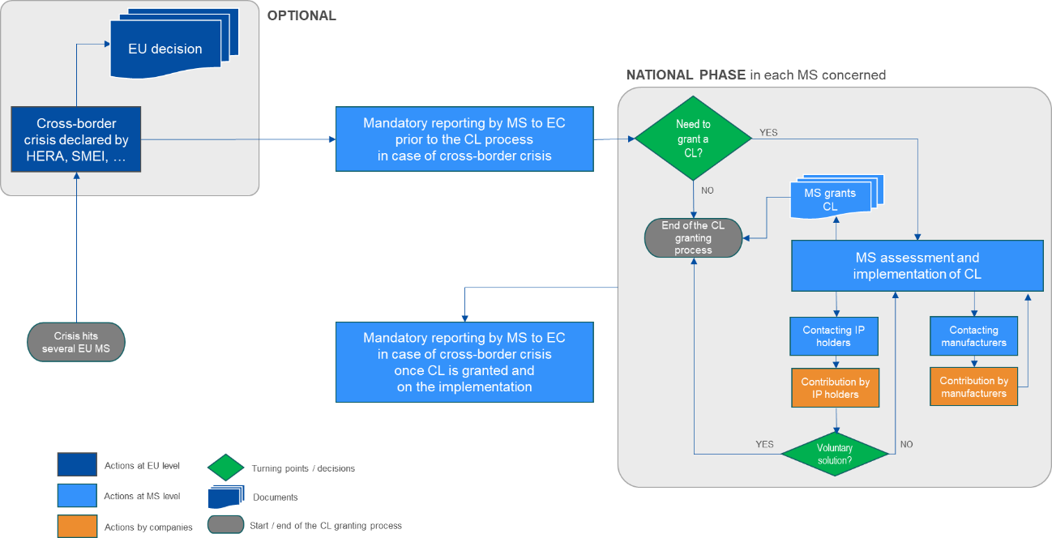

Figure 20: Detailed scheme describing the procedural steps foreseen under Option 3

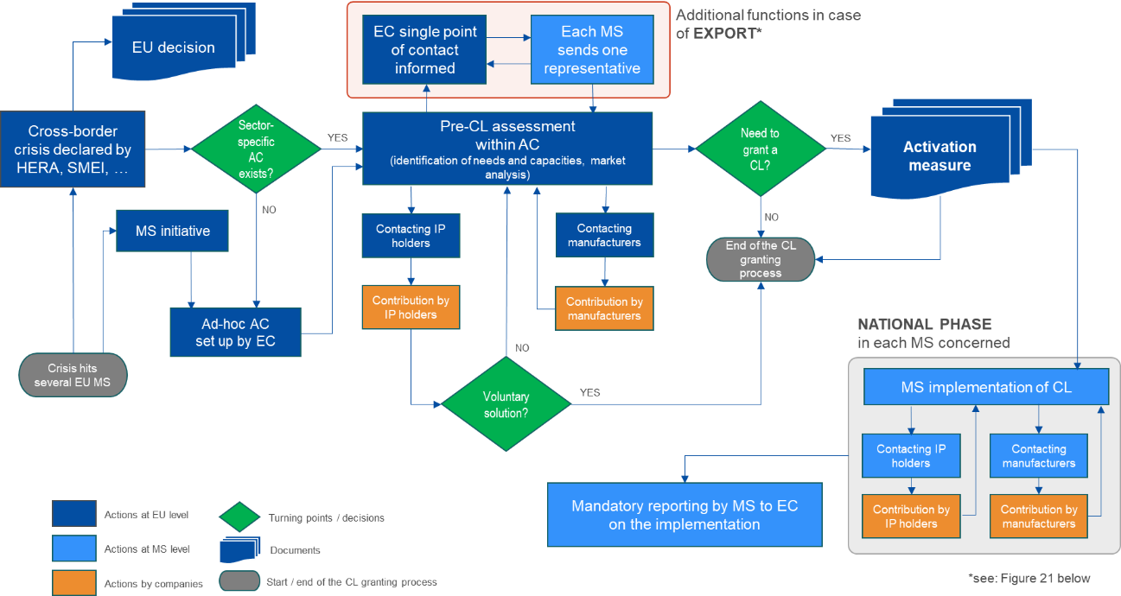

Figure 21: Detailed scheme describing the procedural steps foreseen under Option 3 (export)

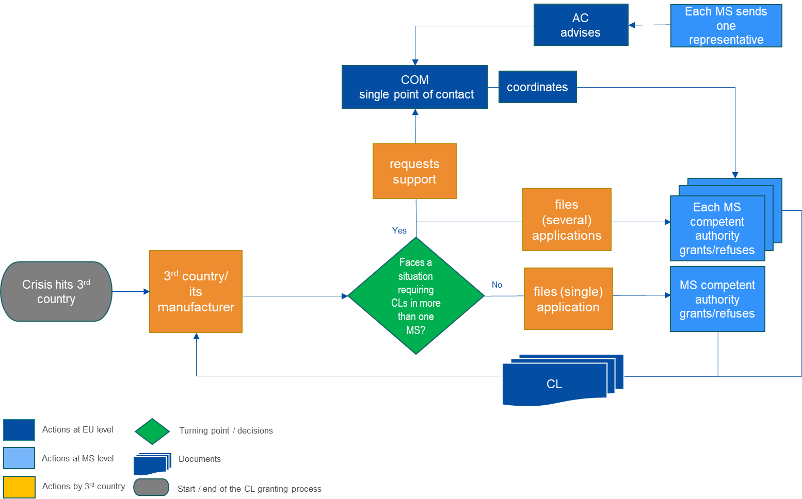

Note: AC – advisory committee, COM – the Commission, MS – Member State.

Figure 22: Detailed scheme describing the procedural steps foreseen under Option 4

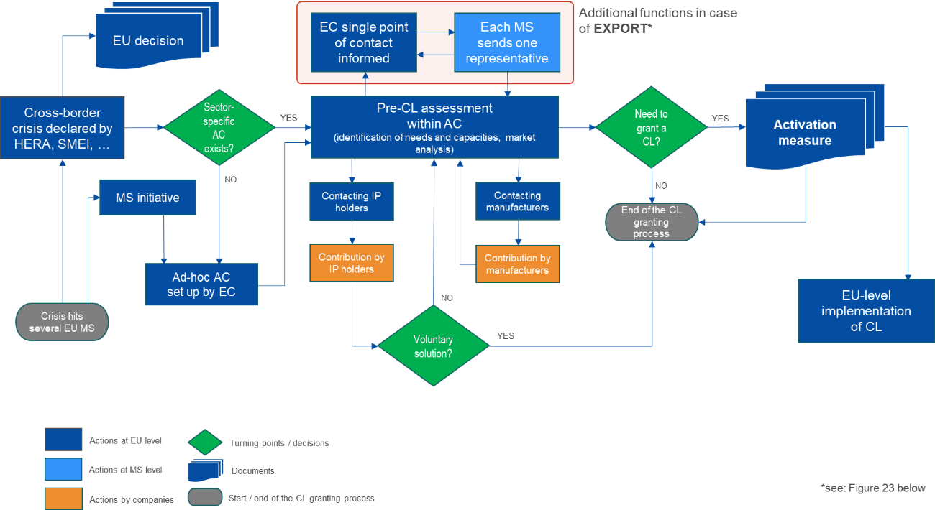

Figure 23: Detailed scheme describing the procedural steps foreseen under Option 4 (export)

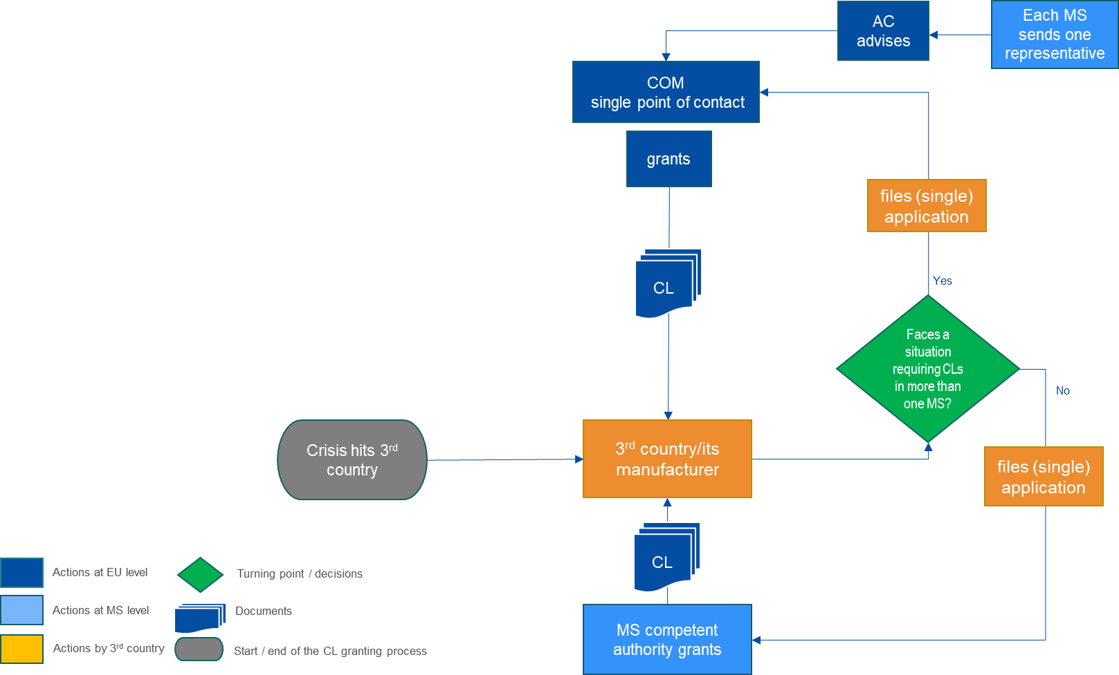

Note: AC – advisory committee, COM – the Commission, MS – Member State.

Figure 24: Typology of impact considered in this impact assessment

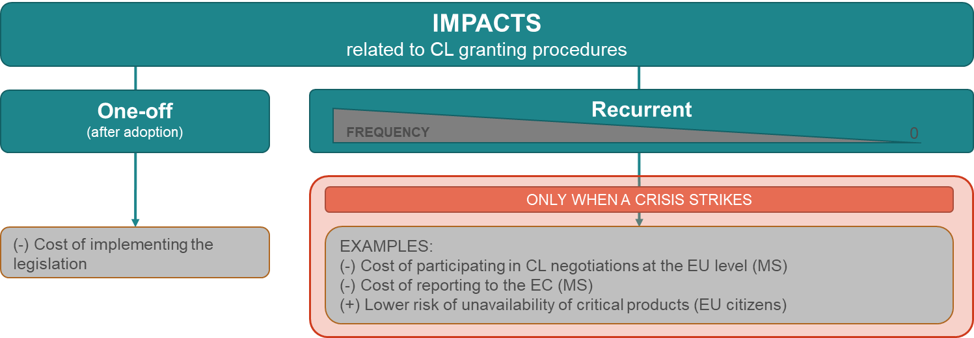

Source: own elaborations

Annex 7: Supplementary legal analysis: the principle of exhaustion in the Single Market

**1. The principle of EU-wide exhaustion in general**

EU rules on exhaustion are largely the result of the jurisprudence of the Court of Justice of the European Union interpreting Article 34 TFEU on measures having equivalent effect to quantitative restrictions between Member States. The Court of Justice has always interpreted the Treaty as meaning that rights conferred by IP rights are exhausted within the Single Market by virtue of putting the relevant goods on the market (by the right holder or with his/her consent) in the European Union. See for instance cases: e.g. Centrafarm and Adriaan de Peijper v Sterling Drug Inc (C-15/74), Merck and Co Inc. vs Stephar BV and Petrus Stephanus Exler (C-187/80).

Under EU law, once a good protected by an intellectual property right has been put lawfully on the market within the European Union (i.e. by the right holder or with his or her consent), the rights conferred by that intellectual property right in relation to the commercial exploitation of the good become exhausted. In that case, the right holder can no longer invoke the intellectual property right in question to prevent the further resale, rental, lending or other forms of commercial exploitation of the good by third parties.

In contrast, once a good protected by an intellectual property right has been put on the market within the EU by a person other than the right holder and without his or her consent, that right holder may inter alia oppose to the import by third parties of such good into the European Union or to the putting, resale or otherwise commercial exploitation of such good into the European Union market in so far as such import or commercial exploitation would constitute an infringement of the intellectual property right concerned.

**2. The principle of exhaustion as regards patents**

In principle, EU secondary law in relation to patents (including rules on supplementary protection certificates extending the protection of patents for pharmaceutical and plant protection products) do not include specific rules on exhaustion, but the general principles affirmed by the jurisprudence of the Court of Justice apply.

Otherwise, “*if a patent proprietor could preclude the importation of protected products marketed in another Member State by him or with his consent, he would be able to partition the national markets and thus restrict trade between the Member States, although such a restriction is not necessary to protect the substance of his exclusive rights under the parallel patents*.” See for instance case: Pharmon v Hoechst (C-19/84).

In this spirit also REGULATION (EU) No 1257/2012 OF THE EUROPEAN PARLIAMENT AND OF THE COUNCIL of 17 December 2012 implementing enhanced cooperation in the area of the creation of unitary patent protection states that in accordance with the case-law of the Court of Justice of the European Union, the principle of the exhaustion of rights should also be applied to European patents with unitary effect. Therefore, rights conferred by a European patent with unitary effect should not extend to acts concerning the product covered by that patent which are carried out within the participating Member States in which that patent has unitary effect after that product has been placed on the market in the Union by, or with the consent of, the patent proprietor, unless there are legitimate grounds for the patent proprietor to oppose further commercialisation of the product (Article 6 and recital 12).

**3. Lack of exhaustion of patent rights on products manufactured under a compulsory licence**

The relationship between the principle of EU-wide exhaustion and compulsory licensing was subject to the CJEU Judgement of 9 July 1985 (C-19/84, Pharmon v Hoechst). The judgement was based on the following facts:

* Hoechst was the proprietor of a patent in Germany and of parallel patents in the Netherlands and in the United Kingdom in respect of the same invention, namely a process for manufacturing the medicine known as 'frusemide'.
* DDSA Pharmaceuticals Ltd, a British company, obtained a compulsory license to exploit the invention in respect of the parallel patent granted to Hoechst in the United Kingdom.
* DDSA sold 'frusemide' tablets which it had produced under the compulsory license to Pharmon, a pharmaceutical company in the Netherlands who intended to market these pharmaceutical products in the Netherlands.
* Hoechst brought an action against Pharmon before the Dutch Courts for infringing rights arising under Hoechst's Netherlands patent.

The CJEU, which had been asked by the Hoge Raad of the Netherlands to give a preliminary ruling, made the following observations in its decision:

* First, the CJEU recalled that in accordance with the principle of the territoriality of the acts of the public authorities of a Member State, a compulsory licence cannot confer on its holder rights in the territories of the other Member States.
* Afterwards the CJEU clarified that the question is whether the principle of EU-wide exhaustion applies where the product imported and offered for sale has been manufactured in the exporting Member State by the holder of a compulsory licence granted in respect of a parallel patent held by the proprietor of the patent in the importing Member State. Briefly: Does EU-wide exhaustion apply to products manufactured under a compulsory licence?
* The CJEU pointed out that where a compulsory licence is granted to a third party which allows to carry out manufacturing and marketing operations which the patent proprietor would normally have the right to prevent, the patent proprietor cannot be deemed to have consented to the operation of that third party. Such a measure deprives the patent proprietor of his right to determine freely the conditions under which he markets his products.
* Finally, the CJEU stated that the substance of a patent right lies essentially in according the inventor an exclusive right of first placing the product on the market so as to allow him to obtain the reward for his creative effort. It is therefore necessary to allow the patent proprietor to prevent the importation and marketing of products manufactured under a compulsory licence in order to protect the substance of his exclusive rights under his patent.

Thus, following this judgement, products manufactured under a national compulsory licence (granted for the use of a national patent) in one Member State cannot be imported in another Member State (where there is a parallel patent) without the consent of the patent proprietor. When products are brought into circulation under a compulsory license the principle of EU-wide exhaustion does not apply. As regards the import of the protected products in another Member State, the patent proprietor is consequently allowed to stop this marketing operation.

**4. Consequences for cross-border supply in times of crisis**

Under the current compulsory licensing regime in the Member States, based on national law and domestic considerations, a Member State cannot consider the impact of a compulsory licence granted in its jurisdiction on the situation in other Member States. Nor can it make EU-wide arrangements when issuing a compulsory licence that would aim at tackling a cross-border crisis (territoriality of national compulsory licensing schemes). In this context, the lack of exhaustion of national patent rights on a product made under a compulsory license is a crucial obstacle preventing an EU-wide approach for addressing a crisis via a compulsory licence. There is no Single Market for products produced under a compulsory licence.

The free movement of goods in the Single Market is one of the fundamental freedoms of the Treaties (articles 34 and 35 TFEU). However, it is not applicable without restrictions. They can be justified by the protection of industrial and commercial property (article 36 TFEU). In its jurisdiction the CJEU has aimed at balancing the different interests involved by, on the one hand, allowing the free circulation of patented goods if the marketing was done with the consent of the patent owner (EU-wide exhaustion), but restricting the free circulation if this consent is missing, as in the case of a compulsory license (no EU-wide exhaustion). Whereas the advantages of a Single Market might not be needed when the crisis affects only one Member State that has the capacities to supply itself with critical products under a national compulsory license, the lack of a Single Market for such products and its effects become a significant barrier to cross-border supply in times of an EU-wide crisis when some Member States depend on the capacities of others.

If a product that is important for solving an EU-wide crises can be manufactured in one Member State under a compulsory licence, that compulsory licence would not allow the supply in another Member State. Multiple compulsory licences would need to be requested in all importing Member States. These additional compulsory licences in the importing Member States would be necessary to prevent the patent holder from exercising his patent rights to stop the goods from being imported (still exercisable due to the lack of exhaustion). Apart from the fact that requiring multiple national compulsory licenses is a high hurdle for cross-border supply within the EU Single Market, this also bears the risk of contradicting decisions (for instance diverging in content) due to the current legal fragmentation of national compulsory licensing schemes.

Annex 8: SME test

This SME-test investigates the impacts of the preferred policy option on SMEs that might be concerned by compulsory licencing issued to address a crisis.

The test has been conducted in line with the 4-steps foreseen, as following:

Step-1: Identification of affected businesses

As mentioned in Annex 3, the majority of EPO patent applications originating from European countries were filed by large companies (75%), followed by SMEs and individual inventors (20%), and 5% by universities and public research organisations (see: Figure 11). The 2022 IP SME Scoreboard collected data among 8.372 SMEs in all 27 EU Member States. Only 10 % of these SMEs reported that they own registered IP rights, such as patents. Among those SMEs owning a registered IP right, national trademarks are the most commonly owned registered type if IP right, owned by 6 % of SMEs. This is followed by EU trademarks (EUTM) and patents (both owned by roughly 4 % of SMEs – 4.2 % EUTMs and 3.6 % patents). The least frequently owned registered types of IP rights are breeder rights / plant variety rights (1 %) and registered Community design (2 %). Thus, the number of patents owned by SMEs is in general low. However, the initiative is considered relevant for SMEs as it targets patented products that are needed for crisis management, regardless of the patent owner (be it a large company or a SME). Since SMEs own patents, even if this applies to them to a small extent, it cannot be ruled out that a SME-owned patent will be subject of a compulsory licence. Nevertheless, as the initiative focuses on patents, only a very small part of the SMEs could possibly be affected directly by compulsory licencing.

Step-2: Consultations of SME Stakeholders

As far the OPC are concerned, the SMEs contributed, but they have not constituted the majority of respondents (74 in total, out of which 18 companies/business organisations), see Figure 25 below.

Figure 25: Number of respondents to the OPC by size-classes among companies

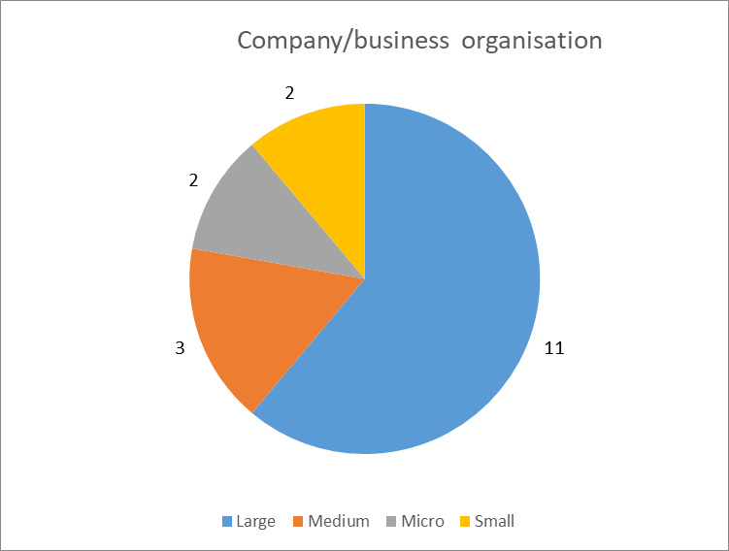

Source: OPC

Additionally, twenty two business associations contributed to the OPC, among which many could have represented the views of smaller companies. Inputs received in the OPC have not pointed out towards potential negative consequences towards SMEs. The same concerned the feedback received following the Call for Evidence.

Step-3: Assessment of the impact on SMEs

Impacts that may materialise as a result of the preferred option (PO4) will mainly concern the patent holders, but the number of SMEs that own IP rights in the EU is relatively low (see above). Furthermore, apart from the fact that a compulsory licence is an extreme event in terms of probability (last resort instrument that has been used very rarely in the past), it can be assumed that small enterprises are more prone to enter into voluntary agreements than larger firms, hence there could be no need to use the CL at all. This is because the manufacturing capacities of an SME may be insufficient to satisfy sudden increase in demand induced by crisis (e.g. carry-out large scale production to serve several Member States), so they would be more willing to benefit from remuneration from a licensing agreement. In other words, if during a major cross-border crisis there is a need for access to critical goods covered by a patent held by an SME, the probability that such circumstances would lead to CL negotiations is lower that if the patent holder was a large company.

Yet, if a CL is nevertheless granted, the terms and conditions for an SME would be the same as for a large company (i.e. the proposed rules would be identical, irrespective of the patent holder size).

Step-4: Minimising negative impacts on SMEs.

The preferred policy option (PO4) is not expected to have negative effects on SMEs.

1. Patent applications must be published and indicate the technical details of the invention they aim at protecting. The granting of a monopoly – limited in time – is done in exchange of sharing the technicalities underlying the invention, based on which new research and invention can develop. This is part of the inherent equilibrium of patent law; allowing at the same time incentive to innovate and access to innovation.
2. In this impact assessment the notion of critical good(s)/ products(s) refers to good(s)/ product(s) that are critical to tackle a crisis, notwithstanding the type of crisis that is being discussed.
3. Waiving IP rights would potentially consist of depriving the patent owner of its rights from the outset, including of the right to adequate remuneration.
4. Discussions at WTO level led to a Ministerial Decision in June 2022, which provided clarifications of existing flexibilities and waived one of the conditions for the production of COVID-19 vaccines, namely the requirement that a CL is granted “predominantly for the domestic market”. It also waived the application of Article 31bis of the TRIPS Agreement which provides for a specific procedure applicable to export. This means that COVID-19 vaccines manufactured under a CL issued under the Decision can be exported to other eligible countries in a much faster and simplified manner. Discussions are still ongoing as regards possible extension of the Decision to COVID-19 therapeutics and diagnostics (see Annex 5C).
5. IP action plan, [COM(2020) 760 final, 25.11.2020](https://ec.europa.eu/info/law/better-regulation/have-your-say/initiatives/13357-Intellectual-property-revised-framework-for-compulsory-licensing-of-patents_en).
6. Commission Work programme of 2023, available [here](https://eur-lex.europa.eu/resource.html?uri=cellar%3A413d324d-4fc3-11ed-92ed-01aa75ed71a1.0001.02/DOC_1&format=PDF).
7. The resolution on the intellectual property action plan to support the EU’s recovery and resilience (2021/2007(INI)).
8. Council conclusions of 18 June 2021, available [here](https://www.consilium.europa.eu/media/50529/st-9932-2021-init.pdf).
9. Where reference is made hereinafter to exports to third countries or non-EU countries, this refers to third countries covered by Regulation (EC) No 816/2006.
10. [Proposal](https://single-market-economy.ec.europa.eu/document/d1d0b38a-cec8-479d-be70-1ffae7e227a5_en) for a regulation of the European Parliament and of the Council establishing a Single Market emergency instrument and repealing Council Regulation No (EC) 2679/98.
11. [Regulation](https://eur-lex.europa.eu/legal-content/EN/TXT/?uri=uriserv%3AOJ.L_.2022.314.01.0026.01.ENG&toc=OJ%3AL%3A2022%3A314%3AFULL) (EU) 2022/2371 of 23 November 2022 on serious cross-border threats to health and repealing Decision No 1082/2013/EU.
12. [Council Regulation](https://eur-lex.europa.eu/legal-content/EN/TXT/?uri=uriserv%3AOJ.L_.2022.314.01.0064.01.ENG&toc=OJ%3AL%3A2022%3A314%3AFULL) (EU) 2022/2372 of 24 October 2022 on a framework of measures for ensuring the supply of crisis-relevant medical countermeasures in the event of a public health emergency at Union level.
13. [Proposal](https://eur-lex.europa.eu/legal-content/EN/TXT/?uri=celex:52022PC0046) for a regulation establishing a framework of measures for strengthening Europe's semiconductor ecosystem (Chips Act).
14. The term “compulsory licence” is found in national patent laws but not in the TRIPS Agreement where article 31 refers to the “use [of patents] without authorization of the right holder”.
15. Recital 10 of Regulation EU No 1257/2012 of 17 December 2012 implementing enhanced cooperation in the area of the creation of unitary patent protection provides that: “compulsory licences for European patents with unitary effect should be governed by the laws of the participating Member States as regards their respective territories.”
16. Regulation (EC) No 816/2006 of the European Parliament and of the Council of 17 May 2006 on compulsory licensing of patents relating to the manufacture of pharmaceutical products for export to countries with public health problems.
17. Plant variety rights cover varieties of all botanical genera and species that are distinct, uniform, stable, and new. In addition, the variety must be designated by a denomination in accordance with the provisions of Article 63 of Regulation No 2100/94 of 27 July 1994 on Community plant variety right. Regulation No 2100/94 of 27 July 1994 on Community plant variety right.
18. Article 29 of Regulation No 2100/94. A compulsory exploitation of rights shall be granted on grounds of public interest. Three grounds in particular can constitute a public interest: a) the protection of life or health of humans, animals and plants; b) the need to supply the market with material offering specific features; c) the need to maintain the incentive for continued breeding of improved varieties (see Article 41(2) of the Commission Regulation (EC) No 874/2009). An application for a compulsory licence was submitted to the Community Plant Variety Office in March 2017 but ultimately denies as the ground of public interest was not proven (see Decision of the Community Plant Variety Office of 28 March 2018, no. NCL001).
19. Article 12 of Directive 98/44/EC of 6 July 1998 on the legal protection of biotechnological inventions.
20. Article 31 of the TRIPS Agreement requires that efforts must be made to obtain authorisation from the right holder on reasonable terms and conditions and that such efforts proved unsuccessful. However, there are no specific rules on what those terms and conditions are or what type and length of efforts are required. Also, this requirement can be waived in “the case of a national emergency or other circumstances of extreme urgency or in cases of public non-commercial use”.
21. However, views on this issue are contrasted among stakeholders: although all (4) public authorities and almost all companies and business association (85%, N=34) agreed with the last resort approach, 4 out of 6 NGOs having replied to the public consultation disagreed.
22. E.g. when the voluntary agreement would not ensure the manufacturing and delivery of the critical goods in a timely manner (e.g. several months or years depending on the nature of the crisis).
23. E.g. when the voluntary agreements would not ensure a sufficient production of critical goods to tackle the crisis.
24. Vaccines and therapeutics provide a good example of the importance of patented inventions as a solution to address a crisis, as illustrated by the COVID-19 crisis.
25. *Patent Index 2021 – Statistics at glance*, EPO 2022, status: 1.2.2022, page 8.
26. Or entering into a manufacturing and purchase agreement with the patent owner, or ensuring the conclusion of a licensing agreement, allowing a licensee to manufacture the critical goods or using the critical technology.
27. Based on PatentSight® query of all patents active in EPO (“active in” understood as the authority in which at least one member of the patent family is active; this includes both pending applications that are still under prosecution and granted patents that are still in force) that resulted in 103 052 unique owners. The analysis was based on 525 329 patent families active at 12/08/2022.
28. This is true for all groups of stakeholders. For instance, 72.5% (N=29) of the companies and business associations, all NGOs, all citizens and three out of four public authorities agree.
29. The terms „a cross-border crisis” or „a crisis affecting the Single Market” will be used interchangeably.
30. Additional explanation and illustrative examples are provided in Figure 15 and Figure 16 in Annex 6.
31. The scenario assumes a CL per country. In practice, the numbers may be lower if some of the importing countries were able to manufacture the necessary components, or higher if some additional CLs were necessary between the manufacturing countries, for example for other items necessary in production.
32. Based on WIPO PatentScope COVID-19 Index (<https://patentscope.wipo.int/search/en/covid19.jsf>)
33. The results of the analysis by selected IPC groups and subgroups are presented in Table 18 (Annex 6). For further details on the methodology, please see Annex 4.
34. For pharmaceutical products, see: *Pharma supply chains of the future,* EY 2022*,* Figure 1, p. 2 that depicts complex multi-country value chain of a medicinal product based on the following stages: 1. Active pharmaceutical ingredient manufacturing, 2. Formulation, 3. Primary packaging, 4. Secondary packaging.
35. Meaning that extra-EU exports were higher than intra-EU exports.
36. <https://ec.europa.eu/eurostat/statistics-explained/index.php?title=Intra-EU_trade_in_goods_-_main_features>
37. The electronics sector is one of the most internationally fragmented sectors, see Figure 18 in Annex 6, Source: Gaulier, G., Sztulman A., Ünal D., *Are Global Value Chains Receding? The Jury Is Still Out. Key Findings from the Analysis of Deflated World Trade in Parts and Components*, CEPII Working Paper 2019-01, Paris.
38. Two thirds of respondents to the OPC consider that the Regulation 816/2206 allows for speedy and efficient procedures for granting compulsory licences to export pharmaceutical products to third countries. Views greatly diverge depending on the group of respondents (all NGOs disagree with this view). When asked about what elements of the regulation could be streamlined, around a third of respondents having expressed an opinion mention the accelerated and simplified procedure (37%) and the conditions to submit an application (30.5%). Slightly more respondents (40%) consider that the procedure set by Regulation (EC) No 816/2006 should be made more flexible to adapt to the needs of the importing countries.
39. Although an explicit reference is made to compulsory licensing to tackle crises. Article 31 of the TRIPS Agreement provides indeed that in the case of a national emergency or other circumstances of extreme urgency, the best-efforts requirement to obtain an authorisation from right holder can be waived.
40. When a patented invention cannot be exploited without infringing an invention patented beforehand.
41. This notion is generally not defined nor exemplified. Most of the time a case-by-case approach prevails, as this is for instance the case in DE, see EPO (2018), p 30. Compulsory licence for Community plant varieties can also be issued on a public interest ground.
42. See Table 19 (Annex 6) listing the different provisions applicable in the EU countries and based on which a compulsory licence could be granted to tackle a crisis.
43. To be noted that FR also restricts the grounds on which a compulsory licence can be granted to public health, national defence, and national economy.
44. Such as FR, IE, and MT, see “Compulsory licensing of intellectual property rights”, Center for International Intellectual Property Studies (CEIPI), Université de Strasbourg (UNISTRA), Impact Licensing Initiative (ILI), Ecorys Nederland BV (Ecorys), Brussels 2023, p. 41 and Table 21 in Annex 6.
45. As reported by CEIPI(2023). Based on that, the patent court of The Hague has refused to grant a compulsory licence for a European Patent application on the ground that the final scope of the application was uncertain and could only be determined after the grant of the patent.
46. An SPC is an IP right that serve as an extension to a patent right, applicable, under specific conditions, to medicinal and plant protection products that have been authorised by regulatory authorities.
47. SPCs are covered by compulsory licensing laws in HR, CZ, EE, EL, HU, LT, RO and SK. In other EU countries, in the absence of any explicit reference or authoritative official documents of interpretative value, legal uncertainty persists, see CEIPI(2023), page 38.
48. A questionnaire was sent to national experts to identify the scope of national compulsory licensing schemes. Responses of the national experts show that the lack of explicit reference to SPC gives rise to legal uncertainty and different interpretation of similarly worded provisions, see CEIPI(2023), page 40.
49. Article 1 of Regulation (EC) No 816/2006 provides that “This Regulation establishes a procedure for the grant of compulsory licences in relation to patents and supplementary protection certificates concerning the manufacture and sale of pharmaceutical products, when such products are intended for export to eligible importing countries in need of such products in order to address public health problems.”
50. See the protection periods set out in Article 14(11) of Regulation (EC) No 726/2004 and in Articles 10(1) and 10(5) of Directive 2001/83/EC.
51. In 2016, the Romanian government contemplated issuing a compulsory licence for the medicine sofosbuvir. However, data exclusivity was only to expire in 2022. In such circumstances, issuing a compulsory licence would have been useless as data exclusivity would still prevent the registration of a generic version of sofosbuvir. See E. ‘t Hoen, P. Boulet and B. Baker, Data exclusivity exceptions and compulsory licensing to promote generic medicines in the European Union: A proposal for greater coherence in European pharmaceutical legislation, [Journal of Pharmaceutical Policy and Practice](https://www.ncbi.nlm.nih.gov/pmc/articles/PMC5490222/pdf/40545_2017_Article_107.pdf) (2017).
52. CEIPI(2023) p. 50 and Table 21 in Annex 6.
53. See Annex 6, Table 20.
54. For instance, in the context of a compulsory licence for public health purposes in BE the application is submitted to the Minister of Economy and forwarded to the Bioethics Advisory Committee.
55. For instance, in BE the patent holder has one month to file her observations on the grant of a compulsory licence and the level of remuneration.
56. See article 7 of Regulation (EC) No 816/2006.
57. Preliminary relief proceedings are short proceedings seeking an immediate provisional judgment in a civil dispute.
58. “European Patent Office, Compulsory licensing in Europe - A country-by-country overview”: Unavailable in: BE, EL, PL, Uncertain: IE, FR, FI, ES, DK, SE.
59. The competence to assess, grant or refuse an application remains with national competent authorities who retain a margin of manoeuvre in that respect.
60. National experts were asked how provision only referring to ‘patent’ in singular form should be interpreted. Views greatly varied between national experts. Some (e.g. experts from AT, BG, DK, FR and LU) considered that a compulsory licence could only be granted per single patent. Others (e.g. EE, FI, EL, LT, LU, PL, RO and ES) considered that the law does not prohibit that a compulsory licence covers more than one patent, see CEIPI(2023) p. 37,
61. Article 6(3) of Regulation (EC) No 816/2006 provides that “The application pursuant to paragraph 1 shall set out the following: (…) the non-proprietary name of the pharmaceutical product or products which the applicant intends to manufacture and sell for export under the compulsory licence”. However national divergences can remain as Member States may prescribe requirements on the identification of the patent(s) and/ or supplementary protection certificate(s).
62. See for instance AT (a CL can only be requested four years after the application date or three years after the grant date); NL (a CL can only be requested after three years of lack of use); IT (a CL can only be requested four years after the application and three years after the grant).
63. For instance, in AT the appropriate remuneration is determined by the Austrian Patent office taking into account the economic value of the licence. In DK, the remuneration is decided in accordance with the general principles of damages.
64. For instance, in AT the appropriate remuneration is determined by the Austrian Patent office taking into account the economic value of the licence. Likewise in ES the Spanish Patent and Trade mark office is competent to decide on the remuneration, based on the economic importance of the invention. In DK, the remuneration is decided the granting court in accordance with the general principles of damages. Court also has the discretion to determine the amount of remuneration in DE.
65. This is for instance the case in BE.
66. They are based on the understanding that: (i) a compulsory licence as a governmental act is necessarily limited to the governed territory and (ii) the compulsory licence (as the limiting factor of the patent) shares the territorial scope of the limited right (national patent).
67. For instance HR: “situations of extreme urgency on a national level”; EE: “national defence, environmental protection, public health or other significant national interests of the Republic of Estonia”; DE: “epidemic situation of national importance”; HU: “in the interest of meeting domestic demand”; IT: “national health emergency”; PL: “to prevent or eliminate the state of national emergency” and “to prevent or remove a threat to important state interests”; RO: “in national emergency”.
68. In other words, once a product is put on the EU market by the IP owner or with the consent of the IP owner, this good can be freely resold, rented, lent throughout the Union. The rights of the IP owner are exhausted; the patent owner cannot further invoke patent rights to oppose the resale, rental, lending or other forms of commercial exploitation of the good by third parties when done in another Member State.
69. If the reply is in the negative, the patent rights are not exhausted. In other words, the patent owner can oppose any further distribution of the goods.
70. CJEU, Judgement of 9 July 1985, C-19/84 (Pharmon), ECLI:EU:C:1985:304.
71. It should however be reminded that since EU countries have opted out from the possibility to be importers under Article 31bis of the TRIPS Agreement, they cannot benefit from the system
72. See article 10(4) of Regulation (EC) No 816/2006.
73. As explicitly required by the TRIPS Agreement. Importation in other countries or into the Single Market is prohibited (see Article 13 of Regulation (EC) No 816/2006).
74. Currently 17 Member States, and up to 25 EU Member States (participating in the enhanced cooperation on unitary patent protection). The unitary patent system will stimulate research, development and investment in innovation, and contribute in that respect to the Union’s resilience. The unitary patent system does not provide for specific rules for compulsory licensing. It only foresees that compulsory licences for unitary patents (‘European patents with unitary effect’) should be governed by the laws of the participating Member States as regards their respective territories (Recital 10 of Regulation (EU) No 1257/2012). For the participating Member States, this means maintaining the status quo, as their existing national compulsory licensing systems, limited to their respective territories, will apply. A CL granted in respect of a unitary patent will not share its unitary nature, and may for instance affect a single Member State, or a few of them – not necessarily all 17 Member States covered by unitary patents (initially).
75. The 17 Member States in which the unitary patent system will initially apply represent about 75 % of the Union’s GDP.
76. For example where the US successfully relied on CL to conclude a voluntary agreement on reasonable terms stems from 2001: when facing anthrax attacks, the US government threatened to grant a CL for the relevant antibiotic drug should Bayer not lower the price thereof. Eventually Bayer lowered the price of its antibiotic drug. Likewise, the US government appeared in a better position than the EU to conclude voluntary agreements during the COVID-19 crisis, which can at least partly be attributed to its possibility to rely on compulsory licensing. By contrast, the EU was not able to rely on an EU-level compulsory licensing as a bargaining chip in the context of negotiations on vaccines.
77. Regulation (EU) No 1257/2012 of the European Parliament and of the Council of 17 December 2012 implementing enhanced cooperation in the area of the creation of unitary patent protection.
78. Understood as countries covered by Regulation (EC) No 816/2006.
79. E.g. in the context of the COVID-19 crisis, only one compulsory licence was granted in the EU (HU).
80. Italy, 2005 – SPC on medicine imipenem-cilastatin (for further details see Table 25 in Annex 6).
81. Germany, 2016 - Medicine raltegravir (for further details see Table 25 in Annex 6).
82. Austria, 1972 - Medicine inderal propranolol hydrochloride (for further details see Table 25 in Annex 6).
83. A submission from Canadian pharmaceutical company Apotex Inc. to manufacture Apo-TriAvir (an HIV antiretroviral drug) was received by Health Canada in December 2005. The medicine was sent to Rwanda in two shipments in September 2008 and 2009.
84. Only 5% (N= 4) respondents to the public consultation consider that compulsory licensing should never be used in crises. Among the respondents having given their opinion on the types of specific crises that should be covered by a compulsory licence, a majority favours a large approach (i.e. crises related to health, war and large-scale attack, energy, and natural disasters). Furthermore, 27 respondents replied to the sub-question on which types of specific crises should be covered. Out of these 27 replies, 25 mentioned health-related crises, 21 war and large-scale attack, 19 energy and 19 natural disasters.
85. Half of the respondents (N= 37) to the public consultation are in favour of a scope covering patent applications, with few disparities between the main categories of stakeholders, except for companies and business associations who remain mainly against (for more details see Annex 2 and Table 25 in Annex 6).
86. 65% of the respondents (N= 48) to the public consultation are in favour of a scope covering SPCs, with few disparities between stakeholders (for more details see Annex 2 and Table 27 in Annex 6).
87. Stakeholders generally agree that RDP should not be an obstacle to the effective implementation of a compulsory licence, see CEIPI(2023) p. 46. As for the OPC, although in absolute terms only 32% of the respondents (N= 37) to the public consultation are in favour of a scope covering RDP, this low score is explained by the many companies and business associations being against it, which is understandable due to their legitimate commercial interests. NGOs, public authorities, and academic/ research institution were predominantly in favour (for more details see Annex 2 and Table 28 in Annex 6).
88. 36% of respondents (N=27) welcome if compulsory licences also included the know-how. However, views are extremely contrasted on this point with only 5% of companies and business associations being in favour. In contrast, academia, NGOs and public authorities, all but one are in favour of including know-how in the scope of a compulsory licence (for more details see Annex 2 and Table 29 in Annex 6).
89. There may be situations in which allowing the use of a patent the invention through a compulsory license is not sufficient to enable the licensee to effectively produce the crisis-relevant goods. This can particularly be the case for complex products that require, in addition to the permission to use the invention, the transfer of know-how including skills, abilities and knowledge. To this end, both parties involved, rights-holder and licensee, should act together in good faith to enable the transfer of the knowledge (know-how) associated with the patented invention, considering the interests of both parties.
90. As regards RDP, the pharmaceutical review would include the lifting of RDP in case of compulsory licensing granted to tackle a crisis.
91. Additionally, 43% of the respondents to the public consultation would welcome an alignment of the type of procedure (administrative or judicial procedure). When it comes to NGOs and academia, 8 out of the 11 respondents are in favour of such alignment. On recourse procedure, a bit more than a third of respondents to the public consultation agree with an alignment of the time limit within which the application of an appeal is admissible (42%, N= 31) and an accelerated appeal procedure (38%, N= 28). 35% (N= 26) of respondents are in favour of the suspensive effect of an appeal.
92. Pre-defined rules on remuneration are deemed useful to speed-up the granting of a compulsory licence by 42% of the respondents to the public consultation.
93. Interestingly, respondents identifying themselves as likely to be the subject of a compulsory licence generally (75%) agree with the cross-border use of a compulsory licence. Stark contrast exists among the different categories of stakeholders, as illustrated in Annex 6.
94. Or recommendation to do so in Option 1.
95. Business associations and company/business organisation accounted for 54% of respondents to the OPC (see Table 12 in Annex 2)
96. In such case, the EU-level decision activating a crisis mode should fulfil the conditions under that specific crisis instrument (e.g. crisis activation decision under SMEI or SCBTH– see Table 22 in Annex 6).
97. The request would have to be made by the Member States willing to be covered by the EU-level compulsory licence (as a manufacturing or receiving country).
98. In order to ensure as much coherence as possible with existing crisis instruments and other acts at Union level, the proposed initiative should draw on existing definitions. For example, the definition of a ‘crisis-relevant product’ could be based on the definitions of SMEI. In similar vein, the determination of the existence of a crisis or emergency would rely on the Union legal act underlying the crisis mechanism and the crisis definition included therein.
99. I.e. a crisis covering multiple EU countries or with manufacturing capacities in a different country than the one experiencing the crisis or with manufacturing capacities spread across several EU countries.
100. E.g. an implementing act.
101. When the advisory body is an existing one, its existing rules of procedure should apply. As regards *ad hoc* advisory bodies, they should be composed of one representative of each Member State in order to provide the Commission with information and input stemming from the national level including information on manufacturing capacities, potential licensees and, if applicable, proposals for voluntary solutions. In addition, the advisory body should have the function of collecting and analysing relevant data as well as ensuring coherence and cooperation with other crisis relevant bodies at Union and national level.
102. The non-binding opinion of the advisory body should be considered in the decision-making process. The advisory body would have to consider the comments made by the patent owner(s). Persons, in particular the licensee and the rights-holder, whose interests may be affected by the compulsory licence should be given the opportunity to submit their observations beforehand.
103. Further details on the possible remuneration criteria are provided in Annex 6.
104. The procedure would however depend on the type of act through which the binding opinion would be granted. It would however always include a judicial procedure, as per requested by the TRIPS Agreement. As regards national decision (and under PO3 aspects such as the remuneration), appeal would be done at national level.
105. E.g. the harmonisation would include some criteria to determine the remuneration at national level.
106. The margin of manoeuvre would concern aspects that are not strictly linked to the crisis. For instance, as regards remuneration, Member States would be able to decide on the amount of remuneration to be paid to the patent owners but should take into account some criteria, such as the economic value of the use authorised under the licence or the non-commercial circumstances relating to the issue of the licence. This option would also provide for coordination on the adequate remuneration with other concerned Member States. On remedies, this option would require Member States to set up a judicial procedure to appeal the national granting decision, in particular as regards remuneration aspects and respect of the conditions set up by the Commission activation measure.
107. Either the advisory body attached to the crisis instrument in the context of which the compulsory licence is granted or, in the absence of such body, the ad hoc advisory body – see footnote 101.
108. Member States would have to provide the EC with key information on the compulsory licence (the subject matter of a CL, companies involved such as patent holders and/or manufacturers, the conditions agreed, etc.).
109. The single contact point should be established at the Commission and act as a focal and coordination point in case third countries face a situation when planning its activities under Regulation (EC) No 816/2006 that requires compulsory licences in more than one Member State.
110. Or applicants as identified by Article 6 of Regulation (EC) No 816/2006.
111. Along the lines of what is provided under PO3.
112. In case of a crisis with a cross-border aspect, along the lines of what is provided under PO3.
113. See footnote 101.
114. Including the appeal procedure, which will depend on the nature of the act (e.g. implementing act or Commission decision) granting the compulsory licence. In contrast to PO3, there will be no national granting decision and therefore no national appeal procedure.
115. Member States would retain full competence to grant national compulsory licences. This option would just add an additional layer to the existing national schemes on compulsory licensing.
116. Just like under PO3, the e advisory body should consider the comments made by the patent owner(s).
117. This would certainly be the case when the trigger is outside an EU crisis instrument and where the procedure leading to the granting of an EU-level compulsory licence would be a request made by more than one Member State to the Commission. In the context of EU crisis instrument, the trigger would usually be a Council decision, such as under SMEI, which would also involve Member States.
118. Including when the procedure is being initiated by some but not all Member States. In such case, all Member States would be represented in the advisory body, so to allow exchange of information and views on the need to issue a compulsory licence and the conditions (including the territorial scope) surrounding such compulsory licence.
119. The appeal procedure would depend on the nature of the act granting the licence but would always involve a judicial review, as requested under the TRIPS Agreement.
120. The Commission would also have the possibility to terminate the licence, subject to adequate protection of legitimate interests, if the conditions of the licence are not respected.
121. If the compulsory licence is granted in the context of an EU crisis instrument, the duration of the compulsory licence should be aligned to the duration of the emergency mode decided in the context of that EU crisis instrument. If the compulsory licence is granted upon request of the Member States, the duration will be specified in the EU-level compulsory licence, after having heard the advisory body (including the patent owner(s) should it make comment on this aspect).
122. Criteria to determine the remuneration would be set-up. The remuneration would be specified in the act granting the EU-level compulsory licence, after having heard the advisory body.
123. The patent owner(s) would have to collaborate in good faith. An obligation to disclose trade secrets would not be provided.
124. Notably: a) the establishment of a single procedure and decision-making at EU level instead of multiple procedures and decisions at national level; b) access to an accelerated procedure (e.g. no best effort obligation to conduct negotiations); c) appeals against decisions should have no suspensive effect, so that the licensee can already start producing under the compulsory licence, regardless of the outcome of the proceedings.
125. See *supra*, point 1.2.
126. A design means ‘the appearance of the whole or a part of a product resulting from the features of, in particular, the lines, contours, colours, shape, texture and/or materials of the product itself and/or its ornamentation’ (Article 3 of regulation (EC) No 6/2002 of 12 December 2001 on Community design, see also Article 1 of Directive 98/71/EC of the European Parliament and of the Council of 13 October 1998 on the legal protection of designs).
127. Article 1(2) of Directive 2009/24 of 23 April 2009 on the legal protection of computer program provides indeed for that “protection in accordance with this Directive shall apply to the expression in any form of a computer program. Ideas and principles which underlie any element of a computer program, including those which underlie its interfaces, are not protected by copyright under this Directive.”
128. One in each of the manufacturing Member States and one in each of the importing Member States.
129. The UN noted that “without urgent socio-economic responses [to the COVID-19 pandemic], global suffering will escalate, jeopardizing lives and livelihoods for years to come. Immediate development responses in this crisis must be undertaken with an eye to the future. Development trajectories in the long-term will be affected by the choices countries make now and the support they receive”, <https://www.undp.org/coronavirus/socio-economic-impact-covid-19>
130. According to CEPI “*The COVID-19 pandemic resulted in an unprecedented economic contraction in 2020, with EU real GDP falling by 6.1%, more than during the global financial crisis*.”, source: <https://cepr.org/voxeu/columns/eu-economy-after-covid-19-implications-economic-governance>
131. “*Intellectual property rights are designed to promote the creation of innovations and thus to promote economic advance and consumer welfare. This occurs by giving the innovator an exclusive legal right to the economic exploitation of his innovation for a period of time; the reaping of profits serves both to reward the innovator for his investment and to induce others to strive to innovate in the future.*”, source: “Competition policy and intellectual property rights”, OECD 1989, p.10.
132. “*The excessive use of compulsory licensing, for example, could lead to increased secrecy and lower investment in R & D.*”, source: *Idem,* p.12
133. As explained in section 5, the reporting obligation would cover: the subject matter of a CL, MS concerned, companies involved (patent holders and/or manufacturers), and the conditions agreed.
134. No particular data exchange systems are envisaged, the CL negotiations would take place as either physical meetings or remotely using existing secured ICT technologies.
135. Based on the estimate of the average number of Member States where Covid-related patents are active, as explained in section 2.2 (for further details see Annex 4 and 6).
136. Yet, this role could be undertaken by the authorities competent for compulsory licensing for export purposes to be designated under Regulation (EC) No 816/2006, see footnote 101.
137. While it is very difficult to estimate the costs of such process as there is no similar precedent, it is assumed that CL negotiations should not take longer than 5 full-day meetings (40 hours) involving a Head of unit, 2 desk officers and secretariat support, while the monitoring of CL implementation might involve 1 FTE over the period of 6 months per a CL case (so 1/6 of FTE per month on average).
138. Based on PatentSight® query of all patents active in EPO (“active in” understood as the authority in which at least one member of the patent family is active; this includes both pending applications that are still under prosecution and granted patents that are still in force) that resulted in 103 052 unique owners. The analysis was based on 525 329 patent families active at 12/08/2022. The number could be higher as the proposed initiative could concern any patent and not only the EP.
139. More than 2 million enterprises were classified as manufacturing in the EU in 2019 (i.e. NACE section C), source: Eurostat dataset sbs_sc_sca_r2, last updated on 27/10/2022.
140. As explained earlier in this impact assessment, safeguards will be established along the whole CL “lifecycle”, notably: i) pre-granting: an EU level CL could only be triggered in specific conditions, with a high threshold (i.e. activation of an EU emergency/ crisis mode, request by more than one Member State in the case of a crisis in the EU with a cross-border dimension); ii) granting: when considering the need to issue a CL and the conditions thereof, the Commission will be assisted by an advisory body, involving Member States and relevant stakeholders; iii) post-granting: the CL granting decision (including the conditions) will be subject to appeal before a judicial court.
141. As illustrated in Table 25 (Annex 6) less than a dozen compulsory licences has been granted in the EU over the last decade, including non-crisis and plant variety compulsory licences.
142. https://ec.europa.eu/info/law/better-regulation/have-your-say/initiatives/13357-Intellectual-property-revised-framework-for-compulsory-licensing-of-patents_en
143. By respondents we refer here to the respondents to the public consultation.
144. This is also true for companies and business associations that consider that rules on compulsory licensing are able to tackle national crises (94%), EU-wide crises (89%) and global crises (92%).
145. Including in particular the interviews and workshops organised within the framework of the CEIPI(2023) study and the OPC.
146. CEIPI(2023), p. 38.
147. CEIPI(2023), p. 47.
148. CEIPI(2023), p. 85.
149. CEIPI(2023), p. 29.
150. CEIPI(2023), p. 73.
151. Some minor administrative costs of reporting may be incurred by Member States, which do not fall under the ‘one-in one-out’ approach.
152. The frequency of recurrent costs is expected to be extremely low, as they would be incurred only in the event of a cross-border crisis and if there is a need to use compulsory licensing for crisis management.
153. If establishing a separate committee necessary (otherwise the existing bodies would be used).
154. <https://patentscope.wipo.int/search/en/covid19.jsf> (the new PatentScope search facility provides search queries specially curated by patent information experts who have identified technological areas relevant to the detection, prevention and treatment of COVID-19)
155. Established by the Strasbourg Agreement of 1971.
156. <https://ec.europa.eu/eurostat/statistics-explained/index.php?title=Glossary:International_patent_classification_(IPC)>
157. Unless supplemented by a text search, which is also an option offered in PatentScope COVID-19 INDEX.
158. PatentSight® is a commercial patent database accessible upon subscription (<https://go.patentsight.com/?welcome=1> )
159. Based on the “Active Authorities Today” variable which listed names of countries where the patents were active (i.e. the authorities in which at least one member of the patent family is currently active. This includes both pending applications that are still under prosecution and granted patents that are still in force)
160. As explained earlier observations were searched (filtered) by IPC groups and subgroups, but once identified, only their subclass IPC codes were exported as this level of granularity was judged sufficient for later descriptive analysis.
161. OECD, *Measuring the technological and economic value of patents, ENQUIRIES INTO INTELLECTUAL PROPERTY'S ECONOMIC IMPACT © OECD 2015, p. 92.*
162. Paris [Convention](https://wipolex.wipo.int/en/text/287556) for the protection of industrial property of March 20, 1883.
163. See article 5(2) of the Paris Convention that provides for that “*Each country of the Union shall have the right to take legislative measures providing for the grant of compulsory licenses to prevent the abuses which might result from the exercise of the exclusive rights conferred by the patent, for example, failure to work*”. Article 5(3) further provides that forfeiture of the patent shall not be provided for except in cases where the grant of compulsory licenses would not have been sufficient to prevent the said abuses and article 5(4) states that a compulsory license may not be applied for on the ground of failure to work or insufficient working before the expiration of a period of four years from the date of filing of the patent application or three years from the date of the grant of the patent, whichever period expires last.
164. The term “compulsory licence” is found in national patent laws but not in the TRIPS Agreement where article 31 refers to the “use [of patents] without authorization of the right holder”.
165. The [Doha Declaration](https://www.wto.org/english/thewto_e/minist_e/min01_e/mindecl_trips_e.pdf) states in that respect that: “Each Member has the right to grant compulsory licences and the freedom to determine the grounds upon which such licences are granted.” Article 31 lists some possible grounds (national emergency or extreme urgency, public non-commercial use, remedy to anti-competitive practices, dependency of patents) that are often included in national legislations (see in that respect the EPO study on Compulsory licensing in Europe, 2018). The only limitation as regards grounds concern semi-conductors where article 31 TRIPS provides that compulsory licensing in such case shall only be for public non-commercial use or to remedy a practice determined after judicial or administrative process to be anti-competitive.
166. Regulation (EC) No 816/2006 of the European Parliament and of the Council of 17 May 2006 on compulsory licensing of patents relating to the manufacture of pharmaceutical products for export to countries with public health problems.
167. Recital 10 of Regulation EU No 1257/2012 of 17 December 2012 implementing enhanced cooperation in the area of the creation of unitary patent protection provides that: “compulsory licences for European patents with unitary effect should be governed by the laws of the participating Member States as regards their respective territories.”
168. Article 19 of Regulation (EC) No 816/2006 provides that “Three years after the entry into force of this Regulation, and every three years thereafter, the Commission shall present a report to the European Parliament, the Council, and the European Economic and Social Committee on the operation of this Regulation including any appropriate plans for amendments. The report shall cover, in particular: (a) the application of Article 10(9) on determining the remuneration of the rights-holder; (b) the application of the simplified and accelerated procedure referred to in Article 16(4); (c) the sufficiency of the requirements under Article 10(5) to prevent trade diversion, and (d) the contribution this Regulation has made to the implementation of the system established by the Decision.”
169. Regulation No 2100/94 of 27 July 1994 on Community plant variety right.
170. Article 29 of the Plant Variety Regulation.
171. Article 12 of Directive 98/44/EC of 6 July 1998 on the legal protection of biotechnological inventions.
172. Article 31 of the TRIPS Agreement requires that efforts must be made to obtain authorisation from the right holder on reasonable terms and conditions and that such efforts proved unsuccessful. However, there are no specific rules on what those terms and conditions are or what type and length of efforts are required. Also, this requirement can be waived in “the case of a national emergency or other circumstances of extreme urgency or in cases of public non-commercial use”.
173. The Doha Declaration states in that respect that “Each Member has the right to determine what constitutes a national emergency or other circumstances of extreme urgency, it being understood that public health crises, including those relating to HIV/AIDS, tuberculosis, malaria and other national emergency or other circumstances of extreme urgency”.
174. Before the TRIPS Agreement, Low and Medium Income Countries (LMCIs) were able to obtain medicines manufactured in countries where patent rights were not recognised. The TRIPS Agreement put a stop to such practices as WTO members were under the obligation to grant and respect patent rights and only allow compulsory licensing predominantly for the supply of their domestic market.
175. Active ingredients necessary for its manufacture and diagnostic kits needed for its use are explicitly included. Vaccines are not explicitly mentioned but it is usually considered that they are covered.
176. Members can decide to use the system as importers in a limited way, for example only in the case of a national emergency or other circumstances of extreme urgency or in cases of public non-commercial use.  This was for instance the case of some EU countries (e.g. Czech Republic, Cyprus, Estonia, Lithuania, etc.) before their accession to the European Union. This is still the case for non EU countries such as China, Israel, Mexico, Türkiye.
177. Unless the importing country is a least developed country.
178. Compulsory licensing of patents and supplementary protection certificates.
179. Pharmaceutical products are defined as any product of the pharmaceutical sector, including medicinal products as defined in Article 1(2) of Directive 2001/83/EC.
180. Article 6(3) of Regulation (EC) No 816/2006 provides the elements to be included in the application (such as the name and contact details of the applicant, the non-proprietary name of the pharmaceutical product, the amount needed, where applicable, evidence of prior negotiation).
181. Member States need to notify the Commission of the designated competent authority to grant compulsory licences under Regulation (EC) No 816/2006.
182. Article 13 of the Regulation provides for the prohibition of importation on the territory of the EU.
183. Médecins Sans Frontières, “Neither expedious, nor a solution: The WTO August 30th decision is unworkable”, Issue Brief, 29 August 2006 : <https://msfaccess.org/neither-expeditious-nor-solution-wto-august-30th-decision-unworkable>
184. Rwanda’s notification to the WTO Council for TRIPS, 19 July 2007, <https://docs.wto.org/dol2fe/Pages/FE_Search/FE_S_S009-DP.aspx?language=E&CatalogueIdList=67527&CurrentCatalogueIdIndex=0&FullTextSearch>=

     - Canada’s notification to the WTO Council of grant of a CL for export under the 30 August 2003 decision, 4 October 2007: <https://www.wto.org/english/news_e/news07_e/trips_health_notif_oct07_e.htm>
185. K. Lybecker and E. Fowler, “Compulsory Licensing in Canada and Thailand: Comparing Regimes to Ensure Legitimate Use of the WTO Rules”, Journal of Law, Medicine & Ethics, Vol. 37, Issue 2, Summer 2009, pp. 222-239.
186. Apotex Corp. Press Release after receiving final tender approval from Rwanda for Vital HIV drugs, 7 May 2008, <https://www.biospace.com/article/releases/apotex-corp-receives-final-tender-approval-from-rwanda-for-vital-aids-drug-/>
187. Médecins Sans Frontières, *idem, supra 130.*
188. T.Talaga, ”Hope for cheap HIV drugs dims”, Toronto Star, 19 September 2009, available at: https://www.thestar.com/life/health_wellness/2009/09/19/hope_for_cheap_hiv_drugs_dims.html.
189. Health Canada evaluation reports: <https://www.canada.ca/en/health-canada/corporate/transparency/corporate-management-reporting/evaluation.html>
190. “Promoting Access to Medical Technologies and Innovation - Second Edition - Intersections between public health, intellectual property and trade”, 29 July 2020: <https://www.wto.org/english/res_e/publications_e/who-wipo-wto_2020_e.htm>
191. EPO(2018), p. 30.
192. EPO(2018), p. 75.
193. EPO(2018), p. 85.
194. EPO(2018), p. 97.
195. EPO(2018), p. 103.
196. Minister + Committee on CL or Minister + Advisory Committee (on Bioethics): “The Advisory Committee on Bio-ethics is an intergovernmental committee established by the national and regional governments to inform the public and the authorities about bio-ethical topics. The Committee is composed of lawyers, geneticists, ethicists, philosophers and physicians from different organizations and representing a broad scale of ideological and philosophical beliefs.”
197. CEIPI(2023): The CL legislation of many Member States does not explicitly refer to the possibility for a CL to cover published patent applications. There are different views among the national experts consulted on how to interpret the absence of reference to published patent applications. In some Member States national experts consider that requests for a CL can cover published patent applications, e.g., in Croatia, Greece, Romania and Spain even though the law is unclear.
198. CEIPI(2023): While it was reported that SPCs are covered by CL legislation in some MS, e.g., in Croatia, Czech Republic, Estonia, Greece, Hungary, Lithuania, Romania and Slovakia, it was reported that in several other MS CLs cannot cover SPCs on the basis of literal interpretation (because SPCs are not explicitly mentioned in the CL provisions). In the absence of cases, explicit mention in the law (e.g., Section 70 d of the Finnish PA and Art. 100(5) of the Spanish PA) or in authoritative official documents of interpretative value (e.g., Memorandum (MvT) for the legislative bill of 19 April 2021, amending the Netherlands Patents Act 1995, p. 2, clarifying the application of CLs to SPCs and paediatric extensions of SPCs).
199. Regulatory Data Protection.
200. Some MS have national laws that provide a certain period during which a CL cannot be requested.
201. The rules allow the Maritime and Commercial High Court or the district court to order a compulsory licence as a preliminary measure. On the other hand, it may be argued that the competence to grant compulsory licences lies only with the Maritime and Commercial High Court in cases on the merits, according to Section 50 of the Patents Act. Whether that would prevent the same court from granting a compulsory licence as a preliminary measure is unclear. If a potential compulsory licence can be granted as a preliminary measure, it would probably at least require that the person requesting the compulsory licence had negotiated with the patentee to obtain a licence by agreement first, according to Section 49 of the Patents Act.
202. According to Section 48 Finnish PA, it is possible for a third party to obtain a CL for the exploitation of an invention where the third party at the time of public disclosure of the patent application documents was exploiting the invention for which the patent has been applied, on the condition that the application leads to the grant of a patent and that there are special reasons for granting the CL and that the third party was not aware or could not have been aware of the patent application. The CL can also extend to a time period preceding the grant of the patent.
203. Given the principle that a preliminary injunction can be requested in all civil litigation, including the lawsuit for granting a compulsory licence based on dependency and lack of genuine use, seeking provisional relief seems to be theoretically possible (other types of compulsory licence belong to the competence of the HIPO and thus are not civil lawsuits). Special provisions of the PA regarding preliminary injunctions (presumptions, factors to be considered) relate only to infringement disputes, and therefore a provisional injunction sought in the context of a compulsory licence would be governed by the general provisions of the Code of Civil Procedure (Act CXXX of 2016).
204. COMMISSION STAFF WORKING DOCUMENT Impact Assessment Report Accompanying the document REGULATION OF THE EUROPEAN PARLIAMENT AND OF THE COUNCIL for a Single Market Emergency Instrument Brussels, 19.9.2022 SWD(2022) 289 final, [Register of Commission Documents - SWD(2022)289 (europa.eu)](https://ec.europa.eu/transparency/documents-register/detail?ref=SWD(2022)289&lang=en)