TECHNICAL ARRANGEMENT (TA) No A.PRG.CAP672.S concluded under
PROGRAMME ARRANGEMENT (PA) No A.PRG.CAP672

BETWEEN

THE FEDERAL MINISTER OF DEFENCE OF THE REPUBLIC OF AUSTRIA
THE MINISTER OF DEFENCE OF THE KINGDOM OF BELGIUM
THE MINISTRY OF DEFENCE OF THE REPUBLIC OF BULGARIA
THE MINISTRY OF DEFENCE OF THE REPUBLIC OF CROATIA
THE MINISTRY OF DEFENCE OF THE REPUBLIC OF CYPRUS
THE MINISTRY OF DEFENCE OF THE CZECH REPUBLIC
THE MINISTRY OF DEFENCE OF THE REPUBLIC OF ESTONIA
THE MINISTRY OF DEFENCE OF THE REPUBLIC OF FINLAND
THE MINISTER OF DEFENCE OF THE FRENCH REPUBLIC
THE FEDERAL MINISTRY OF DEFENCE OF THE FEDERAL REPUBLIC OF GERMANY
THE MINISTRY OF NATIONAL DEFENCE OF THE HELLENIC REPUBLIC
THE MINISTRY OF THE DEFENCE OF HUNGARY
THE MINISTRY OF DEFENCE OF THE ITALIAN REPUBLIC
THE MINISTRY OF DEFENCE OF THE REPUBLIC OF LATVIA
THE MINISTRY OF NATIONAL DEFENCE OF THE REPUBLIC OF LITHUANIA
THE MINISTER OF DEFENCE OF THE GRAND DUCHY OF LUXEMBOURG
THE MINISTER OF DEFENCE OF THE KINGDOM OF THE NETHERLANDS
THE MINISTRY OF DEFENCE OF THE KINGDOM OF NORWAY
THE MINISTER OF NATIONAL DEFENCE OF THE REPUBLIC OF POLAND
THE MINISTRY OF NATIONAL DEFENCE OF THE PORTUGUESE REPUBLIC

THE MINISTRY OF NATIONAL DEFENCE OF ROMANIA
THE MINISTRY OF DEFENCE OF THE SLOVAK REPUBLIC
THE MINISTRY OF DEFENCE OF THE REPUBLIC OF SLOVENIA
THE MINISTRY OF DEFENCE OF THE KINGDOM OF SPAIN
THE GOVERNMENT OF THE KINGDOM OF SWEDEN
AND
THE EUROPEAN DEFENCE AGENCY
On

CROSS BORDER MOVEMENT PERMISSION PROCEDURES FOR SURFACE MOVEMENT IN EUROPE

Hereafter to be referred to as “CBMP SURFACE TA”

TABLE OF CONTENT
INTRODUCTION 6
PART 1: GENERAL 8
CHAPTER I - AIM AND OBJECTIVES 8
PART 2: MOVEMENT SPECIFIC 9
CHAPTER II - PRINCIPLES OF THE MOVEMENT PERMISSION PROCESS 9
CHAPTER III – MOVEMENT PERMISSION PROCESS 10
SECTION 1. INTRODUCTION 10
SECTION 2. ANNUAL MOVEMENT PERMISSION 11
SECTION 3. AD HOC MOVEMENT PERMISSION 13
SECTION 4. ADVANCE COORDINATION 13
SECTION 5. REVOKE OF PERMISSION, MODIFICATION OF A MOVEMENT REQUEST/NOTIFICATION/PERMISSION 14
SECTION 6. TRANSPORT OF DANGEROUS GOODS 15
SECTION 7. GEOGRAPHIC AND OTHER SPECIFIC LIMITATIONS 17
SECTION 8. LOW EMISSION ZONES 17
CHAPTER IV – OTHER ASPECTS RELATED TO MOVEMENT 18
SECTION 1. PRIORITIZATION OF MILITARY MOVEMENT 18
SECTION 2. MILITARY MOVEMENT DURING NATIONAL HOLIDAYS AND/OR CELEBRATIONS 18
SECTION 3. TOLL 18
SECTION 4. REQUIREMENTS FOR ESCORTING CONVOYS OR VEHICLES 18
SECTION 5. SECURITY PROVISIONS FOR RAIL TRANSPORT 18
SECTION 6. TRAIN COMPOSITION 19
PART 3: TA ENTERING INTO EFFECT 20
CHAPTER V - FINAL PROVISIONS 20
SECTION 1. LEGAL ASPECTS 20
SECTION 2. DURATION 20
SECTION 3. AMENDMENT 20
SECTION 4. WITHDRAWAL AND TERMINATION 20
SECTION 5. ADMISSION OF NEW MEMBERS 21
SECTION 6. SIGNATURE AND DATE OF COMING INTO EFFECT 21
ANNEX A MOVEMENT REQUEST/NOTIFICATION/APPROVAL TEMPLATE 22
ANNEX B OVERVIEW OF MOVEMENT ELIGIBLE FOR ANNUAL PERMISSION 26
ANNEX C DECLARATION OF INTENT 27

DEFINITIONS AND ABBREVIATIONS

ADN | Accord européen relatif au transport international de marchandises dangereuses par voies de navigation intérieures; European Agreement concerning the International Carriage of Dangerous Goods by Inland  Waterways
ADR | Accord relatif au transport international de marchandises Dangereuses par Route; Agreement Concerning the International Carriage of  Dangerous Goods by road
AMovP-6 | Allied Movement Publication 6 is the Allied Multi-Modal  Transportation Of Dangerous Goods Directive. AMovP-6 sets out the policy, guidance and criteria for the safe movement of ammunition and explosives by all modes of transport. This NATO Directive is made public to EU Member States.
Annual Permission | An authorization granted by a cM and renewed on an annual basis to the other cMs for movements undertaken under specific conditions. The permission will be valid for a calendar year.
CBMP PA | Cross Border Movement Permission Programme Arrangement  (Programme Arrangement No A.PRG.CAP672 on the optimising cross border movement permission procedures in Europe)
cM(s) | Contributing Member(s) to this Technical Arrangement
Convoy | A group of vehicles organised for the purpose of control and orderly movement with or without escort protection
Diplomatic Clearance | Authorization to enter and transit in a member state’s territory, obtained at political/diplomatic level. Might be obtained at or delegated to the military authority.
EDA | European Defence Agency
Escort | An armed guard that accompanies a convoy, a train, prisoners, etc.
HNS | Host Nation Support: The civil and military assistance, rendered by a Host Nation (HN) to another State and/or organisation which has forces located on, operating on/from, or in transit through the HN's territory.
 | The basis of such assistance arises from bi- and/or multilateral international agreements / arrangements
Military Movement | The change of location of forces, equipment, personnel and stocks as part of a military activity. Movement requires the supporting capabilities of mobility, transportation, infrastructure, movement control and support functions.
Military Vehicle | A vehicle belonging to or operated and controlled by the National Defence/Armed Forces, used for non-commercial purposes.
MIN | Movement Identification Number. Unique number assigned by the sending cM to every single movement.
Movement Permission | The allocation granted to surface movement to move over a specified route and time according to movement instructions. It may include diplomatic clearance and/or other military/diplomatic approvals.
Movement Notification | The act of informing concerned cM(s) about upcoming military movement on their territory.
NPOC(s) | National Point(s) of Contact designated by the respective cM(s)
PA-cM(s) | Contributing Member(s) to the CBMP Programme (those that signed or accede to the CBMP PA).
Participants | All cM(s) and EDA
RID | Règlement concernant le transport international ferroviaire des marchandises dangereuses; Regulations concerning the International Carriage of Dangerous Goods by Rail.
SRD | Standard Related Document, as referred to in the AMovP-6

INTRODUCTION

The Participants to the present TA:
- Considering Council Decision (CFSP) 2015/1835 of 12 October 2015 defining the statute, seat and operational rules of the European Defence Agency and repealing Joint Action 2004/551/CFSP of 12 July 2004 on the establishment of the European Defence Agency;
- Considering the Action Plan on Military Mobility JOIN (2018) 5 final adopted by the High representative and the Commission on 28.03.2018, approved by the Council on 25 June 2018;
- Considering Council Conclusions n°10246/18 regarding military mobility dated 25 June 2018;
- Considering the Joint Report to the European Parliament and the Council on the Implementation of the Action Plan on Military Mobility JOIN (2020) 16 final 19 Oct 2020, or any subsequent document;
- Considering the Agreement between the Member States of the European Union concerning the status of military and civilian staff seconded to the institutions of the European Union, of the headquarters and forces which may be made available to the European Union in the context of the preparation and execution of the tasks referred to in Article 17(2) of the Treaty on European Union, including exercises, and of the military and civilian staff of the member States put at the disposal of the European Union to act in this context (EU SOFA), done on 17 November 2003 and the Agreement between the Parties to the North Atlantic Treaty Regarding the Status of their Forces signed in London on 19 June 1951 (NATO SOFA) and the Agreement Among States Parties to the North Atlantic Treaty and the Other States Participating in the Partnership for Peace regarding the Status of their Forces, signed in Brussels on 19 June 1995, (PfP SOFA);
- Considering the approval by the Council of the Military Requirements for Military Mobility within and beyond the EU (ST 11373/19), approved by the Council on 19 July 2019), as being revised on a regular basis;
- Considering the EDA Steering Board Decision SBD 2018/13 dated 29 May 2018 approving the
“Optimising Cross Border Movement Permission procedures in Europe” as an Ad Hoc Category A Programme;

- Recognising that activities and operations are conducted in a multinational environment where mutual support and cooperation can significantly enhance operational readiness and ability to deploy the forces, in the framework of Military Mobility;
- Recognising that Military Mobility is an area for EU-NATO cooperation in the frame of the implementation of the Warsaw Joint Declaration and the Brussels Joint Declaration;
- Recognising that the deployments, sustainment and redeployments of Defence/Armed Forces remain a national responsibility;
- Recognising the fundamental principle of national sovereignty, meaning that the States of cM(s) retain control of entry into and transit within their territory at all times;
- Recognising that this Technical Arrangement or any other measure adopted in its implementation, shall be understood without prejudice to the legal position of the Kingdom of Spain regarding its sovereignty and jurisdiction in relation to the territory of Gibraltar. The use of Spanish territory for movements of troops having its origin or destination in the territory of Gibraltar shall be prohibited. The use of the airspace of sovereignty of Spain will be prohibited for arrivals or departures of aircraft included in this agreement to / or the Gibraltar aerodrome, except in cases of humanitarian aid and MEDEVAC / CASEVAC duly authorized by Spain;
- Pursuant to the EDA Category A Programme Arrangement entitled Optimising Cross Border Movement Permission procedures in Europe (CBMP PA) No A.PRG.CAP672, which came into effect on 14 May 2019, and is aiming to improve CBMP procedures in Europe to facilitate military movement through EU countries by harmonising procedures to shorten lead times;
- Acknowledging the need to react, by moving their forces over the borders of other cM(s), as well as recognising the value of exercising on cross border movement processes and procedures;

Have reached the following understanding concerning this TA entitled

“CROSS BORDER MOVEMENT PERMISSION PROCEDURES FOR SURFACE MOVEMENT IN EUROPE” (CBMP SURFACE TA)

PART 1: GENERAL

CHAPTER I - AIM AND OBJECTIVES
- The aim of this TA is to improve surface CBMP procedures in order to facilitate military movements through the states of cMs. This is to be achieved by harmonizing and simplifying the movement approval process, including road, railroad and inland waterways movement; harmonizing the procedures; shortening lead-times according to the agreed objectives and developing optimised solutions without additional bureaucratic burden while avoiding unnecessary duplications concerning existing procedures and processes within the competence of the Participants. The cMs might achieve the aim of the TA by further addressing requests for harmonization and simplification of laws, regulations and procedures, to the competent European and national authorities.
- The scope of the TA encompasses the surface military movements, in peacetime, crisis and conflict, executed by military vehicles.
- In this TA the cMs describe a desired end-state, providing European and/or national competent authorities with recommendations on specific and appropriate measures/actions, which should be implemented at the national level in order to achieve the aim of the TA.
- Each cM is encouraged to strive to achieve the objectives of this TA. In this effort, the sovereignty, national decision-making and constitutional requirements of individual cM(s) as well as the specific character of their security and defence policies remain fundamental and will be fully respected.

PART 2: MOVEMENT SPECIFIC

CHAPTER II - PRINCIPLES OF THE MOVEMENT PERMISSION PROCESS
The following principles are retained:
- Every cM retains the right to grant, restrict or deny movement permission regarding the requested military movement.
- Movement requests are processed nationally and end up with a possible movement permission reflecting the decision of the cM.
- cMs understand that movement of persons travelling individually without military vehicle is not subject to this TA.
- Under specific conditions, e.g. as reflected in this TA, annual permission for military movement may be granted.
- Military vehicles and personnel, benefiting from a movement permission will follow the host nation rules and regulations. Executing this TA will not release cMs forces from the obligation of providing transportation documents according to international rules and regulations, when applicable.
- To reduce the time needed for movement permission, cMs coordinate in advance the transport infrastructure to be used;
- cMs comply with international agreements applicable to civilian transport on the transport of dangerous goods on a voluntary basis with regards to military vehicles. In case the movement is not encompassed within these rules above, cMs apply the AMovP-6;
- Bearing in mind that this TA describes a preferred end-state from a military perspective, if the laws and regulations in force in the States of the cMs and/or bilateral or multilateral agreements or arrangements between cMs provide for less restrictive procedures than laid down in this TA, these laws and regulations will prevail.

CHAPTER III – MOVEMENT PERMISSION PROCESS

Section 1. Introduction
- Under this TA the movement permission process is understood as the way military movements are requested, handled and approved, with an aim to reduce the administrative burden by considering cases where the movement permission process can be simplified and streamlined.
- The movement permission process consists of the following elements:
  - request from sending cMs, with necessary details of the movements and potentially demanded HNS;
  - procedures and forms harmonized to the extent possible and agreeable;
  - answer from transit or host cMs;
  - an agreed lead time to issue the answer.
- Those cMs that plan movements will take into account all elements, (including inter-alia date, routes to be used, possible restrictions or exemptions affecting the movement planning), to optimise the use of resources and meet the requirements of a movement.
- cMs are responsible for sending and receiving all information required for the permission process.
- cMs are expected to conduct coordination in advance, taking into account any deadline.
- This TA foresees two types of movement permission:
  - Annual movement permission
  - Ad hoc movement permission
The following scheme presents the main elements constituting the movement. These elements determine if additional coordination is needed.
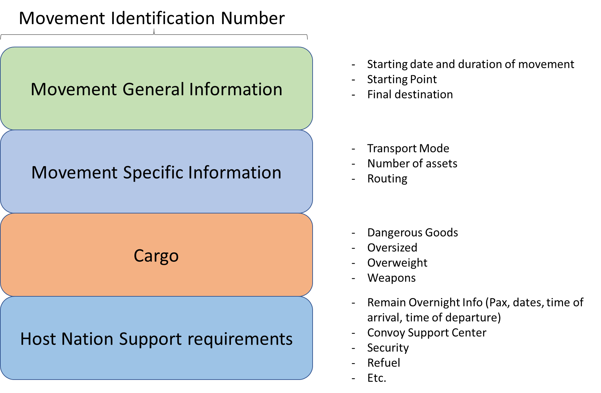
- To conduct exercises, a large amount of preparations has to be made. This varies from reserving exercise area(s), contracting service providers, planning movement, etc. Those cMs who plan to hold any exercises that require cross border military movements by incoming forces, will, as soon as possible, include all concerned cMs in the planning process and inform others when relevant. In case there are arrangements/agreements made for a specific exercise, those arrangements or agreements will prevail.

Section 2. Annual Movement Permission
- The annual movement permission will contribute to ease the administrative burden of stakeholders and it will enable the effective, efficient, timely and safe deployment, movement and transportation of military personnel, material and assets upon cMs’ needs for various military activities, including UN and NATO activities, under the conditions of this TA.

- Cases of annual movement permission cMs agree to include the following movements eligible for annual permission:
  - One vehicle including personnel, or;
  - Convoys consisting of 10 or less wheeled vehicles including personnel; This applies to movement with:
  - Personnel carrying governmental provided individual armament; - as well as required ammunition per individual weapon.
  - Transporting dangerous goods in compliance with the legislation applied to civilian transport on the transport of dangerous goods; (see details in Section 6 of this Chapter)
  - Transporting dangerous goods in accordance with the regulations as laid down in the AMovP6;
This applies to movement without:
  - Required HNS;
  - Personnel tasked with a security mission;
  - Transport of non-nominative allocated armament (not assigned to personnel);
  - Transport of weapon systems;
  - Oversized/overweight vehicles.

- cMs will display the existing status of implementation of its annual movement permission in an annual permission matrix (a template is included as Annex B), to be managed by the NPOCs.

- Procedure of requesting the annual movement permission
In principle, two months before the end of the calendar year cMs will send a request to all other cMs to grant or renew the annual movement permission for the next year. No later than one month before the end of the calendar year cMs will conclude the procedure to grant, deny or renew an annual movement permission. cMs will also notify any national restrictions in the surface domain foreseen for the next year.
In order to execute the movement under the annual movement permission, a notification (Annex A) will be sent by the sending cM to the respective cM at least two working days prior to the border crossing, as a confirmation of an already provided permission. cMs may specify exemptions to the notification requirements to other cMs.

Section 3. Ad Hoc Movement Permission
- As soon as military authorities of the sending cMs recognise a movement requirement (or develop their movement plan) they will submit a Movement Request Form (including possible HNS requirements), using the template at Annex A.
- Once the movement request is processed, the involved cMs should issue a movement permission (or inform otherwise), within five working days of the submitted request, using the same template (Annex A).
- In case of transit through several cMs, the sending cM will submit the movement request (including possible HNS requirements) using the template at Annex A, to all involved cMs at the same time. The involved cMs process the request simultaneously, using advanced coordination as much as possible.
- When a permission is granted, a notification (according to Annex A) could be required by the involved cM, taking into account the set timelines for the movement permission process.

Section 4. Advance Coordination
- National restrictions to the overall permissions will be distributed, published and updated by the cMs through the NPOCs.
  - Advance coordination comprises the use of designated roads, transport nodes and supporting facilities like convoy support centres, make use of the military network as encompassed in the Military Requirements (approved by the Council: the Military Requirements for Military Mobility within and beyond the EU). cMs take responsibility to keep their information updated on the possibility to use this network. In case usage is not possible, cMs inform the relevant bordering cMs and agree on alternatives to be used.
  - Nothing in this TA would prejudice the rights and entitlements of the host / transit cMs to check the data of the incoming and transit transport in the planning / request phase, and to check the transports in the execution phase, both at the entry and exit points and en-route, whether they conform with the requests and permissions. Host / transit cMs may request to submit missing data, to use correct data or correct forms, and may request to submit new movement request in case of significant changes.
- The cMs intend to establish a web-based platform in order to facilitate the exchange of information regarding the movement permission process. The exchange of information regarding the movement permission process will be done using NPOCs.

Section 5. Revoke of permission, modification of a movement request/notification/permission
- Annual permissions:
Annual movement permission can be revoked or suspended without any justification by any cM. The cM revoking or suspending the permission should notify the relevant cMs as soon as possible but in principle, not later than 1 month before the revocation or suspension becomes effective. The notification on suspension or revocation should be processed through the NPOCs. The notification of suspension should also contain an estimation of the duration of the suspension.
At any time cMs are allowed to declare restrictions or limitations in the implementation of the annual movement permission. In such a case cMs should notify each other well in advance and, in principle, not later than 1 month before the activation of such restrictions and limitations.
- Ad hoc permissions:
Ad hoc movement permission can be revoked, without any justification by any cM. The cM revoking the permission should notify the concerned cMs as soon as possible.
In case of other changes in the issued permission the cM should notify the concerned cMs as soon as possible.
Modification of previously submitted Movement Request can be made no later than 2 working days prior to the originally planned date of arrival at Border Crossing Points.
Reply to modification requests shall be given no later than 1 working day before the planned arrival.
No modification is accepted, but a new Movement Request/Notification is required if the planned change concerns transport of dangerous goods, overweight/oversized transport, significant changes to the HNS or a change of dates.
In case the number of involved vehicles and or personnel is decreased while this changed movement is included in the overview of movement eligible for annual permission, no modification of request is required. Any modification should be communicated through the NPOCs.

Section 6. Transport of Dangerous Goods
- cMs strive to use documents and related information of the ADR, RID and ADN which contain all the information in section 5.4.1 of those regulations. Dangerous goods transport documents, irrespective of whether they are in electronic, or paper form should be kept available throughout the journey.
- Security provisions associated with the transport of Dangerous Goods
a. The security provisions must be equivalent to those described in the civilian rules, i.e. Chapter
1.10 Security provisions as laid down in ADR, RID and ADN.
    - Relevant cMs authorities (NPOCs) must be informed of the risk and security measures associated with dangerous goods (in accordance with ADR, RID and ADN).
    - Security involves also other national regulations and must be based on a risk assessment of threat.
- Safety provisions associated with the transport of Dangerous Goods
    - Relevant cMs authorities (NPOCs) must be informed of the risk and safety measures associated with dangerous goods (in accordance with ADR, RID and ADN).
    - Safety involves also other national regulations and should be based on a risk assessment.
- In case relevant cMs apply waivers to ADR, RID and ADN for military transport, the regulations as laid down in the AMovP-6 will apply.
- Combined transport of personnel and Dangerous Goods
    - Only people who are required for the military movements involving dangerous goods (crew) should be present on board of the means of transport (vehicle/wagon/ship/transport unit) carrying dangerous goods. Other personnel should be transported separately.
    - The distance for the separation of dangerous goods wagons and the crew in rail transport should be at least 18 meters (as laid down in the RID 7.5.3).

- Transport of Dangerous Goods with possible eligibility for Annual Permission:

Technical conditions of the movement |  | Y/N
Transport of dangerous goods according to ADR, RID or ADN | Dangerous Goods excluding class 1
 | Dangerous goods including 1.4S, excluding other items of Class 1.
 | Explosives (Class1) other than 1.4S
 | Explosives (Class1) other than 1.4S, which needs security measures e.g., during a rest overnight (provided by Host Nation)
Transport of Dangerous goods not according to ADR, RID or ADN | Non-compliant, but according AMovP-6  SRDs 2, 3, 5 (including applicable National Deviations)
 | Non-compliant
 | Combat loaded tactical vehicles
Y: Eligible for annual permission N: Not eligible for annual permission

Explanation of several cells
Transport of Dangerous Goods
Dangerous goods as listed in the ADR, ADN and RID. All these goods have an UN number and a proper shipping name. The transport will be done in accordance with those European agreements as it is done in the civilian domain (Shipment, truck, drivers and documentation).
Dangerous goods excluding class 1 All dangerous goods from class 2-9.
Dangerous goods including 1.4S, excluding other items of Class 1.
All dangerous goods from class 2-9 and class 1 division 4 compatibility group S (1.4S).
Explosives (Class1) other than 1.4S
These items of class 1 are transported according to the ADR, RID, ADN but as a result of the international information exchanges about explosives between cMs, this is a separate group. Relevant cMs can make their own risk-, safety- and security assessments (This all depending on national law, threat and required services, as mentioned in paragraphs 2c and 3b of this section).
Explosives (Class1) other than 1.4S which need to be secured or need a rest overnight These are Class 1 items of which the sending nations wants support for security reasons, mostly for parking and rest overnight.
Transport of Dangerous goods not according to ADR, RID, ADN
Dangerous goods as listed in the ADR, ADN, RID, all these goods have an UN number and a proper shipping name. The transport will not be carried out i.a.w. these agreements (e.g. Shipment, truck, driver’s documentation are not or only partly according to ADR, RID or ADN).
Non-compliant, but according AMovP-6 SRDs 2, 3, 5 (including applicable national deviations)
The transport of dangerous goods is not done according to the civilian agreements but there are exemptions and possibilities described in AMovP-6 SRDs 2, 3, 5.
Non-compliant
The transport of dangerous goods is not done according to the civilian agreements and there are no exemptions or possibilities described in AMovP-6 SRDs 2, 3, 5.
Combat loaded tactical vehicles
Tactical vehicles, certified or declared as such by the competent authorities of the sending cM, loaded with ammunition in the foreseen racks, magazines and storage places (not in the weapon or weapons are disarmed). There are no other dangerous goods (than those required for the operation of the vehicle) on board of this tactical vehicle.

Section 7. Geographic and other specific limitations
Any cM can impose geographic or other specific limitations on military movements into or through its territory. The limitations can inter alia limit access to certain areas or sectors of its sovereign land territory.

Section 8. Low Emission Zones
In case cMs have restrictions in using low emission zones, cMs will investigate measures to exempt each other’s military vehicles from these restrictions in order to facilitate and enable military movement when moving through low emission zones, without prior need to apply for an exemption and without any additional administrative burden.

CHAPTER IV – OTHER ASPECTS RELATED TO MOVEMENT

Section 1. Prioritization of military movement
Upon request from a sending cM, cMs will take available measures to prioritize military movement over civilian movement.

Section 2. Military movement during national holidays and/or celebrations
The cMs will take available measures to facilitate and enable military movement also during holidays, national celebrations and weekends.

Section 3. Toll
- Military movement should not be hampered by inadequate infrastructure at toll gates (too narrow or not opening). cM will make a best effort, as applicable, to make this possible. In case needed relevant cM can request additional information.
- All cMs need to make a best effort to ensure that military movement is free of toll and user charges.
- Sending cMs make their best effort to follow the applicable rules of the host / transit cMs on the exemption of toll and similar fees and to send their vehicle data in due time.

Section 4. Requirements for escorting convoys or vehicles
- Subject to national laws and given circumstances host/transit cMs decide whether escort is necessary or mandatory.
- Escort is aimed at ensuring security for road movement and may be requested from host / transit cMs, when submitting a movement request.
- cMs may reject movement requests when escort is necessary or mandatory, but it is not available or cannot be provided during the requested period.
- Host / transit cMs may require reimbursement for the cost of the escort.

Section 5. Security provisions for rail transport
- The sending cM is responsible for providing security requirements (if required by this sending cM) and details for rail transport, if such is deemed necessary. When considered necessary by host /transit cMs, pre-coordination with all involved cMs will be done to clarify all details, including e.g.:
  - Number of persons being part of a security detail;
  - Presence of small arms;
  - Lines of communication during the transport.
- Security provisions may be added in the territory of host / transit cMs if movement permission given by host / transit cMs.

Section 6. Train composition
Train composition for cross border military movement should stay intact throughout the journey. In case national regulations of any relevant cM require to attach a wagon, cMs take this into consideration at the initial train composition. Only in case of a gauge change (width of the rail), ensuring train composition remaining intact is not applicable.

PART 3: TA ENTERING INTO EFFECT

CHAPTER V - FINAL PROVISIONS

Section 1. Legal aspects
- Any difference in the interpretation or application of this TA will be resolved solely by consultation between the Participants.
- All claims arising within the context of the performance of the TA will be dealt with in accordance with international and national laws and regulations of the cMs.
- This TA does not constitute a treaty as defined by the 1969 Vienna Convention on the Law of Treaties. In case of any conflict between this TA and international or national laws and regulations of the cMs, the latter will prevail. The cMs to the TA will notify each other in the event of any such conflict.

Section 2. Duration
This TA will remain effective unless all cMs consent in writing to its termination on the proposal of any of the Participants.

Section 3. Amendment
- Upon cM(s) proposal, this TA may be amended at any time in writing by unanimous decision of all the cMs for which the TA has become effective, taking into account that no amendment can be made to this TA or its annexes in the first 6 months following the coming into effect of this TA.
- Upon a proposal by cM(s), annexes to this TA may be modified by consensus of all the cMs for which the TA has become effective through a 60 calendar days silence procedure, organised by EDA. After this period has ended and if no objections have been raised, the modifications will become effective. EDA will provide a communication on the outcome to the cMs. Modifications to the Annexes do not constitute an amendment to the TA.

Section 4. Withdrawal and Termination
- Any cMs can withdraw from this TA at any time at their own discretion via a written notice to EDA, two months prior to the desired withdrawal date. EDA will notify the remaining cMs.
- In case of termination of this TA or the withdrawal from the TA by any cMs, the commitments arising from this TA (e.g. provided annual permission) during their period of validity remain in effect.
- A cM that withdraws from the CBMP PA will simultaneously withdraw from this TA. Termination of the CBMP PA means also termination of this TA. In case of termination of the CBMP PA or the withdrawal from the CBMP PA by any cM, the commitments arising from this TA during their period of validity remain in effect.

Section 5. Admission of new Members
- Any PA-cM, will become a cM by means of a Declaration of Intent both in the English and French language (enclosed at Annex C to this TA) at the date of signature of this declaration. The Declaration of Intent will be sent to EDA, which will inform all cMs.
- EDA will accordingly update the list of cMs on the front page of this TA. This update does not constitute an amendment to the TA.

Section 6. Signature and date of Coming into Effect
- This TA will be signed both in the English and French languages, each version being equally valid. The original will be held by the EDA, with one certified true copy being sent to each cM, upon request.
- This TA will become effective at the date of signature of a minimum of 10 cMs and EDA. For other cMs this TA will become effective on their respective date of their signature.

ANNEX A MOVEMENT REQUEST/NOTIFICATION/APPROVAL TEMPLATE
A Movement Identification Number (MIN) will be assigned by the sending cM to a specific cross border movement, if required by the involved cM. This MIN is inserted on the first page of the template. It consists of 18 digits with the following information per digit:
- First 2 digits: cM letters (for example IT for Italy);
- Next 8 digits: The date mandatory written as year/month/ day (yyyymmdd). For example, 20181222 for 22 December 2018. This is the date of submitting the MIN;
- The next 1 digit is to identify union or non-union goods (“U” or “N”), In case transport of goods is not applicable, a “U” will be inserted. In case no goods or cargo are transported, a “Z” will be inserted;
- The next 1 digit is to identify if it is NATO (“N”), EU (“E”) or national related activity (Other:
“O”);
- The last 6 digits can be used by the cM as unique numbering.

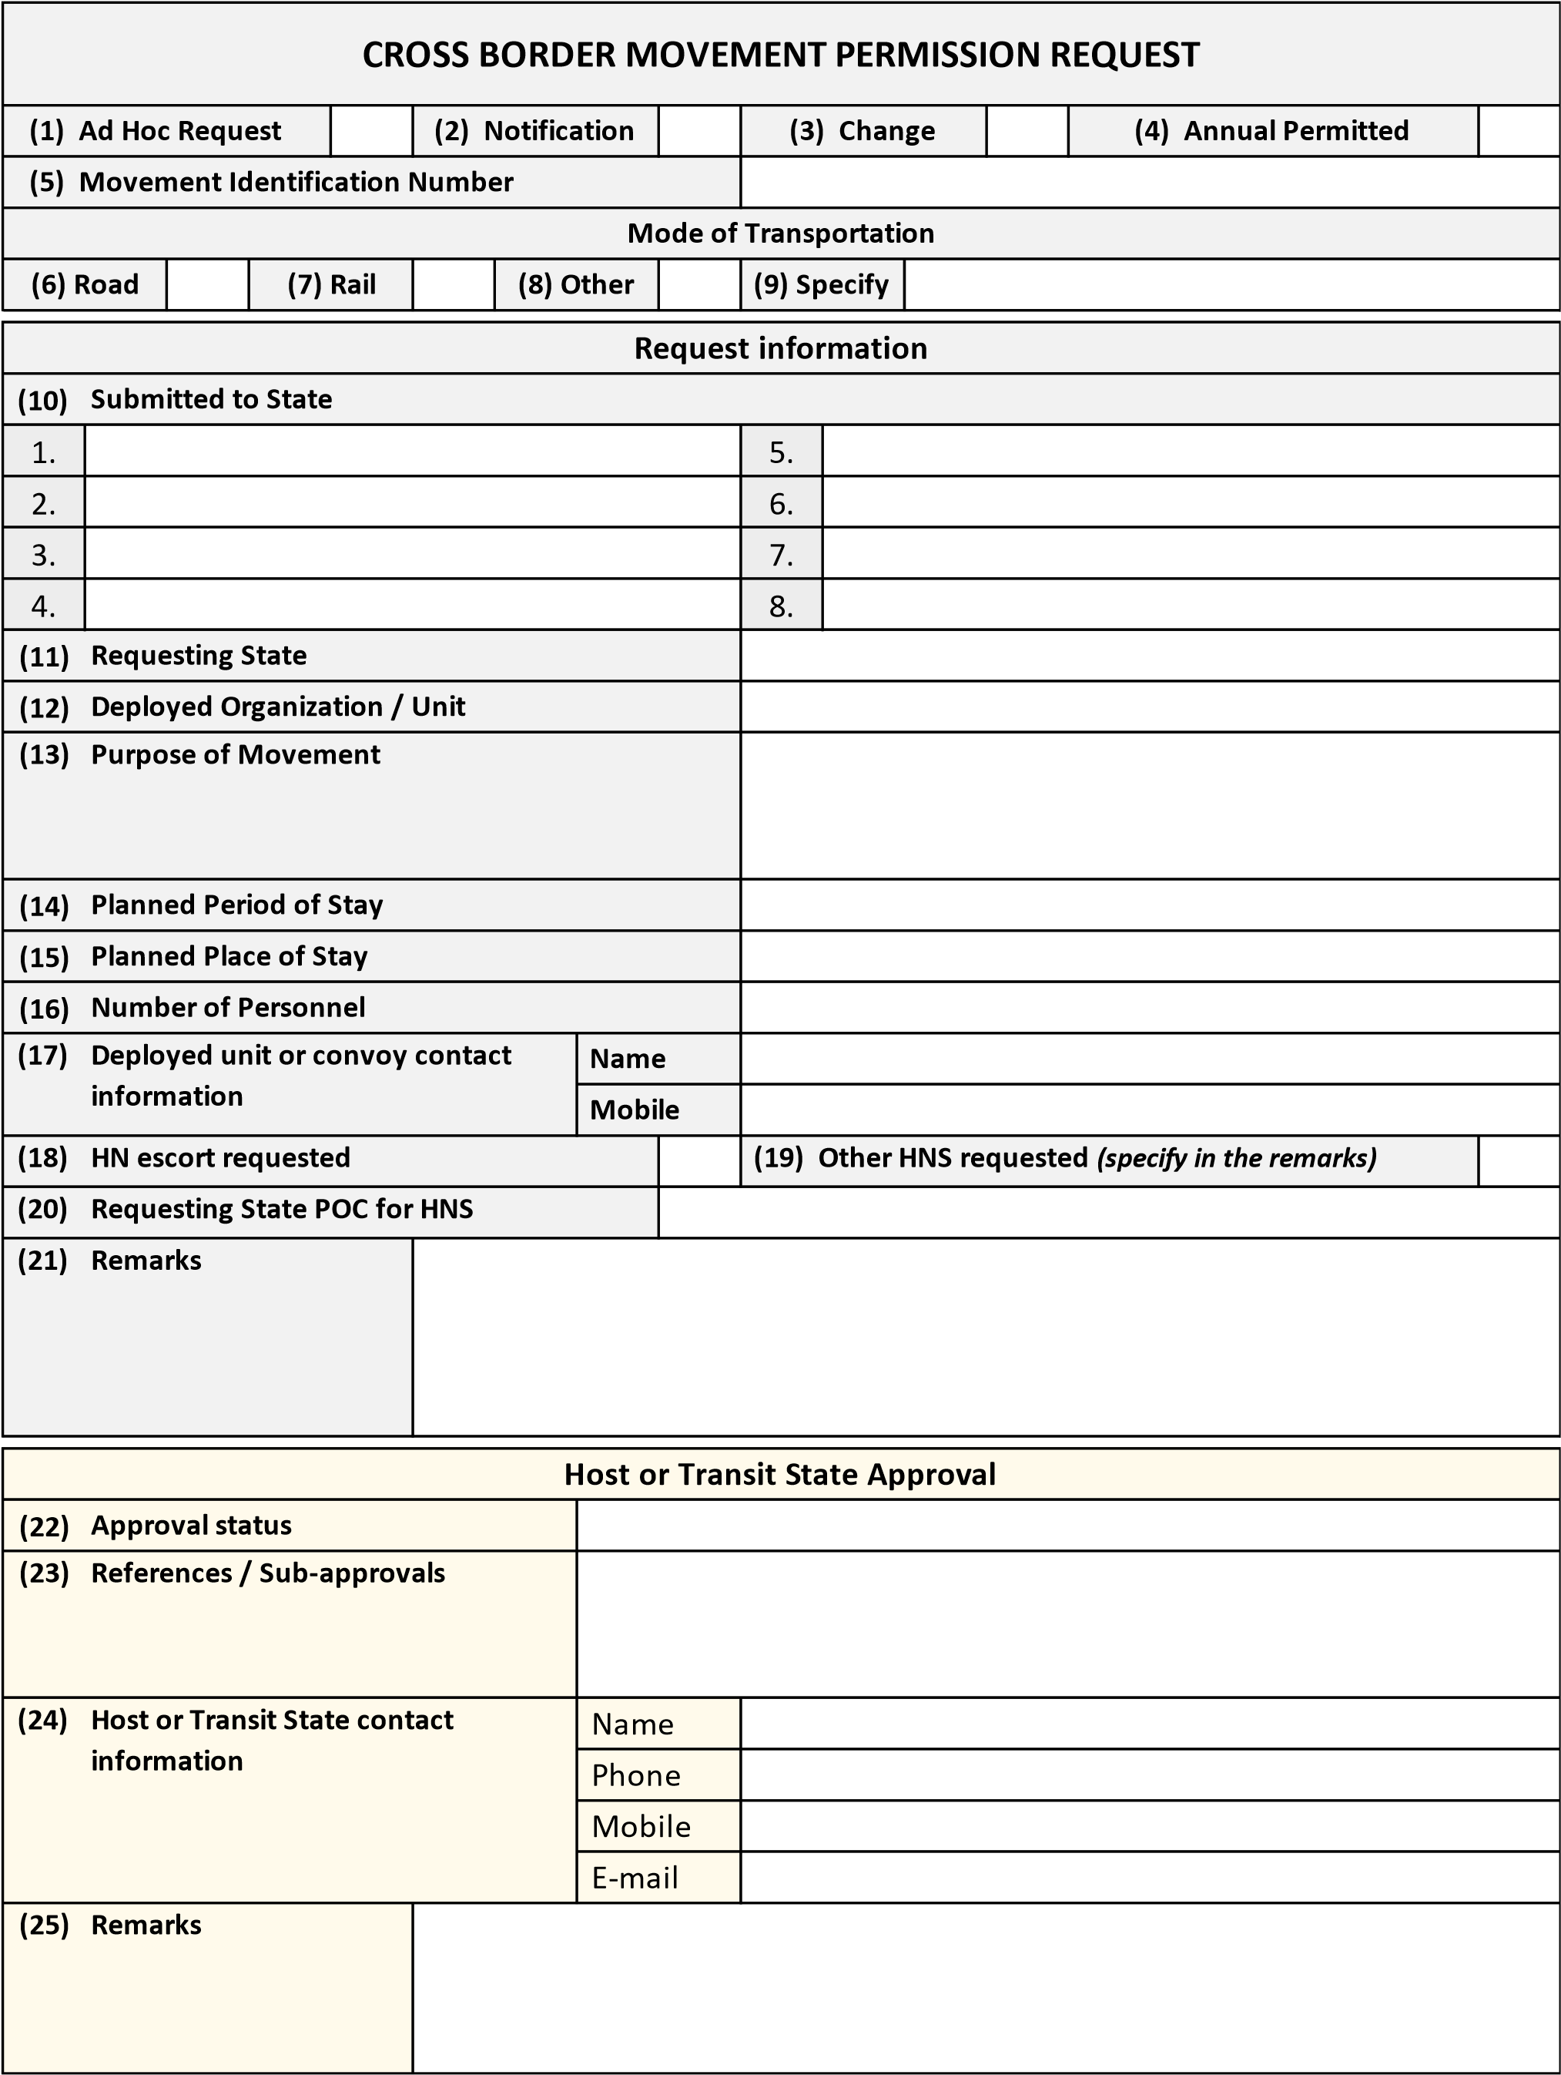

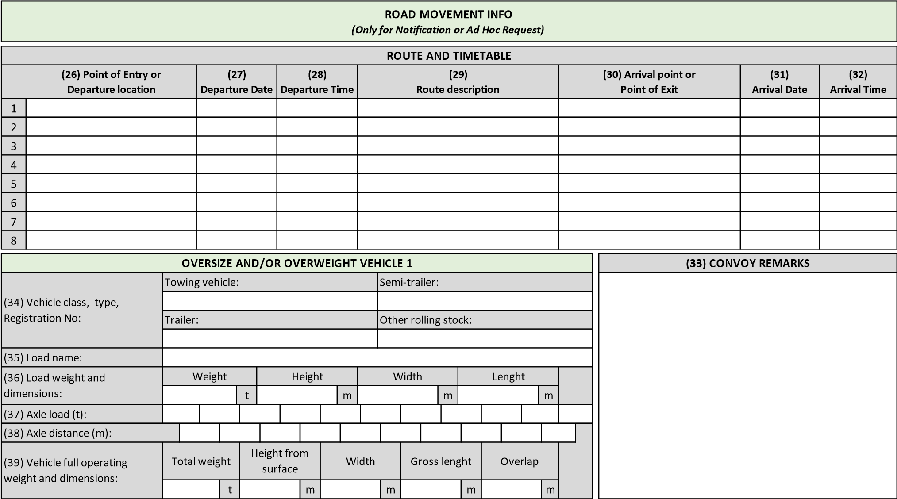

 | ARMAMENT, VEHICLES AND SENSITIVE EQUIP  (Only for Notification or Ad Hoc Request) |  | MENT LIST
(40) Type of equipment | (41)  Equipment description | (42)  Qty (pcs) | (43) Remarks

DANGEROUS GOODS LIST
(Only for Notification or Ad Hoc Request)
(44)  Regulation | (45)  C or NC | (46) UN Nr | (47)  Proper Shipping Name | (48)  Class or  Classification  Code | (49)  Gross weight | (50)  Total Net  Quantity | (51)  Total NEQ (Class 1) | (52) Remarks

VEHICLES DATA FOR ROAD TOLL
(Only for Notification or Ad Hoc Request and if required by host or transit state)
(53)  Type of Vehicle | (54) Mark and model | (55)  Reg. Plate No | (56) Remarks

ANNEX B OVERVIEW OF MOVEMENT ELIGIBLE FOR ANNUAL PERMISSION

Technical conditions of the movement | cM Y/N
One vehicle including personnel
Convoys consisting of 10 or less wheeled vehicles including personnel
This applies to movement with:
- Personnel carrying governmental provided individual armament;
- as well as required ammunition per individual weapon.
- Transporting dangerous goods in compliance with the legislation applied to civilian transport on the transport of dangerous goods;
- Transporting dangerous goods in accordance with the regulations as laid down in the AMovP-6;

Technical conditions of the movement including Dangerous Goods |  | cM  Y/N
Transport of dangerous goods according to  ADR, RID or ADN | Dangerous Goods excluding class 1
 | Dangerous goods including 1.4S, excluding other items of Class 1.
 | Explosives (Class1) other than 1.4S
 | Explosives (Class1) other than 1.4S, which needs security measures e.g., during a rest overnight (provided by Host Nation)
Transport of Dangerous goods not according to ADR, RID or ADN | Non-compliant, but according AMovP-6  SRDs 2, 3, 5 (including applicable National Deviations)
 | Non-compliant
 | Combat loaded tactical vehicles
Y: Eligible for annual permission
N: Not eligible for annual permission

ANNEX C DECLARATION OF INTENT

The Republic/Kingdom/Government/Ministry/Minister of ….................. represented by ...................................………………………………………..

DECLARING that it wishes to participate in the:
TECHNICAL ARRANGEMENT (TA) Nº A.PRG.CAP672.S
On Cross Border Movement Permission Procedures for Surface Movement in Europe (SURFACE TA);
Acknowledging that the terms in this declaration have the same meaning as in the afore-mentioned Technical Arrangement;
ACCEPTS to:
- participate in the SURFACE TA as per Chapter V, Section 5 of this TA;
- contribute to the SURFACE TA and to adhere to all TA provisions including its Annexes and related approved documents in the versions valid at the time;
- mandate the EDA to update the list on the front page of this TA and integrate the signatures at the end of the SURFACE TA accordingly.

For the Republic/Kingdom/Government/Ministry/Minister of ....…................................…………….
………………………………………………………………….
Date: ...............................

SIGNATURES

The Federal Minister of Defence of the Republic of Austria,

Signature

Place
Date

The Minister of Defence of the Kingdom of Belgium

Signature

Place
Date

The Ministry of Defence of the Republic of Bulgaria,

Signature

Place
Date

For the Ministry of Defence of the Republic of Croatia,

Signature

Place
Date

The Ministry of Defence of the Republic of Cyprus,

Signature

Place
Date

The Ministry of Defence of the Czech Republic,

Signature

Place
Date

The Ministry of Defence of the Republic of Estonia,

Signature

Place
Date

For the Ministry of Defence of the Republic of Finland,

Signature

Place
Date

The Minister for the Armed Forces of the French Republic,

Signature

Place
Date

The Federal Ministry of Defence of the Federal Republic of Germany,

Signature

Place
Date

The Ministry of National Defence of the Hellenic Republic,

Signature

Place
Date

The Ministry of the Defence of Hungary,

Signature

Place
Date

The Ministry of Defence of the Italian Republic,

Signature

Place
Date

The Ministry of Defence of the Republic of Latvia,

Signature

Place
Date

The Ministry of National Defence of the Republic of Lithuania,

Signature

Place
Date

The Minister of Defence of the Grand Duchy of Luxembourg,

Signature

Place
Date

The Minister of Defence of the Kingdom of the Netherlands,

Signature

Place
Date

The Ministry of Defence of the Kingdom of Norway,

Signature

Place
Date

The Minister of National Defence of the Republic of Poland,

Signature

Place
Date

The Ministry of National Defence of the Portuguese Republic,

Signature

Place
Date

The Ministry of National Defence of Romania,

Signature

Place
Date

The Ministry of Defence of the Slovak Republic,

Signature

Place
Date

The Ministry of Defence of the Republic of Slovenia,

Signature

Place
Date

The Ministry of Defence of the Kingdom of Spain,

Signature

Place
Date

The Government of the Kingdom of Sweden

Signature

Place
Date

The European Defence Agency

Signature

Place
Date

According to the OJ C321(31/12/2003). The reference should now read Article 42 (1) and 43 (1) TEU (ex-Art. 17).
cMs decided to use 18 meters separation, being the standard length of a railway wagon.

