FINANCIAL AGREEMENT
&
TECHNICAL ARRANGEMENT

BETWEEN

NATO SCHOOL OBERAMMERGAU

AND

THE MINISTRY OF DEFENCE OF THE REPUBLIC OF SLOVENIA

REGARDING

THE MOBILE EDUCATION AND TRAINING TEAM

FOR

THE NATO SYSTEMS APPROACH TO TRAINING COURSE

In order to facilitate the Mobile Education and Training Team (METT) for the NATO Staff Officer and NCO Orientation Course, the NATO School Oberammergau (NSO) and the Ministry of Defence of the Republic of Slovenia have come to the following understanding,having regard to the provisions of the Agreement between the Parties to the North Atlantic Treaty regarding the Status of their Forces (NATO SOFA), done in London June 19, 1951:
- At the invitation of The Ministry of Defence of the Republic of Slovenia and Slovenian Armed Forces (SVN), NSO will conduct the NATO S7-136 Systems Approach to Training course over the period 21-25 NOV 2022 in Maribor, Slovenia. The course content will be based on the S7-136 Course conducted by NSO. The Course curriculum will be agreed upon, in more detail, by the NSO Course Director and the SVN assigned responsible officer (Annex A).

- Students who successfully complete the course will be issued a Certificate of Completion - S7-136 Systems Approach to Training course. Successful completion of the course requires attendance of at least 4 full days. Students whose absence exceeds a full day will not receive a Certificate of Completion.

- NSO METT personnel (Course Director) will arrive in Maribor on 20 NOV 2022. All METT personnel are to depart no later than 26 NOV 2022.

- A visit of the training area’s facilities was conducted on 27-28 JUN 22 in order to complete course preparations. Associated costs have been incorporated to the cost proposal (Annex B).

- NSO will provide SVN with the rank, names, nationality, arrival and departure schedule as well as personal identification number for all METT personnel. METT personnel will be issued temporary security badges, allowing unescorted access to the training area’s facilities.

- The Training Audience will consist of approximately 17 students from the Slovenian Armed Forces. SVN is to provide a nominal roll (names and ranks of all students) to the METT CD NLT 07 NOV 22 for the welcome message and the issuing of NSO Course Certificates upon completion of the course. The payment of student tuition fees is described in Annex B.

- The NATO Systems Approach to Training Course will be conducted in the English language throughout. The training audience is to have a proficiency standard of English as described in STANAG 6001: 3333 in order to understand the course content as well in addition to actively participating in the course syndicate work.

- The classification of the NATO Course is NATO UNCLASSIFIED.

- The accommodation of METT personnel will be at a hotel in Maribor in accordance with NSO standards and agreed between NSO and SVN (rooms must have in-room Wi-Fi access to enable connectivity via VPN to the NSO IT system). SVN will pay for the initial cost of the hotel accommodation.

- The transportation of METT personnel for the site survey and the METT will be provided by NSO duty car and associated costs included in the invoice. (see Annex B).

- Emergency medical care is to be provided for all METT personnel at the training area’s facilities or civilian hospitals. Basic first aid is to be provided, at no cost, during working hours at the training area’s infirmary. All other treatment, including hospitalization, is to be provided on a reimbursement basis and the cost will be based upon current rates. Procedures for reimbursement are to be in accordance with current bilateral agreements between the SVN National Health Service and the National Health Service of each METT member. The host nation is required to facilitate COVID tests prior to return trips for the METT staff if required.

- SVN is to provide appropriate equipment and ancillaries for the effective execution of the METT at the training location (see Annex C). COVID-19 hygiene and safety rules and measures (masks, distancing, sanitizers) shall be in force wherever applicable in the training facility. All students and METT staff shall comply with these rules.

- The NATO SOFA will govern the legal status of the METT personnel. The METT personnel will respect national laws and regulations of the SVN.

- This Financial Agreement & Technical Arrangement is not to conflict with national laws and regulations of the Participants or with the international law and arrangements in effect. In case of conflict between the Financial Agreement & Technical Arrangement and national laws and regulations and/or international law and arrangements, the latter will prevail over this Financial Agreement & Technical Arrangement. Any dispute relating to the interpretation or execution of this Financial Agreement & Technical Arrangement will be resolved solely by negotiations between the signing Participants. No dispute is to be referred to court, tribunal or a third party for settlement.

- The end and/or termination of this Arrangement does not release the Parties from their obligations incurred in the course of its implementation.

- The S7-136 METT will be confirmed, postponed or cancelled on 24 OCT 2022.

- This Arrangement comes into effect upon the date of the last signature.

Ryan B. Craycraft Peter Zakrajšek
Colonel, USA-AF Brigadier General
Dean of Academics Commander
NATO School Oberammergau Military Schools Centre

Oberammergau, ___________ 2022 Maribor, ___________ 2022

Annexes:

A. Course Curriculum.
B. Financial Procedures and Course Costs.
C. Required equipment and ancillaries
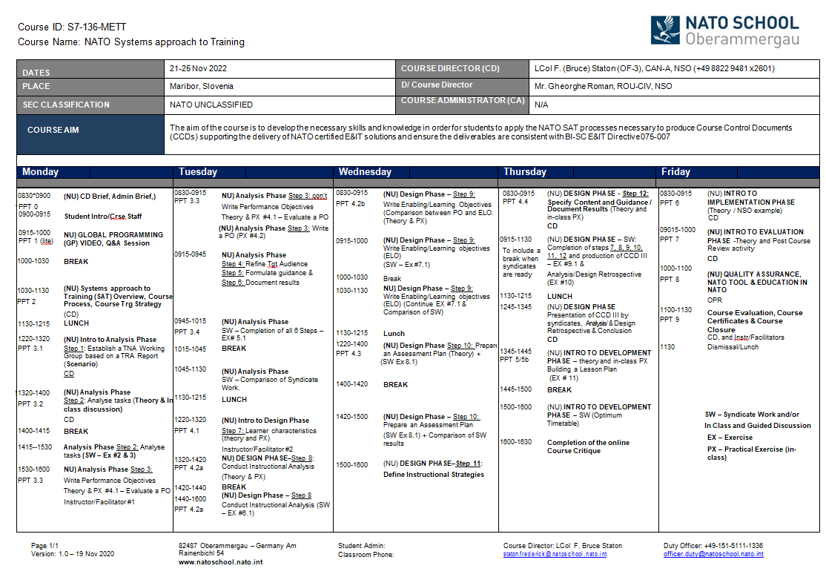

FINANCIAL PROCEDURES FOR THE METT SYTEMS APPROACH TO TRAINING IN MARIBOR, SLOVENIA, 21-25 NOV 2022.
- SVN agrees to pay NSO a tuition fee of €400 for each student to attend the NATO Systems Approach to Training Course. If less than 15 students attend the course SVN will still be invoiced for 15 students at €400 each. SVN will receive a consolidated invoice reflecting the actual number of students (minimum 15).
- SVN agrees to reimburse NSO for all expenses associated with the planning and conduct of the METT itself, including (but not limited to): travel, accommodation and per-diem. The per-diem rates to be reimbursed are in accordance with the NSO standard (based on the US Joint Federal Travel Regulation).

- If the scheduled METT is cancelled after confirmation date, due to circumstances not attributable to the NSO, except in the case of COVID-19 international travel restrictions, all agreed expenses incurred by NSO in the preparation of the METT will be reimbursed by SVN. No money will be involved prior to confirmation date.

- Within 30 days from the completion of the METT, NSO will forward to SVN, the invoice for tuition fees and all expenses to be paid by SVN. Supporting documents/receipts will form an annex to the invoice.

- The currency for reimbursement is the Euro. Payment is due 30 days from date of invoice.

- Complete billing/mailing address for SVN:
Military Schools Centre
Engelsova ulica 15
2111 Maribor

- Points-of-Contact:
Agency | Point-of-Contact | Contact Information
Slovenian Armed Forces  Officer in Charge | SMS XIV. CLASS Valerija BERNIK | TEL: +386 2 449 5011  Email: valerija.bernik@mors.si
Slovenian Armed Forces Finance POC | GM Aleksander VARGA | TEL: +386 2 449 5352  Email: aleksander.varga@mors.si
NSO  Action Officer | CSM Johnny Delrée  METT Coordinator | TEL : +49 8822 9481 2703  Email : delree-schmitt.johnny@natoschool.nato.int
NSO Course Director | LtCol Frederic STATON  SET Department | TEL: +49-8822-  Email: Staton.Frederick@natoschool.nato.int
NATO School  CJ8 Budget & Finance Department  Am Rainenbichl 54  82487 Oberammergau | Mr Günther SCHREINER  METT Financial Coordinator | Tel: +49-8822-9481-1805  Fax: +49-8822-9171-1805  Email: schreiner.guenther@natoschool.nato.int

COURSE COSTS

- Based on the NATO School Oberammergau CJ-8 Cost proposal, for the NATO Systems Approach to Training Course 21 – 25 NOV 22, the Parties agree upon payment of the following costs:
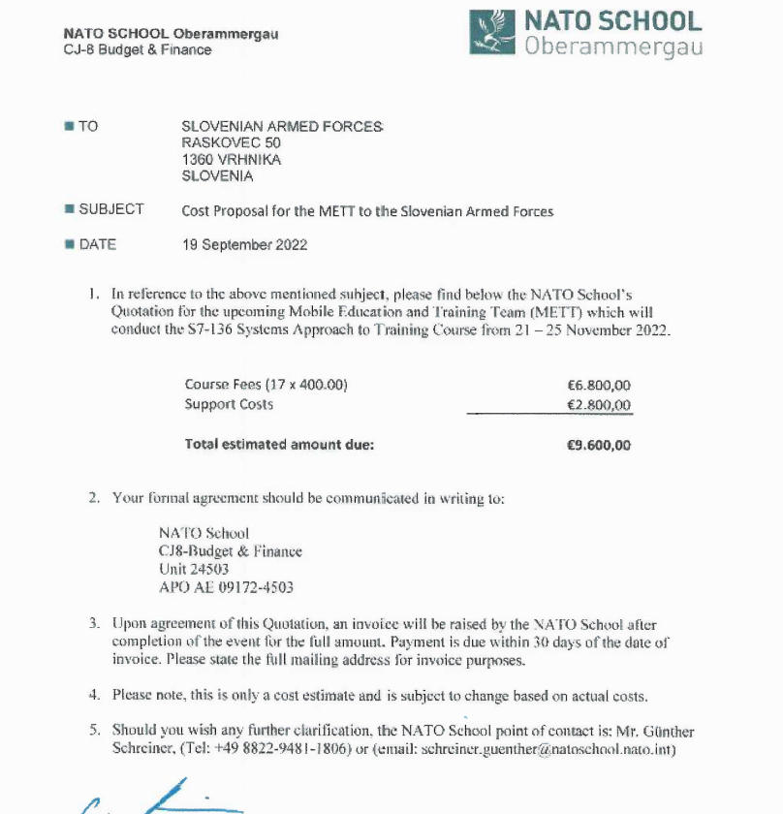
- This is only a cost estimate and is subject to changed based on actual staff participation and support costs.

- The difference in cost values between the invoice and this table are to be agreed by all Parties of the Arrangement.

REQUIRED EQUIPMENT AND ANCILLARIES FOR THE METT SYTEMS APPROACH TO TRAINING IN MARIBOR, SLOVENIA, 21-25 NOV 2022.

In order to deliver the S7-136 NATO Systems Approach to Training course to Slovenian Armed Forces students with the same quality and standards as if it were a resident course, the training facility in SVN is requested to provide the following facilities for the METT use from 21-25 NOV:

  - One plenary classroom sufficient to seat all students and METT personnel – approximately 17 personnel.

  - 3 syndicate rooms sufficient to seat 7 people (students and METT personnel).

  - A room for METT personnel.

  - Computers in plenary and syndicate rooms must be networked to enable file sharing or equipped with functional drives to enable file sharing. The METT staff room must have internet access.

  - If possible, students should be equipped with a networked/Internet-capable tablet or laptop in order to access course materials and references from the NSO Learning Management System (LMS).

  - METT personnel may require USB access to computers for up/downloading of course material this is only required if NSO team is unable to access the NSO LMS using available wi-fi.

  - The student and staff file structure will be provided by NSO. Controlled access for students and staff to the appropriate electronic files will be arranged by the training facility IT staff in coordination with the Course Director. The IT staff will establish and then conduct the daily management of the IT system throughout the course. (NOTE: All course and student files can be accessed through the NSO LMS if there is Wi-Fi access and/or network access to the INTERNET.

.

REQUIRED EQUIPMENT AND ANCILLARIES

MAIN PLENARY CLASSROOM
Computer (MS Office 2010, CD drive, with enabled USB port) connected to the Network | 1
Projector with projection screen or Large TV Screen (connected to computer) | 1
(Large White Board) | 1
Speakers (connected to computer) | 1
Infrared Mouse (or other method for speaker to change slides) | 1
Podium | 1
Chairs & Desks | 1 per person
SYNDICATE ROOM (3)
Computer (MS Office 2010, CD drive with enabled USB port) connected to the network | 2 per syndicate room
Projector with projection Screen or Large TV Screen (connected to computer) | 1
Large/Magnetic White Board or Walls suitable for Pins/Post-It notes for syndicate work | 1
Printer connected to computer – not required | 1
Infrared Mouse (or other method for speaker to change slides) | 1
Desk & Chair | 1 per student
METT PERSONNEL ROOM
Computer (MS Office 2010) with Internet connectivity, CD drive with enabled USB port | At least 2
Telephone with international access | 1
Printer connected to computers | 1
Copy machine | 1
Office Supplies | As required
Coffee point | As required

